User’s Manual for TweetPy

This document will be a brief run down on the features of the TweetPy application.

When first loaded into the browser, the user will be prompted to login or register

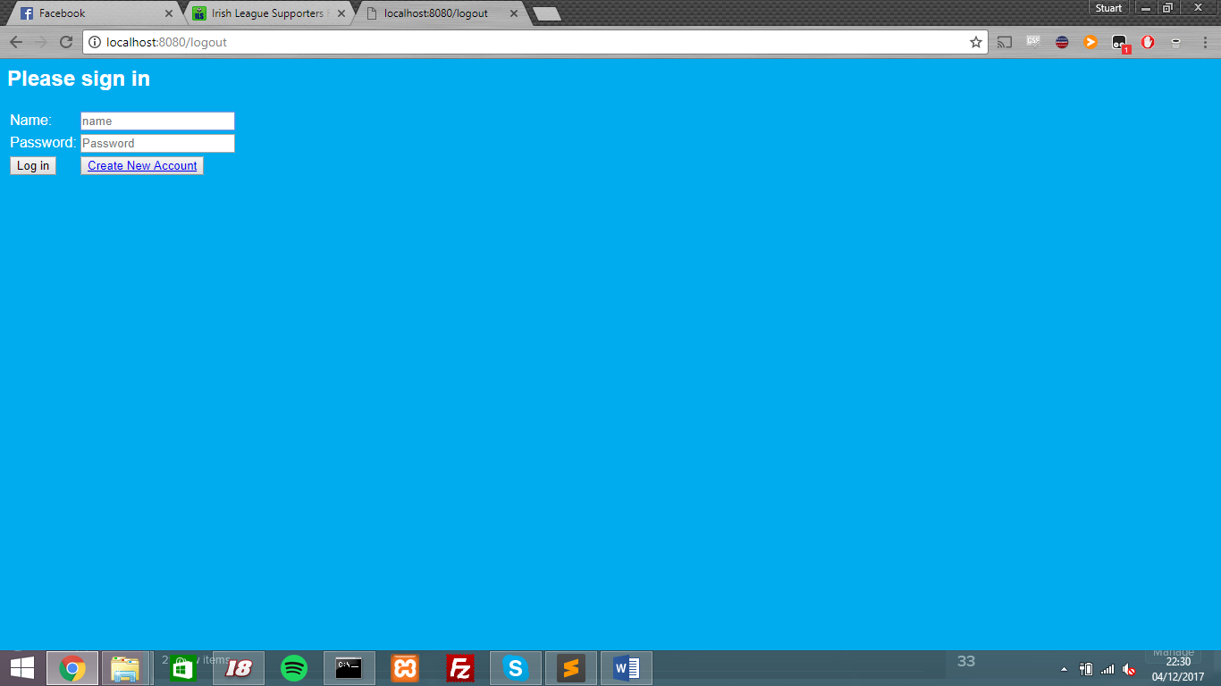  
If the user selects the reigster option, they will be redirected to a form page to enter their username and password. If the password is correct then the form will say that it was added to the database and will then prompt the user to sign in.

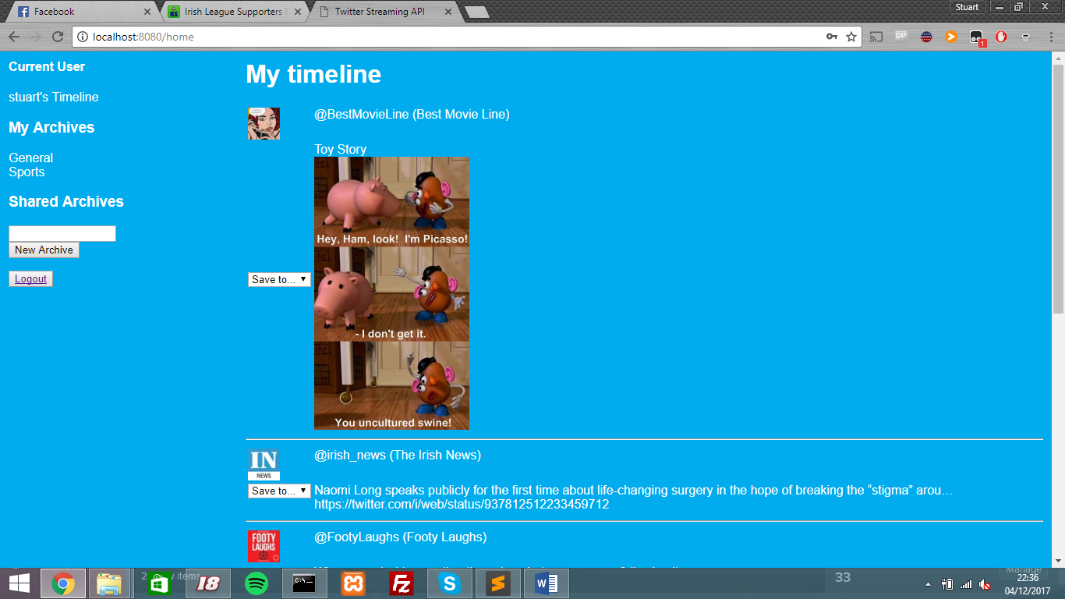Users can chose to archive tweets in order to view them later. Clicking on the drop down box beside the tweet will give you the option to save it to the available archives. Users can also create their own archives by using the box on the menu with “New Archive” below it

Once saved, archives can be retrieved from the menu on the left by clicking on the archive the user saved the tweet to.

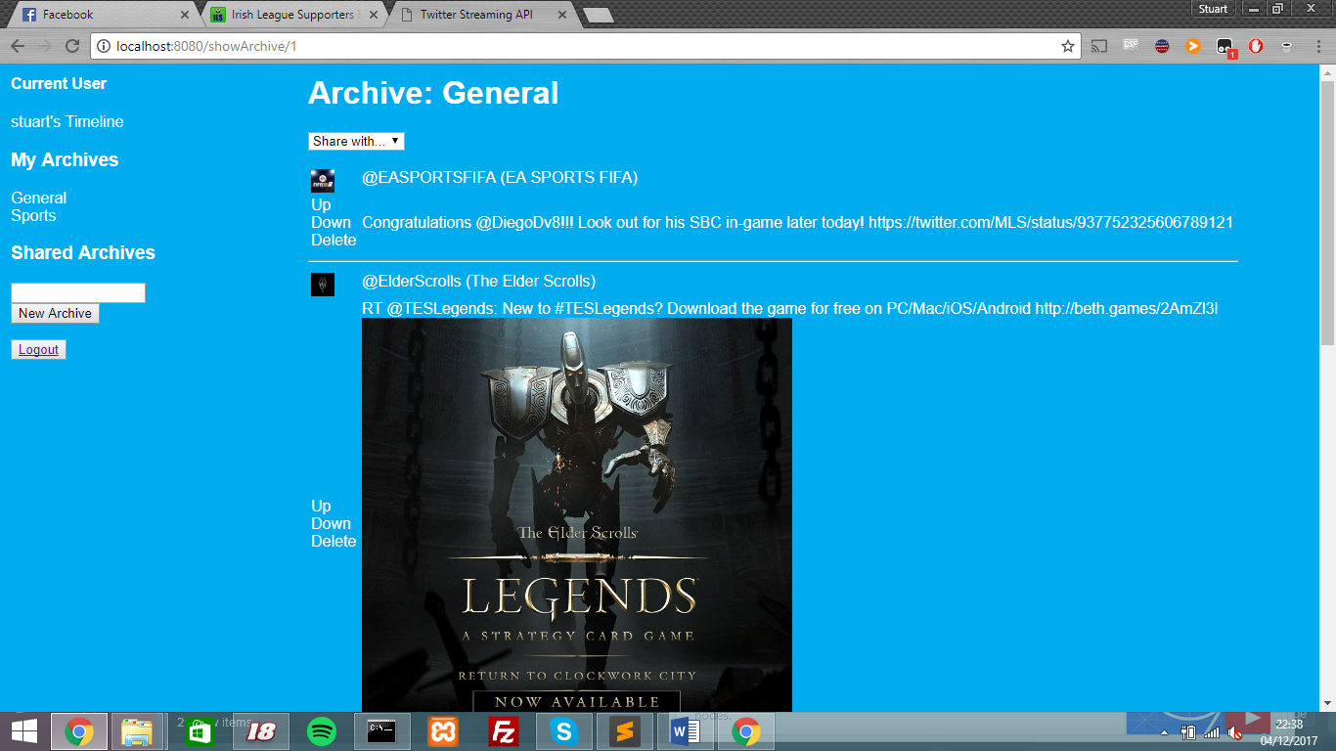

Finally, users can click on the screen names of users that appear on their time line in order to view all of their recent posts. This also goes for hashtags as well.

