GumTree Test
Development – D666
Document Version / Détails : Ver 1.0/17th March-2015

Record of Release

Version No. | Modified By | Reviewed By | Authorized By | Release Date | Modifications Done
1.0 | Cameron | Client | Client | 17 March 2015 | Yes

Introduction
To design and develop Android based application
The purpose of this app_test is to evaluate the ability to take UX requirements and to produce a suitable looking Android application based on the requirements.
To build a single screen Android application that will connect to an API endpoint and display the data in the UI as described below in the UX brief.

Design Approach

Assumptions and Constraints
Assumptions:

- MVC Design Pattern
- Adapter Design Pattern
- Use GIT
- Google Maps

Constraints:
- Application has to be developed for Android using Java.
- Device should have 3G connectivity or WIFI active.
- Use of fragments and activities for building advanced UI
- Function in both landscape and portrait orientation
- Work on both tablets and phones
- Feature a share functionality
- Support for multiple pictures
- Minimum API 14 support

Requirements Omitted
- None.

Design Principles
This application is divided mainly in three packages, namely Application UI, Adapters, Model

Application UI: This is developed in Java using Android SDK. Since application is to be designed in Java, the user interface will use standard controls so that it is consistent with the design guidelines given for Android applications. This module will mainly have UI controls and UI application logic.

Adapter: Displays all the fragments within the activity

Model: Pojo for the item to sell

System Architecture

Physical Environment
The test application will be developed on Java using Android SDK and Android Studio.

System Structure

This application will have UI, Adapter and model modules:

- UI
This module is developed in Java. This module will have all UI components and logic.

This module will be responsible for displaying the information and error handling for various user events such as button taps, checkbox, text changes, screen transitions, graphic stats etc.
This module will follow its own MVC architecture, where ItemActivity is the main activity for the item screen, the adapter classes are responsible for correctly populating the Listview with the various fragment layouts.
The user can add the item as a favourite, email/call the seller and find the location of the seller using Google Maps

- Model Module:
Pojo of item(s) to be sold in the ItemActivity

- Adapter Module:
This module is used to store various fragments in and populate the ListView within the ItemActivity with the various fragment layouts to produce a clean looking UI

High-Level Design
Figure: Use Case
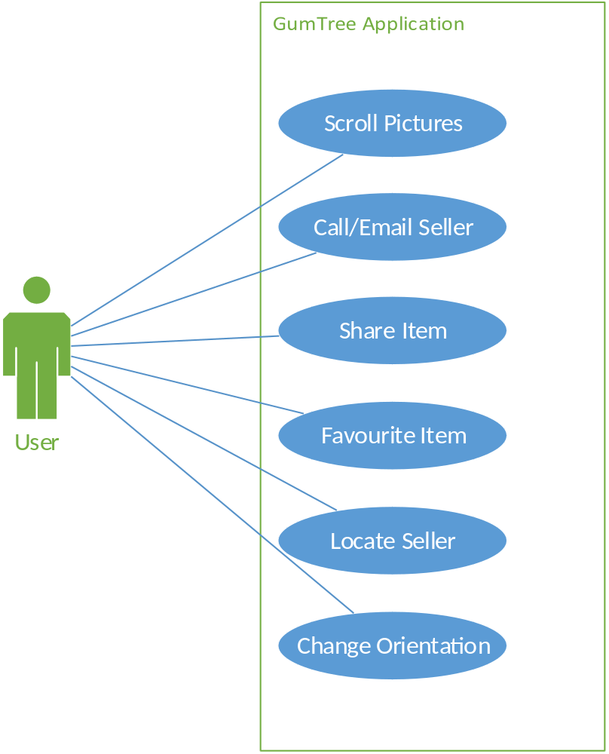

User Interface Design
Figure: Home

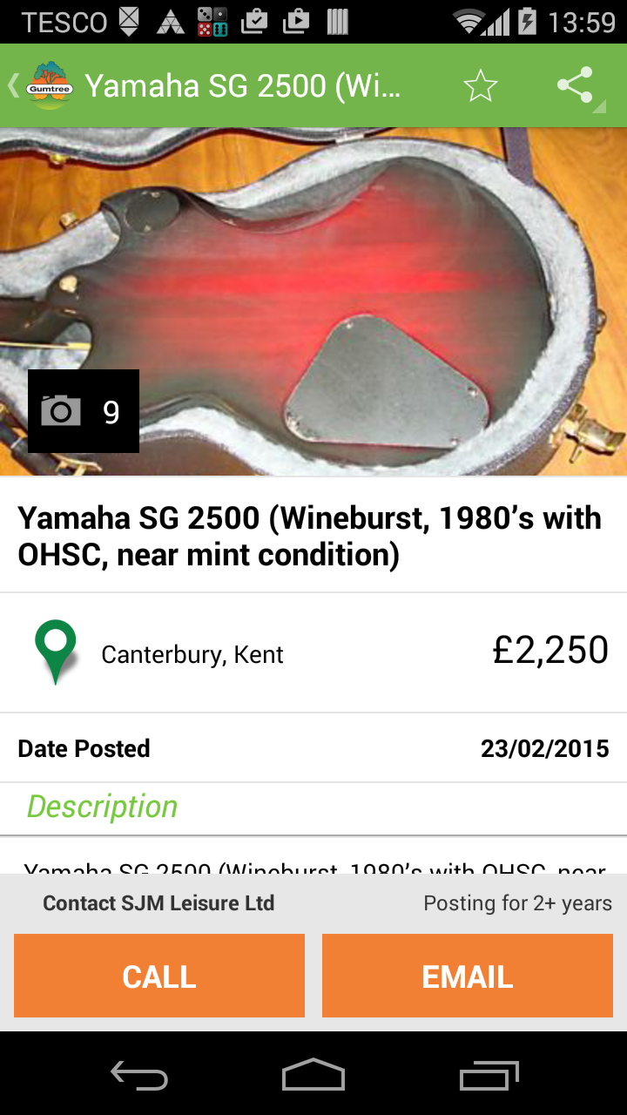

Development Environment

Android Studio will be used for development.

