Interactive, Collaborative and Multi-user Augmented Reality Applications in Primary and Secondary Education

A systematic review

<https://doi.org/10.3991/ijxx.vx.ix.xxxx>

**Abstract**— Augmented reality is a technology that enhances human perception with additional, artificially generated sensory inputs. This creates new experiences enriching human vision by combining natural with digital elements. Augmented reality development dates back to the early sixties but it is only in the last decade, thanks to improvements to hardware and software, when it has begun to be rapidly incorporated in several fields, including education. This study presents a systematic review of the literature on the use of augmented reality applications in primary and secondary schools, with a specific focus on collaborative, multi-user and interactive applications. The aim of the study is to investigate the characteristics of such applications, the processes that led to their adoption, and their effectiveness in enhancing the learning experience. This study synthesizes a set of 100 publications from 2015 to 2020 and performs a qualitative analysis of their content. The review describes the current state of the art in research in augmented reality for education and provides future research lines, as well as trends for the future of such applications in educational settings, analyzing the relevance of the multi-user interaction challenge within the augmented reality ecosystem.

**Keywords—**Augmented Reality, Education, Literature Review, Interactive Technologies, Multi-user applications, Collaborative

1. Introduction

Digital transformation is profoundly impacting and disrupting every facet of society, and education is no exception. In recent decades, Augmented Reality (AR) has broken into the educational area. Even though he term “Augmented Reality” was first introduced in 1992 by Caudell [1], when he described a concept of glasses that enabled workers to see virtual labels and information while assembly a Boeing jet’s wiring, it took many years before AR was first applied in schools as a tool to facilitate learning. Nowadays, thanks to the widespread adoption of devices that support AR applications, as well as the availability of software libraries such as ARKit[1] or ARCore[2] which greatly simplify and speed-up the development process, AR has become a technology which is being more and more used in educational settings. Given its surge in popularity, AR has become an active research topic and several systematic studies have been performed to analyze how this technology has been used in educational contexts.

Some studies presented an analysis of the advantages and drawbacks of AR in generic educational settings [2] [3] [4] or have provided insights on the status of the technology as well as suggestions for future research [5] [6] [7] [8]. Other reviews have focused on specific subjects, such as Science, Technology, Engineering and Math (STEM) [9] [10] [11] or language learning [12] [13]; on specific topics such as AR-based serious games [14] [15] [16], the evaluation of the usage of AR in schools [17] [18] or the impact of AR applications in learning effectiveness [19]. Table 1 summarizes the content of some of the most recent and comprehensive Systematic Literature Reviews (SLRs) about AR in educational settings.

1. Summary of SLRs about usage of AR in education.

|  |  |  |  |  |
| --- | --- | --- | --- | --- |
| Study | Year | Purpose | Studies reviewed | Findings |
| Systematic review and meta-analysis of augmented reality in educational settings [19] | 2019 | Identify the status and tendencies in the usage ofAR in education | 61 | AR has a medium effect on learning effectiveness; lack of studies considering accessibility features in AR apps |
| Augmenting the learning experience in primary and secondary school education: a systematic review of recent trends in augmented reality game-based learning [8] | 2019 | Explore the combination of AR with Game Based Learning (ARGBL) | 21 | Motivation and enrichment are pillars of ARGBL; ARGBL compares favorably to traditional learning |
| Augmented Reality for STEM learning: A systematic review [9] | 2018 | Perform qualitative analysis of the characteristics of AR apps for STEM learning | 28 | Most apps offer exploration or simulation activities, but usually without helping in carrying out learning activities; similar design features across all studies |
| Advantages and challenges associated with augmented reality for education: A systematic review of the literature [2] | 2017 | Identify advantages of AR in education and identify current gaps in AR research | 68 | Conflicting results regarding cognitive overload of AR; low usability is the main challenge of AR apps for education |

Since the publication of the seminal paper on collaborative AR by Billinghurst and Kato [20], which first discussed how AR could be used to enhance online and offline collaboration, much progress has been made in providing collaborative tools for AR applications. To the best of our knowledge, only the work of Phon et al. [21] evaluates the usage of collaborative AR applications for education, by reviewing publications on the subject from 2000 to 2013. Given the many advancements of AR technology in the last few years, we believe that a systematic review of more recent publications is required, to see how AR apps are used as tools to improve collaboration be-tween students as well as between students and teachers, or how multi-user interfaces facilitate cooperation and learning.

Cooperative learning, defined as the instructional use of small groups to promote students working together to maximize their own and each other’s learning [22], has long been used as an educational approach to improve students’ learning and performance [23] [24]. Technology can help foster collaboration among students, but their engagement depends on how much they can interact with the different tools. AR per se is not a multi-user and collaborative tool: it is up to researchers and developers to provide such functionalities in an AR-based educational application. With this work, we aim to evaluate which publications described AR applications that provided the following features:

* *Levels of interactivity*: the app should respond to the user input and let the student modify the app content using different interaction methods (which will be described in detail in Section 3.2;
* *Multi-user functionalities:* more than one user at the same time can use the app and the actions of one user are directly reflected in the other users’ devices;
* *Collaboration:* besides being multi-user, a collaborative app engages its users to collaborate or compete to reach a goal or complete a task*.*

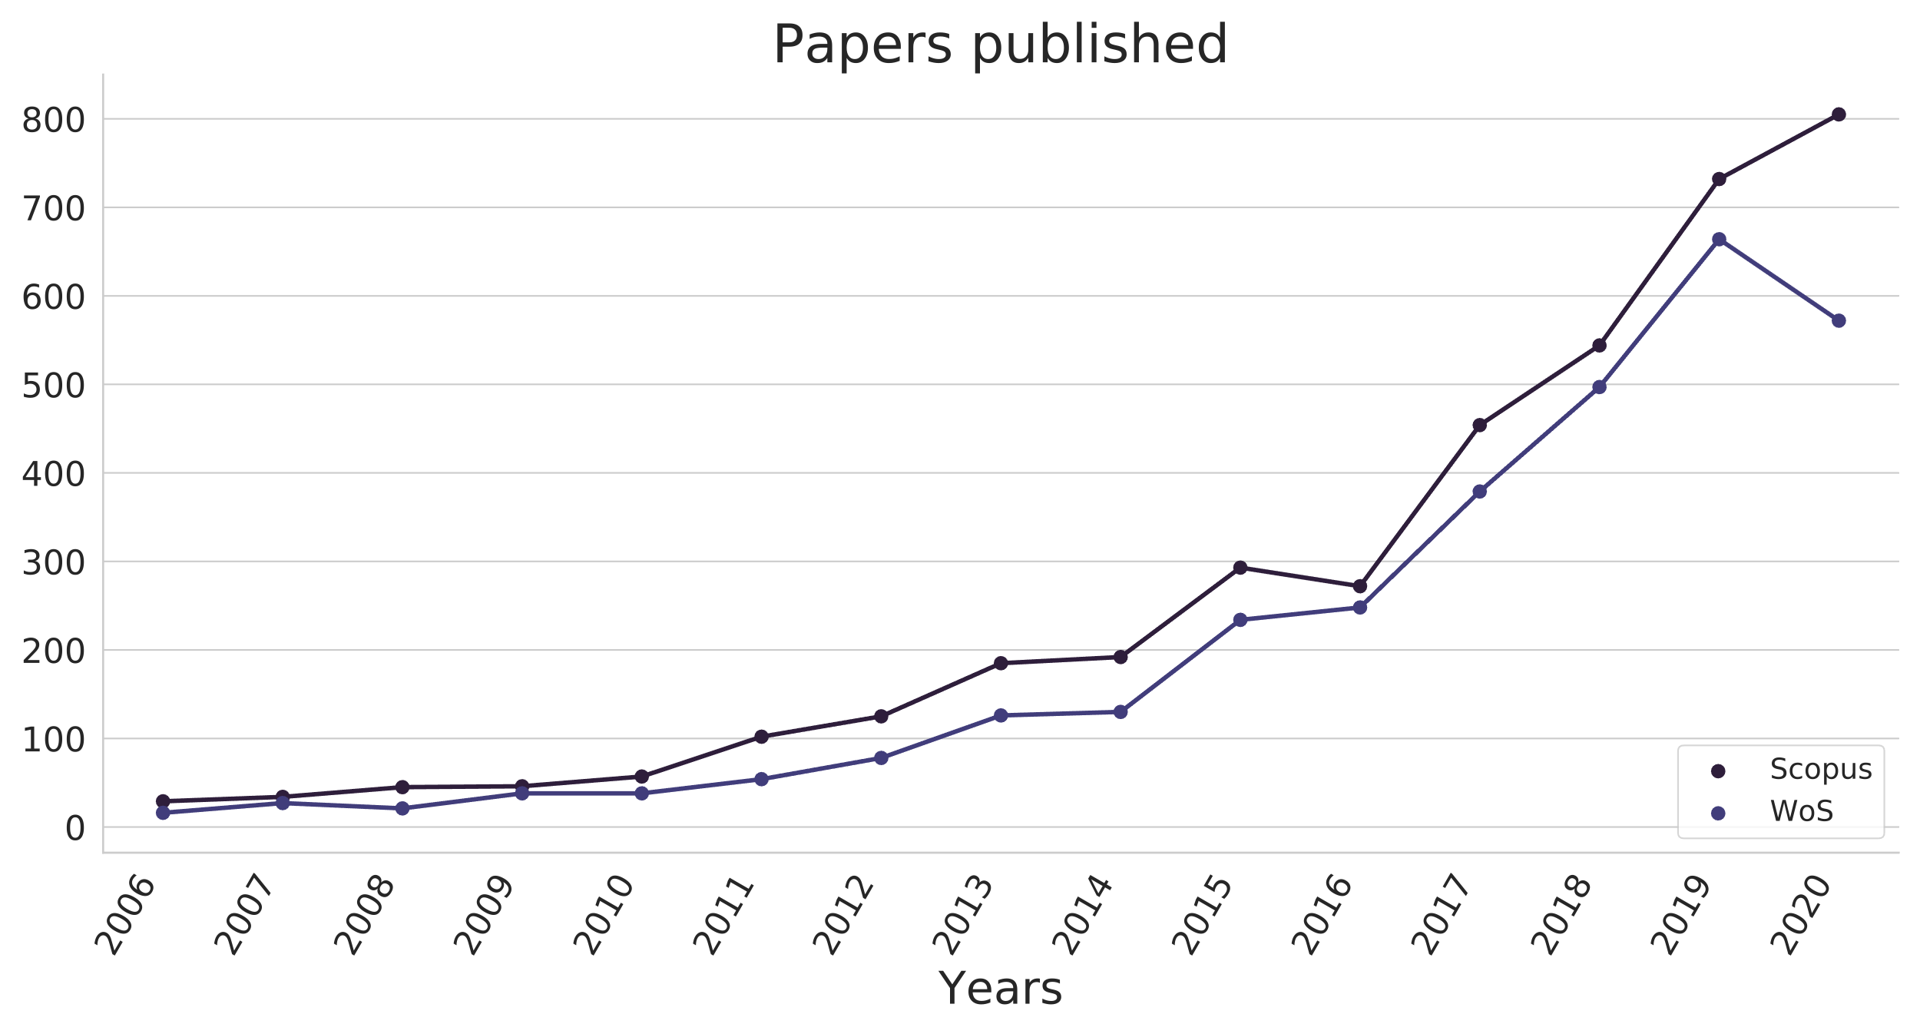

1. Numbers of papers published per year with topic “augmented reality”

Furthermore, we are also interested in analyzing how the usage of these applications affected the students’ engagement and their academic performance.

The main contribution of this paper is to provide an SLR of the AR applications deployed in primary and secondary schools, with a particular focus on the collaborative, multi-user and interactive characteristics of such applications. We decided to consider only the articles published from 2015 to the end of 2020, since in 2015 the number of publications related to the application of AR in education has seen a huge increase (as shown in Figure 1).

The Research Questions (RQ) that we addressed with this study are:

* RQ1: What collaborative, multi-user, interactive AR applications have been used in an educational environment in primary or secondary schools?
* RQ2: Is there a motivation for using these AR applications as an educational tool? If so, what is it?
* RQ3: How effective are these AR applications at improving the students’ knowledge of a subject? How is this evaluated?

Besides answering these research questions, we will also discuss the different technologies used by such applications, for example, the hardware required (Head Mounted Display (HMD), tablet or smartphone), the way the system tracks information from the real world (marker-based, markerless, location-based), whether the application augments other senses beyond vision, and which design strategies (if any) have been used to make the applications accessible.

The rest of the paper is structured as follows. Section 2 describes the methodological design of the study, including an explanation of the work done to plan, conduct and report the review. Section 3 presents the findings of the systematic review and the answers to the research questions. Section 4 discusses the results obtained and suggests possible research lines as well as trends for the future of AR in education. Finally, Section 5 summarizes the conclusions of the paper.

1. Method

For this review, we followed the guidelines proposed by Kitchenham et al. [25] and framed the search using the PICOC criteria [26]:

* **Population**: Applications, Developers
* **Intervention**: Collaborative, multi-user and interactive AR applications
* **Comparison**: Students’ results in classes using AR applications with classes that do not
* **Outcome**: Effectiveness in increasing understanding of a topic
* **Context**: Education, primary or secondary schools

Once the research questions have been defined, the literature review is split into three steps: planning, conducting and reporting. We used the online tool Parsifal[3] to conduct the first two steps of the review while the third was performed using Google Forms[4] and collecting the results in a spreadsheet. The results of the data collection, as well as the code used to generate the figures in this document, are available on GitHub[5].

* 1. Study selection

The aim of this phase is to select the papers which are relevant for the systematic review, define the inclusion and exclusion criteria, and to provide the categories for the analysis. We have selected publications from IEEExplore, Scopus, Springer and ISI Web of Science, as these four digital libraries collect a large amount of the research that is published in the area of technology enhanced learning. We used the search terms Augmented Reality, Education ∨ Learning, Collaborative ∨ Interactive ∨ Multi-user, Application ∨ Evaluation, as we wanted to include only papers that could help address RQ1 and RQ3.

For this work, we only considered papers which appeared online from 2015 to the end of 2020. The search returned 1829 results, of which 238 were marked as duplicates. We read the abstract of the remaining 1591 articles and, applying the inclusion and exclusion criteria specified below, we were left with 260 articles. We finally proceeded to read the selected articles and excluded 160 further articles, thus selecting 100 articles for the literature review.

1. Query strings and number of papers returned.

|  |  |  |  |  |
| --- | --- | --- | --- | --- |
| Digital Library | Query String | Papers | Duplicates | Selected |
| IEEExplore | (“All Metadata”: “Augmented reality” AND (“Education” OR “Learning”) AND (“Collaborative” OR “Interactive” OR “multi-user” OR “multi-user”) AND (“Application” OR “Evaluation”)) Filters Applied: 2015 - 2020 | 136 | 48 | **37** |
| Scopus | TITLE-ABS-KEY (“Augmented reality” AND (“Education” OR “Learning”) AND (“Interactive” OR “multi-user” OR “multiuser” OR “collaborative”) AND (“Application” OR Evaluation”)) AND (PUBYEAR > 2014) | 521 | 65 | **98** |
| Springer | (collaborative OR interactive OR multiuser OR multi-user) AND “augmented reality” AND (education OR learning) AND (primary OR secondary) AND (application OR evaluation) within Chapter - Conference Paper 2015 - 2020 | 904 | 69 | **72** |
| Web of Science | “Augmented reality” AND (“Education” OR “Learning”) AND (“Collaborative” OR “Interactive” OR “multi-user” OR “multiuser”) AND (“Application” OR “Evaluation”) | 268 | 56 | **53** |

Table 2 summarizes the selection process, specifying the search string used for each digital library as well as the number of papers returned, marked as duplicated and selected for the systematic review.

As inclusion criteria, we required that the studies:

* Were published from 2015 to 2020 (both inclusive);
* Describe AR applications which has actually been implemented;
* Have a target audience of primary and/or secondary school students.

The decision of including only works with an audience comprised of primary or secondary students was taken because this study was conducted in the context of a H2020 European project[6], studying multi-user AR applications for primary and secondary schools.

The exclusion criteria are the following:

* The application described is not interactive, multi-user or collaborative;
* The paper does not describe an AR application;
* The paper describes an unrelated application (e.g., for museums or clinical training);
* The paper is not peer reviewed;
* The paper is not written in English.

Fig. 2 shows a flowchart depicting the systematic review process. The 260 papers were reviewed, evenly split, by three researchers. To compute the interrater agreement, two researchers read a set of 50 abstracts randomly selected from all the studies (excluding duplicates) and 10 papers (among the 260 eligible papers). The interrater agreement, as defined in [27] was 0.88 for the abstracts and 0.73 for the papers.

1. Results

In this section we present the results of the three RQs introduced in Section 1, focusing on the adoption of collaborative and multi-user tools, the advantages and disadvantages of using AR solutions in the classroom and the evaluation of the interventions. We will also briefly analyze and summarize the main characteristics of the AR applications described in the studies selected.

* 1. Overview of reviewed studies

Of 100 studies reviewed, most of them (73articles) were published in 2018 or afterwards. The vast majority (68 studies) of the AR apps analyzed cover STEM subjects, while 18 studies cover Humanities and Foreign language subjects. The remaining articles cover specific subtopics such as sustainability, creativity and social interactions or do not specify the subject. Fig. 3 summarizes the subjects covered by the AR apps analyzed in this SLR.

1. Prisma flowchart of the search protocol.

Regarding which AR type is used in the classroom, marker-based solutions (either image or QR-code based) are the most used, as two thirds of the studies described apps using markers as the exclusive source of the augmentations. Some studies describe applications using multiple types of AR, usually a combination of markers and object detection based methods. Other types of AR such as markerless or location based are seldom implemented, as they were used only in 9 and 2 articles, respectively. Fig. 4 summarizes the types of AR used by the articles analyzed in this SLR.

With reference to the hardware required to experience the AR apps and the software used to develop them we notice a similar pattern. Most of the studies describe apps which have been developed for smartphones or tablets using the Unity[7] framework, often in conjunction with the Vuforia[8] Standard Development Kit (SDK). Some studies, usually the oldest ones, describe systems using projectors or PCs with depth sensor cameras such as Microsoft Kinect[9]. Only six articles describe apps which require HMDs or smart glasses [28] [29] [30] [31] [32] [33]. This might be due to the higher cost of such devices and their consequent limited adoption compared to smartphones or tablets.

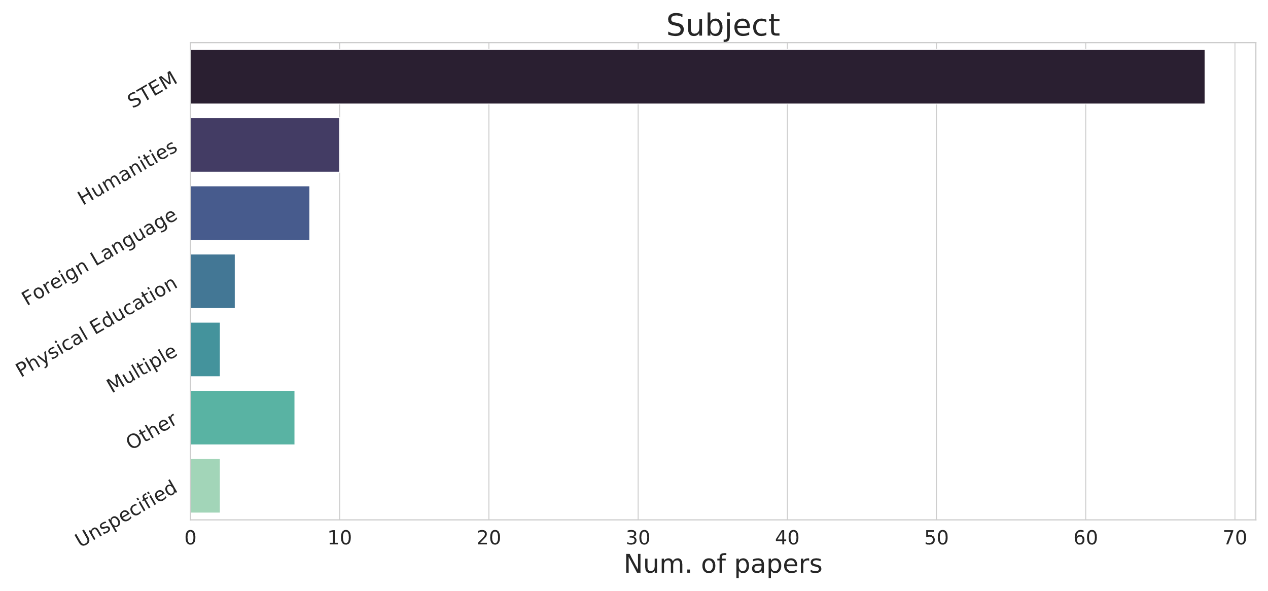

1. Subjects covered in the studies analyzed.

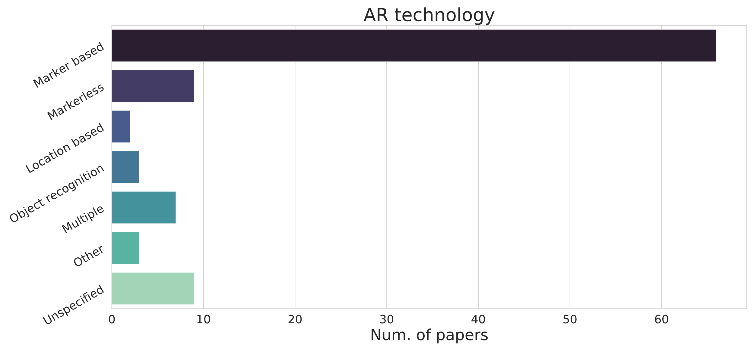

1. Different types of AR used in the studies analyzed.

Using web technologies for the creation of AR application is still the exception rather than the norm: despite the availability of a Javascript library such as Three.js[10] and frameworks such as A-Frame[11], only the works of Abriata [34] and Protopsaltis et al. [35] provide augmented content that can be consumed through the browser. Somewhat surprisingly, very few studies rely on the libraries produced by Google and Apple (ARCore and ARKit), which were developed to provide advanced AR functionalities for smartphone and tablets. Usage of specialized Computer Vision (CV) libraries or Deep Learning (DL) framework is also very low, which probably means that researchers prefer to use the functionalities provided by Unity. Statistics about software usage may be skewed, though, as about one third of the studies did not provide information about it.

Fig. 5 and Fig. 6 summarize the hardware required and the software used by the apps analyzed in this SLR. The total in this case does not sum up to 100 since the same application could support more than one device and likewise it may have been developed using several software libraries.

Unfortunately, researchers very rarely publish their code alongside their peer reviewed publication. Of all the studies we analyzed, only four [34] [36] [37] [38] publicly released the source code of their application. In some cases, the researchers published the application for free on Google Play or the App Store. Although in principle this allows other researchers to test the application, without releasing the source code this is impractical, as it is very rare that the application can be used without

some form of adaptation (for example, translation of the content, inclusion of new multimedia elements or adjustments to the school curricula).

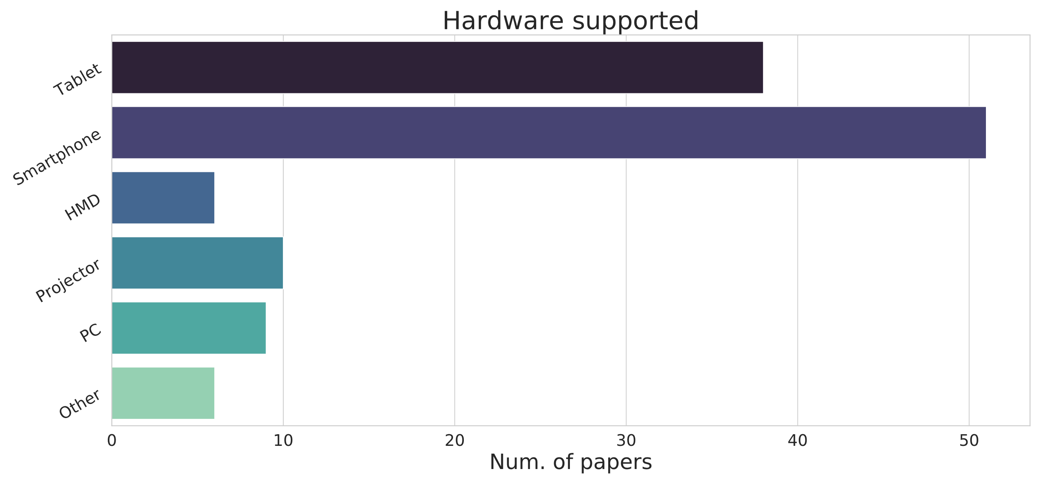

1. Device types supported by the AR applications.

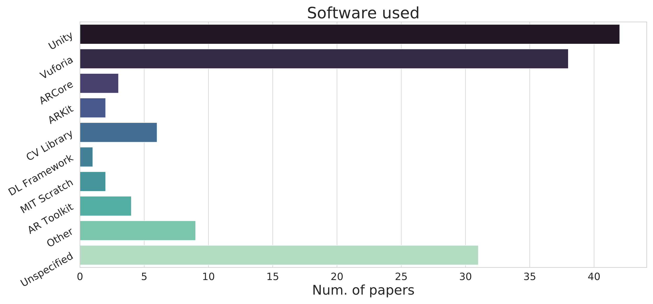

1. Software used to develop AR applications.
   1. Interactive and collaborative capabilities of AR applications

This subsection addresses the first research question. We analyzed interactive, multi-user and collaborative capabilities of the AR apps described in the selected studies. We categorized the studies into five different clusters, based on how the applications provide interactive functionalities. The categories were chosen by analyzing the common traits of each study, as well as considering the characteristics of interactive applications in the context of education (assessment, feedback to the teacher, quizzes) and of user interface elements that enable the interaction. The five interactivity levels we defined are as follows:

* *Basic interactivity*: the student can interact with the app through User Interface (UI) elements such as menus and buttons directly in the augmented space.
* *Object interaction*: the student can interact directly with the augmented content, without having to use UI elements.
* *Quiz*: the application provides quizzes (or allows teachers to add new ones) to test the students’ understanding of a topic directly within the app, or it includes gamification concepts.
* *Behavior tracking*: the application keeps track of student behavior and, using this information, the teacher can modify the content shown to the user. Both the active interactions (questions answered, buttons clicked) as well as passive usage of the app (time spent on each activity, for example) are logged and made available to the teacher so that the lecture can be modified accordingly.
* *Augmented interactions*: the augmented content shown to the students can change depending on the relative position of different markers, or on the distance of the device from the markers.

In addition to these, we also consider multi-user AR experiences, where multiple students are viewing the same augmented content and any change in it, for example caused by the interactions of one of the students, is visible to all the other students as well. Finally, we are also interested in collaborative AR applications, that is multi-user applications where the students share a common goal and work together (or compete against each other) to reach it.

We are particularly interested in these applications because interactive learning environments have been shown to have a positive impact on the students’ education [39]. At the same time, collaborative learning offers the students several benefits at the social, psychological, academic and assessment level [40]. In Table 3, we classify the 100 articles we reviewed into the categories described above. Some of the studies can appear on multiple rows in the table, meaning that they may offer multiple interaction types as well as provide multi-user or collaboration functionalities.

As far as the interactive capabilities of an AR application are concerned, there are a few studies worth mentioning. In [32], the authors implemented a mixed reality system based on HoloLens[12] smart glasses and several stretch and Inertial Measurement Unit (IMU) sensors, where the users can control and move augmented objects using their arms or an ad-hoc controller. The multi-user application is used to teach the students physics concepts such as force fields or velocity vectors, without needing to set up a laboratory.

1. Classification of articles according to interactivity and collaboration capabilities.

|  |  |
| --- | --- |
| Interaction type | Articles |
| Basic Interactivity | [32] [35] [36] [41] [42] [43] [44] [45] [46] [47] [48] [49] [50] [51] [52] [53] [54] [55] [56] [57] [58] [59] [60] [61] [62] [63] [64] [65] [66] [67] [68] [69] [70] [71] [72] [73] [74] [75] [76] [77] [78] [79] [80] [81] [82] [83] [84] [85] [86] [87] |
| Object interaction | [28] [29] [31] [33] [38] [45] [48] [81] [85] [87] [88] [89] [90] [91] [92] [93] [94] [95] [96] [97] [98] [99] [100] [101] [102] [103] [104] [105] [106] [107] [108] [109] [110] [111] [112] [113] [114] |
| Quiz or gamification | [28] [30] [35] [37] [41] [48] [50] [61] [66] [82] [84] [103] [105] [14] [114] [115] [116] [117] [118] [119] |
| Behavior tracking | [35] [36] [56] [61] [65] [101] |
| Augmented interaction | [34] [37] [47] [72] [84] [87] [90] [91] [119] [120] [121] [122] [123] [124] [125] [126] [127] |
| Multi-user | [29] [30] [31] [37] [73] [96] [103] [105] [109] [112] [118] [119] [120] [123] [124] [128] [129] |
| Collaborative | [29] [30] [37] [38] [92] [96] [103] [105] [109] [112] [118] [120] [123] |

Other studies use multiple markers to increase interactivity. The work of Wang et al. [121] uses AR to teach the double-slit experiment (a physics experiment demonstrating the characteristic of light being both a wave and a particle). In the application each marker is related to one part of the experimental apparatus. By modifying the distance of each marker from the next one, the augmented animation generated by the app changes its behavior, visually showing the dual nature of light. A similar idea is implemented by Boonbrahm et al. [125]. In the app, which was created to facilitate learning English as a foreign language, each marker by itself only shows a letter in 3D. When multiple markers are combined to create an English word (from a predefined set), the app will show a 3D model of the corresponding word. In [123], the students learn the basics of computer science by visually implementing algorithms. Each marker, besides showing augmented content, represents an instruction in ALGO, a specially developed programming language, and sequences of different markers generate different behavior from the augmented content. Macariu et al. [84], implemented an app for learning Chemistry that includes a text recognition module to provide information on specific Chemistry-related words, as well as 3D animations that show the molecule created when combining different atoms, with each atom using a specific marker.

Only a few studies experiment with other senses beyond sight. The work of Kenoui and Mehdi [111] uses the IBM Watson SDK[13] to allow the user to interact by asking questions in English, while the answer is shown both as text above the augmented content and as computer-generated audio. Mikułowski and Brzostek-Pawłowska [78] designed a system for visually impaired students that detects mathematical formulas and generates both an audio description as well as a Braille representation on the Braille display.

In the context of multi-user applications, different studies employed different strategies to foster collaboration. Boonbrahm et al. [96] describe an application where the users aim to solve a jigsaw puzzle. Since students cannot move two pieces in a row but are forced to alternate their moves, the puzzle can only be solved with if the participants collaborate. In the work of Ortiz et al. [105], the app is an ARGBL where the user learns about different regions of Colombia while competing for resources. In this case, competition with others stimulate the students to learn about the subject. Another form of collaboration is described by Oh et al. [29]: the authors created a smart-glasses-based AR application where the user can study properties of light such as reflection and refraction. Each user acts as a light source and sees what happens when light hits a wall or passes through different materials. At the same time, two or more users can generate multiple light rays and see how they interact with each other. Using a projector system, users without smart glasses can share the same experience, although not as actively as users wearing them.

* 1. Motivation for using AR as an educational tool

This subsection addresses the second research question. While the studies reviewed do not usually motivate the choice of the application presented in the articles, they do present however, several advantages provided by AR in the classroom. The main advantage provided by AR is that it can integrate seamlessly with the real world, especially for markerless applications that can interact with objects or printed material already available in the classroom. This encourages student engagement and minimizes the time required to learn how to use the technology, allowing the students to spend more time learning the subject, as shown by Thamrongat et al. [102]. A more recent work by the same authors [114] shows that using gamification concepts in AR significantly impacts the students results.

Another advantage provided by AR is that this technology does not require the existing curriculum to be remodeled, rather it can be used as a tool to stimulate interest or to supplement existing pedagogical materials by simply adding more contextual experiences. Pombo and Marques [55] mention that using an AR app improves the engagement and interest of the students visiting an urban park by providing information that would otherwise be available only on textbooks.

AR is also a powerful tool for visualization and animation, especially for STEM subjects, as it offers several advantages for displaying 3D or 3D+t information (i.e., tridimensional data changing over time) in comparison to books, blackboards or videos. The work of Cao and Liu [89] describes an application for learning 3D geometry where the user can interact with 3D objects with their hands. The fingers are tracked with a Leap Motion Controller[14] while a set of markers are used to generate the augmented content. In [85], the authors use advanced features provided by ARKit (such as joint detection) together with object tracking technologies to provide interactions and visualizations through sketches drawn on the device.

In the context of collaborative and multi-user applications, AR similarly helps to provide new opportunities for students to learn how to communicate and collaborate with one another, as well as to inspire empathy and to teach the importance of teamwork [130].

Some of the reviewed studies used AR applications as radically new tools that could improve skills and grades of children with mental or developmental disabilities: Luna et al. [49] describe an application that helps students with Attention deficit/hyperactivity disorder (ADHD) improve their English literacy skills. Similarly, the work of Chen et al. [74] uses AR together with concepts maps to teach kids with Autistic Spectrum Disorder (ASD) different types of social cues designed to help them when meeting people. Takahashi et al. [109] designed a large-scale AR and projection system, modifying the gymnasium of the school, to create a learning game for children with ASD, which intends to keep their attention focused on the content provided.

In [131], the authors check the effects of using mixed reality applications and how they impact the students’ motivation. They show that while such apps do not significantly impact the motivation to learn, they increase the students’ motivation for collaborative working, and the results are more significant for AR than for Virtual Reality (VR) apps. More in general, AR also compares favorably with respect to VR not only because it allows users to perform tasks faster [132], but also because its requirements (namely a stable internet connection and one or more mobile devices), can be provided at a lower cost and the system does not need as much time to set up. Cost is often seen as one of the most important factors limiting the access of newer technologies, so in this sense AR is often seen as a better tool in comparison with VR or expensive hardware such as laptops and projectors.

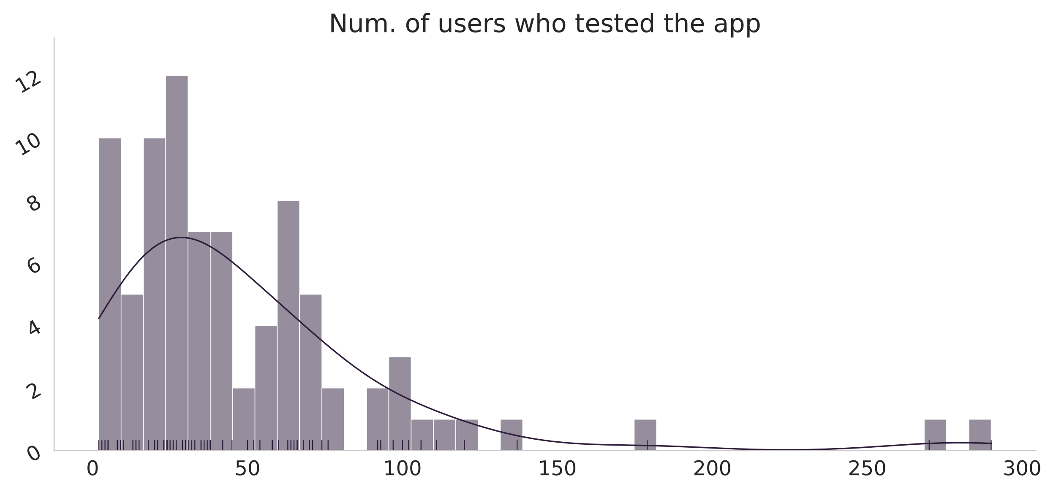

1. Histogram of the participants in user tests across different studies (grey) and its smooth density estimate (black).
   1. Effectiveness of collaborative AR applications

This subsection addresses the third research question. Of the 100 studies selected for this SLR, only 84 provided information about the number of students who tested the AR application. The number of students participating ranged from 2 to 290. Around 60% of the studies were carried out with fewer than 40 participants, and another 30% were carried out with a number of participants between 41 and 80 students. Only 8 studies employed 100 or more students for the evaluation. Fig. 7 shows the histogram representing the distribution of users who tested the AR application across the studies selected for review.

The analysis of the studies shows three main ways for evaluating how effective a AR application can be in helping students improve their understanding of a subject:

* Performing pre and post tests;
* Comparing with a control group;
* Asking the teachers to fill put surveys after the experiment.

While the first two options try to objectively measure the impact of using AR, by analyzing the students’ grades, the third option relies on the personal judgement of the teachers and can, in principle, be subject to bias. In Table 4, we classify the 100 reviewed articles into the categories described above. Some of the studies can appear on multiple rows in the table, meaning that they evaluate students’ results in more than one way. The table does not include studies in which no evaluation was performed, or in which surveys only asked about the app usability and ease of use.

It is worth mentioning the work described in [61], as here the researchers developed a system which, apart from the AR application, included a Database Management System (DBMS), a teacher interface and an e-learning platform. The evaluation of the system includes a statistical analysis of the performance of the students and their learning achievements, as well as an analysis of the ease of use of the system for teachers and students.

1. Classification of studies according to the method used to evaluate effectiveness of AR in the classroom.

|  |  |
| --- | --- |
| Evaluation type | Articles |
| Pre and post tests | [41] [47] [89] [51] [90] [52] [61] [115] [57] [93] [116] [97] [98] [122] [63] [64] [124] [66] [102] [105] [107] [70] [118] [73] [30] [74] [75] [113] [79] [81] [82] [114] [83] [84] |
| Control group | [45] [90] [52] [61] [120] [58] [59] [60] [102] [105] [71] [72] [108] [109] [113] [82] [114] [83] |
| Teacher survey | [48] [49] [50] [51] [90] [61] [53] [91] [54] [55] [56] [29] [92] [121] [36] [38] [62] [98] [63] [99] [123] [128] [124] [101] [129] [66] [105] [107] [71] [126] [30] [74] [84] [85] [86] |

The application described in [102] uses AR to teach children about 3D geometry. Pre and post tests were used along with quizzes to evaluate the system. The results showed that students who used the AR applications consistently had better grades than the control group, but such results were not statistically significant. Analyzing the results for different tasks, however, the data showed that the group who used AR performed worse on the easiest task, while performing much better (with statistically significant results) than the control group in more complex tasks. From this, the authors conclude that AR can be a valuable tool for learning difficult geometric concepts. The same study also conducted tests about the user experience, and the results showed that the AR application could engage its users in extremely worthwhile, highly attractive and interesting learning activities with good usability.

The app described in [90] is used to teach Chemistry to 45 high school students and behaves differently depending on the distance of the device from the markers. The authors performed a quantitative evaluation of the system, analyzing grades and the distribution of mistakes in the different quizzes. They conclude that there is a statistically significant improvement in the performances of the students, and that the greater the difficulty level of the question, the bigger the performance improvement is over the control group. The authors conclude that their Augmented Immersive Reality (AIR) system is most likely responsible for the bulk of learning improvements and the knowledge retention gains demonstrated in their case study, since that is the critical component differentiating their system from other applications available on the market.

Of the 59 studies presenting a quantitative evaluation of the results, none of them conclude that using AR in the classroom has a negative impact on the students’ results and their level of engagement in the classroom. Even though in many cases the improvement over traditional teaching methods is limited, only the work of Carlos-Chullo et al. [113] does not detect any positive impact. This consensus on the effectiveness of AR applications is unexpected: besides the commonplace explication (AR is indeed a successful medium with a positive impact on students’ results) two other possible explanations are the novelty effect [133], which explains the performance improvements introduced by a new technology such as AR as being due to an increased interest of the user, and the positive publication bias [134], which makes it harder for researchers to publish studies with negative results.

Only the work of Lin et al. [116] presents an analysis of the retention of the topics learned through AR over a time span of more than two months. As most of the students who participated in the tests had not previously used AR applications, there is a specific risk that the novelty effect introduced a recency bias, by increasing user engagement and knowledge acquisition, indirectly leading to better test scores.

1. Discussion

This study shows that the research community is very active in investigating how AR applications can improve education and facilitate students’ understanding of difficult concepts. Even though collaboration and participation by students is often seen as a key towards improving knowledge retention, we still see a lack of support for cooperation mechanisms in AR applications for education: of the 100 studies analyzed, only 17 described multi-user application and only 13 employ some sort of collaboration between users. ARGBL is also quite uncommon, as only 11 articles describe applications which implement gamification concepts.

By reviewing the existing literature, we have also identified several issues that are preventing the widespread adoption of collaborative AR in the classroom:

* Lack of authoring tools: with the exception of the works of Lytridis et al. [110] and Whitlock et al. [135] there is no authoring tool that simplifies the creation of AR experiences. This means that every AR application must be developed from scratch, requiring longer development times and multiplying the amount of work required from the developers.
* Lack of standardization for the description of AR experiences: of all the papers we analyzed, none of them mentioned using a standard for the description of how AR is used in the application. This is mainly due to a lack of specific standards, as the IEEE ARLEM standard [136] for AR-based learning experiences was only released in February 2020, while the ETSI Augmented Reality Framework[15] for the interoperability of AR components has not been published yet. We believe that adoption of these standards will drive and simplify the development of AR applications for education, as well as foster interoperability.
* Availability of 3D content for education: a few repositories where users can freely download 3D objects already exist, but there is a lack of 3D content specialized for education purposes. Although there are currently efforts being made to solve this issue [137], it does severely hinder the possibility of quickly creating new AR apps for primary and secondary schools: very often the apps never leave the prototype stage and they are not turned into a fully-fledged product or used further in the classroom.
* Code publication: another issue with most of the studies we reviewed is that only a small fraction of the authors published the code of the AR application. This means that other researchers cannot build upon the results of previous researchers: even for the more interesting and highly cited articles there will be no follow up work, except for that from the original authors.

We noticed that studies claiming to have a stronger positive impact on educational achievements are the ones where the AR application is part of bigger learning environments. We believe that providing automatic logging functionalities, for example through xAPI [138], a teacher dashboard where the educator can track the progress or the grades of each student and a set of tools for improving communication capabilities could go a long way to better integrate AR applications in standard schools’ curricula. Using xAPI could simplify the application of learning analytics techniques for the analysis and improvement of students’ learning. This is especially the case for distance learning, in which the students are not in the same physical space as the teacher or other students but are following their classes remotely.

On the technical side, researchers are slowly adopting the latest advancement in technology, but most of the studies analyzed are still focusing on more limited AR functionalities, for example marker-based systems. The implementation of AR applications that make use of Edge Artificial Intelligence (EAI) or which are based on web technologies such as WebXR[16] is currently limited because only the most recent devices have hardware capable of supporting them. Nonetheless, we believe these are key technologies that enable more immersive experiences and facilitate collaboration.

Most of the studies we reviewed, except for the works described in [78] [98] [111], focus on vision-based augmentations. Although it is clear that students rely predominantly on sight to collect and process information, providing other types of augmentations such as haptic or audio is worth investigating, since these could make the user experience more immersive and they could improve accessibility of AR applications for students with sight impairment.

None of the studies explored the possibility of using multi-user AR application for distance learning. The apps described by Oh et al. [30] and López-Faican and Jaen [112] use PUN, a network library that enables communication across different devices, but the applications require that the users share the same physical space. Especially after the prolonged lockdown due to the Covid-19 pandemic, newer technologies should provide AR apps with capabilities for the students to share the same experience even though they are not in the same room. This would be useful for teachers, who could make remote lessons more engaging, and for students, who would have the chance to work together with other schoolmates even when they are at home.

Regarding the effectiveness of AR applications in the classroom, most of the studies present an evaluation of the AR solution described. There are great differences between the questions for teachers and students in the user surveys, but in general users find AR a successful education tool which is both useful and engaging. The most common critiques identified refer to the user friendliness of the application and the errors in identifying the markers. More specifically, the users complained about the difficulty of navigating through the UI, due to its lack of consistency and about the difficulty of identifying and tracking the markers in poor lighting conditions or when the camera was not close enough.

1. Conclusion

In this paper we presented a systematic review of the literature relative to applications of immersive, collaborative and multi-user AR in primary and secondary education. We analyzed 100 studies and evaluated their technical characteristic sand their advantages compared to traditional teaching tools as well as the impact they had on knowledge retention. We believe that the findings described in Sections 3 and 4 can be useful for researchers in driving the design of the next generation of AR applications.

With the first Research Question (RQ1) we wanted to identify which studies described interactive, multi-user and collaborative AR experiences, and we compared the main features of the AR applications described. Every paper presented AR-based interactions, but only a few applications provided multi-user and collaborative capabilities. Our analysis showed that Unity and Vuforia, the de-facto standard tools for creation of AR applications, do not provide researchers and developers the tools to easily include collaboration mechanisms in AR applications.

The second Research Question (RQ2) aimed to understand the motivation behind the usage of AR as an educational tool. In this case we analyzed both the motivations presented by the researchers and the results of surveys conducted on students. Even though few papers provided information in this sense, it appears that the main motivation for using AR in schools is to facilitate understanding of abstract concepts and to increase students’ engagement.

Finally, the objective of the third Research Question (RQ3) was to measure, as objectively as possible, the impact of using AR in the classroom. The studies analyzed pre/post tests or comparisons with control groups to assess the usefulness of AR and, in general, they showed that making use of AR applications leads to a small but statistically significant improvement compared to the scores obtained by the test group.

* 1. Limitations of this study

This review was limited in that it examined articles from four databases: IEEExplore, ISI Web of Science, Scopus, and Springer, from 2015 to 2020. The articles in these databases are considered to have a high impact on the field; however, the latest technical reports and business demonstrations of AR in education were excluded from this review, which may limit the representation of the state of the art. Nevertheless, despite the number of papers included in this review being limited, the selection process followed a systematic process to avoid bias.

1. Acknowledgment

<Removed for review>

1. References

|  |  |
| --- | --- |
| [1] | T. P. Caudell and D. W. Mizell, "Augmented reality: an application of heads-up display technology to manual manufacturing processes," in *Proceedings of the Twenty-Fifth Hawaii International Conference on System Sciences*, 1992. |
| [2] | M. Akçayır and G. Akçayır, "Advantages and challenges associated with augmented reality for education: A systematic review of the literature," *Educational Research Review,* vol. 20, p. 1–11, 2017. |
| [3] | I. Radu, "Augmented reality in education: a meta-review and cross-media analysis," *Personal and Ubiquitous Computing,* vol. 18, p. 1533–1543, 2014. |
| [4] | P. Diegmann, M. Schmidt-Kraepelin, S. Eynden and D. Basten, "Benefits of augmented reality in educational environments-a systematic literature review," *Benefits,* vol. 3, p. 1542–1556, 2015. |
| [5] | K.-H. Cheng and C.-C. Tsai, "Affordances of augmented reality in science learning: Suggestions for future research," *Journal of science education and technology,* vol. 22, p. 449–462, 2013. |
| [6] | F. Arici, P. Yildirim, Ş. Caliklar and R. M. Yilmaz, "Research trends in the use of augmented reality in science education: Content and bibliometric mapping analysis," *Computers & Education,* vol. 142, p. 103647, 2019. |
| [7] | J. Bacca, S. Baldiris, R. Fabregat, S. Graf and Kinshuk, "Augmented Reality Trends in Education: A Systematic Review of Research and Applications," *J. Educ. Technol. Soc.,* vol. 17, pp. 133-149, 2014. |
| [8] | N. Pellas, P. Fotaris, I. Kazanidis and D. Wells, "Augmenting the learning experience in primary and secondary school education: A systematic review of recent trends in augmented reality game-based learning," *Virtual Reality,* vol. 23, p. 329–346, 2019. |
| [9] | M.-B. Ibáñez and C. Delgado-Kloos, "Augmented reality for STEM learning: A systematic review," *Computers & Education,* vol. 123, p. 109–123, 2018. |
| [10] | B. L. Nielsen, H. Brandt and H. Swensen, *Augmented Reality in science education–affordances for student learning,* Nasjonalt senter for naturfag i opplæringen (Naturfagsenteret …, 2016. |
| [11] | N. Ahmad and S. Junaini, "Augmented Reality for Learning Mathematics: A Systematic Literature Review," *International Journal of Emerging Technologies in Learning (iJET),* vol. 15, p. 106–122, 2020. |
| [12] | S. N. A. Majid and A. R. Salam, "A Systematic Review of Augmented Reality Applications in Language Learning.," *International Journal of Emerging Technologies in Learning,* vol. 16, 2021. |
| [13] | B. Khoshnevisan and N. Le, "Augmented reality in language education: A systematic literature review," *Adv. Glob. Educ. Res,* vol. 2, p. 57–71, 2018. |
| [14] | J. Li, E. D. Van der Spek, L. Feijs, F. Wang and J. Hu, "Augmented reality games for learning: A literature review," in *International Conference on Distributed, Ambient, and Pervasive Interactions*, 2017. |
| [15] | N. A. Bartolomé, A. M. Zorrilla and B. G. Zapirain, "Can game-based therapies be trusted? Is game-based education effective? A systematic review of the Serious Games for health and education," in *2011 16th International Conference on Computer Games (CGAMES)*, 2011. |
| [16] | T. H. Laine, "Mobile educational augmented reality games: a systematic literature review and two case studies," *Computers,* vol. 7, p. 19, 2018. |
| [17] | P. Chen, X. Liu, W. Cheng and R. Huang, "A review of using Augmented Reality in Education from 2011 to 2016," in *Innovations in smart learning*, Springer, 2017, p. 13–18. |
| [18] | M. M. O. Da Silva, J. M. X. N. Teixeira, P. S. Cavalcante and V. Teichrieb, "Perspectives on how to evaluate augmented reality technology tools for education: a systematic review," *Journal of the Brazilian Computer Society,* vol. 25, p. 3, 2019. |
| [19] | J. Garzón, J. Pavón and S. Baldiris, "Systematic review and meta-analysis of augmented reality in educational settings," *Virtual Reality,* vol. 23, p. 447–459, 2019. |
| [20] | M. Billinghurst and H. Kato, "Collaborative augmented reality," *Communications of the ACM,* vol. 45, p. 64–70, 2002. |
| [21] | D. N. E. Phon, M. B. Ali and N. D. A. Halim, "Collaborative Augmented Reality in Education: A Review," in *2014 International Conference on Teaching and Learning in Computing and Engineering*, 2014. |
| [22] | D. Johnson, "Cooperation in the classroom," *Psyccritiques,* vol. 36, p. 1106–1107, 1991. |
| [23] | R. T. Johnson and D. W. Johnson, "Active learning: Cooperation in the classroom," *The annual report of educational psychology in Japan,* vol. 47, p. 29–30, 2008. |
| [24] | G. D. Kuh, J. Kinzie, J. A. Buckley, B. K. Bridges and J. C. Hayek, Piecing together the student success puzzle: Research, propositions, and recommendations: ASHE higher education report, vol. 116, John Wiley & Sons, 2011. |
| [25] | B. Kitchenham, O. P. Brereton, D. Budgen, M. Turner, J. Bailey and S. Linkman, "Systematic literature reviews in software engineering–a systematic literature review," *Information and software technology,* vol. 51, p. 7–15, 2009. |
| [26] | M. Petticrew and H. Roberts, Systematic reviews in the social sciences: A practical guide, John Wiley & Sons, 2008. |
| [27] | J. Cohen, "A coefficient of agreement for nominal scales," *Educational and psychological measurement,* vol. 20, p. 37–46, 1960. |
| [28] | X. Wei, D. Guo and D. Weng, "Improving Authentic Learning by AR-Based Simulator," in *Chinese Conference on Image and Graphics Technologies*, 2018. |
| [29] | S. Oh, K. Park, S. Kwon and H.-J. So, "Designing a multi-user interactive simulation using AR glasses," in *Proceedings of the TEI'16: Tenth International Conference on Tangible, Embedded, and Embodied Interaction*, 2016. |
| [30] | S. Oh, H.-J. So and M. Gaydos, "Hybrid augmented reality for participatory learning: The hidden efficacy of multi-user game-based simulation," *IEEE Transactions on Learning Technologies,* vol. 11, p. 115–127, 2017. |
| [31] | H. H. Kum-Biocca, H. Kim, F. Biocca and Y. Cho, "AR-VIS: Augmented Reality Interactive Visualization Environment for Exploring Dynamic Scientific Data," in *International Conference on Human-Computer Interaction*, 2019. |
| [32] | M. Khan, F. Trujano and P. Maes, "Mathland: Constructionist Mathematical Learning in the Real World Using Immersive Mixed Reality," in *International Conference on Immersive Learning*, 2018. |
| [33] | S. Matsutomo, T. Manabe, V. Cingoski and S. Noguchi, "A computer aided education system based on augmented reality by immersion to 3-D magnetic field," *IEEE transactions on magnetics,* vol. 53, p. 1–4, 2017. |
| [34] | L. A. Abriata, "Building blocks for commodity augmented reality-based molecular visualization and modeling in web browsers," *PeerJ Computer Science,* vol. 6, p. e260, 2020. |
| [35] | A. Protopsaltis, M. Mentzelopoulos, J. Ferguson and K. Kaloyan, "Quiz Cube: an AR mobile learning application," in *2016 11th International Workshop on Semantic and Social Media Adaptation and Personalization (SMAP)*, 2016. |
| [36] | G. Mylonas, D. Amaxilatis, L. Pocero, I. Markelis, J. Hofstaetter and P. Koulouris, "An educational iot lab kit and tools for energy awareness in european schools," *International Journal of Child-Computer Interaction,* vol. 20, p. 43–53, 2019. |
| [37] | J. Laviole, L. Thevin, J. Albouys-Perrois and A. Brock, "Nectar: Multi-user Spatial Augmented Reality for everyone: Three live demonstrations of educative applications," in *Proceedings of the Virtual Reality International Conference-Laval Virtual*, 2018. |
| [38] | C. Manrique-Juan, Z. V. E. Grostieta-Dominguez, R. Rojas-Ruiz, M. Alencastre-Miranda, L. Muñoz-Gómez and C. Silva-Muñoz, "A Portable Augmented-Reality Anatomy Learning System Using a Depth Camera in Real Time," *The American Biology Teacher,* vol. 79, pp. 176-183, 2017. |
| [39] | W. L. Johnson, J. W. Rickel, J. C. Lester and others, "Animated pedagogical agents: Face-to-face interaction in interactive learning environments," *International Journal of Artificial intelligence in education,* vol. 11, p. 47–78, 2000. |
| [40] | M. Laal and S. M. Ghodsi, "Benefits of collaborative learning," *Procedia-social and behavioral sciences,* vol. 31, p. 486–490, 2012. |
| [41] | A. S. Y. Lai, C. Y. K. Wong and O. C. H. Lo, "Applying augmented reality technology to book publication business," in *2015 IEEE 12th international conference on e-business engineering*, 2015. |
| [42] | J. K. T. Tang, T.-Y. A. Duong, Y.-W. Ng and H.-K. Luk, "Learning to create 3D models via an augmented reality smartphone interface," in *2015 IEEE International Conference on Teaching, Assessment, and Learning for Engineering (TALE)*, 2015. |
| [43] | I. J. X. Ang and K. H. Lim, "Enhancing STEM Education using Augmented Reality and Machine Learning," in *2019 7th International Conference on Smart Computing & Communications (ICSCC)*, 2019. |
| [44] | F. Sorrentino, L. D. Spano and R. Scateni, "Speaky Notes Learn languages with augmented reality," in *2015 International Conference on Interactive Mobile Communication Technologies and Learning (IMCL)*, 2015. |
| [45] | C. Arcos, W. Fuertes, C. Villacı́s, M. Zambrano, T. Noboa, A. Tacuri, H. Aules and T. Toulkeridis, "Playful and interactive environment-based augmented reality to stimulate learning of children," in *2016 18th Mediterranean Electrotechnical Conference (MELECON)*, 2016. |
| [46] | G. Zhao, Q. Zhang, J. Chu, Y. Li, S. Liu and L. Lin, "Augmented Reality Application for Plant Learning," in *2018 IEEE 9th International Conference on Software Engineering and Service Science (ICSESS)*, 2018. |
| [47] | W.-H. Chao, C.-Y. Yang and R.-C. Chang, "A Study of the Interactive Mathematics Mobile Application Development," in *2018 1st IEEE International Conference on Knowledge Innovation and Invention (ICKII)*, 2018. |
| [48] | M. C. Costa, A. Manso, J. M. Patrício, A. Carvalho, B. Alegria and V. Zinatulins, "An augmented reality platform targeted to promote learning about planetary systems," in *2019 International Symposium on Computers in Education (SIIE)*, 2019. |
| [49] | J. Luna, R. Treacy, T. Hasegawa, A. Campbell and E. Mangina, "Words Worth Learning-Augmented Literacy Content for ADHD Students," in *2018 IEEE Games, Entertainment, Media Conference (GEM)*, 2018. |
| [50] | M. J. H. Ramos and B. E. V. Comendador, "ARTitser: A Mobile Augmented Reality in Classroom Interactive Learning Tool on Biological Science for Junior High School Students," in *Proceedings of the 2019 5th International Conference on Education and Training Technologies*, 2019. |
| [51] | M. El Kouzi, A. Mao and D. Zambrano, "An Educational Augmented Reality Application for Elementary School Students Focusing on the Human Skeletal System," in *2019 IEEE Conference on Virtual Reality and 3D User Interfaces (VR)*, 2019. |
| [52] | T.-C. Huang, C.-C. Chen and Y.-W. Chou, "Animating eco-education: To see, feel, and discover in an augmented reality-based experiential learning environment," *Computers & Education,* vol. 96, p. 72–82, 2016. |
| [53] | Y.-H. Wang, "Exploring the effectiveness of integrating augmented reality-based materials to support writing activities," *Computers & Education,* vol. 113, p. 162–176, 2017. |
| [54] | L. Pombo and M. M. Marques, "Marker-based augmented reality application for mobile learning in an urban park: Steps to make it real under the EduPARK project," in *2017 International Symposium on Computers in Education (SIIE)*, 2017. |
| [55] | L. Pombo and M. M. Marques, "THE EduPARK MOBILE AUGMENTED REALITY GAME: LEARNING VALUE AND USABILITY," *MOBILE LEARNING 2018,* p. 23, 2018. |
| [56] | C.-H. Chen, Y.-Y. Chou and C.-Y. Huang, "An augmented-reality-based concept map to support mobile learning for science," *The Asia-Pacific Education Researcher,* vol. 25, p. 567–578, 2016. |
| [57] | H.-H. Liou, S. J. H. Yang, S. Y. Chen and W. Tarng, "The influences of the 2D image-based augmented reality and virtual reality on student learning," *Journal of Educational Technology & Society,* vol. 20, p. 110–121, 2017. |
| [58] | T.-C. Hsu, "Learning English with augmented reality: Do learning styles matter?," *Computers & Education,* vol. 106, p. 137–149, 2017. |
| [59] | N. Hrishikesh and J. J. Nair, "Interactive learning system for the hearing impaired and the vocally challenged," in *2016 International Conference on Advances in Computing, Communications and Informatics (ICACCI)*, 2016. |
| [60] | P. Sarkar, J. S. Pillai and A. Gupta, "ScholAR: a collaborative learning experience for rural schools using augmented reality application," in *2018 IEEE Tenth International Conference on Technology for Education (T4E)*, 2018. |
| [61] | S.-C. Chang and G.-J. Hwang, "Impacts of an augmented reality-based flipped learning guiding approach on students’ scientific project performance and perceptions," *Computers & Education,* vol. 125, p. 226–239, 2018. |
| [62] | C.-p. Chen and C.-H. Wang, "Construction of a synchronized multi-display augmented reality simulation module for learning tidal effects," in *2015 2nd International Conference on Information Science and Security (ICISS)*, 2015. |
| [63] | T.-C. Huang, M.-Y. Chen and W.-P. Hsu, "Do Learning Styles Matter? Motivating Learners in an Augmented Geopark," *Journal of Educational Technology & Society,* vol. 22, p. 70–81, 2019. |
| [64] | X.-F. Lin, Q. Wu, W. Shen, Q. Zhu and J. Wang, "Primary School Students’ Science Inquiry Learning and Behavior Patterns While Exploring Augmented Reality Science Learning," in *International Conference on Technology in Education*, 2019. |
| [65] | R. Cao and W. Hou, "Research on the Interaction Design of AR Picture Books via Usability Test," in *International Conference on Human Centered Computing*, 2018. |
| [66] | L. Pombo and M. M. Marques, "Learning with the augmented reality EduPARK game-like app: its usability and educational value for primary education," in *Intelligent Computing-Proceedings of the Computing Conference*, 2019. |
| [67] | X. Wei, G. Yang and D. Weng, "The Influence of Mobile Augmented Reality-Based Sandbox Games on Chinese Characters Learning," in *Chinese Conference on Image and Graphics Technologies*, 2019. |
| [68] | J. Cerqueira, C. Sylla, J. M. Moura and L. Ferreira, "Learning Basic Mathematical Functions with Augmented Reality," in *Interactivity, Game Creation, Design, Learning, and Innovation*, Springer, 2018, p. 508–513. |
| [69] | H. Klautke, J. Bell, D. Freer, C. Cheng and W. Cain, "Bridging the Gulfs: Modifying an Educational Augmented Reality App to Account for Target Users’ Age Differences," in *International Conference of Design, User Experience, and Usability*, 2018. |
| [70] | K.-E. Chang, J. Zhang, Y.-S. Huang, T.-C. Liu and Y.-T. Sung, "Applying augmented reality in physical education on motor skills learning," *Interactive Learning Environments,* p. 1–13, 2019. |
| [71] | M.-C. Hsieh and S.-H. Chen, "Intelligence Augmented Reality Tutoring System for Mathematics Teaching and Learning," *Journal of Internet Technology,* vol. 20, p. 1673–1681, 2019. |
| [72] | R. M. Yilmaz and Y. Goktas, "Using augmented reality technology in storytelling activities: examining elementary students’ narrative skill and creativity," *Virtual Reality,* vol. 21, p. 75–89, 2017. |
| [73] | I.-J. Lee, C.-H. Chen, C.-P. Wang and C.-H. Chung, "Augmented reality plus concept map technique to teach children with ASD to use social cues when meeting and greeting," *The Asia-Pacific Education Researcher,* vol. 27, p. 227–243, 2018. |
| [74] | C.-H. Chen, C.-Y. Huang and Y.-Y. Chou, "Effects of augmented reality-based multidimensional concept maps on students’ learning achievement, motivation and acceptance," *Universal Access in the Information Society,* vol. 18, p. 257–268, 2019. |
| [75] | C. Liu, S. Wu, S. Wu and S. Cai, "An AR-Based Case Study of Using Textual and Collaborative Scaffolding for Students with Different Self-Efficacy to Learn Lever Principles," in *2020 6th International Conference of the Immersive Learning Research Network (iLRN)*, 2020. |
| [76] | A. Pérez-Muñóz, D. Castro-Idrovo, Y. Robles-Bykbaev, V. Robles-Bykbaev and F. Pesántez-Avilés, "An interactive application based on augmented reality and rules-based reasoning to support educational activities of high school students," in *2020 IEEE World Conference on Engineering Education (EDUNINE)*, 2020. |
| [77] | X. Yin, S. Hou and H. Hu, "Research on Interactive Design of Social Interaction Training APP for Children with Autistic Spectrum Disorder (ASD) Based on Multi-modal Interaction," in *E3S Web of Conferences*, 2020. |
| [78] | D. Mikułowski and J. Brzostek-Pawłowska, "Multi-sensual Augmented Reality in Interactive Accessible Math Tutoring System for Flipped Classroom," in *International Conference on Intelligent Tutoring Systems*, 2020. |
| [79] | E. Korosidou and T. Bratitsis, "Gamifying Early Foreign Language Learning," in *Interactive Mobile Communication, Technologies and Learning*, 2019. |
| [80] | A. Estudante and N. Dietrich, "Using Augmented Reality to Stimulate Students and Diffuse Escape Game Activities to Larger Audiences," *Journal of Chemical Education,* vol. 97, p. 1368–1374, 2020. |
| [81] | A. A. Syahidi, A. Mohamed and others, "Mobile Augmented Reality Application with Multi-Interaction for Learning Solutions on the Topic of Computer Network Devices (Effectiveness, Interface, and Experience Design)," in *2020 Third International Conference on Vocational Education and Electrical Engineering (ICVEE)*, 2020. |
| [82] | J. P. Cruzado, D. H. Huaman, J. R. Capa and M. Q. Bellizza, "IdeAR: Augmented Reality Applied to Reading Comprehension Stories," in *2020 IEEE Engineering International Research Conference (EIRCON)*, 2020. |
| [83] | U. L. Yuhana, R. R. Hariadi, M. Mukramin, H. Fabroyir and S. Arifiani, "AUGGO: Augmented Reality and Marker-based Application for Learning Geometry in Elementary Schools," in *2020 International Conference on Computer Engineering, Network, and Intelligent Multimedia (CENIM)*, 2020. |
| [84] | C. Macariu, A. Iftene and D. Gîfu, "Learn Chemistry with Augmented Reality," *Procedia Computer Science,* vol. 176, pp. 2133-2142, 2020. |
| [85] | R. Suzuki, R. H. Kazi, L.-Y. Wei, S. DiVerdi, W. Li and D. Leithinger, "RealitySketch: Embedding Responsive Graphics and Visualizations in AR with Dynamic Sketching," in *Adjunct Publication of the 33rd Annual ACM Symposium on User Interface Software and Technology*, New York, NY, USA, 2020. |
| [86] | C. S. Yusof, N. Ahmad, A. W. Ismail and M. S. Sunar, "Mathematics Lesson using Accelerometer Sensor Interaction in Handheld Augemented Reality Application for Kindergarten," in *2020 6th International Conference on Interactive Digital Media (ICIDM)*, 2020. |
| [87] | H. G. Theodoropoulou, C. Kiourt, A. S. Lalos, A. Koutsoudis, E. Paxinou, D. Kalles and G. Pavlidis, "Exploiting Extended Reality Technologies for Educational Microscopy," in *Virtual Reality and Augmented Reality*, Cham, 2020. |
| [88] | M. Z. Iqbal, E. Mangina and A. G. Campbell, "Exploring the use of Augmented Reality in a Kinesthetic Learning Application Integrated with an Intelligent Virtual Embodied Agent," in *2019 IEEE International Symposium on Mixed and Augmented Reality Adjunct (ISMAR-Adjunct)*, 2019. |
| [89] | R. Cao and Y. Liu, "Hand ControlAR: An Augmented Reality Application for Learning 3D Geometry," in *2019 IEEE International Symposium on Mixed and Augmented Reality Adjunct (ISMAR-Adjunct)*, 2019. |
| [90] | L. Cen, D. Ruta, L. M. M. S. Al Qassem and J. Ng, "Augmented Immersive Reality (AIR) for Improved Learning Performance: A Quantitative Evaluation," *IEEE Transactions on Learning Technologies,* 2019. |
| [91] | V. Ferrer, A. Perdomo, H. R. Ali, C. Fies and J. Quarles, "Virtual humans for temperature visualization in a tangible augmented reality educational game," in *2017 IEEE Virtual Reality Workshop on K-12 Embodied Learning through Virtual & Augmented Reality (KELVAR)*, 2017. |
| [92] | M. Tscholl and R. Lindgren, "Designing for learning conversations: How parents support children's science Learning within an immersive simulation," *Science Education,* vol. 100, p. 877–902, 2016. |
| [93] | T. H. Laine and H. J. Suk, "Designing mobile augmented reality exergames," *Games and culture,* vol. 11, p. 548–580, 2016. |
| [94] | M. Rusiñol, J. Chazalon and K. Diaz-Chito, "Augmented songbook: an augmented reality educational application for raising music awareness," *Multimedia Tools and Applications,* vol. 77, p. 13773–13798, 2018. |
| [95] | M. H. Kurniawan, G. Witjaksono and others, "Human anatomy learning systems using augmented reality on mobile application," *Procedia Computer Science,* vol. 135, p. 80–88, 2018. |
| [96] | P. Boonbrahm, C. Kaewrat and S. Boonbrahm, "Interactive Augmented Reality: A New Approach for Collaborative Learning," in *International Conference on Learning and Collaboration Technologies*, 2016. |
| [97] | M. B. Ibáñez, A. U. Portillo, R. Z. Cabada and M. L. Barrón, "Impact of augmented reality technology on academic achievement and motivation of students from public and private Mexican schools. A case study in a middle-school geometry course," *Computers & Education,* vol. 145, p. 103734, 2020. |
| [98] | I.-C. Chen, "The Application of Augmented Reality in English Phonics Learning Performance of ESL Young Learners," in *2018 1st International Cognitive Cities Conference (IC3)*, 2018. |
| [99] | M. T. Mahmoudi, F. Z. Zeraati and P. Yassini, "A Color Sensing AR-Based Interactive Learning System for Kids," in *2018 12th Iranian and 6th International Conference on e-Learning and e-Teaching (ICeLeT)*, 2018. |
| [100] | P. E. Antoniou, M. Mpaka, I. Dratsiou, K. Aggeioplasti, M. Tsitouridou and P. D. Bamidis, "Scoping the Window to the Universe; Design Considerations and Expert Evaluation of an Augmented Reality Mobile Application for Astronomy Education," in *Interactive Mobile Communication, Technologies and Learning*, 2017. |
| [101] | T.-Y. Hsu, H. Liang, C.-K. Chiou and J. C. R. Tseng, "CoboChild: a blended mobile game-based learning service for children in museum contexts," *Data Technologies and Applications,* 2018. |
| [102] | P. Thamrongrat and E. L.-C. Law, "Design and Evaluation of an Augmented Reality App for Learning Geometric Shapes in 3D," in *IFIP Conference on Human-Computer Interaction*, 2019. |
| [103] | L.-K. Lee, C.-P. Chau, K.-N. Tsoi, N. L. Yang and N.-I. Wu, "A Mobile Game for Learning English Vocabulary with Augmented Reality Block Builder," in *International Conference on Technology in Education*, 2019. |
| [104] | M. Amrit, H. Bansal and P. Yammiyavar, "Studies in Application of Augmented Reality in E-Learning Courses," in *ICoRD’15–Research into Design Across Boundaries Volume 2*, Springer, 2015, p. 375–384. |
| [105] | A. Ortiz, C. Vitery, C. González and H. Tobar-Muñoz, "Evaluation of an Augmented Reality Multiplayer Learning Game," in *Joint International Conference on Serious Games*, 2018. |
| [106] | D. Rammos and T. Bratitsis, "Alternative Teaching of History Subject in Primary School: The Case of the 3D HIT Playful Activity," in *International Conference on Games and Learning Alliance*, 2019. |
| [107] | J. Li, E. Van der Spek, J. Hu and L. Feijs, "See me roar: On the over-positive, cross-cultural response on an AR game for math learning," in *Joint International Conference on Serious Games*, 2018. |
| [108] | S. Giasiranis and L. Sofos, "Flow experience and educational effectiveness of teaching informatics using AR," *Journal of Educational Technology & Society,* vol. 20, p. 78–88, 2017. |
| [109] | I. Takahashi, M. Oki, B. Bourreau, I. Kitahara and K. Suzuki, "An Empathic Design Approach to an Augmented Gymnasium in a Special Needs School Setting.," *International Journal of Design,* vol. 12, 2018. |
| [110] | C. Lytridis, A. Tsinakos and I. Kazanidis, "ARTutor—an augmented reality platform for interactive distance learning," *Education Sciences,* vol. 8, p. 6, 2018. |
| [111] | M. Kenoui and M. A. Mehdi, "Teach-Me DNA: an Interactive Course Using Voice Output in an Augmented Reality System," in *020 1st International Conference on Communications, Control Systems and Signal Processing (CCSSP)*, 2020. |
| [112] | L. López-Faican and J. Jaen, "Emofindar: Evaluation of a mobile multiplayer augmented reality game for primary school children," *Computers & Education,* vol. 149, p. 103814, 2020. |
| [113] | J. D. Carlos-Chullo, M. Vilca-Quispe and E. Castro-Gutierrez, "Voluminis: An Augmented Reality Mobile System in Geometry Affording Competence to Evaluating Math Comprehension," in *International Conference on Remote Engineering and Virtual Instrumentation*, 2020. |
| [114] | P. Thamrongrat and E. Lai-Chong Law, "Analysis of The Motivational Effect of Gamified Augmented Reality Apps for Learning Geometry," in *32nd Australian Conference on Human-Computer Interaction*, New York, NY, USA, 2020. |
| [115] | S. Limsukhawat, S. Kaewyoun, C. Wongwatkit and J. Wongta, "A Development of Augmented Reality-supported Mobile Game Application based on Jolly Phonics Approach to Enhancing English Phonics Learning Performance of ESL Learners," in *The 24th International Conference on Computers in Education*, 2016. |
| [116] | C.-Y. Lin, W.-J. Yu, W.-J. Chen, C.-W. Huang and C.-C. Lin, "The effect of literacy learning via mobile augmented reality for the students with ADHD and reading disabilities," in *International conference on universal access in human-computer interaction*, 2016. |
| [117] | Y. Daineko, M. Ipalakova, D. Tsoy, A. Shaipiten, Z. Bolatov and T. Chinibayeva, "Development of practical tasks in physics with elements of augmented reality for secondary educational institutions," in *International Conference on Augmented Reality, Virtual Reality and Computer Graphics*, 2018. |
| [118] | S. Xefteris and G. Palaigeorgiou, "Mixing Educational Robotics, Tangibles and Mixed Reality Environments for the Interdisciplinary Learning of Geography and History," *Int. J. Eng. Pedagog.,* vol. 9, p. 82–98, 2019. |
| [119] | A. Dave, M. Kang, J. Hwang, M. Lorenzo and P. Oh, "Towards Smart Classroom: Affordable and Simple Approach to Dynamic Projection Mapping for Education," in *2020 10th Annual Computing and Communication Workshop and Conference (CCWC)*, 2020. |
| [120] | S. Cai, F.-K. Chiang, Y. Sun, C. Lin and J. J. Lee, "Applications of augmented reality-based natural interactive learning in magnetic field instruction," *Interactive Learning Environments,* vol. 25, p. 778–791, 2017. |
| [121] | T. Wang, H. Zhang, X. Xue and S. Cai, "Augmented reality-based interactive simulation application in double-slit experiment," in *Online Engineering & Internet of Things*, Springer, 2018, p. 701–707. |
| [122] | J. Nasongkhla, S. Chanjaradwichai and T. Chiasiriphan, "Implementing multiple AR markers in learning science content with junior high school students in Thailand," *International Journal of Emerging Technologies in Learning (iJET),* vol. 14, p. 48–60, 2019. |
| [123] | A. Gardeli and S. Vosinakis, "The Effect of Tangible Augmented Reality Interfaces on Teaching Computational Thinking: A Preliminary Study," in *International Conference on Interactive Collaborative Learning*, 2018. |
| [124] | S. Xefteris, G. Palaigeorgiou and A. Tsorbari, "A Learning Environment for Geography and History Using Mixed Reality, Tangible Interfaces and Educational Robotics," in *International Conference on Interactive Collaborative Learning*, 2018. |
| [125] | S. Boonbrahm, C. Kaewrat and P. Boonbrahm, "Using augmented reality technology in assisting english learning for primary school students," in *International Conference on Learning and Collaboration Technologies*, 2015. |
| [126] | S. Kalpakis, G. Palaigeorgiou and K. Kasvikis, "Promoting historical thinking in schools through low fidelity, low-cost, easily reproduceable, tangible and embodied interactions," *International Journal of Emerging Technologies in Learning (iJET),* vol. 13, p. 67–82, 2018. |
| [127] | M. C. Lam, H. K. Tee, S. S. M. Nizam, N. C. Hashim, N. A. Suwadi, S. Y. Tan, N. A. Abd Majid, H. Arshad and S. Y. Liew, "Interactive Augmented Reality with Natural Action for Chemistry Experiment Learning," *TEM Journal,* vol. 9, p. 351, 2020. |
| [128] | I. Triantafyllidou, A.-M. Chatzitsakiroglou, S. Georgiadou and G. Palaigeorgiou, "FingerTrips on tangible augmented 3D maps for learning history," in *Interactive Mobile Communication, Technologies and Learning*, 2017. |
| [129] | G. Palaigeorgiou, A. Karakostas and K. Skenteridou, "Touching and traveling on 3D augmented tangible maps for learning geography," *Interactive Technology and Smart Education,* 2018. |
| [130] | J. Hill and K. B. Miller, Classroom instruction that works with English language learners, ASCD, 2013. |
| [131] | D. Beyoglu, C. Hursen and A. Nasiboglu, "Use of mixed reality applications in teaching of science," *Education and Information Technologies,* vol. 25, p. 4271–4286, 2020. |
| [132] | M. Krichenbauer, G. Yamamoto, T. Taketom, C. Sandor and H. Kato, "Augmented Reality versus Virtual Reality for 3D Object Manipulation," *IEEE Transactions on Visualization and Computer Graphics,* vol. 24, pp. 1038-1048, 2018. |
| [133] | J. Pisapia, J. Schlesinger and A. Parks, Learning Technologies in the Classroom: Review of the Literature., ERIC, 1993. |
| [134] | C. B. Begg, "Publication bias," *The handbook of research synthesis,* vol. 25, p. 299–409, 1994. |
| [135] | M. Whitlock, J. Mitchell, N. Pfeufer, B. Arnot, R. Craig, B. Wilson, B. Chung and D. A. Szafir, "MRCAT: In Situ Prototyping of Interactive AR Environments," in *International Conference on Human-Computer Interaction*, 2020. |
| [136] | F. Wild, C. Perey and D. Brandt, "IEEE Standard for Augmented Reality Learning Experience Model (ARLEM)," IEEE Standards Association, 2020. |
| [137] | S. Masneri, A. Domı́nguez, F. Wild, J. Pronk, M. Heintz, J. Tiede, A. Nistor, G. Chiazzese and E. Mangina, "Work-in-progress—ARETE-An Interactive Educational System using Augmented Reality," in *2020 6th International Conference of the Immersive Learning Research Network (iLRN)*, 2020. |
| [138] | J. M. Kevan and P. R. Ryan, "Experience API: Flexible, decentralized and activity-centric data collection," *Technology, knowledge and learning,* vol. 21, p. 143–149, 2016. |

1. Authors

<Removed for review>

Article submitted 2021-09-10. Resubmitted xxxxxx. Final acceptance xxxxxx. Final version published as submitted by the authors.

1. developers.google.com/ar/
2. developer.apple.com/documentation/arkit/
3. parsif.al
4. https://forms.gle/D7NHktgfaRmAeWTS8
5. <Removed for review>
6. <Removed for review>
7. unity.com
8. developer.vuforia.com
9. developer.microsoft.com/en-us/windows/kinect/
10. threejs.org
11. a-frame.io
12. http://www.microsoft.com/en-us/hololens
13. http://www.ibm.com/cloud/watson-speech-to-text
14. http://www.ultraleap.com/product/leap-motion-controller/
15. www.etsi.org/committee/1420-arf
16. www.w3.org/TR/webxr