**Stock Licensing Protocol**

Decentralized protocol for licensing stock assets (photos, videos, music, vectors, templates)

**By:** James Wheeler

**Last Updated:** March 1, 2022

Abstract

Currently the stock asset industry is controlled by an oligopoly of stock agencies and plagued by the inefficiencies of centralization. This whitepaper outlines a more efficient way to license stock assets using decentralized technologies that will benefit all parties: Creators, License Buyers, Stock Marketplaces and Creator Technology Partners.

The Stock Licensing Protocol is an open-source protocol for selling stock licenses built with decentralized technologies. The protocol includes several components that work together to provide all protocol participants with a better way to license stock assets. The protocol uses economic incentives to reward all protocol participants while instituting a more collaborative way for creators to sell their works to buyers via marketplaces. The protocol will be developed and governed in an open and transparent way to facilitate a community of creators, buyers and marketplaces who all benefit economically from this more efficient system.

**Table of Contents**

**Introduction**3

Stock Asset Agencies 3

Non Fungible Tokens (NFT) 3

Solution 3

**Protocol Participants**3

Creators 4

License Buyers 4

Stock Marketplaces 4

Creator Technology Partners 4

**Protocol Design**5

NFTs and Tokens 5

Stock Licensing Protocol Token 5

Stock Licensing NFT 5

Non Fungible License 6

License Credit 6

Stock Licensing Metadata Standard 6

Creators Licensing NFT Studio 6

Stock NFT License Agreement 7

Search Infrastructure 7

Reference NFT Stock Marketplace 7

Secure File Storage Protocol 7

Digital Asset Antispam and Copyright Protection Protocol 7

Stock Licensing Protocol DAO 8

**Token Cryptoeconomics**8

Token Distribution 9

Development Team and Initial Investors 9

Early Creative Contributors 9

Incentives and Marketing for Initial Buyers 10

Development Grants, Partnerships and Bounties 10

DAO Treasury and Emergency Fund 10

Liquidity Pools and LP Mining 10

Token Release Schedule 10

**Roadmap**11

Phase 1 11

Phase 2 11

Phase 3 11

**References**12

# Introduction

The stock asset market was estimated to be 3.3 billion USD in 2020 and projected to grow to 4.8 billion USD by 2028 [1]. Currently the stock asset industry is bogged down by the inefficiencies of centralization which is limiting the growth of the industry. Decentralized technologies like NFTs can be used to solve these inefficiencies but not in their current form.

## Stock Asset Agencies

The stock asset industry is an oligopoly controlled by a small number of large companies that act as agencies between stock asset creators and buyers. These agencies markup the price of stock assets by 200%-1000%. This complex and unnecessary system of middlemen has created an inefficient market with a lack of innovation in recent years. The technology platforms of these middlemen are built on web 2.0 technologies and would be made significantly more efficient using decentralized technologies, benefiting both stock asset creators, marketplaces and buyers.

## Non-Fungible Tokens (NFT)

The non-fungible token market size reached 50 billion USD in 2021 and is forecast to grow to 130 billion by 2028 [2]. In 2021 the majority of NFTs revenue were collectable NFTs developed with the ERC721 or ERC1155 NFT standard. The collectable NFT standards are not useful for licensing because royalty fees are not honored between different marketplaces and the NFTs are freely transferable. However, ERC721 and ERC1155 can be implemented with modifications to make them suitable for licensing any stock asset.

## Solution

To facilitate creativity and growth of the stock industry it needs a new model and technology to license digital assets. The rest of this whitepaper will describe a decentralized stock licensing protocol based around a stock licensing NFT. The stock licensing NFT will use a blockchain to manage stock asset payments and licensing. To achieve this, decentralized technologies will be used to disintermediate the stock asset middlemen creating more efficient marketplaces for stock assets.

When a creator mints a stock licensing NFT, they are giving anyone permission to sell a license for the price specified when minting the NFT. This will create a collection of stock photos, videos, and other creative assets that can be sold by any marketplace in a decentralized way. The entire stock asset ecosystem can be rebuilt with an open-source protocol managed by a decentralized autonomous organization (DAO) based on tokenomics incentives.

# Protocol Participants

This improved stock asset ecosystem will be composed for four primary protocol participants. These four groups will be collectively referred to as the Stock Licensing Protocol community.

## Creators

Creators create and own copyrighted digital stock assets like photos, videos, music, vector art, and templates. Creators typically retain the copyright to their work and license usage of their creative works to businesses and individuals at a specified fee.

Creators will benefit from the stock licensing protocol as they will be able to:

* Receive higher percentage of their asset licensing price
* Automatically collect fees for licenses sold
* Easily add their assets to a collection sold on multiple marketplaces

## License Buyers

Stock License Buyers purchase licenses to use creative works for commercial or editorial purposes. License Buyers typically prefer to search a large collection of stock assets to quickly find the best assets for their project within a specific budget.

License Buyers will benefit from the stock licensing protocol by:

* Lower cost to purchase licenses due to reduced middleman fees
* Volume discounts for purchasing multiple licenses
* Standardized and immutable proof of license purchase
* Standardized platform for licensing images among multiple marketplaces

## Stock Marketplaces

With the Stock Licensing Protocol, agencies are no longer required and will be replaced by stock marketplaces. The key difference between a stock marketplace and a stock agency is that a stock marketplace does not require any contracts with creators to license the creators' photos. Marketplaces will market and resell the Stock Licensing Protocol collection.

Stock Marketplaces will benefit from the stock licensing protocol by:

* Being able to markup the creators price to profit from license sales on their marketplace
* Easily be able to search through a large collection of images
* Filter which stock assets are sold on their marketplace
* Open-source marketplace code and technical support from the Stock Licensing Protocol community

## Creator Technology Partners

The Stock Licensing Protocol allows creators to mint stock licensing NFTs by interacting directly with the blockchain. However, creating an NFT directly on a blockchain is a very technical task and most creators will want a more user-friendly way to create stock licensing NFTs. This user-friendly way to create and manage NFTs will be provided by creator technology partners.

Creator Technology Partners will benefit from the stock licensing protocol by:

* Being able to embed a royalty fee in each stock licensing NFT created on their platform.
* Decreased development costs by utilizing open source code and technical support from the Stock Licensing Protocol community

# Protocol Design

The Stock Licensing Protocol will consist of multiple components that are outlined below. All of these components will be open source and developed and maintained by the stock licensing protocol community.

The NFT and tokens will be deployed on an environmentally friendly proof of stake EVM compatible blockchain. Stock marketplaces and creator technology partners will be able to choose centralized or decentralized technologies to meet the needs of creators and License Buyers.

This document provides a high-level description of each Stock Licensing Protocol component, but technical specifications are out of scope of this document. Technical specifications and open-source code will be provided during the implementation of each component.

## NFTs and Tokens

The Stock Licensing Protocol requires multiple NFTs and one token to meet the needs of all participants in the Stock Licensing Protocol community. The utility of each token is outlined below.

### Stock Licensing Protocol Token

The stock licensing protocol token will provide incentives and governance of the protocol. Each stock licensing NFT will require a predetermined number of tokens to mint. Requiring tokens to mint stock licensing NFTs will reduce spam and copyright infringement within the protocol.

In addition, once the Stock Licensing Protocol DAO has been established, token holders will be able to influence protocol governance decisions by voting on protocol changes including:

* Allocation of the DAO treasury
* Changes in pricing for License Credits
* Amount of Stock Licensing Protocol Token required to mint a Stock Licensing NFT
* Changes to the protocol service fee

### Stock Licensing NFT

The Stock Licensing NFT represents the licensable stock asset. Creators will mint a stock licensing NFT for each of their licensable assets. Minting a stock licensing NFT will require a predetermined amount of Stock Licensing Protocol Tokens to prevent spam and copyright infringement. These tokens will be held by the smart contract while the NFT is available on sale. If the owner decides to burn a stock licensing NFT then the deposited Stock Licensing Protocol Tokens will be returned to the owner of the NFT.

The Stock Licensing NFT will be used to sell licenses to License Buyers by receiving payment from buyers and automatically distributing the payment to the relevant wallets. The owner of the Stock Licensing NFT will receive the revenue from the sale so most creators will never sell or transfer the Stock Licensing NFT after creating. If they do sell or transfer their Stock Licensing NFT then the new owner will receive revenue from any future license sales.

### Non-Fungible License

A Non-Fungible License represents a license granted to a License Buyer to use an asset within the conditions specified in the Stock NFT License Agreement. A Non-Fungible License can only be minted by Stock Licensing NFTs when a License Buyer sends the Creators the specific purchase price. The blockchain smart contract ensures the license NFT is minted only after the creator receives the purchase price. The Stock Licensing Protocol will also add a protocol service fee which is initially planned at 2.5% and will be deposited into the Stock Licensing Protocol Dao treasury which will be controlled by the stock licensing protocol community via the DAO governance process.

Non-Fungible License are not transferable and allow the owner of the NFT to download and use the asset per the license agreement.

### License Credit

It is common practice for centralized stock agencies to provide licenses at substantially reduced prices if License Buyers commit to a monthly subscription or to purchase multiple licenses. The Stock Licensing Protocol will support volume discounts via the License Credits. License Credits will be implemented as an NFT because each credit will have a unique price paid for it.

License Buyers can purchase License Credits at a volume discount, the price of license credits will be initially set at a competitive price compared to centralized stock companies but can be changed by the Stock Licensing Protocol community via the governance process. License Credit NFTs are minted when purchased and the purchase tokens will be stored in the NFT contract. A License Credit NFT can be used to purchase a license from a creator who has opted to accept License Credit NFTs as payment. When a License Buyer spends a License Credit NFT the price paid for the credit is transferred from the smart contract to the creator and the License Credit NFT is burnt.

## Stock Licensing Metadata Standard

Every NFT requires a token URI that references a JSON file containing information about the NFT. There is a standardized JSON format for NFTs supported by current NFT marketplaces. The Stock Licencing Protocol will include a more specific metadata standard that will conform to the format currently used by NFT marketplaces but will also include additional data to support rich search features expected by stock License Buyers.

## Creators Licensing NFT Studio

Building a JSON file that conforms to the Stock Licensing Metadata Standard and interacting with smart contracts on blockchains is a very technical task and typically would be done with a separate tool. The Stock Licensing Protocol will include an open source user interface to allow creators to easily mint and manage their Stock Licensing NFTs. Open sourcing the Creators Licensing NFT Studio will allow the community to suggest and develop feature requests. The code for the studio can also be used as a reference for centralized tools looking to add NFT licensing features to their products.

## Stock NFT License Agreement

The Stock Licensing Protocol will include a license agreement stating exactly which rights are given when an asset is licensed. The initial licensing agreement will be a royalty free license with similar terms to popular centralized stock agencies. The accepting the license agreement will be required to create a Stock Licensing NFT or purchase a Non-Fungible License.

## Search Infrastructure

It is important for License Buyers to be able to quickly find images needed for their project. With centralized technologies, supporting search requires building and maintaining an indexing server which requires a significant amount of engineering effort and cost. The Stock Licensing Protocol will support popular decentralized indexing services by publishing an open-source code and documentation on how to easily integrate with these services.

## Reference NFT Stock Marketplace

The goal of the protocol is for many stock marketplaces to be developed and deployed by entrepreneurs and marketers that all reference the Stock Licensing Protocol collection. To reduce the development costs of building an NFT stock marketplace, a Reference NFT Stock Marketplace will be developed and deployed. The marketplace will be open sourced, and deployment of the marketplace will be encouraged by providing technical support and possible economic incentives.

## Secure File Storage Protocol

The Secure File Storage Protocol will store full size stock assets and only allow access to those files to users who own a purchased Non-Fungible License. This will allow creators to control the access to the full-size files which can deter copyright infringement. However, use of the secure file storage protocol will be optional because the Stock NFT License Agreement will protect creators from copyright infringement by specifying the usage allowed by the License Buyers. Creators who do not utilize the Secure File Storage Protocol can provide links to the stock assets in the Stock Licensing Metadata.

## Digital Asset Antispam and Copyright Protection Protocol

The Stock Licensing Protocol will be deployed on a low gas fee blockchain to allow asset creators to mint Stock Licensing NFTs for an insignificantly small gas fee. This will benefit creators but will also open the protocol to spam NFTs and copyright infringement. We have seen this on other platforms like the Opensea where it is estimated 80% go gas free NFT mints were plagiarized, spam or fake [3]. So, the Stock Licensing Protocol needs anti-spam and copyright protection built into the protocol at the smart contract level.

The Stock Licensing Protocol Token will be the primary method for limiting spam and copyright infringement by making these activities prohibitively costly to bad actors. Minting a Stock Licensing NFT will require a predetermined amount of Stock Licensing Protocol Tokens. Initially the Stock Licensing Protocol Tokens will be fairly distributed to creators with libraries of existing stock assets. The intent will be for these creators to use the tokens to create their Stock Licensing NFTs because there will not be a market to sell the tokens. These creators will be incentivized to use the tokens to sell their own creative works and not spam the protocol or infringe on others' copyright.

As the success of the protocol grows, Stock Licensing Protocol Tokens will be available for purchase on decentralized marketplaces. As a result, a bad actor wanted to spam the system will be required to purchase tokens to spams.

It will be possible for copyright holders to submit DMCA takedown notices or for community members to flag NFTs as spam. If a DMCA takedown notice is successful, then the tokens used to create the Stock Licensing NFT will be forfeited and not returned to the creator (who is a bad actor). This will enforce an economic disincentive to bad actors. It will also be possible for marketplaces to flag Stock Licensing NFTs as fraudulent and the Search Infrastructure will provide streamlined ways to remove flagged NFTs from search results.

Initially Creator Technology Partners will be responsible for flagging Stock Licensing NFTs as spam or copyright infringement but the intent is for future versions of the protocol to create a decentralized enforcement mechanism where anyone in the Stock Licensing Protocol community can contribute to ensuring bad actors are not profiting from the protocol.

## Stock Licensing Protocol DAO

A DAO will be created to govern the Stock Licensing Protocol with an initial goal of encouraging growth and innovation on the protocol. The Stock Licensing Protocol DAO will be able to make changes to the protocol. These types of changes include:

* Allocation of the DAO treasury
* Changes in pricing for License Credits
* Amount of Stock Licensing Protocol Token required to mint a Stock Licensing NFT
* Changes to the protocol service fee
* Enforcing DMCA takedowns and preventing spam

The DAO will be governed with a voting process where Stock Licensing Protocol Token holders will be able to vote on improvement proposals in a decentralized manner. A small percentage of every license fee will be distributed to the treasury for operations and maintenance. More details on the specifics of the DAO and voting structure will be provided in future documentation.

# Token Economics

The Stock Licensing Protocol Token will have a fixed supply of one billion tokens. There will be two primary uses for the token:

1. Required to create every Stock Licensing NFT
2. Participate in the Stock Licensing Protocol DAO

However, future token uses may be added to the protocol as it matures. Additional possible uses for the token include:

1. Using tokens to increase search results for a Stock Licensing NFT
2. Use in the decentralized DMCA take down and spam reporting process

## Token Distribution

The initial planned token distribution is listed below however this may change before the token contract is deployed without notice.

20% - Development Team and Initial Investors

20% - Early Creative Contributors

20% - Incentives and marketing for Initial Buyers

15% - Development grants, partnerships and bounties

15% - DAO treasury and emergency fund

10% - Liquidity Pools and LP Mining

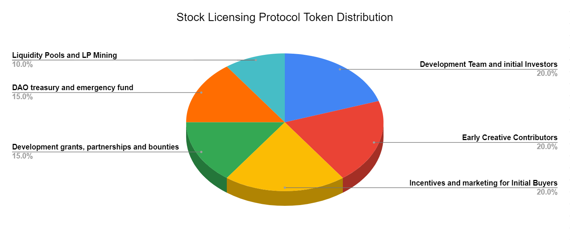

### Development Team and Initial Investors

The initial development of the protocol will be financed with one fifth of the tokens. The development team will be allocated tokens and sales of a small portion of the tokens to initial investors will raise funds to increase the speed of development and pay for other fees related to releasing the first version of the protocol.

### Early Creative Contributors

Creators will be incentivized to upload their pre-existing stock assets to the protocol with free Stock Licensing Protocol tokens. A process will be developed to incentivize creators to use the tokens to mint Stock Licensing NFT with their free tokens rather than hold for future gains or sell immediately. This will also control access to who can mint Stock Licensing NFTs while the collection is being populated to reduce spam and copyright infringement.

### Incentives and Marketing for Initial Buyers

Buyers will also be incentivized to purchase Non-Fungible Licenses with tokens. One fifth of the tokens will be used to market to stock buyers and provide incentives for buyers to use the protocol.

An example of how these tokens will be used is to buy License Credits with the tokens, essentially giving an initial set of free stock licenses to buyers similar to how stock agencies provide free licenses for joining their platforms. However, when the License Credit is redeemed for a license, the creator will receive the Stock Licensing Protocol Tokens. The result of this is creators of the most marketable stock assets will accumulate a larger percentage of stock licensing protocol tokens giving them a larger say in the governance of the protocol.

### Development Grants, Partnerships and Bounties

The Stock Licensing Protocol can only be successful with a strong development community. A portion of the tokens will be reserved for rewarding and incentivizing participation in the development and growth of the community. This would include engaging and incentivizing existing Web 2.0 companies and applications to integrate with the Stock Licensing Protocol.

### DAO Treasury and Emergency Fund

The Stock Licensing Protocol DAO will receive tokens for initial funding. This will create the initial treasury which will be directed by protocol improvement proposals. It is expected that this treasury with the protocol fees will be used to maintain the protocol after the initial development has been completed.

### Liquidity Pools and LP Mining

Initially tokens will be distributed to creators and license buyers for free to incentivize early use of the protocol. However, after the initial distribution Stock Licensing Protocol tokens will need to be purchased by creators to mint Stock Licensing NFTs. These tokens will be available for purchase on decentralized exchanges. A portion of tokens will be set aside for liquidity pools and to incentivize token owners to provide liquidity to these pools.

## Token Release Schedule

The initial planned token release schedule is outlined below but this may change before the token contract is deployed without notice.

**Development Team and Initial Investors** - 2 years monthly even distribution

**Early Creative Contributors** - 2 years monthly even distribution

**Incentives and Marketing for Initial Buyers** - 4 years monthly even distribution

**Development Grants, Partnerships and Bounties** - 4 years monthly even distribution

**DAO Treasury and Emergency Fund** - 4 years monthly even distribution

**Liquidity Pools and LP Mining** - Released at listing decentralized listing

Assuming the decentralized listing is completed after 12 months the release schedule will look like the following.

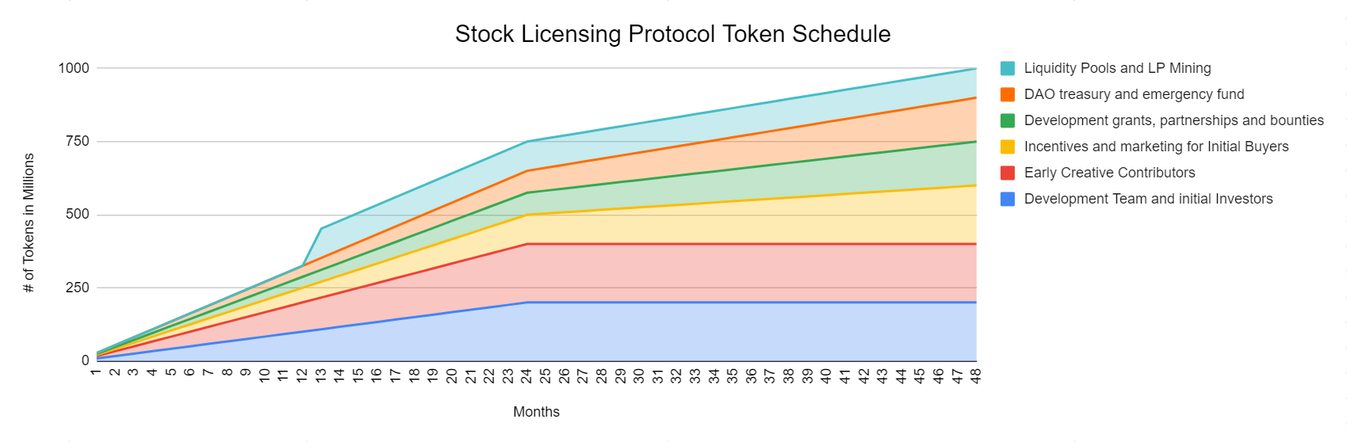

# Roadmap

The stock licensing protocol will roll out in 3 phases. The first phase is a fully functional minimal viable product that allows early adopters to license their stock assets. Future phases will add additional functionality. The roadmap may change without notice, reference the Stock Licensing Protocol website roadmap for more details.

## Phase 1

Phase 1 is intended to be a minimum viable product to initiate the growth of the collection.

* Stock Licensing NFT
* Non-Fungible License
* Stock Licensing Protocol Token
* Stock Licensing Metadata Standard
* Non-Fungible License
* NFT Stock Marketplace
* Digital Asset NFT License Agreement

## Phase 2

* Digital Asset Storage Protocol
* Digital Asset Antispam and copyright protection protocol

## Phase 3

* Digital Asset Protocol DAO

# 

# References

[1] Stock Photography Market Analysis. Published Jul 2021. URL: <https://www.coherentmarketinsights.com/market-insight/stock-photography-market-4549> (visited on 02/15/2022)

[2] Non fungible Token Market. Published Jan 2022. URL: <https://www.emergenresearch.com/industry-report/non-fungible-token-market> (visited on 02/15/2022)

[3] OpenSea reveals that over 80% of its free NFT mints were plagiarized, spam or fake URL: <https://www.theblockcrypto.com/linked/132511/opensea-reveals-that-over-80-of-its-free-nft-mints-were-plagiarized-spam-or-fake> (visited on 02/28/2022)