REVISION HISTORY
REV | DESCRIPTION | DATE
1 | Original Issue | 12/02/14

HOW TO USE
STOCK ANALYSIS EXCEL ADD IN

PURPOSE:
To describe the use of the Stock Analysis Excel Add-In.
SCOPE:
This procedure describes the use of the Stock Analysis Excel Add-In features.

DEFINITIONS:
N/A
REFERENCED DOCUMENTS:
N/A
RECORDS:
N/A
APPLICATIONS REQUIRED:
Microsoft Excel
Custom Excel Add-In

Warnings:
N/A

NOTE:
This procedure is written for Microsoft Excel 2010. It may be compatible with Excel 2007 but has not been tested with that application.

LAUNCHING THE APPLICATION

Launch the Microsoft Excel program.

Ensure that the Home tab is selected.

Verify that the Stocks section of the ribbon is present.

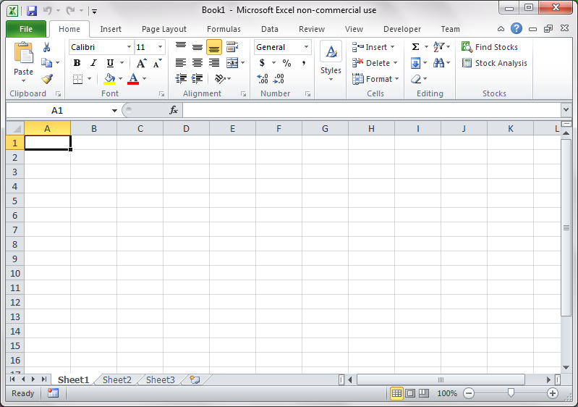
Figure 1.1 Microsoft Excel Home Tab

If Stocks section is not present, refer to Installing the Excel Add-In.

find stocks

Press the “Find Stocks” button to begin searching for stocks.

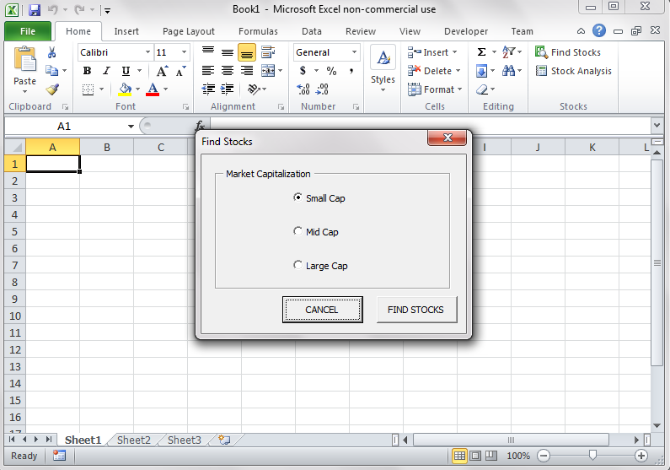
Figure 2.1 Find Stocks Dialog Box

Select the capitalization of stocks to search for.

Small Cap stocks are companies with a market capitalization between 250 million and 2 billion.

Mid Cap stocks are companies with a market capitalization between 2 billion and 10 billion.

Large Cap stocks are companies with a market capitalization between 10 billion and 100 billion.

Press FIND STOCKS button to search for stocks. The internet browser will launch and navigate to Google Stock Screener with the predefined search criteria.

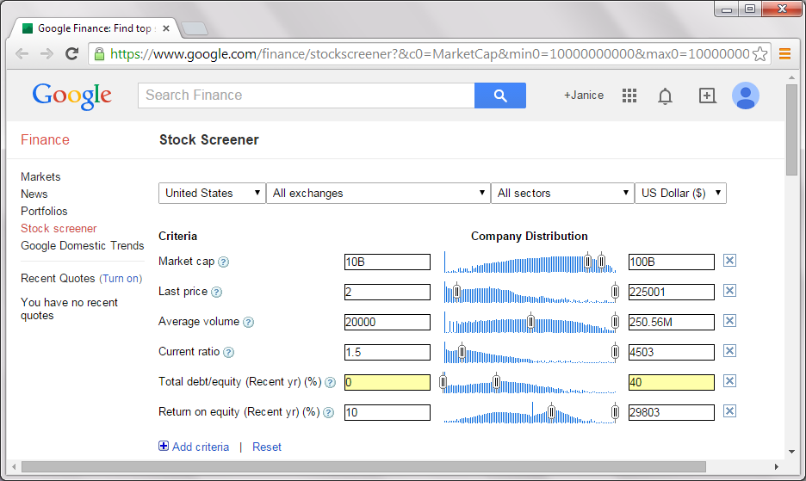

Figure 2.2 Google Stock Screener

The stock screener will yield a list of stocks that fit the defined requirements.

ACQUIRING DATA

Press the “Stock Analysis” button to begin analyzing a stock.

The Ticker Symbol dialog box will appear.
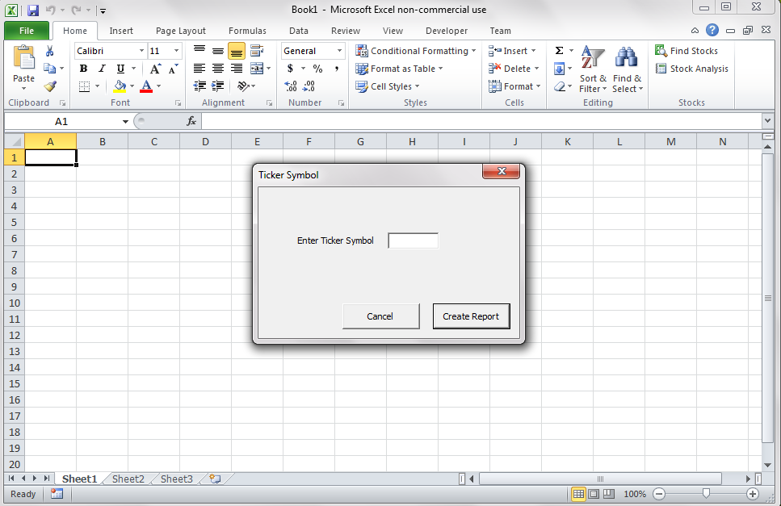

Figure 3.1 Ticker Symbol Dialog Box

Enter the Ticker Symbol for the company to be evaluated and press the “Create Report” button.

The Excel status bar will indicate the current status of the application. It will navigate to Google Finance, navigate to the company page, and acquire the financial statement information.

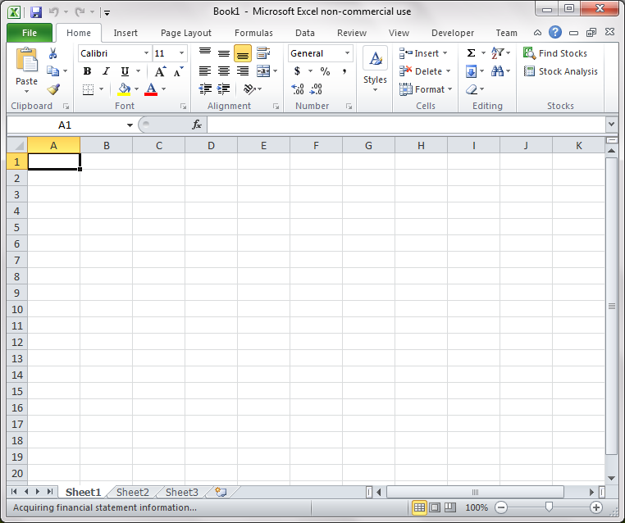

Figure 3.2 Excel Status Bar

Once the data is acquired, several worksheets will be generated:
- Income Statement
- Balance Sheet
- Cash Flow Statement
- Summary
- Analysis

STOCK ANALYSIS

The analysis statement will contain a 9-point checklist used to perform stock analysis.
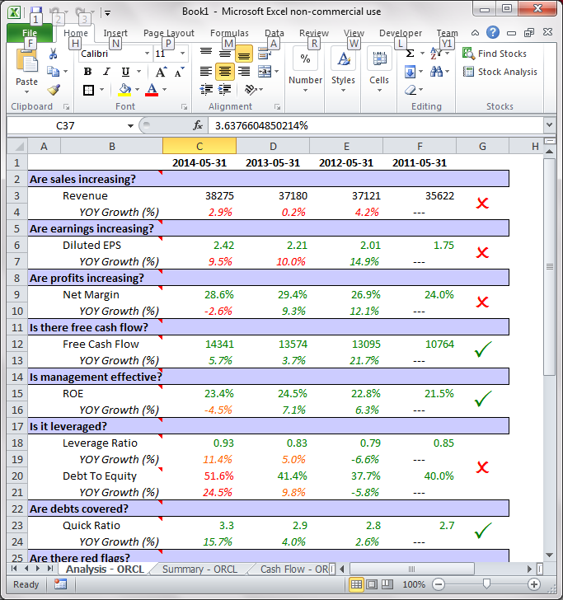

Figure 4.1 Stock Analysis Checklist

Hovering over each checklist criteria provides additional information:
- What is it – description or definition of the criterion
- Why is it important – explanation of why it is included in the checklist
- What to look for – explanation of requirements for passing
- What to watch for – description of other factors that affect criteria

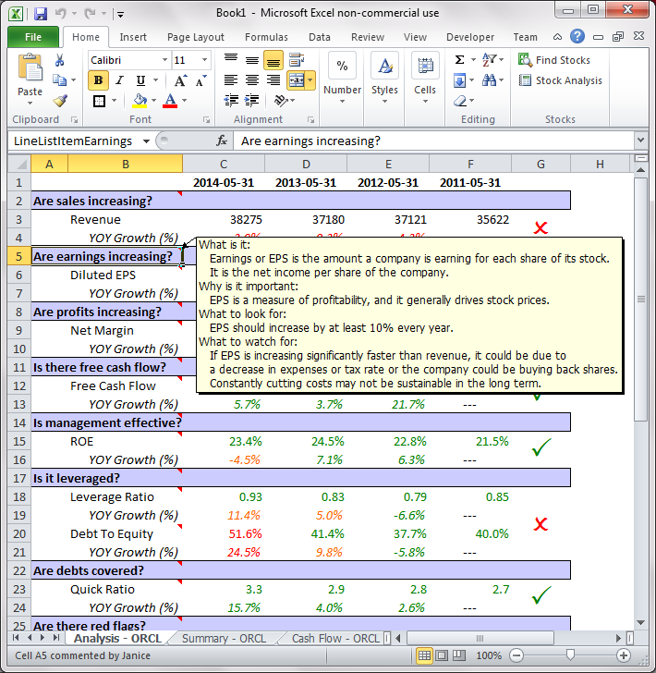

Figure 4.2 Stock Analysis Checklist Information

Hovering over the items in the checklist provides additional data.

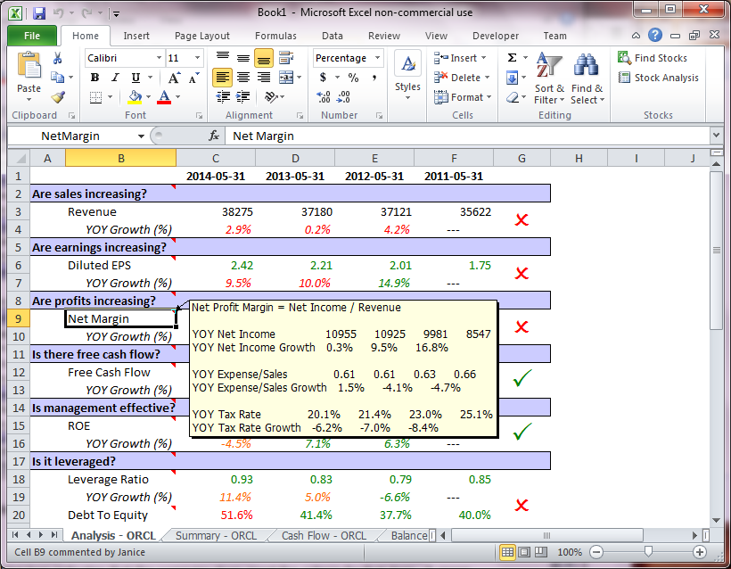

Figure 4.2 Stock Analysis Checklist Item Information

A red ‘X’ on a checklist item indicates that the company does not meet the criteria for that item. A green check indicates the company passes the criteria.

Green text indicates that the data and calculated values pass the required criteria. Orange text indicates caution, which means it may need further investigation. Red text indicates where the criteria are not met.

THE PROCEDURE FOR USING THE STOCK ANALYSIS EXCEL ADD-IN IS NOW COMPLETE.

