REVISION HISTORY
REV | DESCRIPTION | DATE
1 | Original Issue | 09/10/14

INSTALLING EXCEL ADD IN

PURPOSE:
To ensure the proper installation of an Excel Add-In.
SCOPE:
This procedure describes the method used to install, load, unload, and remove an Excel Add-In.

DEFINITIONS:
XLA – Stands for eXceL Add-in. XLA files are written using Visual Basic for Applications and may be developed by Microsoft or a third party user.
REFERENCED DOCUMENTS:
N/A
RECORDS:
N/A
APPLICATIONS REQUIRED:
Microsoft Excel
Custom Excel Add-In

Warnings:
N/A

NOTE:
This procedure is written for Microsoft Excel 2010. It may be compatible with Excel 2007 but has not been tested with that application.
In general, the term install with regards to XLA Add-Ins means to add the Add-In or to Excel’s list of known add-ins. The term load means to open the Add-In and make its functionality available to excel. This is done one time, and the add-in will remain on the machine until it is unloaded or removed. If you have acquired an XLA Add-In, you must install and load it as necessary to allow Excel to access the functions provided.

PROCESS:

INSTALLING A NEW ADD-IN

Save the Add-In file to the desired location.

Launch the Microsoft Excel program.

Display the File tab of the ribbon.

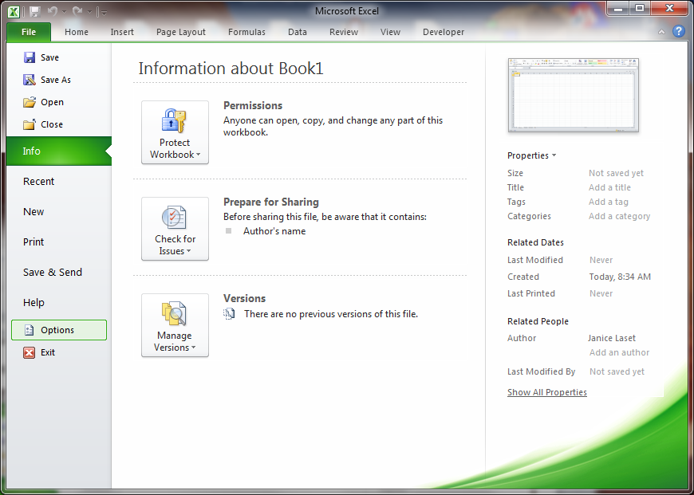
Figure 1.1 Microsoft Excel File Tab

Select Options in the menu on the left and select Add-Ins from the Options dialog box.

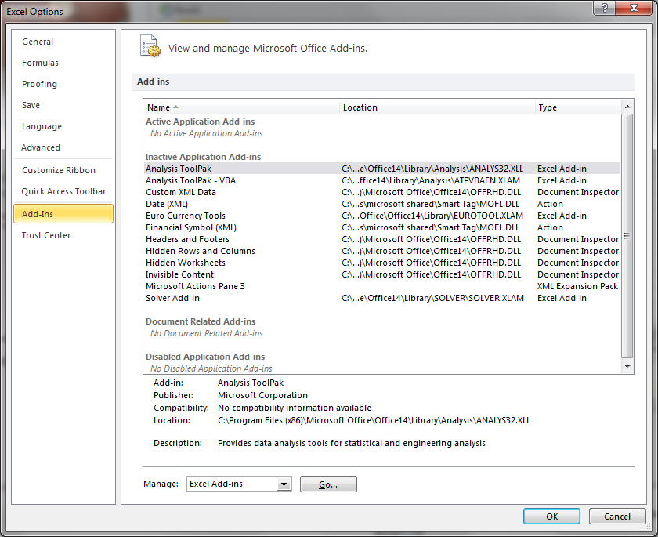
Figure 1.2 Microsoft Excel Options Dialog Box

Select Excel Add-Ins in the Manage input box.

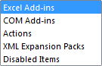
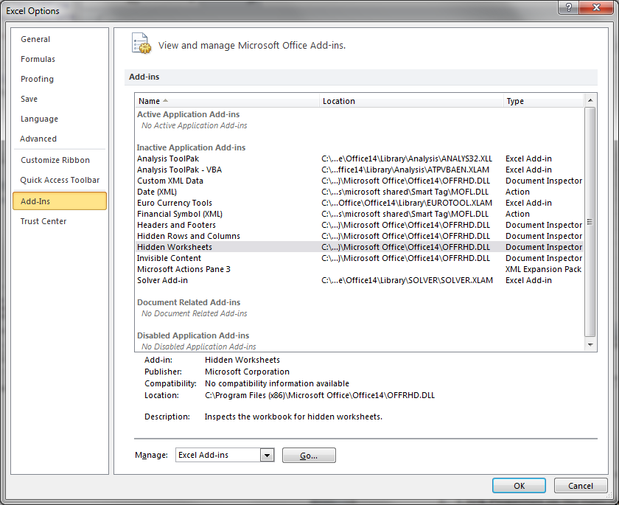

Figure 1.3 Microsoft Excel Add-Ins Option

Press Go to open the Add-Ins dialog box.

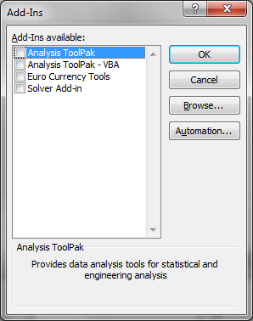
Figure 1.4 Microsoft Excel Add-Ins Dialog Box

Press Browse and navigate to the folder where the Add-In file is stored. Select the file to install the add-in. The Add-Ins dialog box should appear with the selected Add-In and the box checked indicating that it is loaded.

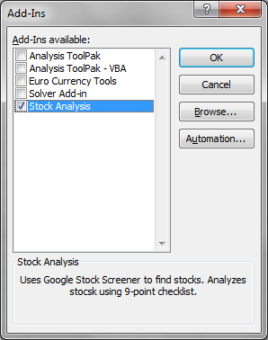
Figure 1.5 Microsoft Excel Add-In Loaded

Press OK to complete the operation and load the Add-In.

LOADING and unloading AN EXISTING ADD-IN

Repeat 1.3 to 1.6 to navigate to the Add-Ins dialog box.

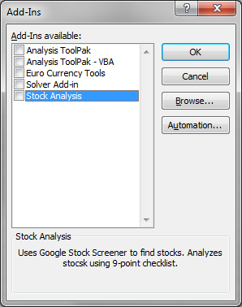
Figure 2.1 Microsoft Excel Add-Ins Dialog Box

To load an Add-In, check the box next to the Add-In to be loaded.

To unload an Add-In, uncheck the box next to the Add-In to be unloaded.

Press OK to complete the operation.

THE PROCEDURE FOR INSTALLING EXCEL ADD-INS IS NOW COMPLETE.

