REVISION HISTORY
REV | DESCRIPTION | DATE
1 | Original Issue | 09/10/14

CREATING EXCEL ADD IN

PURPOSE:
To ensure the proper creation of an Excel Add-In.
SCOPE:
This procedure describes the method used to create an Excel Add-In.

DEFINITIONS:
N/A
REFERENCED DOCUMENTS:
N/A
RECORDS:
N/A
APPLICATIONS REQUIRED:
Microsoft Excel

Warnings:
N/A

NOTE:
This procedure is written for Microsoft Excel 2010. It may be compatible with Excel 2007 but has not been tested with that application.

PROCESS:

Creating A NEW ADD-IN

Launch the Microsoft Excel program.

Display the File tab of the ribbon and select Info in the menu on the left.

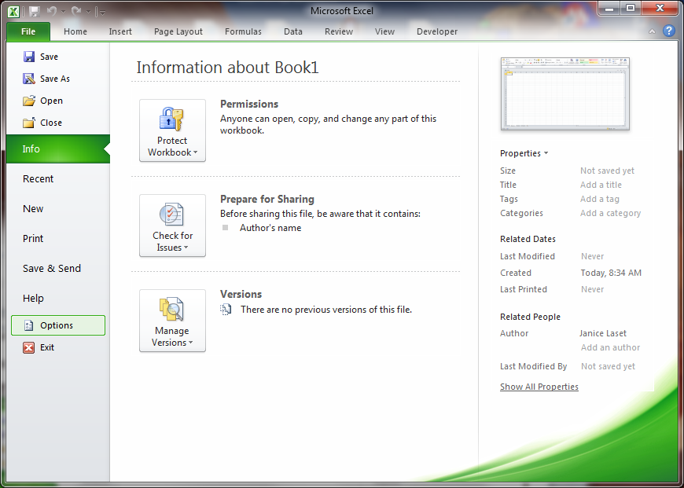
Figure 1.1 Microsoft Excel Info Option

Select Properties on the right side of the dialog box and select Advanced Properties.

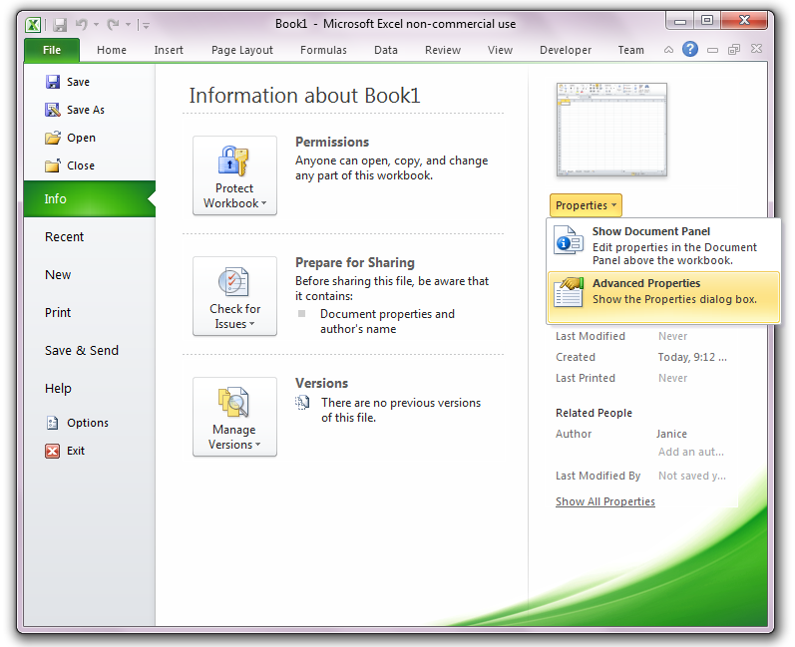
Figure 1.2 Microsoft Excel Properties Option

Select the Summary tab in the Advanced Properties dialog box.

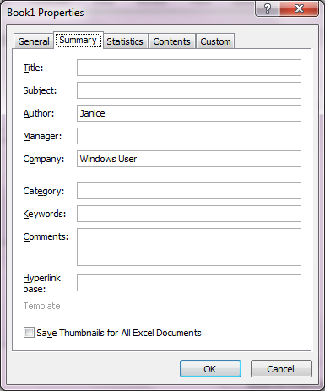
Figure 1.3 Advanced Properties Summary

Enter the name of the Add-In in the Title field.

Enter the description of the Add-In in the Comments field.

Save the file as an Excel Add-In (*xlam).

Microsoft Excel 2010 expects add-ins to reside in the following location:
C:\Users\UserName\AppData\Roaming\Microsoft\AddIns

The file path is changed to the default add-in location when *.xlam format is selected. Change the file path as desired.

modifiying the add-in properties

Properties of an existing Add-In can be modified by right-clicking on the file and selecting Properties.

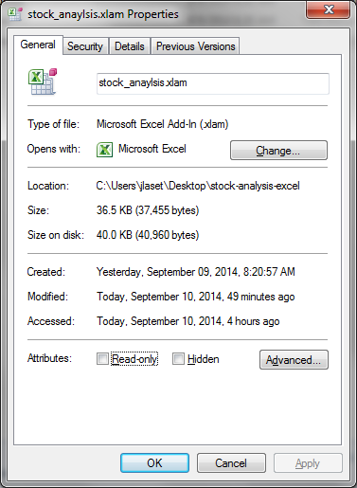
Figure 2.1 Microsoft Excel Add-In Properties

Select the Details tab in the Properties window.

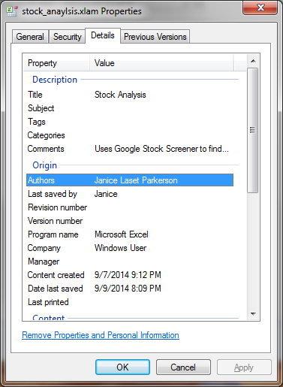
Figure 2.2 Microsoft Excel Add-In Details

Click on any of the property values and change as desired.

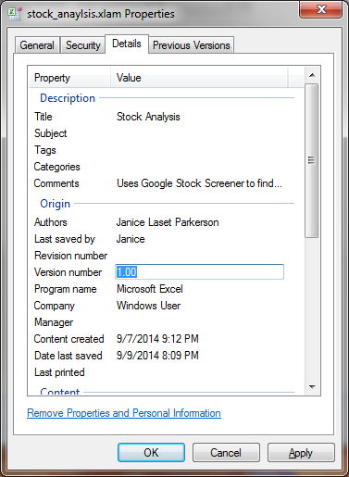
Figure 2.3 Modifying Add-In Details

Press OK to complete the operation.

THE PROCEDURE FOR CREATING EXCEL ADD-INS IS NOW COMPLETE.

