1. Open Excel program.
2. Display the File tab of the ribbon and select Info on the drop down menu on the left.

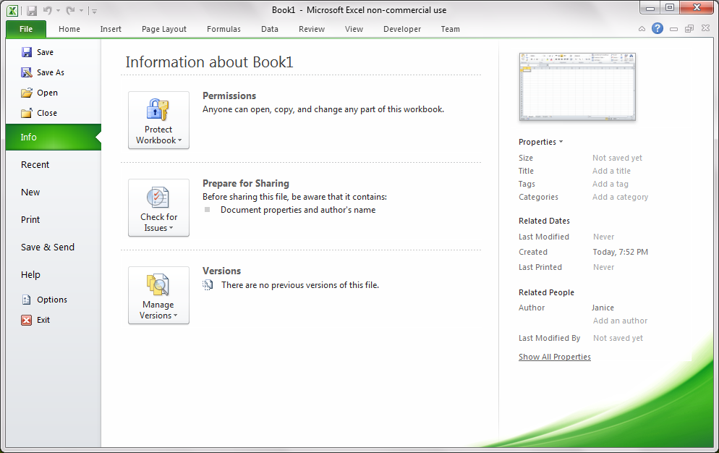

1. Click Properties on the right side of the menu and select Advanced Properties.

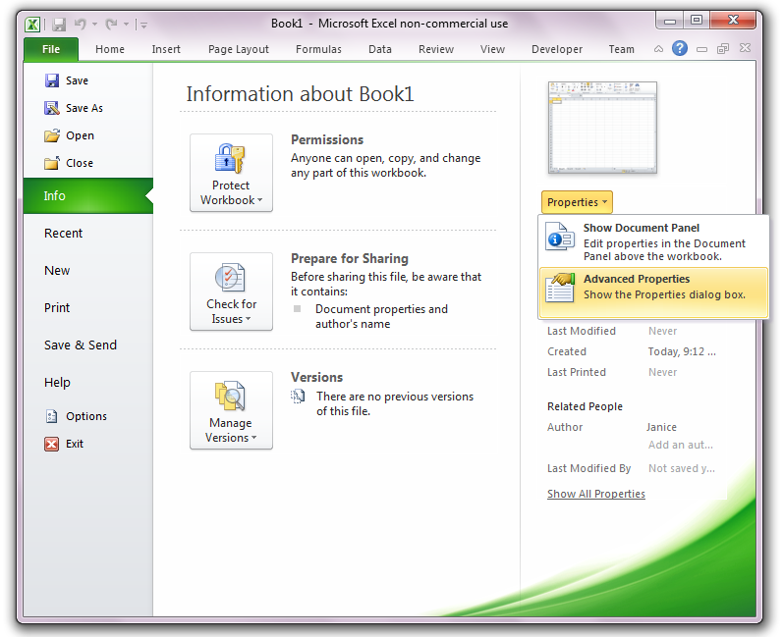

1. Select the Summary tab in the Advanced Properties dialog box.

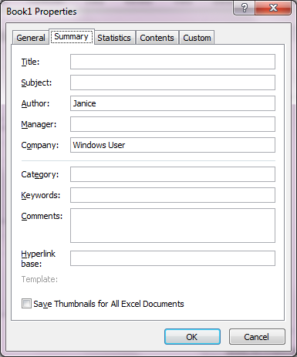

1. Enter the name of the Add-In in the Title field.
2. Enter the description of the Add-In in the Comments field.
3. Save the file as an Excel Add-In (\*.xlam).

*Microsoft Excel 2010 expects Add-Ins to reside in the following location:*

C:\Users\UserName\AppData\Roaming\Microsoft\AddIns

*Notice that the file path is changed to this location when the \*.xlam format is selected.*

*When installing Add-Ins, Excel searches for the Add-In in this folder.*

1. Change the file path as desired. The user will need to use the Browse button when installing the Add-In.