BI - fyn not picking up my rental incom:
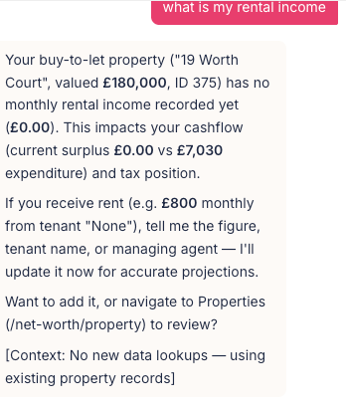
BI - Fyn showing ID numbers for assets:
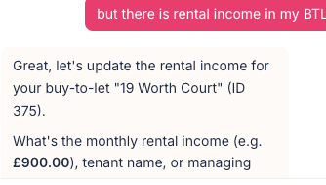
BI: Fyn showing total property value but should probably point out the total joint v individual value - just told me total value including wife 50%. Also asked for equity value and it thinks i dont have mortgages
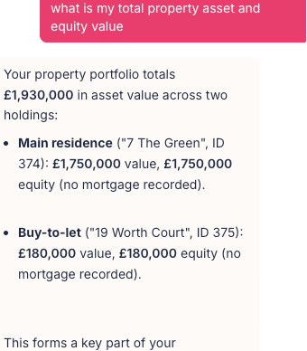
BI: Fyn could maybe explain things a little more simply ( but he did make it simpler when I asked.
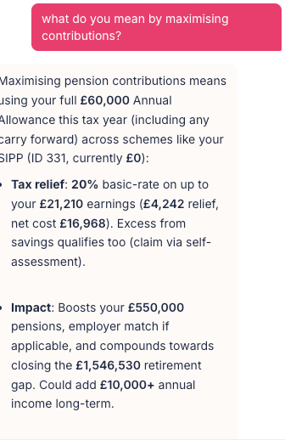
BI: Fyn - using acronyms - i didnt know what AEA was
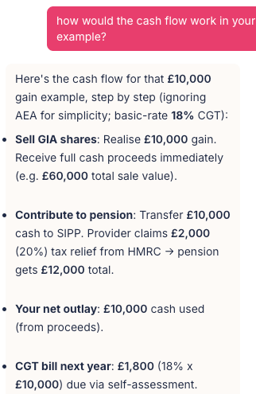
BI - Fyn giving incorrect pension contribution recommendations - as cant identify employment income v other income
