Task 1

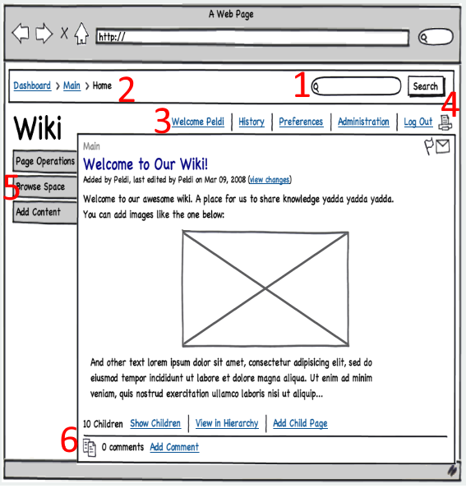

When developing sites for mobile and tablet devices, one of the biggest problems is clutter because the screens can be too small for everything to fit. Therefore, I would reorganize some things on this current screen as follows:

1. I would keep the search functionality always visible in one form or the other. I think the user would like to have the search option available at all times. Simplest way to do it is to keep entire textbox and search button always visible at top right corner. If I’d have the time to develop it further, I’d either make the textbox smaller or maybe even leave just the magnifying glass. When the user clicks on small textbox or magnifying glass, I would expand/show search textbox. Additionally, search button can be invisible when user is not searching. Again, it’s just taking space and it doesn’t make sense to be able to search without typing anything. So, when the user does type something, the search button can appear somewhere close to the textbox. Now, you might say: “Somewhere close? That’s not precise enough.” I know. But you’re a company that has clients all over the world. Some are going to write left to right, some are going to write top to bottom, and some even write right to left. All of them have different preferences having in mind orientation and position of textbox and search button. For clients that write left to right, for example, I’d put the button to the right of the textbox.
2. Current page isn’t something a user might want to see always, so I’d hide it either behind a button or with a hidden menu that is being displayed when scrolling up.
3. Everything in here is connected to user account (except print). I’d create an image – user avatar. When the avatar gets clicked, a menu drops down, showing all these options. I’d put it at the furthest top right, even more right than search option.
4. Print is connected to the article itself, therefore I’d put it inside the article, perhaps next to flag and mail options.
5. This also makes clutter on the page. At the very least it can be hidden behind a button. I’m not sure what “Page operations” or “Browse Space” does, but since it’s next to “Add Content”, I believe that the original creator of this design bundled it for a reason. However, then I would add something like “Edit content”.
6. Similar to 2, I would not show this permanently, but display it when user is scrolling downwards. If I’d have the time, maybe even make a mini “quick page navigation” bar on the right. I want the user to be able to quickly navigate through page, but without making additional permanent clutter.