Technical Manual for the

Waste Impact Calculator

By

Martin J. Brown  
Oregon Dept. of Environmental Quality  
Martin.Brown@state.or.us  
+1 503 229 5502

Introduction

The Waste Impact Calculator model (WIC) is a tool for sustainability and environmental workers in the fields of materials management, solid waste, recycling, and so on.

WIC estimates the life cycle environmental impacts associated with solid waste, including municipal solid waste and recycling streams. It also allows the user to create new scenarios for managing solid waste and to project the life cycle impacts associated with those scenarios. For example, a user might be interested in seeing how the greenhouse gas impacts of food waste would change under scenarios of: a) increased composting; or b) decreased food waste generation.

WIC is available in two forms:

* A collection of R scripts and related data files – mostly of interest to those with R programming skills. It is available on github at INSERT LINK HERE.
* An interactive web app, available at INSERT LINK HERE.

WIC was created for the state of Oregon in mind, and many of its defaults are specific to Oregon. However, its form, mechanics, and impact factor database could be used or adapted by other jurisdictions or organizations. This document aims to provide sufficient understanding of the workings of the model that its code and databases could be adapted by others.

Conception of environmental impacts

Materials in the waste stream, whether bound for “disposal” such as landfilling, or “recovery” such as recycling, are taking part in the “materials life cycle.” [ref smm]. The earth is the ultimate source of materials – they are extracted, farmed, or harvested, processed into products and distributed (steps which might be summarized as “production”), after which they are used, and, at the “end of life,” discarded for disposal or recovery. At each of these “life cycle stages,” environmental impacts occur. For example, farming utilizes fresh water, and distribution of food in trucks creates GHG emissions. The sum total of such impacts are the “life cycle impacts.”

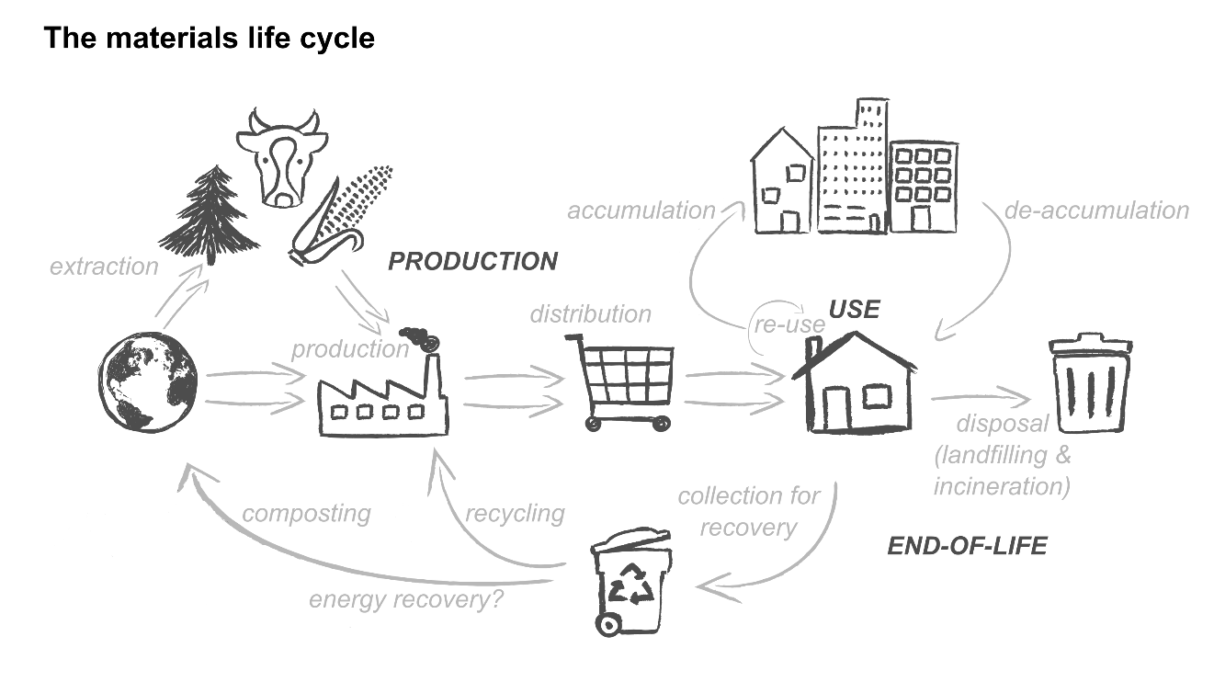

WIC calculates life cycle impacts by working “backwards” through this cycle.

* It starts with observed quantities of materials in the disposal and recovery stream
* It calculates the impacts of those processes
* It adds on the production-related impacts for those same quantities of materials.

WIC does not estimate impacts linked to the “use” phase. The ***use*** phase of the materials life cycle is ignored, as it is too difficult to model for the huge variety of materials in the waste stream. For some materials (e.g. single-use packages) impacts at this stage are probably negligible.

The life cycle impacts associated with the waste stream (ISWS) are defined as the sum of the emissions associated with the production (PROD) and end-of-life treatment (EOL) of each individual material. More formally, for materials *i=1* to *m*…

$$ISWS= \sum_{i=1}^{i=m}{{(PROD}_{i}}+ {EOL}_{i})$$

**Production** is used in the broad sense, and includes extraction of resources, manufacturing or other processing, distribution and transport to retail. **End-of-life** emissions reflect whatever happens when a material is discarded. End-of-life emissions may be positive, for example when organic material is placed in a landfill and decays, or negative (that is, a reduction), for example, when steel is recycled and we assume it prevents production impacts from newly extracted materials.

*PRODi* and *EOLi* are not measured directly. Rather, the solid waste stream is first characterized by the masses of each material found in solid waste records. Then those masses are converted to *PRODi* and *EOLi* using ***impact factors***, for example “3.2 kg CO2 equivalents per kg of waste.”

Production-related emissions for each material (*PRODi*) are straightforward to calculate, as the product of the total mass of that material in the solid waste stream (*MASSi*) and a production impact factor (*PIFi*):

End-of-life impacts for each material (*EOLi*) are more complex, because materials have multiple plausible ***dispositions*** at the end of their useful lives, and each of those dispositions is associated with different kinds of environmental impacts. For example, steel has two plausible dispositions (recycling and landfilling), each with distinct impact factors. For material i and dispositions *j=1* to *d*…

$${EOL}_{i}= \sum_{j=1}^{j=d}{{EOL}_{i,j}}$$

The end-of-life impacts for each material and disposition (EOLi,j) are the sum of two components, end-of-life process impacts (EOLPi,j), and end-of-life transportation impacts (EOLTi,j).

Both process impacts and transportation impacts have their own impact factors. The end-of-life transport impact factor must be scaled by comparing the transport distances the user associates with the disposition to the distance assumed in the calculation of the impact factor.

Technical notes.

* Yes, the transport impact factor is linear. Deal with it. This makes it somewhat inflexible… changes in distance may be ok, but not changes in mode.

Material life cycle

Work backwards

Basic processing

There are two data files, baseline_mass_profile (which contains weights of materials) and impact_factors (which contain impact factors per ton of materials). These are linked and combined via key values (e.g. material and disposition names). Detailed impacts are calculated by multiplying weight by impact factor. Then the detailed impacts are summed to the level of detail of interest.

It is fairly simple in concept, but during data processing care must be taken that the appropriate number of tons are associated with each impact stage.

WIC work

Data dictionary

baseline_mass_profile

This file (or data frame) contains all of the data about solid waste. There should be one record for each combination of these fields:

* year – in Oregon this field represents a calendar year (e.g. “2018”), but this field could also be used to hold any integer value serving to identify a group of solid waste records, for example “1” could represent “Group 1”.
* wasteshed – in Oregon this field represents a geographic area from which solid waste is collected (e.g. “Curry County”), but this field could also be used to hold any character string serving to identify a group of solid waste records, for example “Company A.”
* material – name of the material (e.g. “Aluminum”). These names must be unique and match values in the impact_factors table.
* disposition -- a name describing the processing of the material, for example “landfilling,” “combustion,” “composting,” etc. These names must match values in the impact_factors table. These names must uniquely identify the process for each material, rather than express the conceptual nature of the process. So for example, if there are two ways to recycle glass, recycling to containers and recycling to fiberglass, they must have different disposition names, e.g. “recyclingToContainer” and “recyclingToFiberglass”. For records associated with the production life cycle stage, this field contains the value “production”.
* umbDisp – this represents “umbrella disposition,” a field designed to record how the disposition in question is perceived for calculations of “recycling rate,” “recovery rate” or “landfill diversion.” This is necessary because jurisdictions and authorities tend to disagree on what counts as “recycling” or “diversion” – for example incineration may be counted as recycling in one place, but disposal in another. The umbDisp field records this interpretation. Note that whether a disposition, such as combustion, is counted as recycling or not, the impact factors linked with it remain the same. For the production life cycle stage, this field should contain the value “production”.

The fields above serve to uniquely identify a record. Each record also contains this data field:

* tons – short tons of the material in question
* miles -- this is a special field only relevant to the “endOfLifeTransport” life cycle stage (if this field contains values for other life cycle stages, they should be ignored, as they will not be used in impact calculations). miles expresses the number of transport miles to be used in the calculation of the endOfLifeTransport impact. This is used to scale the endOfLifeTransport impact factor, which is based on an implied mileage (see “impliedMiles” in the impact_factors table documentation). If this field is missing, the implied mileage will be used as a default.

impact_factors

This file (or data frame) contains all of the impact factors associated with all the materials of interest. There should be one record for each combination of these fields:

* material – the material name
* LCstage – life cycle stage, either “production,” “endOfLifeTransport,” or “endOfLife”
* disposition – a name describing the processing of the material in the relevant LCstage, for example “landfilling,” “combustion,” “composting,” etc. Names must uniquely identify the process for each material, rather than express the conceptual nature of the process. So for example, if there are two ways to recycle glass, recycling to containers and recycling to fiberglass, they must have different disposition names, e.g. “recyclingToContainer” and “recyclingToFiberglass”. For records associated with the production life cycle stage, this field contains the value “production”.
* impactCategory – the type of impact being calculated, for example “Global warming potential,” or “Eutrophication potential.”

The fields above serve to uniquely identify a record in the impact factor file. Each record also has impact data fields:

* impactUnits – the scientific units used to quantify the impactCategory, per short ton of the given material (in its given life cycle stage and disposition). For example if the impact category is “Energy demand,” impactUnits should say “MJ” for megajoules.
* impactFactor – the actual magnitude of the impact for a short ton of the material given its life cycle stage and disposition. For example, if the impact category was “Energy demand,” a value of “685” would communicate an impact of 685 megajoules per short ton of the given material, in its given life cycle stage and disposition.
* impliedMiles – this is a special field only relevant to the “endOfLifeTransport” life cycle stage (if this field contains values for other life cycle stages, they should be ignored, as they will not be used in impact calculations). impliedMiles expresses the number of transport miles assumed in the calculation of the endOfLifeTransport impact factor. This allows for some adjustability in the calculation of endOfLifeTransport impacts. In the script-based model, custom mileages may be associated with specific wastesheds and end-of-life dispositions, by creating entries in the custom_mileages table. In the interactive app, an interface may allow the entry of custom mileages. See the section on “impact calculations” for more details.