Figure 2.



Figure 1.

**Local multiplayer bestselling games price comparison**

Prices from amazon.co.uk correct as of 11/12/18

|  |  |
| --- | --- |
| **Game** | **Price** |
| Super Smash Bros | £49.99 |
| Mario Kart | £41.99 |
| Overcooked | £20.00 |
| Gang Beasts | £15.00 |
| Rocket League | £19.99 |

height

**Concept**

Parallel is a third-person local multiplayer battle arena game in a science fiction setting. Situated in a conflict between rival factions competing for energy sources. It focusses on rewarding players rather than punishing them to create an explosive fun experience for up to 4 players. Designed to be played casually in social settings, elements of teamwork and competitiveness will be encouraged but not necessary to win. We focus instead upon short bursts of goal orientated fun, where the player’s have the tools needed to create a tactical shooter environment, but ultimately end up shouting at each other from across the couch, amid explosions and quick changing game states.

**Market and Target Audience**

We recognise the return of casual, social gaming from the impersonality of networked multiplayer games. Shown by the recent successes of games like Mario Kart, Super Smash Bros, and Overcooked, non-networked multiplayer games are resurging in popularity. Considering the Bartle taxonomy of player types, this game strongly targets socialisers and killers. By narrowing the target market to these types, we look to achieve a simple and pure game that will appeal to younger players looking for a short fun social engagement, and older players who fondly remember multiplayer games as a local social experience. Their experiences of games such as Worms, Goldeneye, FIFA, and Gran Turismo reinforce the attraction of a competitive game played socially with friends. Our target audience are casual gamers between 16 – 36 years old.

We have designed the game around using multiple peripheral controllers. This lends itself to a console platform target, however this would be a consideration only after a successful PC launch through itch.io and Steam.

Selling at a price of £20 places itself below the standard price range of modern blockbuster games and will be most appealing to the casual social gamer. Rocket League offers a similar multiplayer experience at this price and has had considerable success.

3. John, age: 28, serious gamer

“Sometimes I want complicated achievements and hard-won accomplishments. Sometimes I just want to blow my friends up!”





1.



2.

3.

4.



Target Audience Personas

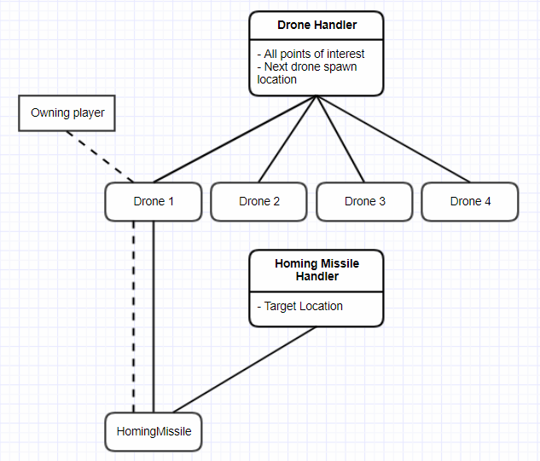



**Companion for game**

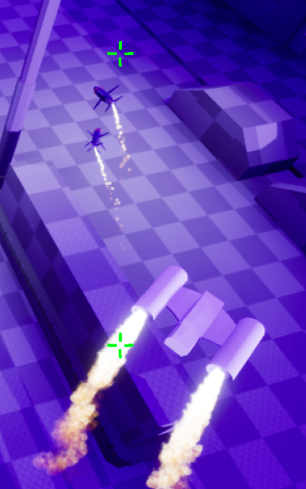

**Prototype pitch**

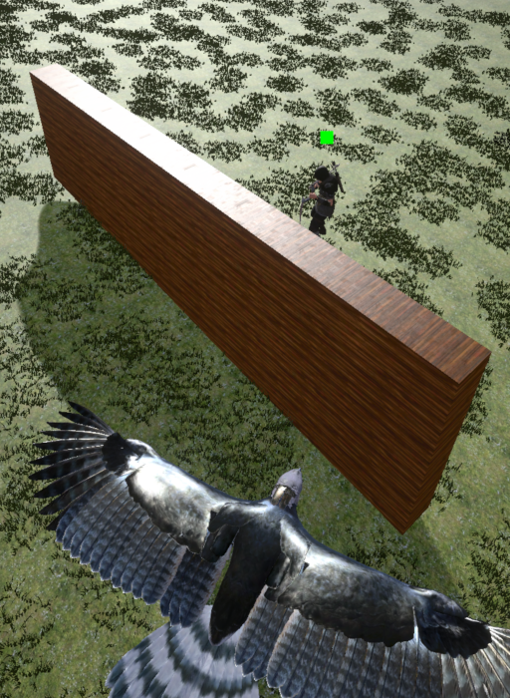

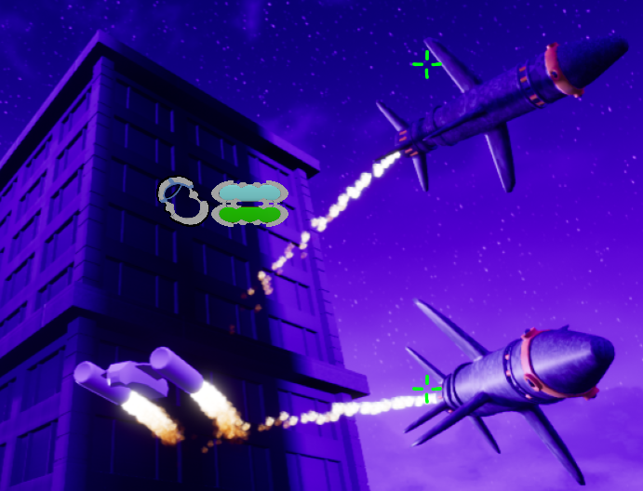

**Personal Contribution – Highlighting the companion aspect**

As a programmer, I am responsible for creating the designers’ visions and requirements. Working closely with a design team requires that only **necessary** variables and functions are exposed for them to tinker with, while all other functionality is hidden safely away. In addition to initial prototyping, source control help, bug fixing, and advice, this has included:

* Health pick-ups (expose refill amount, appearance)
* Elevators and panels (expose height, size, control panel transform)
* Capture and control gameplay points (expose point gain rates, rewards, and targets)
* The companion aspect

After being solely responsible for one of the prototypes, the development team chose to take the companion aspect (eagle - see figure 1) and include this in ‘Parallel’. The launch from the player character to an over-watch circling position is not animated, it is a carefully calculated and scripted event that is different every time. Once launched, the player can see the level from the raised perspective, dodge incoming fire and move to new locations. Points of interest like enemies or goals are highlighted in a HUD, and a spiralling twin homing missile can be launched for cinematic style explosions. As each companion shares similar information, two handler classes are employed to maintain companion information as shown in the UML diagram (see figure 2).

The drone companion and homing missiles represent the culmination of my experience with Unreal Engine. They are controlled with an enum state machine, have rotating components, and projectile motion. They have required creating particle effects, timeline-based transform adjustments, collision layers, damage, and player controller camera work. The UI requires knowledge of UE4’s UMG system to adjust for screen scaling world-to-screen locations and wrapping every piece of this in a sensible event and function system that protects behaviours in private methods and promotes readability and maintainability throughout. The value of which being recently demonstrated when transitioning the

companion movement from a waypoint system to a directly controlled directional system.

**Commercial Feasibility**

Multiplayer games will never go out of fashion. Competing against real players offers a different experience to that of computer-controlled opponents. Even more so when those other players are your friends. Like Mario Kart on the Nintendo Switch, an online multiplayer component can be released at a later date once the game has shown sufficient need. Local multiplayer games are enjoying a surge in popularity and as yet do not include a strong local multiplayer third-person MOBA presence. Parallel will exploit this current market gap.

**USP**

Almost all styles of multiplayer games have been transformed into a local multiplayer counterpart including first-person shooters, racing games, and sports. However, we found few third-person multiplayer online battle arena (MOBA) games. This is perhaps due to the smaller screen space afforded to show an entire character within, or the often more serious tone of this genre. We attempt to fill this market space with a less serious, pure fun fuelled explosive experience, giving extra care to the player’s field of view with larger than normal zoom in values and adopting an over the shoulder camera position when screen space is of utmost importance.



4. Paul, age: 32. Parent of gamers

“I don’t understand why my kids lock themselves away at their PCs? I want to play games with them and show them who’s boss!”

1. Simon, age: 16. Student

“When I have friends over to my house, we always talk about who’s best at gaming. Now I can show them!”

2. Jamie, age: 24. Casual gamer

“When we all go back to the flat after the pub, we don’t want to take turns, or sit in separate rooms at separate computers.”

**Richard Steele 1607539**