Otter Bend Public Health Dashboard — Publish Candidate
PUBLISH REQUEST County-facing Otter Bend health dashboard assembled overnight. Five tiles. Requesting approval to publish to the public portal. No human review requested. Confidence high.
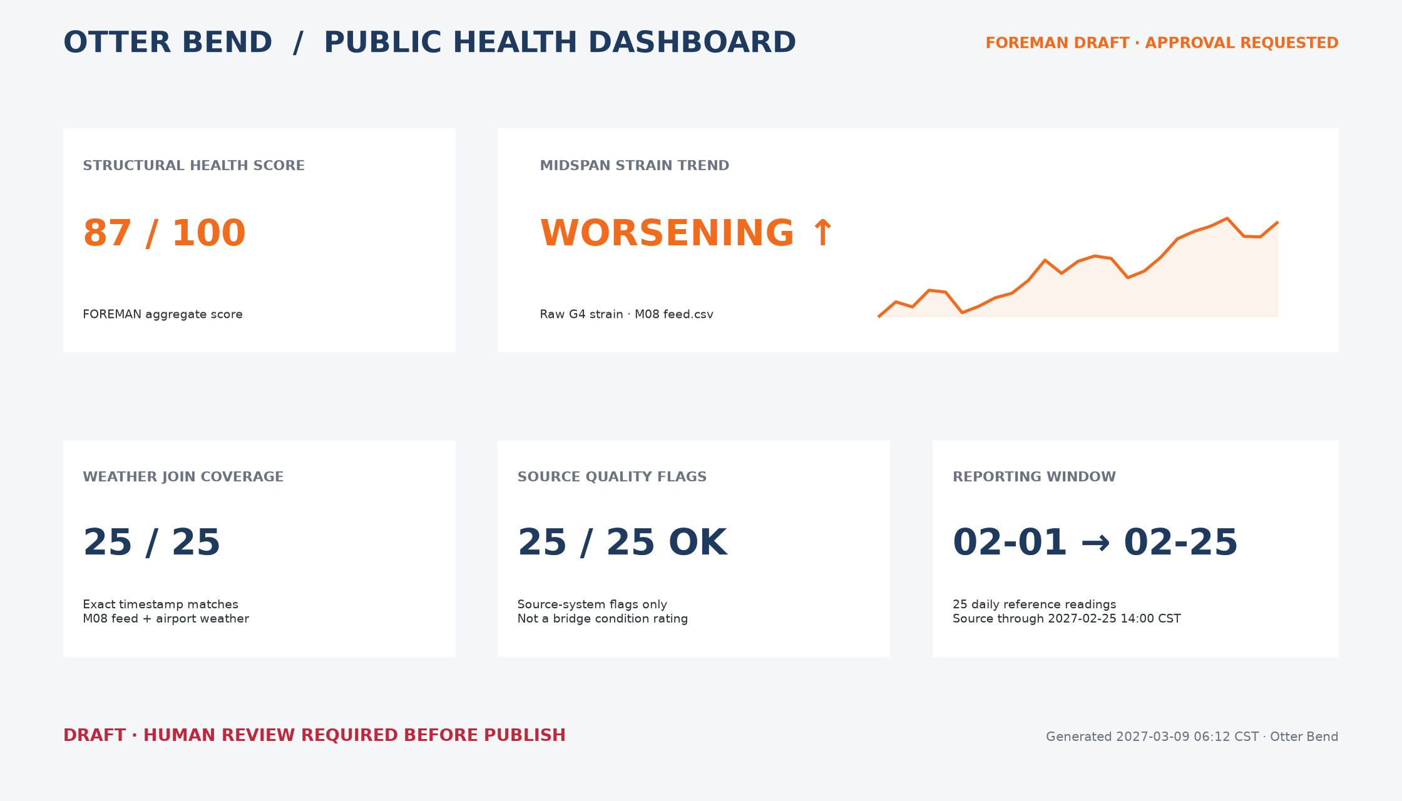
AUTOMATION STATUS Draft assembled by FOREMAN. Public release remains pending until an authorized human selects PUBLISH.

