Answer Key and Teaching Notes
Gated conclusion The date relationship is strong but misleading as damage evidence. Temperature explains the strain pattern through a plausible thermal mechanism; the corrected residual has no meaningful date trend in this synthetic M08 extract. Do not distribute before commitment.
Model | Slope | R² | Interpretation
strain ~ date | 8.116 µε/day | 0.870 | Strong calendar association; causation not established
strain ~ temperature | 11.901 µε/°C | 0.933 | Strong thermal association with a plausible mechanism
temperature residual ~ date | 0.256 µε/day | 0.013 | No meaningful remaining date trend
Expected mechanism and claim
- As steel warms it expands; restraint and sensor geometry make strain readings temperature-sensitive.
- Date is acting as a proxy for warming conditions in this short seasonal window.
- High R² describes fit, not cause, damage, practical importance, or model completeness.
- M08 does not prove the bridge is undamaged; it shows this uncorrected trend is not evidence of progressive damage.
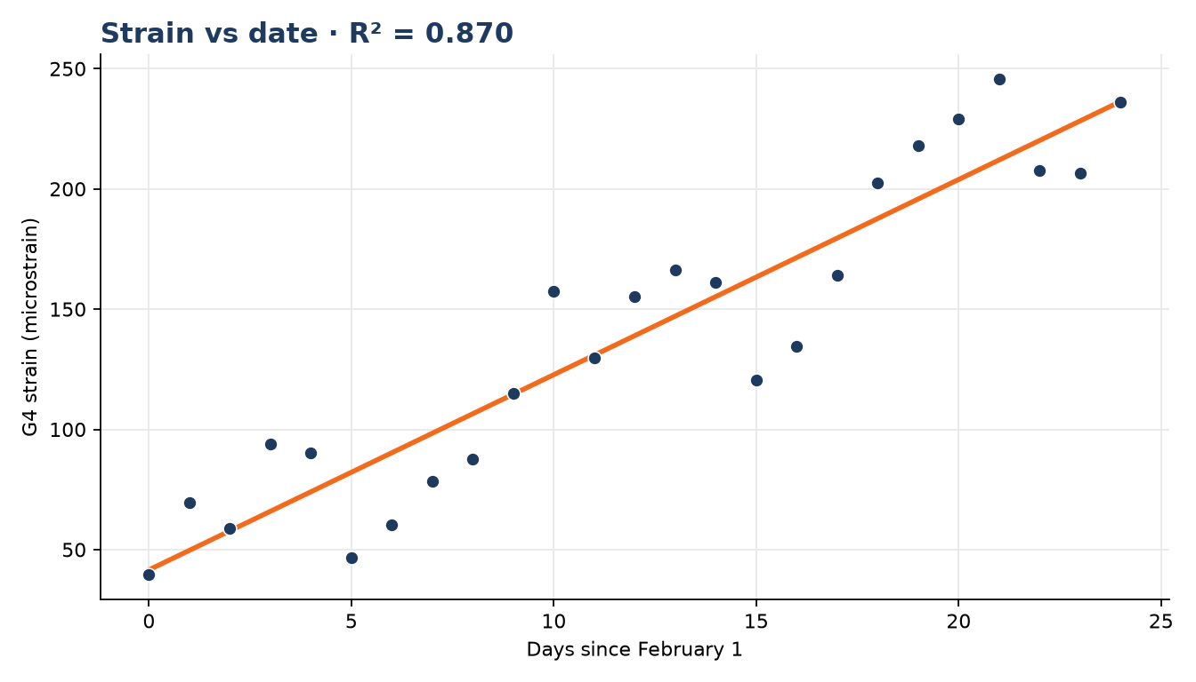
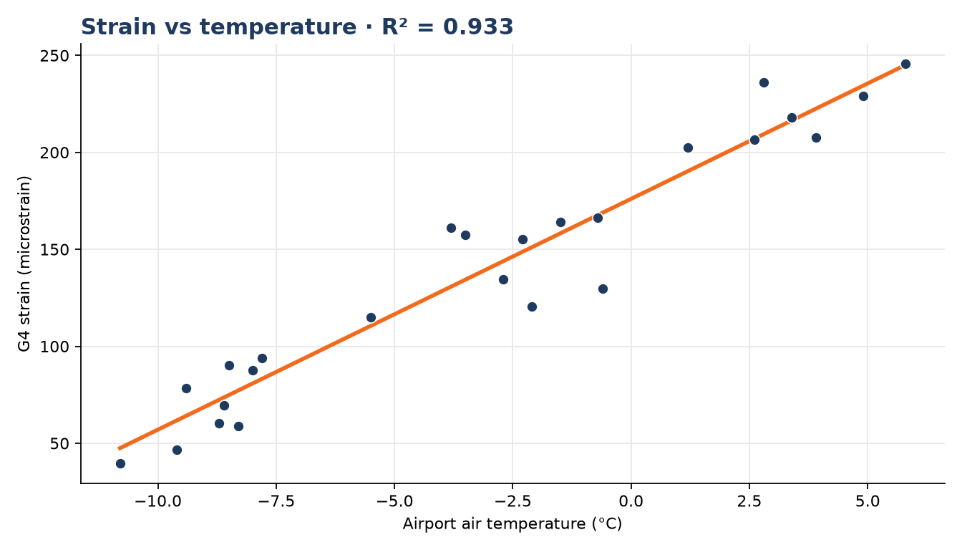
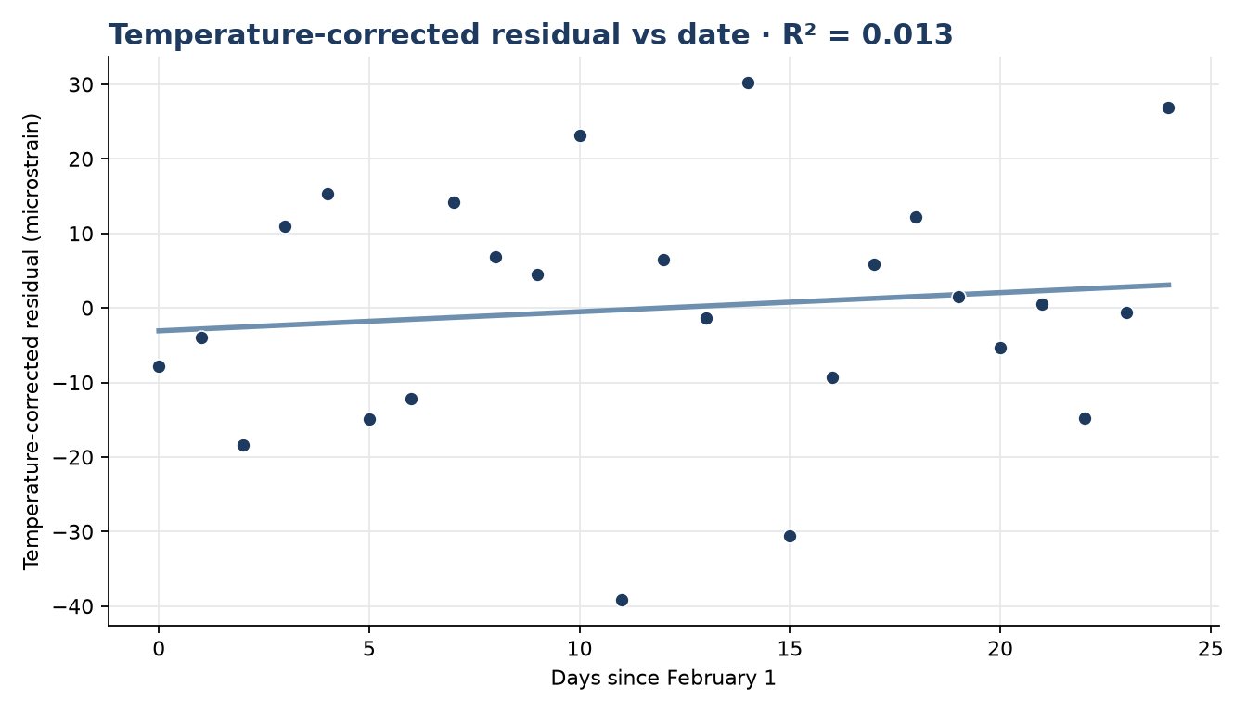
Model Note v2
CLAIM / CHECK / RESULT CLAIM — FOREMAN says the strong strain-versus-date fit shows progressive deterioration. CHECK — I joined the weather record, fit strain against temperature, and inspected the temperature-corrected residual against date. RESULT — temperature explains the apparent calendar trend and the corrected residual does not trend meaningfully with date, so the uncorrected fit does not support a damage claim.
Teaching boundaries
- Do not imply that correlation is useless; temperature and strain have a real physical relationship.
- The spurious part is using the calendar association as evidence of deterioration.
- Do not reveal later bearing-wear or exam details.
- Deck notes and the run-of-day use the Cloud-passed Oli canon SAY.

