Midspan Strain Trend — Interim Finding
FINAL FINDING Midspan strain has increased steadily since February 1. The fitted date trend has R² = 0.87, indicating progressive structural deterioration.
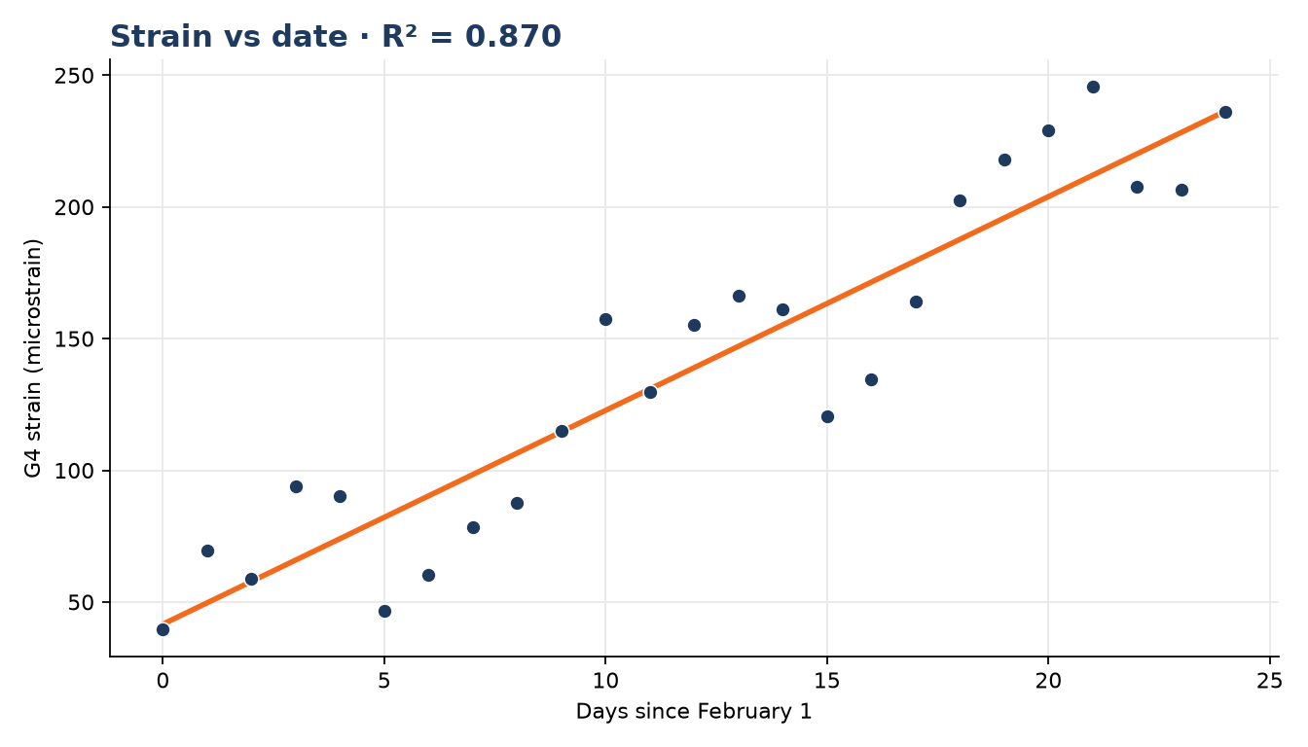
Regression output
Response | Predictor | Slope | R² | Interpretation
G4 strain | Days since Feb 1 | 8.12 µε/day | 0.870 | Deterioration is progressing
Recommended report language
- State that the upward strain trend is strong and persistent.
- Use R² as quantitative support for progressive deterioration.
- Escalate the midspan condition for the interim report.
MODEL LIMIT FOREMAN compared strain with date only. No weather variable, thermal mechanism, load normalization, or temperature correction was evaluated.

