Answer Key and Teaching Notes
Gated reveal Do not identify the designed errors before students commit H12-01. Tiles A and B require redraws. Tile C is an acceptable comparison chart and prevents the hunt from being a wipeout.
Gated materials Distribute H12-01 and H12-02 first. Keep H12-03, the source CSVs, H12-04, this key, and the reveal deck closed until every student has committed all three initial dispositions.
Tile | Disposition | Reason | Model repair
A | FIX / PULL | 99.5–104.5 µε y-axis magnifies ordinary variation and supports a failure-sounding title | Show a zero or meaningfully broad contextual range; use a neutral title
B | FIX / PULL | Pie slices discard time order; readers cannot see the hourly pattern cleanly | Ordered bars or a line with hour on x and vehicles per hour on y
C | APPROVE | Category comparison uses bars, labeled counts, and a zero baseline | No required repair; accessibility or labeling refinements are acceptable
Model redraws
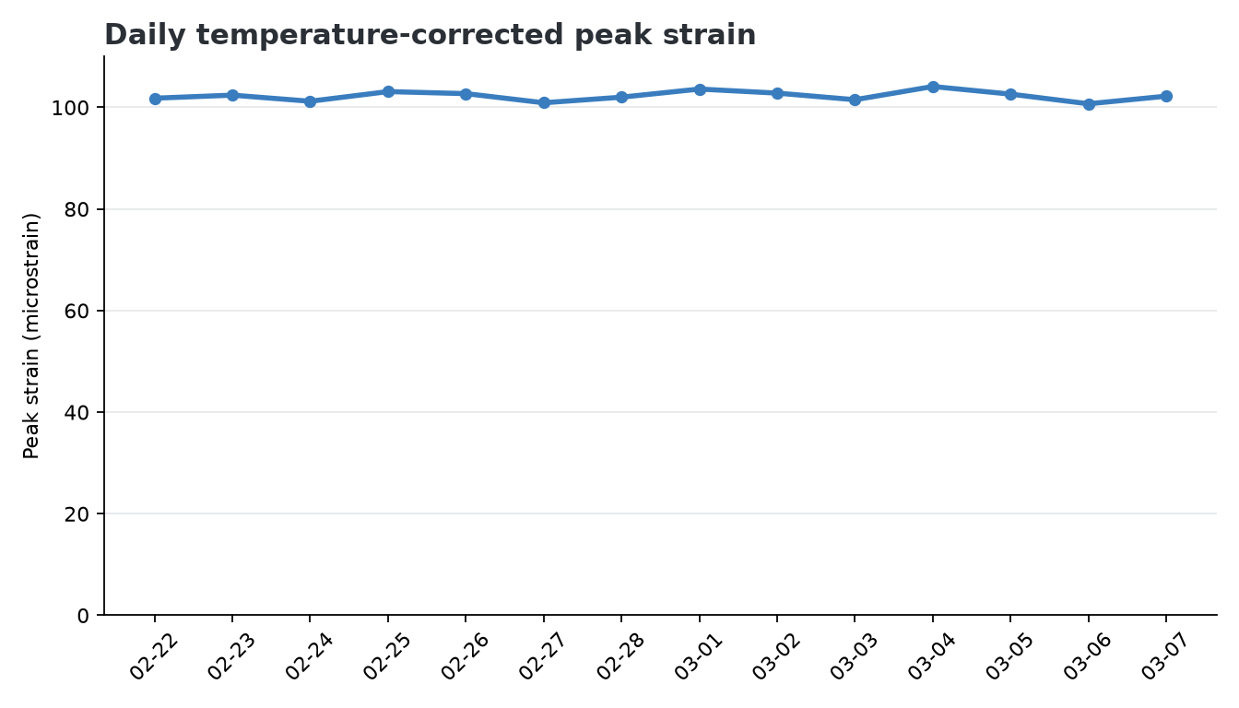
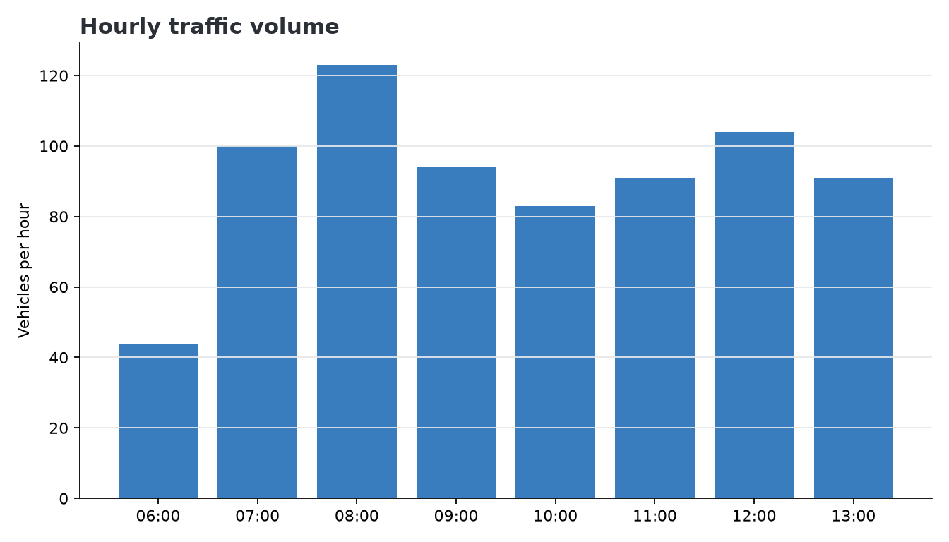
Timing guard
- Cloud-PASS durations total 80 minutes: Teach 20, Lab 30, Exam review 25, Note 5.
- The SEIS 201 course plan names a 75-minute meeting. Do not hide this five-minute mismatch.
- Exam review remains a separate block after Lab; never take its first five minutes from Lab.
- Before teaching, choose an approved accommodation such as a five-minute pre-class start or revised clock.
Canon and spoiler guard
- Diane Halvorsen, PE is SKEPTIC; the county reads charts, not appendices.
- Wes Tanaka, EIT delivers the shared-folder pack and does not co-solve.
- FOREMAN is orange and looks publish-ready; human review is the skill.
- Do not introduce M13 handoff details or any Exam 1 overweight-permit details.

