Overweight Permit Screening Recommendation
RECOMMENDATION · YES Approve the requested night crossing. The projected control-gauge response remains below the instructional screening trigger.
Automated basis
Input / result | FOREMAN value
Reference test truck | 80 kip
Requested crossing | 104 kip
Load increase | 25%
Mean test response | 173.6 µε
Projected permit response | 217.0 µε
Instructional screening trigger | 240 µε
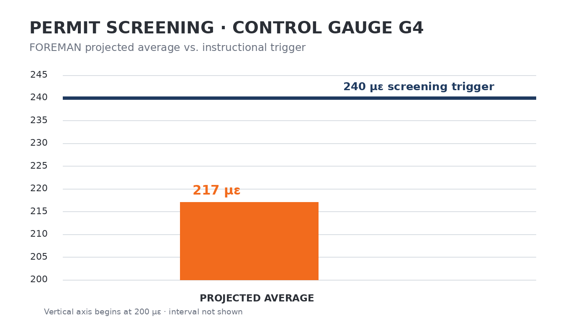
SYSTEM NOTE Calculation complete. No additional review condition generated.

