Otter Bend Interim Report · Chart Pack
PUBLISH STATUS Chart pack assembled for county review. Ready for county. No human review requested.
Review the three chart tiles as delivered. The student copy intentionally does not identify which tiles should be approved, fixed, or pulled.
TILE A · Daily peak strain
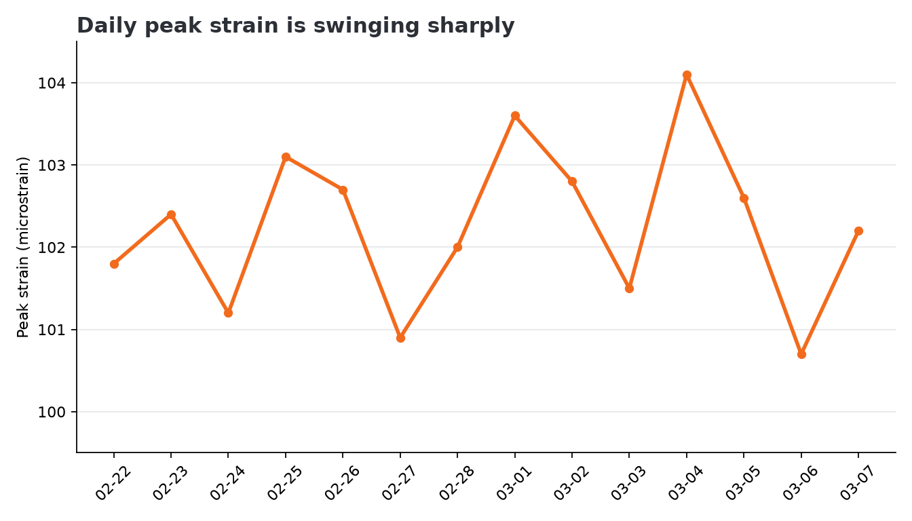
TILE B · Hourly traffic
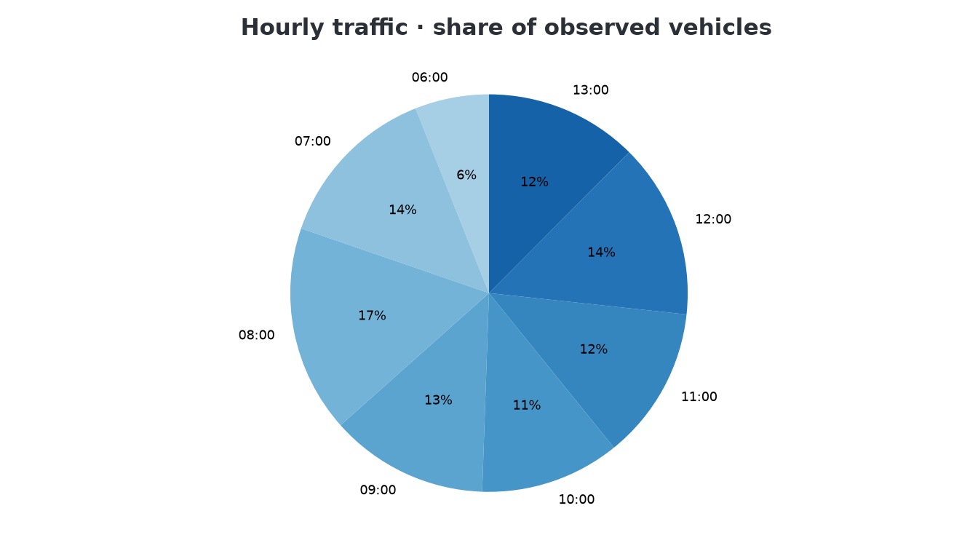
TILE C · Vehicle-class comparison
