Otter Bend Site and Exposure
Use this page with H7-01. It records deployment conditions that may matter to image coverage; it does not diagnose damage.
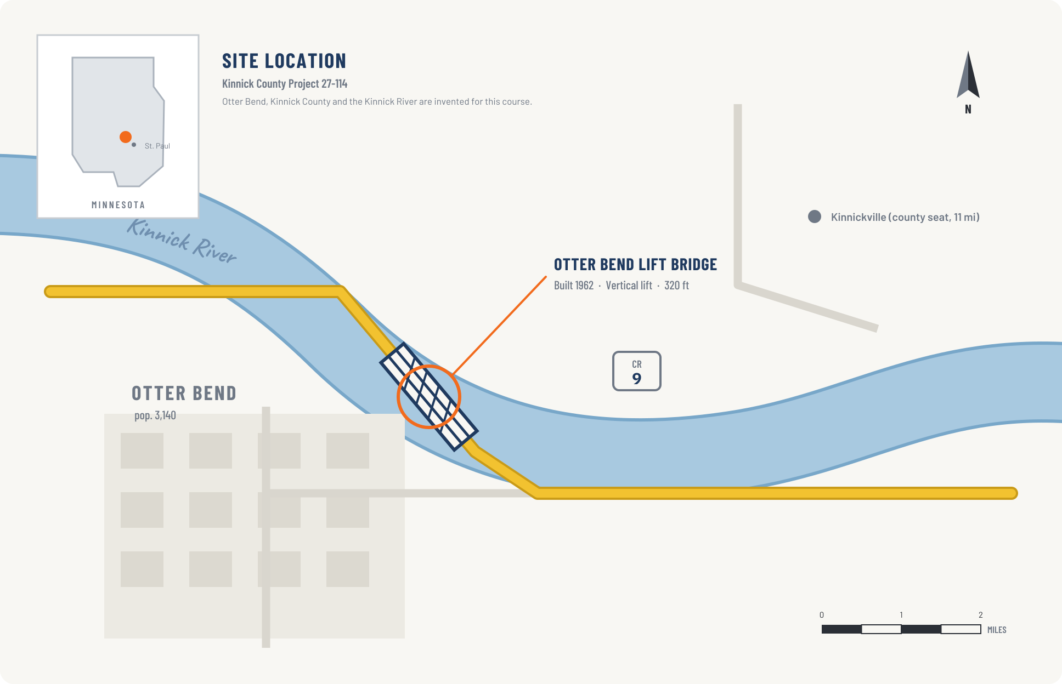
Deployment conditions
Dimension | Otter Bend
Bridge configuration | 1962 vertical-lift bridge with fixed approaches, towers, and a moving lift span
Lift machinery | motors, reduction gearboxes, operating sheaves and bearings, counterweight ropes, span locks, controls
Seasonal exposure | Minnesota freeze and thaw cycles
Road exposure | deicing road salt and wet-dry cycling
Inspection set | 12 simulated images: fixed span, towers, machinery rooms, and moving components
Hunt Compare each condition with H7-01. List lift machinery, freeze–thaw exposure, and road salt wherever the training summary does not establish coverage.

