Otter Bend Inspection Image Set
Scope These 12 simulated field-image records support a training-coverage audit. Do not infer a defect from the schematic image alone; a qualified inspection remains the source for component condition.
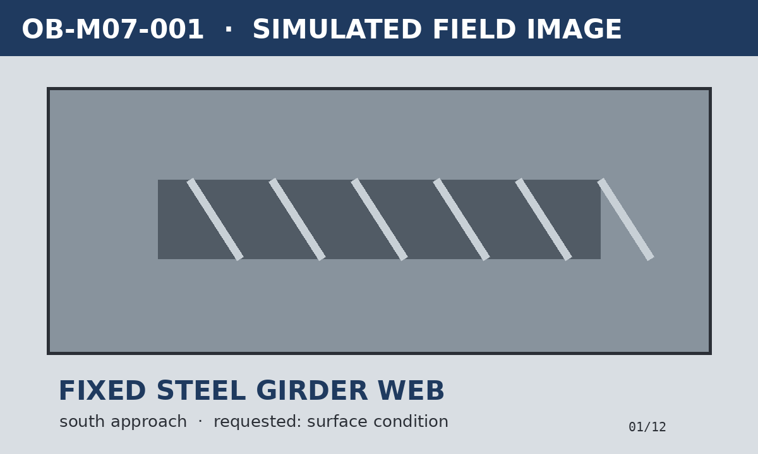
OB-M07-001 fixed span · south approach · FOREMAN 96%
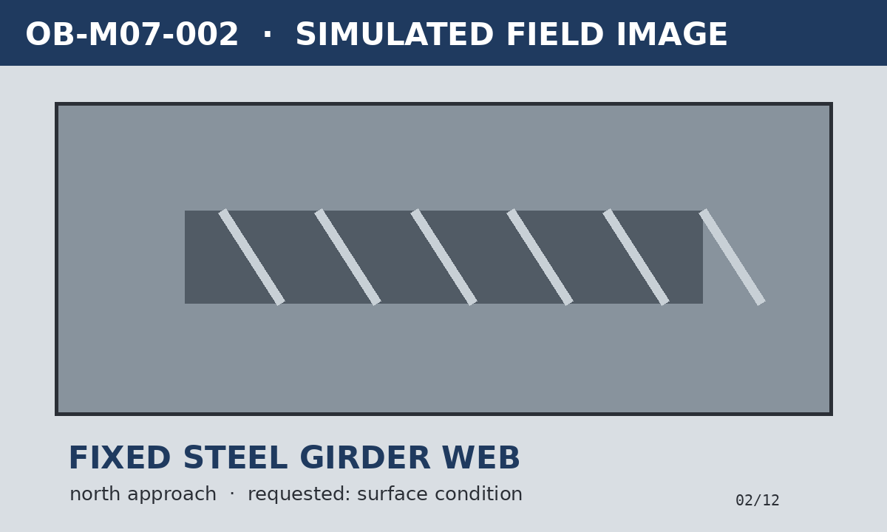
OB-M07-002 fixed span · north approach · FOREMAN 95%

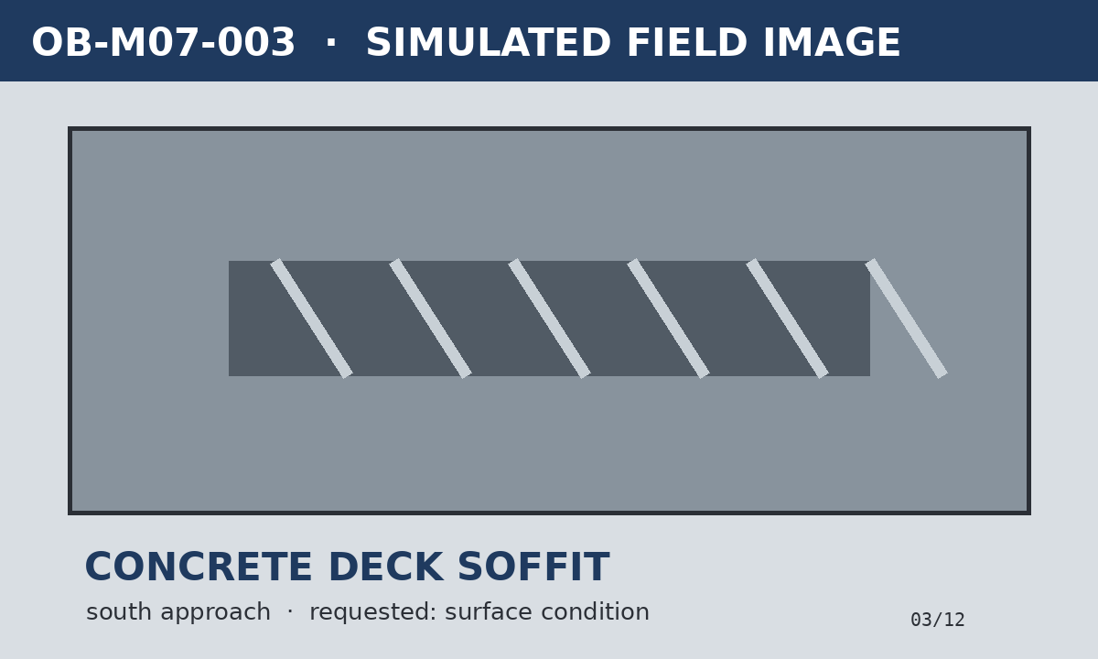
OB-M07-003 fixed span · south approach · FOREMAN 94%
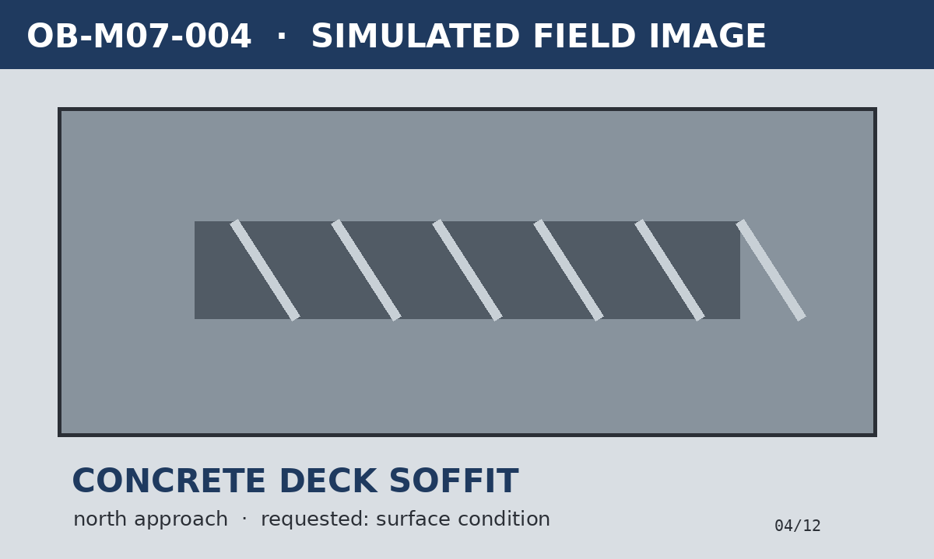
OB-M07-004 fixed span · north approach · FOREMAN 93%

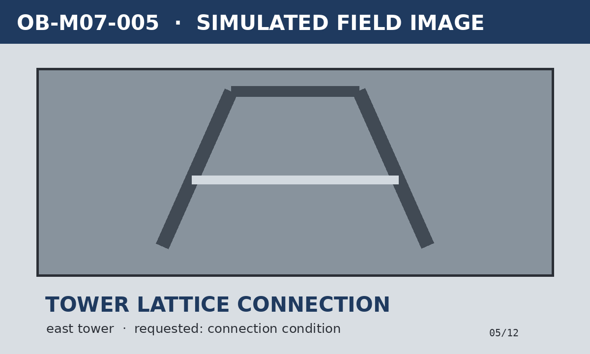
OB-M07-005 lift structure · east tower · FOREMAN 95%
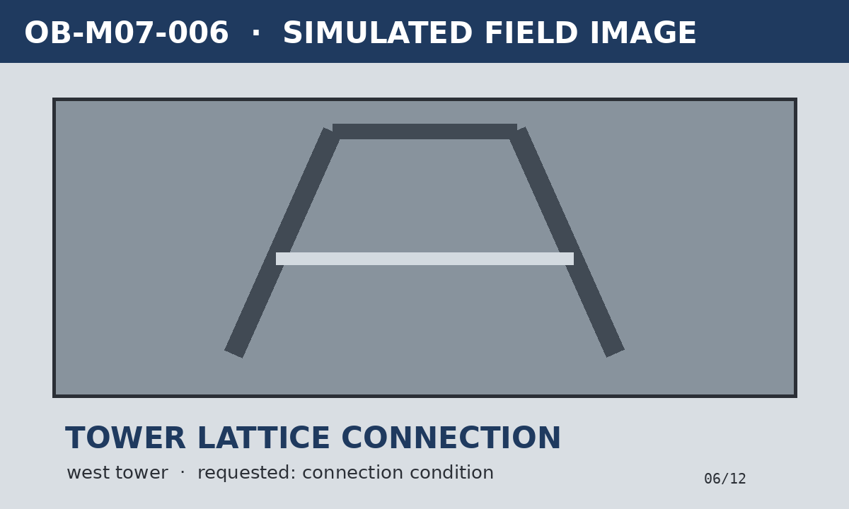
OB-M07-006 lift structure · west tower · FOREMAN 94%

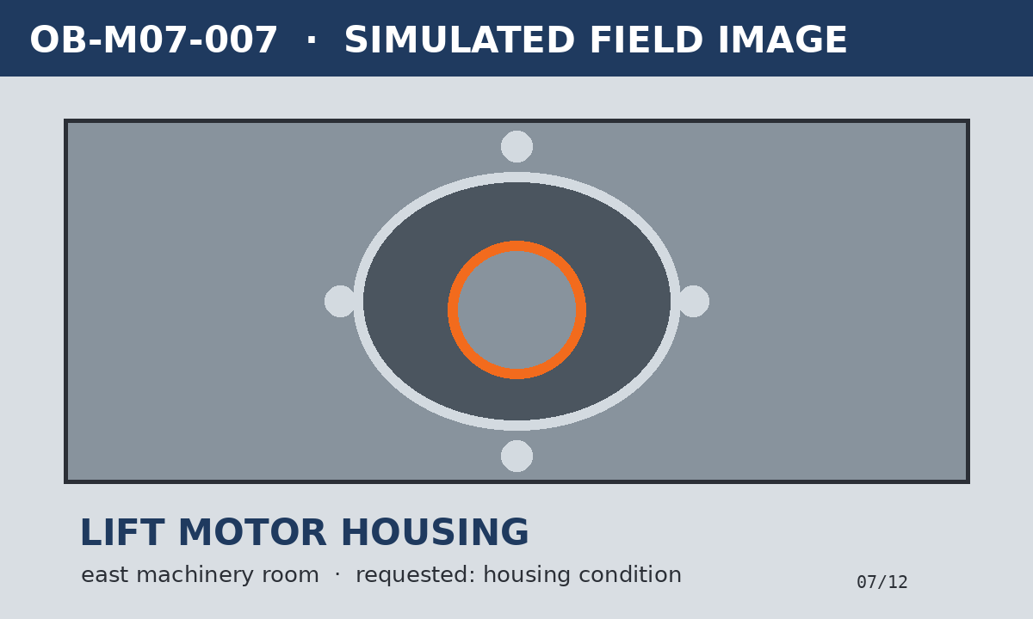
OB-M07-007 moving machinery · east machinery room · FOREMAN 97%
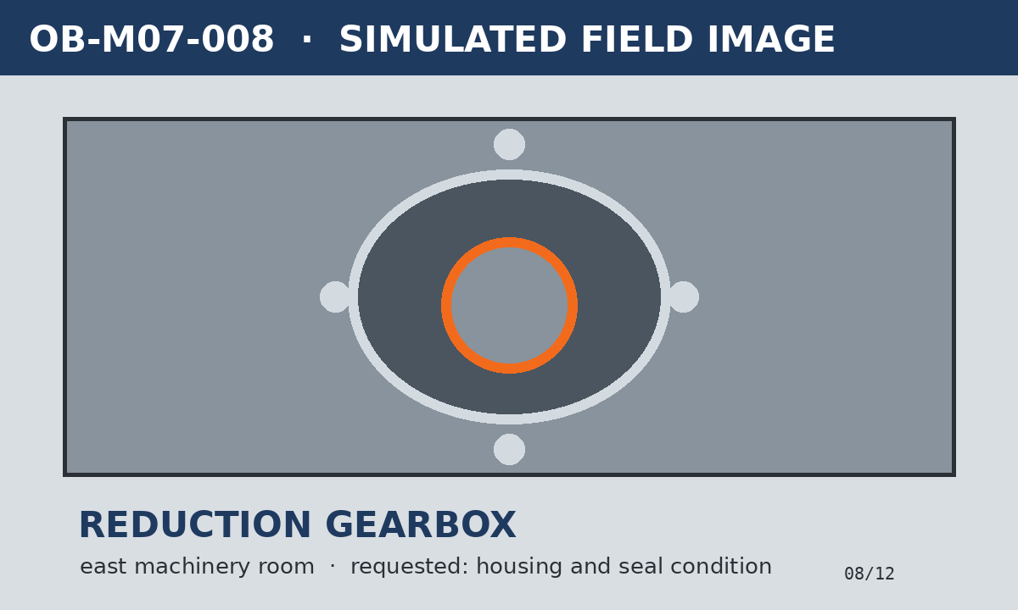
OB-M07-008 moving machinery · east machinery room · FOREMAN 96%

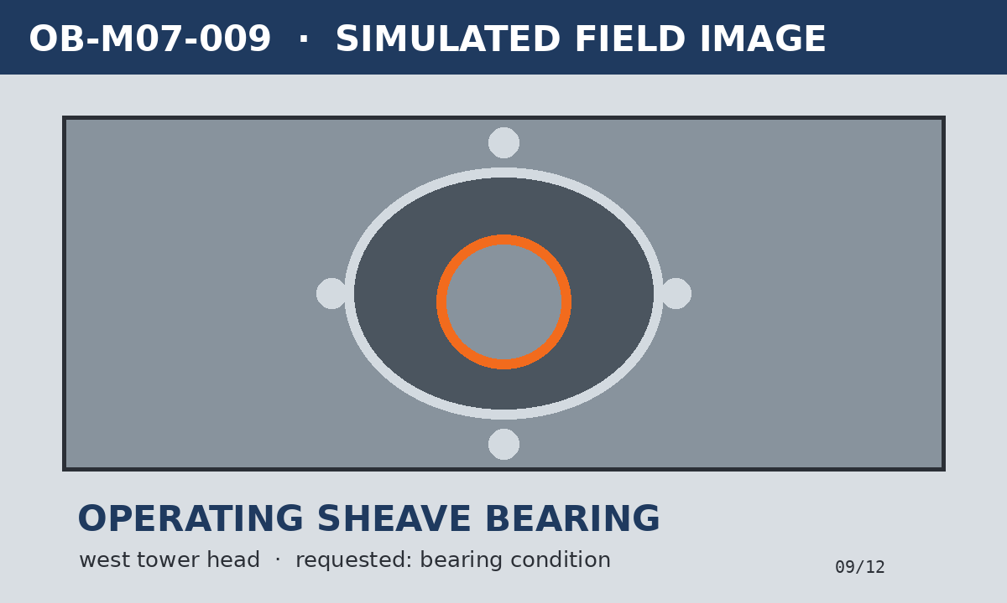
OB-M07-009 moving machinery · west tower head · FOREMAN 95%
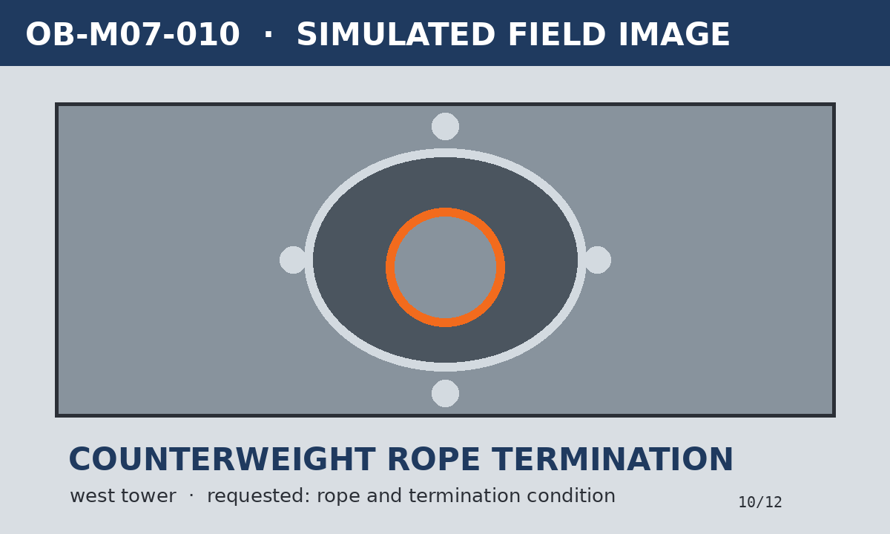
OB-M07-010 moving machinery · west tower · FOREMAN 94%

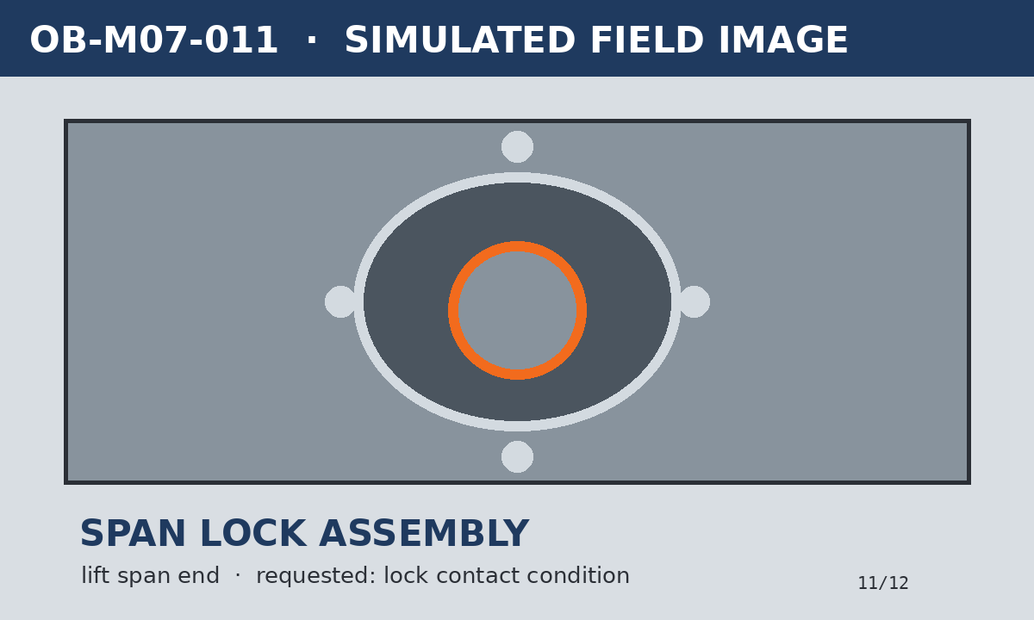
OB-M07-011 moving machinery · lift span end · FOREMAN 96%
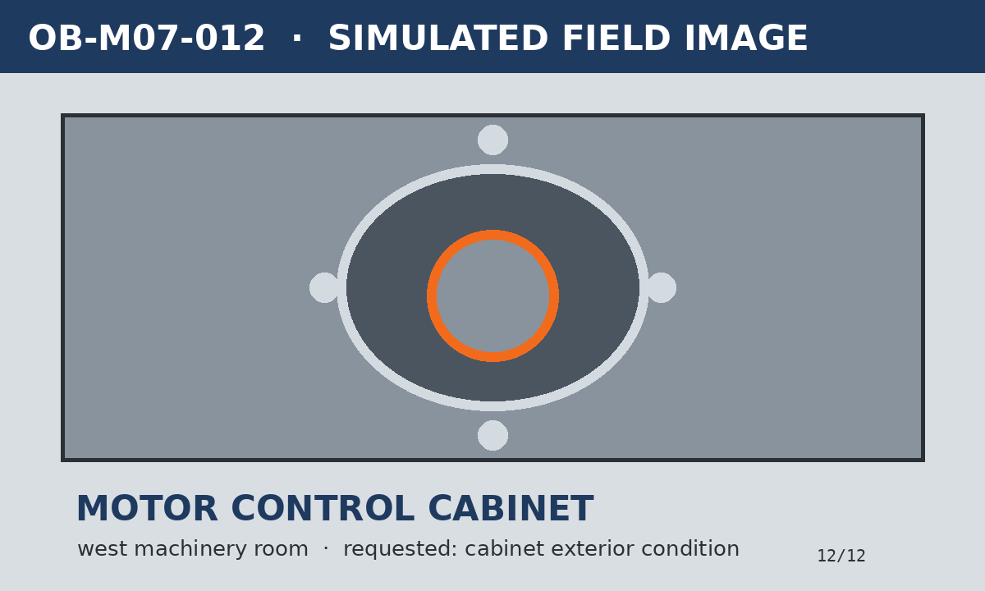
OB-M07-012 moving machinery · west machinery room · FOREMAN 93%

