Answer Key and Teaching Notes
Gated conclusion FOREMAN's 41,872,316-cycle display is arithmetic, not supported resolution. The tests vary by tens of millions of cycles, were recorded to 10,000 cycles, and do not establish component life. Open only after students commit H9-02 and H9-06.
Evidence | Key value | Meaning
Test count | 12 | Small synthetic set; one batch and stress range
Mean tested life | 44,872,500 cycles | Point summary, not a component guarantee
Sample SD | 6,268,750 cycles | Variability overwhelms unit-cycle or decimal reporting
Observed test span | 35,780,000–56,000,000 | Descriptive span, not a formal interval
Source resolution | 10,000 cycles | Digits below this place are visibly unsupported
Screening remainder | 41,872,316 cycles | Arithmetic difference only
Acceptable reporting
MODEL RESPONSE About 42 million cycles is the screening point estimate. The synthetic tests show substantial scatter (SD about 6 million cycles), and the estimate does not quantify component transfer, service loading, environment, or inspection uncertainty; do not treat it as a guaranteed remaining life.
A student may round differently if the retained scale is justified. Do not require a confidence interval; that method begins in M10. The observed min/max is descriptive, not a prediction interval.
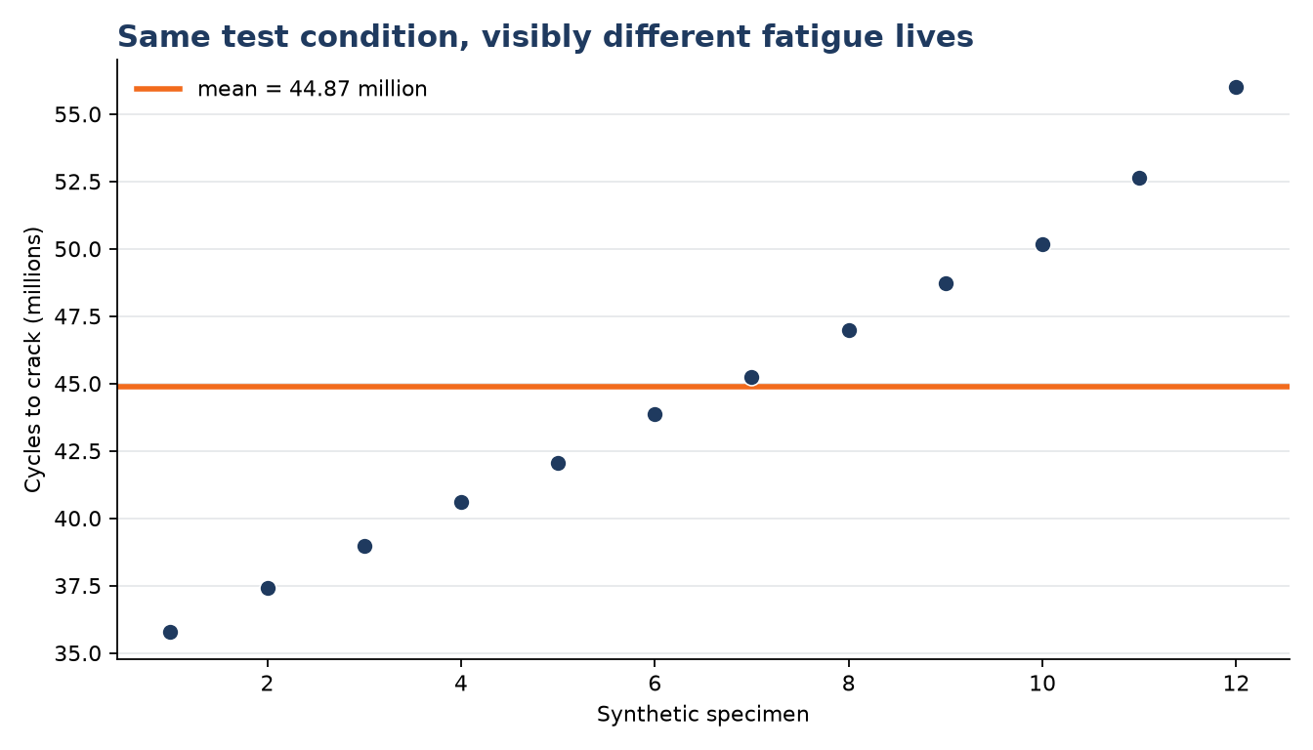
Sampling demonstrator
- Twelve random n = 8 means range from 4,607.5 to 5,107.5 psi.
- Different samples vary even when selection is random and the population is fixed.
- The simulated 200-row population makes that variability visible; it is not Otter Bend evidence.
- The 24 actual simulation cores are a convenience sample: every drill_zone is shoulder.
- Random-sampling language cannot repair a sampling frame that excludes lane and center regions.
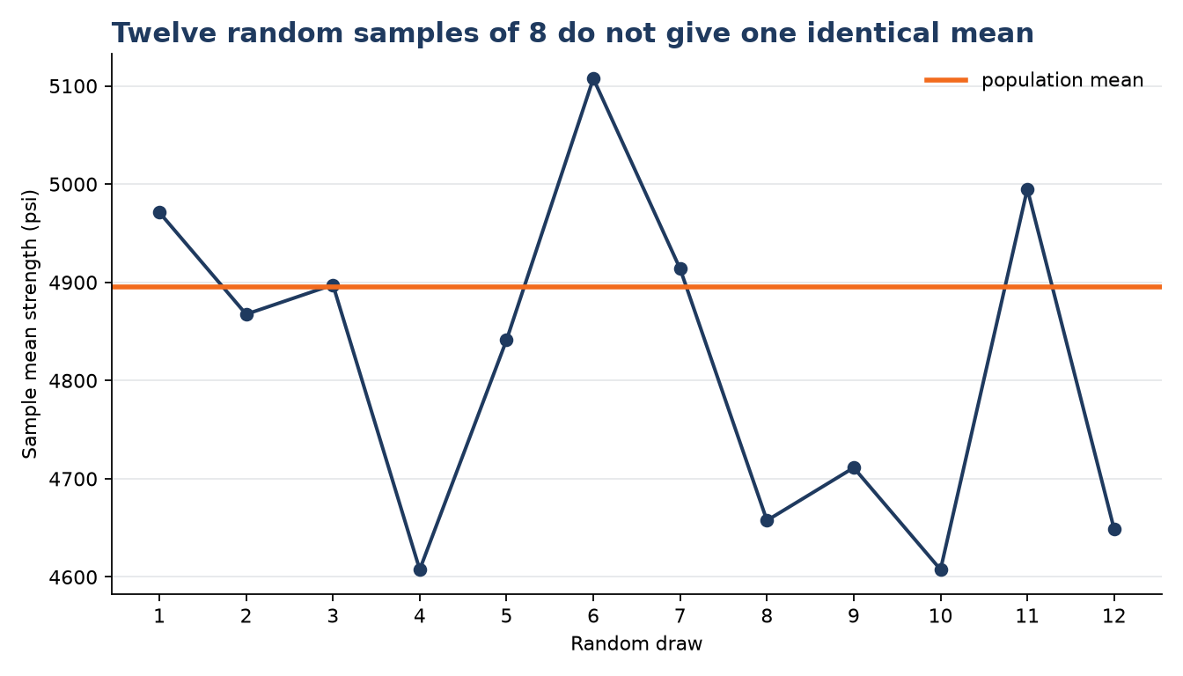
Model Note v2
CLAIM / CHECK / RESULT CLAIM — FOREMAN reports 41,872,316 cycles remaining with high confidence. CHECK — I traced the result to 12 tests recorded to 10,000 cycles and found a sample SD of about 6.3 million cycles, plus unquantified transfer assumptions. RESULT — I would report about 42 million cycles only as a screening point estimate, keep the uncertainty and limitations visible, and obtain qualified review.
Teaching boundaries
- Correct subtraction does not justify the display precision or the component-life claim.
- Do not turn significant figures into a mechanical decimal-place rule; connect rounding to evidence.
- Do not introduce formal standard error, t multipliers, confidence intervals, or p-values before M10.
- Do not imply the 200-row demonstrator reveals the true Otter Bend deck population.
- Use only the Cloud-approved M09 SAY in the notes and run-of-day; keep the M10 toolkit out of the close.

