Deck Load-Test Comparison — Final
FINAL FINDING Mean strain under the reference test truck increased 6 percent from 2019 to 2027. The change is statistically significant (p = 0.04), so there is a 96 percent chance the deck has deteriorated. Deterioration is confirmed.
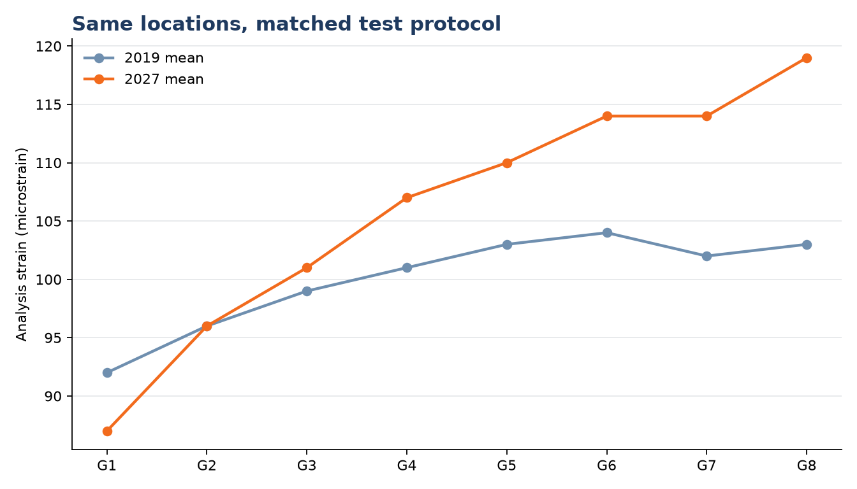
Reported basis
Comparison | 2019 mean | 2027 mean | Change | Disposition
8 paired locations | 100.0 µε | 106.0 µε | +6.0% | Confirmed deterioration
Recommendation
- Enter “deterioration confirmed” in the interim report.
- Treat p = 0.04 as 96% confidence that the deterioration claim is true.
- Do not distinguish statistical significance from engineering magnitude.
MODEL LIMIT FOREMAN gives no interval, does not show the confidence-level sensitivity, and does not separate repeatability noise, process controls, and the estimated between-year change.

