Answer Key and Teaching Notes
Gated conclusion The matched-location data support a small positive mean change at 95% confidence, but the 99% interval includes zero. The defensible claim is “probably a small real change,” not confirmed deterioration or a 96% probability that deterioration occurred.
Coupon warm-up
n | Mean | SD | SE | t* (95%, df 5) | 95% CI
6 | 49.50 ksi | 1.22 | 0.50 | 2.571 | [48.22, 50.78] ksi
Paired deck comparison
Level | Mean change | SD | SE | t* | Interval | Zero?
95% | 6.00 µε | 6.82 | 2.41 | 2.365 | [0.29, 11.71] µε | No
99% | 6.00 µε | 6.82 | 2.41 | 3.499 | [-2.44, 14.44] µε | Yes
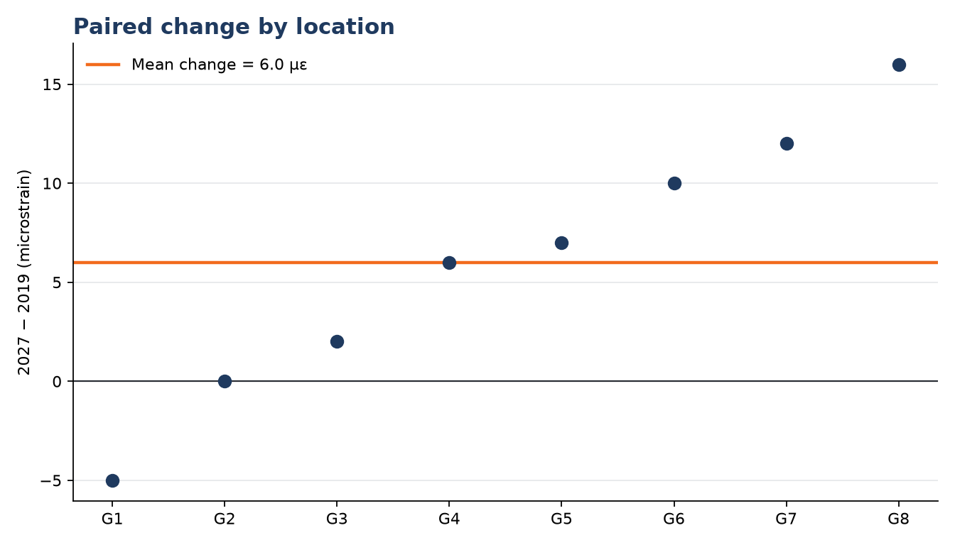
Signal versus noise
- Same-location pairing removes much of the stable location-to-location baseline variation.
- Three passes show repeatability noise near one microstrain—smaller than the six-microstrain mean change.
- Matched truck load, lane, speed, and recorded temperature correction reduce process explanations.
- The eight paired changes still vary widely; standard error and the interval carry that uncertainty.
- A positive average strain change is evidence of changed response, not by itself a diagnosed damage mechanism.
Model Note v2
CLAIM / CHECK / RESULT CLAIM — FOREMAN says a 6% increase and p = 0.04 confirm deck deterioration. CHECK — I calculated the interval on eight same-location changes and compared the change with repeatability and matched process controls. RESULT — mean strain increased 6.0 µε; the 95% CI is [0.29, 11.71] µε, while the 99% CI is [-2.44, 14.44] µε. The evidence supports probably a small real change, not confirmed deterioration.
Teaching boundaries
- Keep the reveal closed until students commit H10-03.
- Do not convert a p-value into the probability that the claim is true.
- Do not equate statistical significance with engineering importance or a damage diagnosis.
- Do not introduce any Exam 1 scenario details.
- All facilitator SAY remains placeholder text until the separate Oli Cloud PASS arrives.

