系统：win10

平台：git

参考：

<http://www.jianshu.com/p/8f843034c7ec>

# 装GIT

<https://git-for-windows.github.io/>

# 装GitHub

<https://desktop.github.com/>

下了半天都下不下来

最后找到

<https://www.zhihu.com/question/23110947>

装离线安装包

# 新建一个index.html

<https://pages.github.com/>

怎么登都登不上去

后来用了VPN就好了。

Git学习教程：

<http://www.liaoxuefeng.com/wiki/0013739516305929606dd18361248578c67b8067c8c017b000>

# 下载ruby

<http://rubyinstaller.org/downloads/>

下了个2.3.1 有病毒被windows defender删了

2.2.5成功

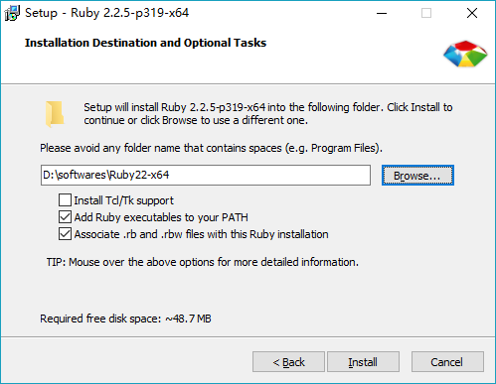

Td tk开发有界面的程序

安装完成后输入ruby –v



表示安装成功

# Bundle Jekyll

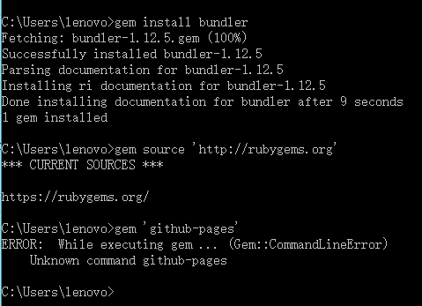

换了VPN也不行

尝试用淘宝镜像

<https://ruby.taobao.org/>



还是不行 taobao gems停止维护

说明：

<http://www.oschina.net/news/71749/taobao-gems-ruby-china>

官网：

<https://gems.ruby-china.org/>

rubygems教程：

<http://guides.rubygems.org/>

gem sources –add <https://gems.ruby-china.org>还是有错误，把https换成http就好了

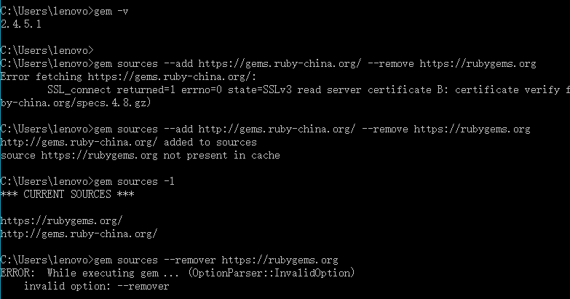

但是查看源的时候，还是有<https://rubygems.org>

按照<http://www.jianshu.com/p/8f843034c7ec>

说的第二步安装jekyll未成功

直接gem install Jekyll



Jekyll new d:/website

D:

Cd website

Jekyll s

打开浏览器：<http://localhost:4000> 但是没反应

Jekyll官网教程：

<http://jekyll.bootcss.com/docs/home/>

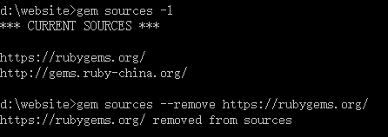

Gem sources应该只有一个，在remove的时候最后要加上/

在浏览器中还是打开不了

发现

下载DevKit

<http://rubyinstaller.org/add-ons/devkit/>

解压安装

Gem updata –system

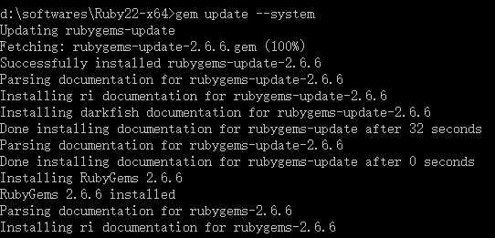

Gem install Jekyll

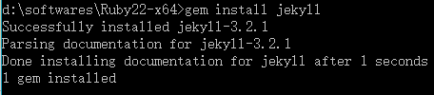

然后创建网站、再运行还是不行

错了错了

应该先建好文件夹 比如d:/website

然后从命令符进入d:/website

再jekyll new myweb

# 换个教程

<http://playingfingers.com/2016/03/26/build-a-blog/>

# 配置git SSH

$ git config --**global** user.name "{username}" *// 用你的用户名替换{username}*

$ git config --**global** user.email "{name@site.com}" *//* [*用你的邮箱替换{name@site.com}*](mailto:用你的邮箱替换%7bname@site.com%7d)

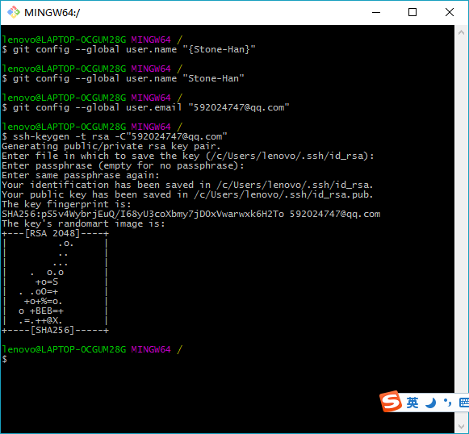

# Fork一个网站

Fork完还是不能访问，今天的VPN用完了

# Clone到本地

新建工作环境 d:/gitworkspace

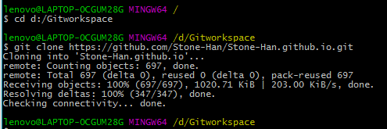

# 修改并发出

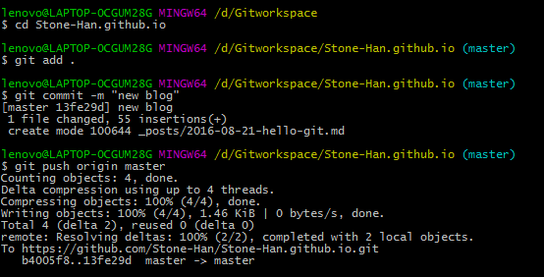

# 安装ruby

# 安装rubygems（过）

# 安装jekyll（过）

# 安装jekyll-paginate

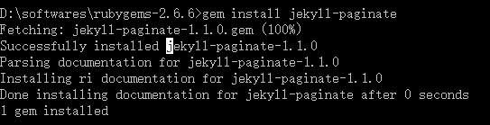

# 进入文件夹



# 开启服务

还是不行



# Bundler

在命令行里敲了个bundler

然后莫名其妙地出现了：

Fetching gem metadata from https://rubygems.org/

Fetching version metadata from https://rubygems.org/

Fetching dependency metadata from https://rubygems.org/

Resolving dependencies...

Installing RedCloth 4.2.9 with native extensions

Gem::InstallError: The 'RedCloth' native gem requires installed build tools.

Please update your PATH to include build tools or download the DevKit

from 'http://rubyinstaller.org/downloads' and follow the instructions

at 'http://github.com/oneclick/rubyinstaller/wiki/Development-Kit'

Installing fast-stemmer 1.0.2 with native extensions

Gem::InstallError: The 'fast-stemmer' native gem requires installed build tools.

Please update your PATH to include build tools or download the DevKit

from 'http://rubyinstaller.org/downloads' and follow the instructions

at 'http://github.com/oneclick/rubyinstaller/wiki/Development-Kit'

Installing directory_watcher 1.5.1

Installing kramdown 0.13.8

Installing liquid 2.4.1

Installing syntax 1.0.0

Installing posix-spawn 0.3.6 with native extensions

Gem::InstallError: The 'posix-spawn' native gem requires installed build tools.

Please update your PATH to include build tools or download the DevKit

from 'http://rubyinstaller.org/downloads' and follow the instructions

at 'http://github.com/oneclick/rubyinstaller/wiki/Development-Kit'

Installing yajl-ruby 1.1.0 with native extensions

Gem::InstallError: The 'yajl-ruby' native gem requires installed build tools.

Please update your PATH to include build tools or download the DevKit

from 'http://rubyinstaller.org/downloads' and follow the instructions

at 'http://github.com/oneclick/rubyinstaller/wiki/Development-Kit'

Installing rdiscount 1.6.8 with native extensions

Gem::InstallError: The 'rdiscount' native gem requires installed build tools.

Please update your PATH to include build tools or download the DevKit

from 'http://rubyinstaller.org/downloads' and follow the instructions

at 'http://github.com/oneclick/rubyinstaller/wiki/Development-Kit'

可能是DevKit没配置好

# 配置devkit

<http://jingyan.baidu.com/article/6b182309b59ba1ba58e159a0.html>

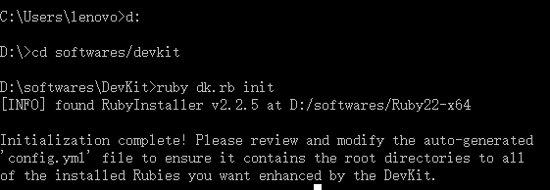

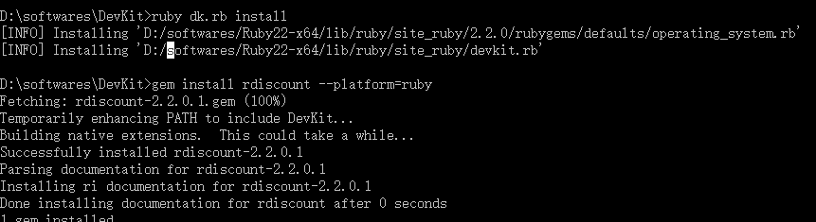

配置好了 还是不行

要 Redcloth

在C盘目录下装gem install redcloth没成功

到D盘下成功

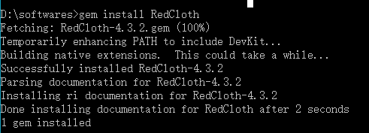

Gem list查看已经装上

但是jekyll s还是不行

决定重启一下。