1. dilivery rate: 0.9989174485094099

2. longest consecutive string of successful pings: 7302

3. longest burst of losses: 18

4. （1） Given that echo request #N received a reply, what is the probability that echo

request #(N+1) was also successfully replied-to ： 0.9997776975018757

（2）Given that echo request #N did not receive a reply, what is the probability that

echo request #(N+1) was successfully replied-to： 0.8205128205128205

（3）The packet loss events are highly correlated. If the previous reply is received, the next reply is highly likely received as well (greater than the overal delivery rate); while if the previous reply is loss, the next reply is also very likely loss.

5. minRTT: 228 ms

6. maxRTT: 435 ms

7.

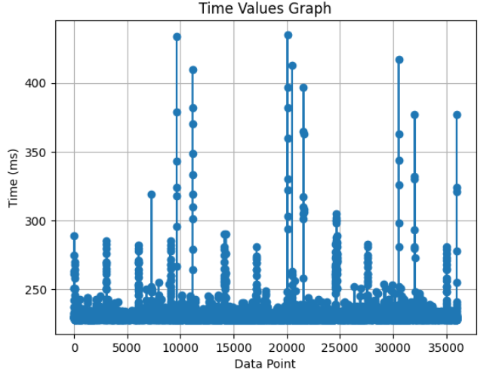

8. Most RTTs are concentrating at a specific interval around 230ms.

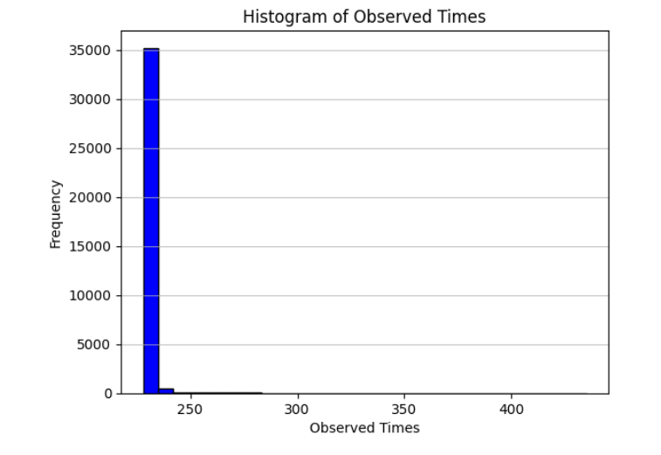

9.

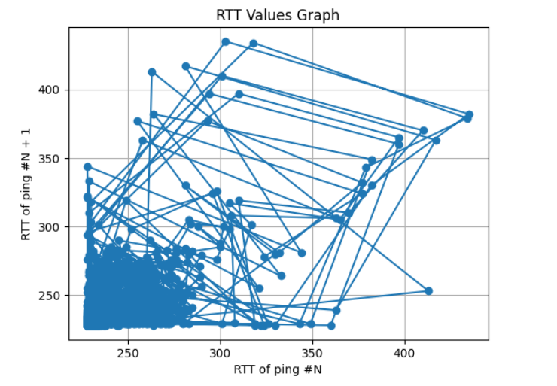

“RTT of ping #N” and “RTT of ping #N+1” is not highly correlated. It could be high RTT of ping #N while low RTT of next ping #N + 1, and vice versa.

10.

The packet loss events are highly correlated. If the previous reply is received, the next reply is highly likely received as well (greater than the overall delivery rate); while if the previous reply is loss, the next reply is also very likely loss.

Most RTTs are concentrating at a specific interval around 230ms.

“RTT of ping #N” and “RTT of ping #N+1” is not highly correlated. It could be high RTT of ping #N while low RTT of next ping #N + 1, and vice versa.