PiPicoFX Stomp Manual

Overview
Analog Gain for Mic and Intrument
Quickdials (only functional in Live mode)
Output clipping
Input clipping
Screen

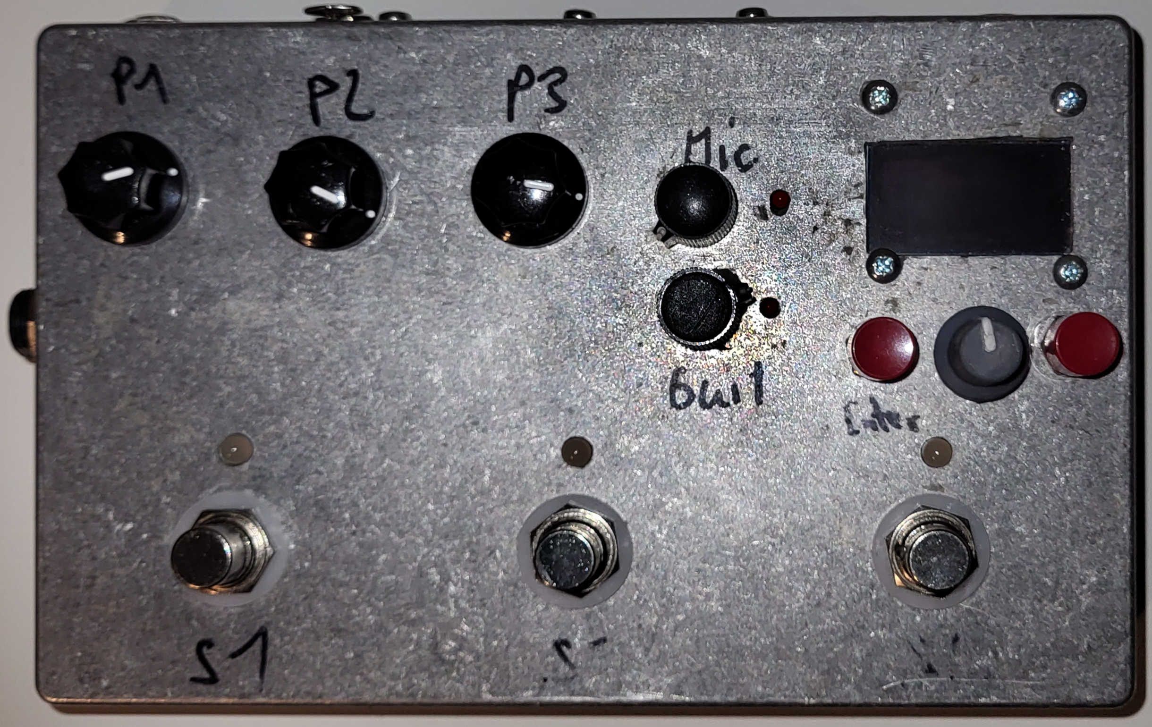
Power Connector
(12V~)
Stompswitches and LED’s
Enter
Exit
Rotary Dial

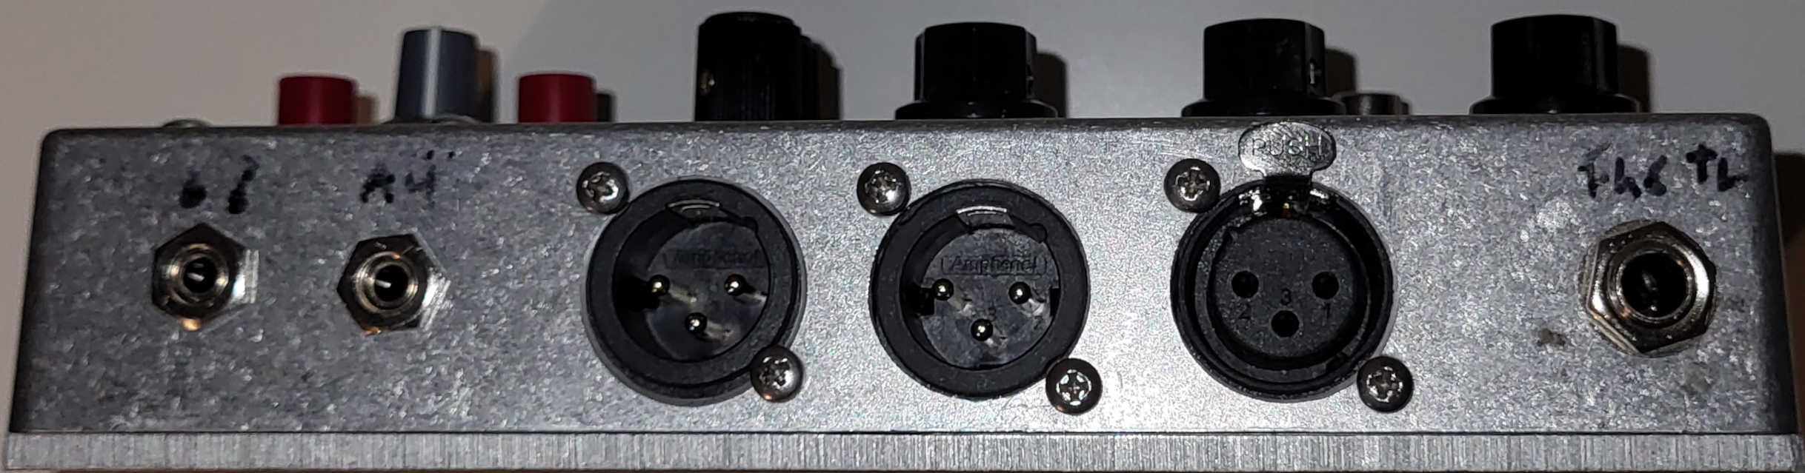

Phones Aux In Out R Out L Mic In (symm) Hi-Z In (unbal)

Quickstart (Live-Mode)

* Connect one or both XLR Outs to a Speaker or mixing desk
* Connect a microphone or instrument to an input
* Connect a 12 AC power supply to the barrel Jack

Use the Rotary Dial to change effect and the Quickdials to edit the first three parameters listed in that program.
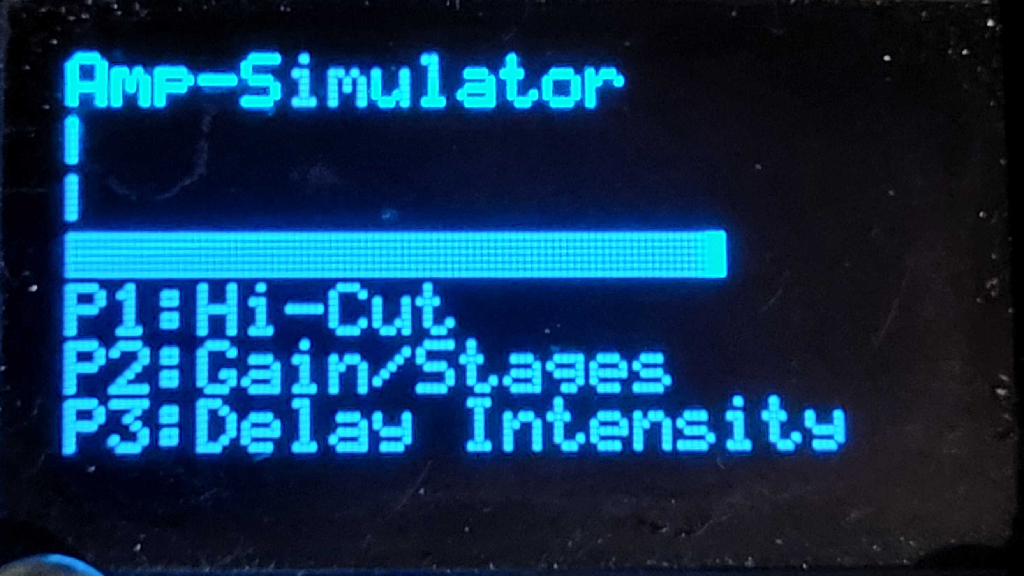
Effect name
Input Level
Output Level
CPU Load
Parameter assigned to P1
Parameter assigned to P2
Parameter assigned to P3

Edit more parameters

Press “Enter” to switch to the Parameter Edit Page, the rotary dial is used to browse through the parameters. Note that the first three Parameters are exclusively accessible through the Quickdials.

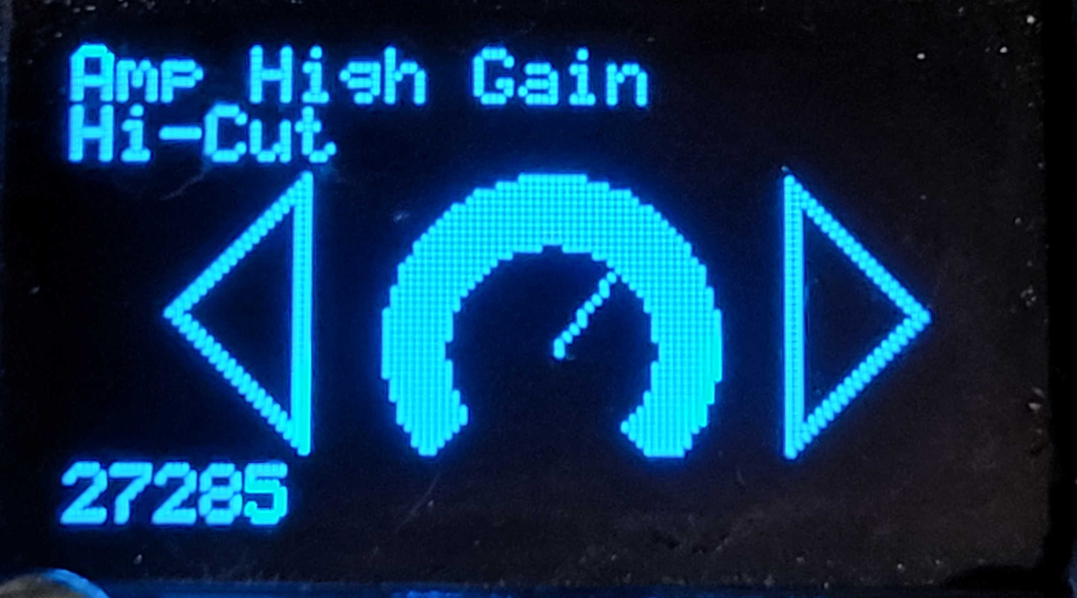
Effect Name
Parameter Name

“analog” display of current val

digital display of current val

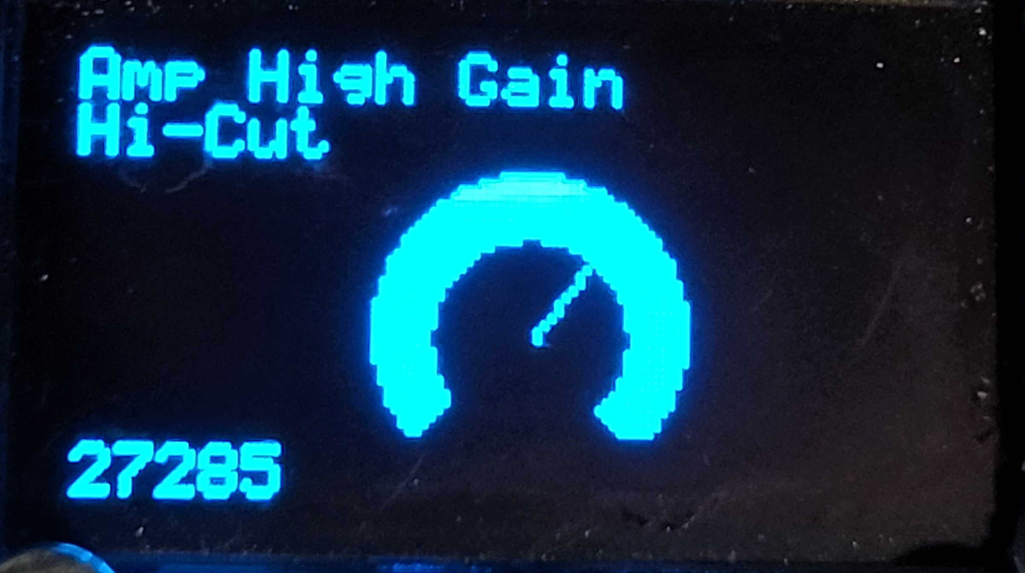
To edit a certain parameter via rotary dial, press “Enter” again. The parameter value can the be changed using the rotary dial.

Presets

Press any of the stomp switches to enter preset mode. Presets are organized in banks of of three Presets, each one being accessible via the respective Stomp Switch.
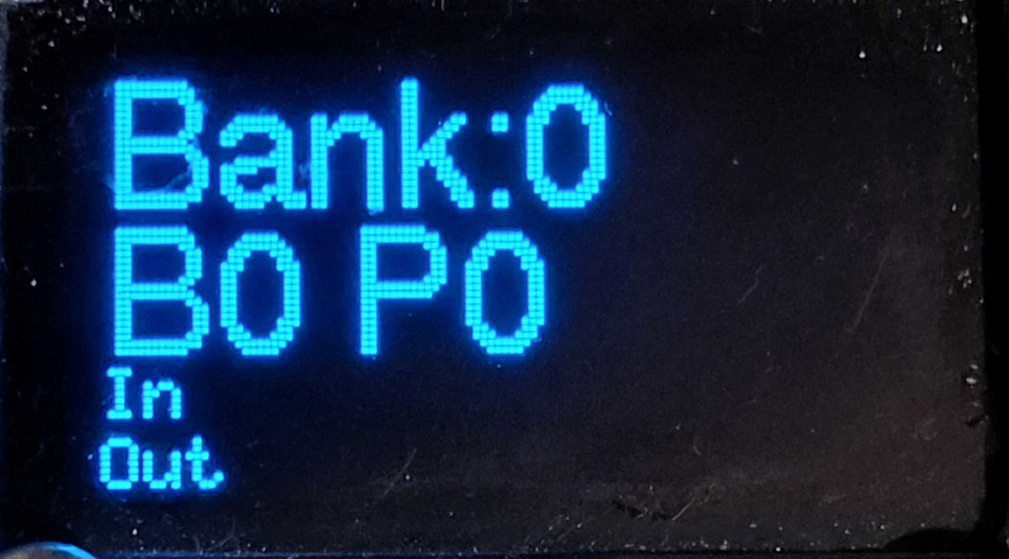

Bank Number

Name of the Preset

Input and Output
Level Indicators

A Preset consists of a Effect / Program with a fixed set of parameters.

Changing Presets: Tap the Stomp switch below an unlit LED to change to this Preset.

Changing Banks: Tap the left and middle Footswitch to lower the Bank, middle and right to
increase the bank. Note that changing bank does not change the preset
automatically

Edit a Preset
Press enter, navigate to the pen overlay (see below), and press Enter again
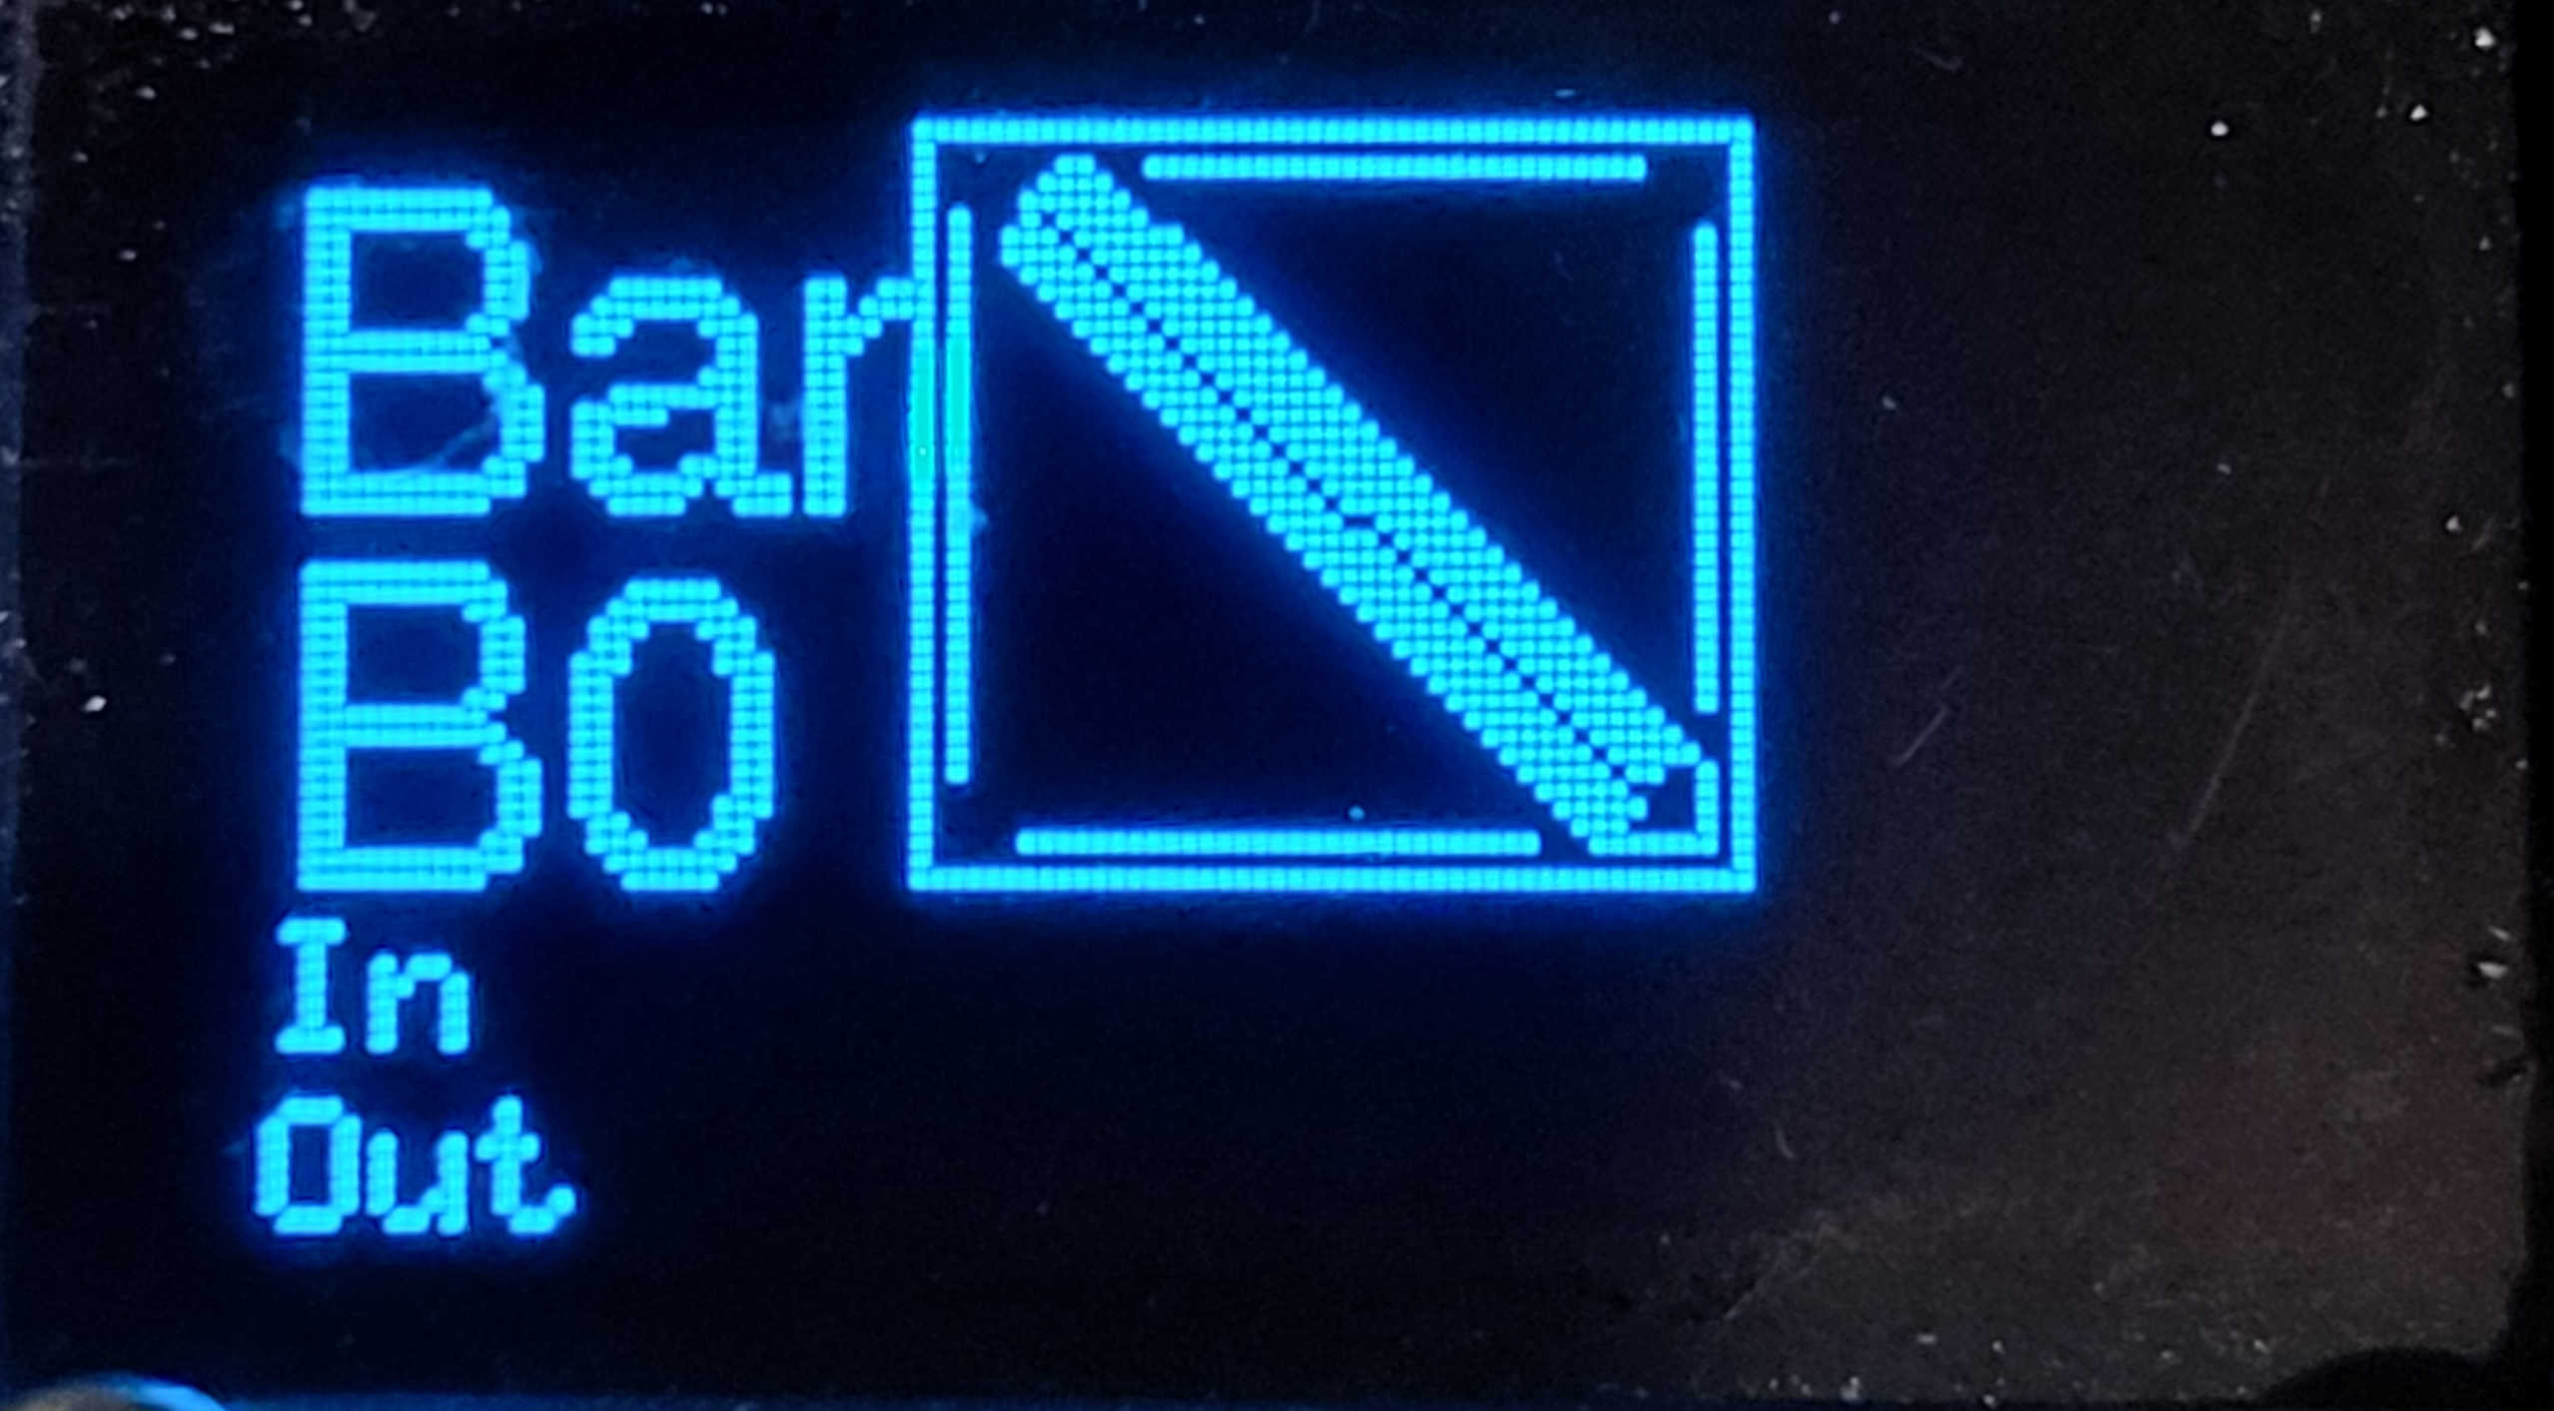

This activates the editing mode, currently indicated by the Preset Name in the top line.
Within the preset Editing Mode the following options can be chosen with the rotary dial
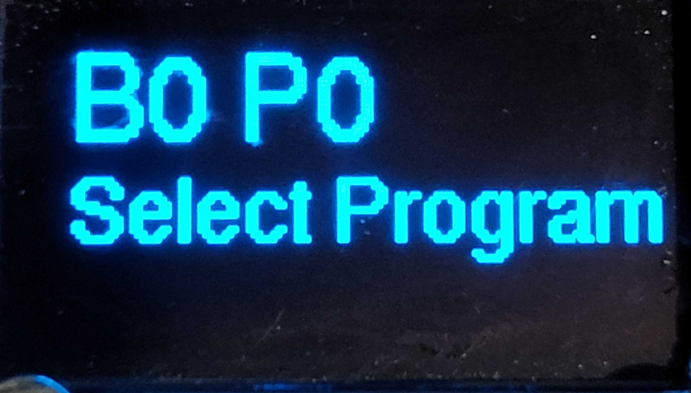
a) Select the effect / program, confirming with “Enter”
Changes to the Program selection mode. This is the
same as live mode except that the quickdials are
functionless.
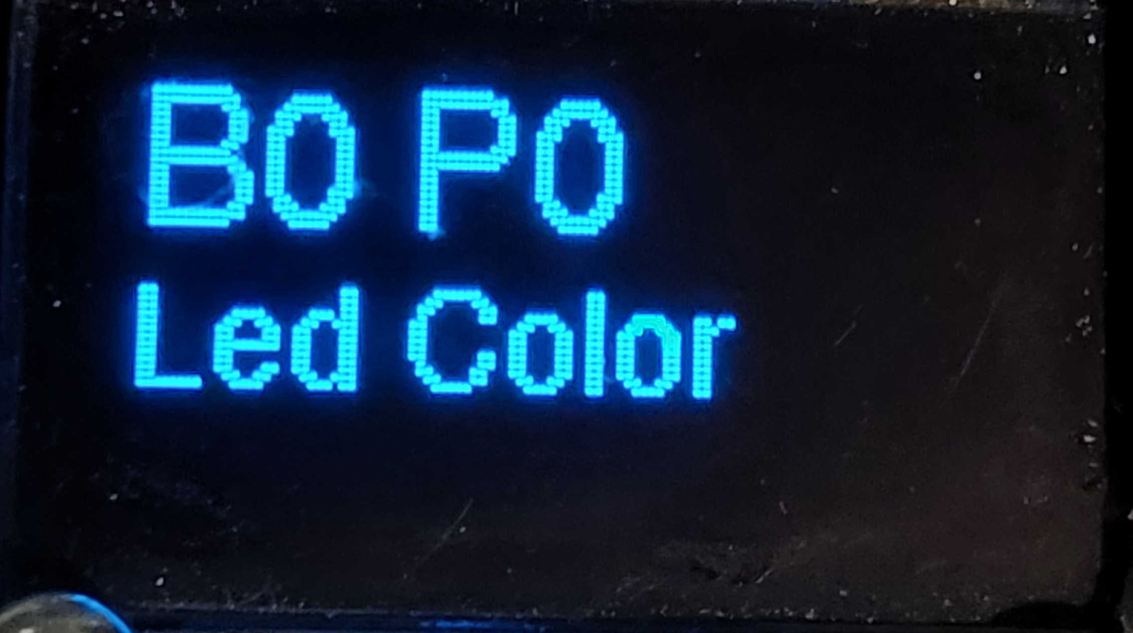

b) Change the LED Color, pressing Enter toggles
through the 3 available colors

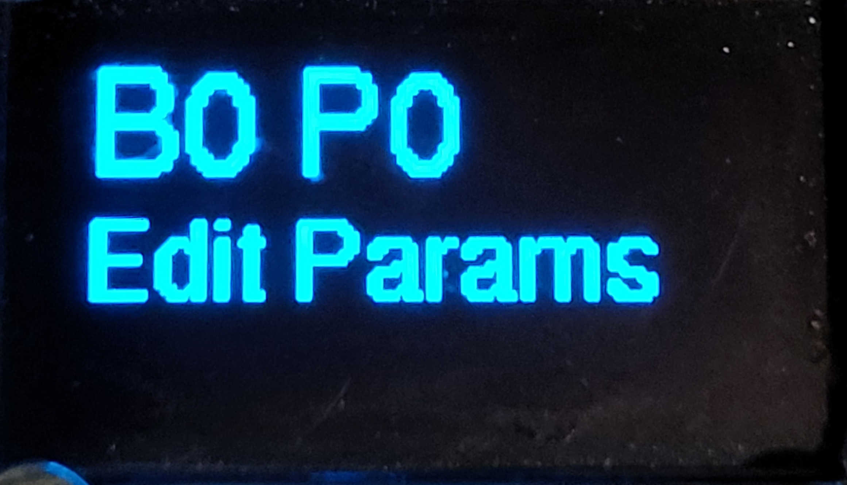
c) Edit the Parameters of the given program,
confirming with “Enter” goes in the same mode
as parameter editing in live mode, except that
all parameters can be edited.
From Edit Mode, pressing Exit allows to return to Preset Mode, either by saving the edited preset or discarding and reverting the changes. This can be chosen by the rotary dial. Another tap on “Exit” confirms the choice and returns to the Preset Mode.

Settings

From Preset Mode choose the “mixer” overlay using the rotary dial, confirm with “Enter”.
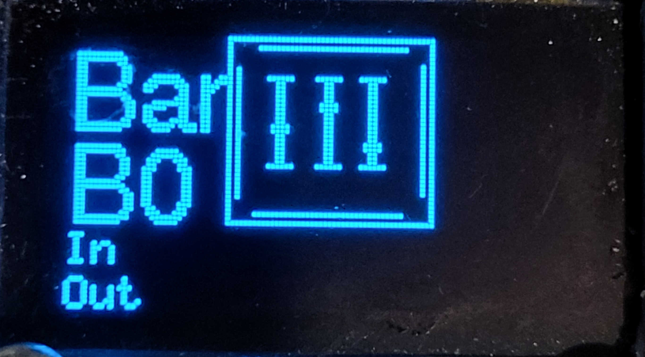

Within the Settings mode, the input can be switched on and off and the output volume can be controlled.
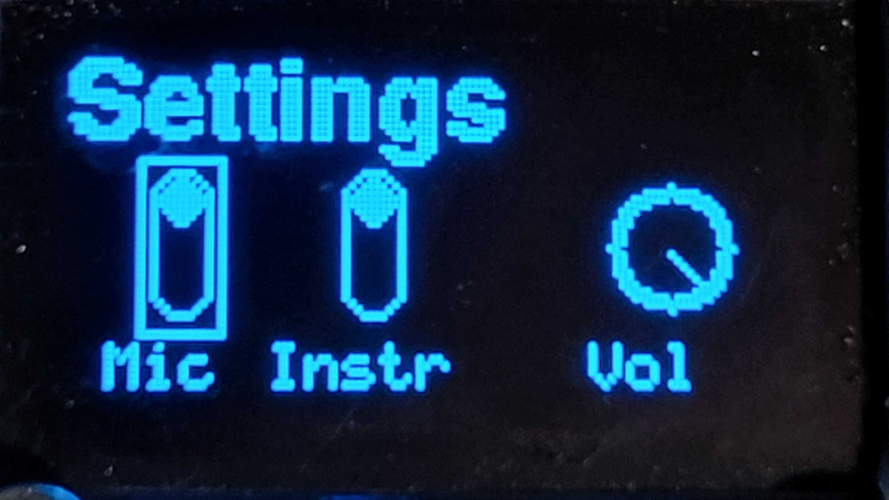

When a thin frame is displayed, the rotary dial chooses the parameter to edit. When a thick frame is displayed the actual change is made using the rotary dial.
One can go from selecting to editing via “Enter” and back using “Exit”.

Firmware Update

From Preset Mode choose the “chip” overlay using the rotary dial, confirm with “Enter”.

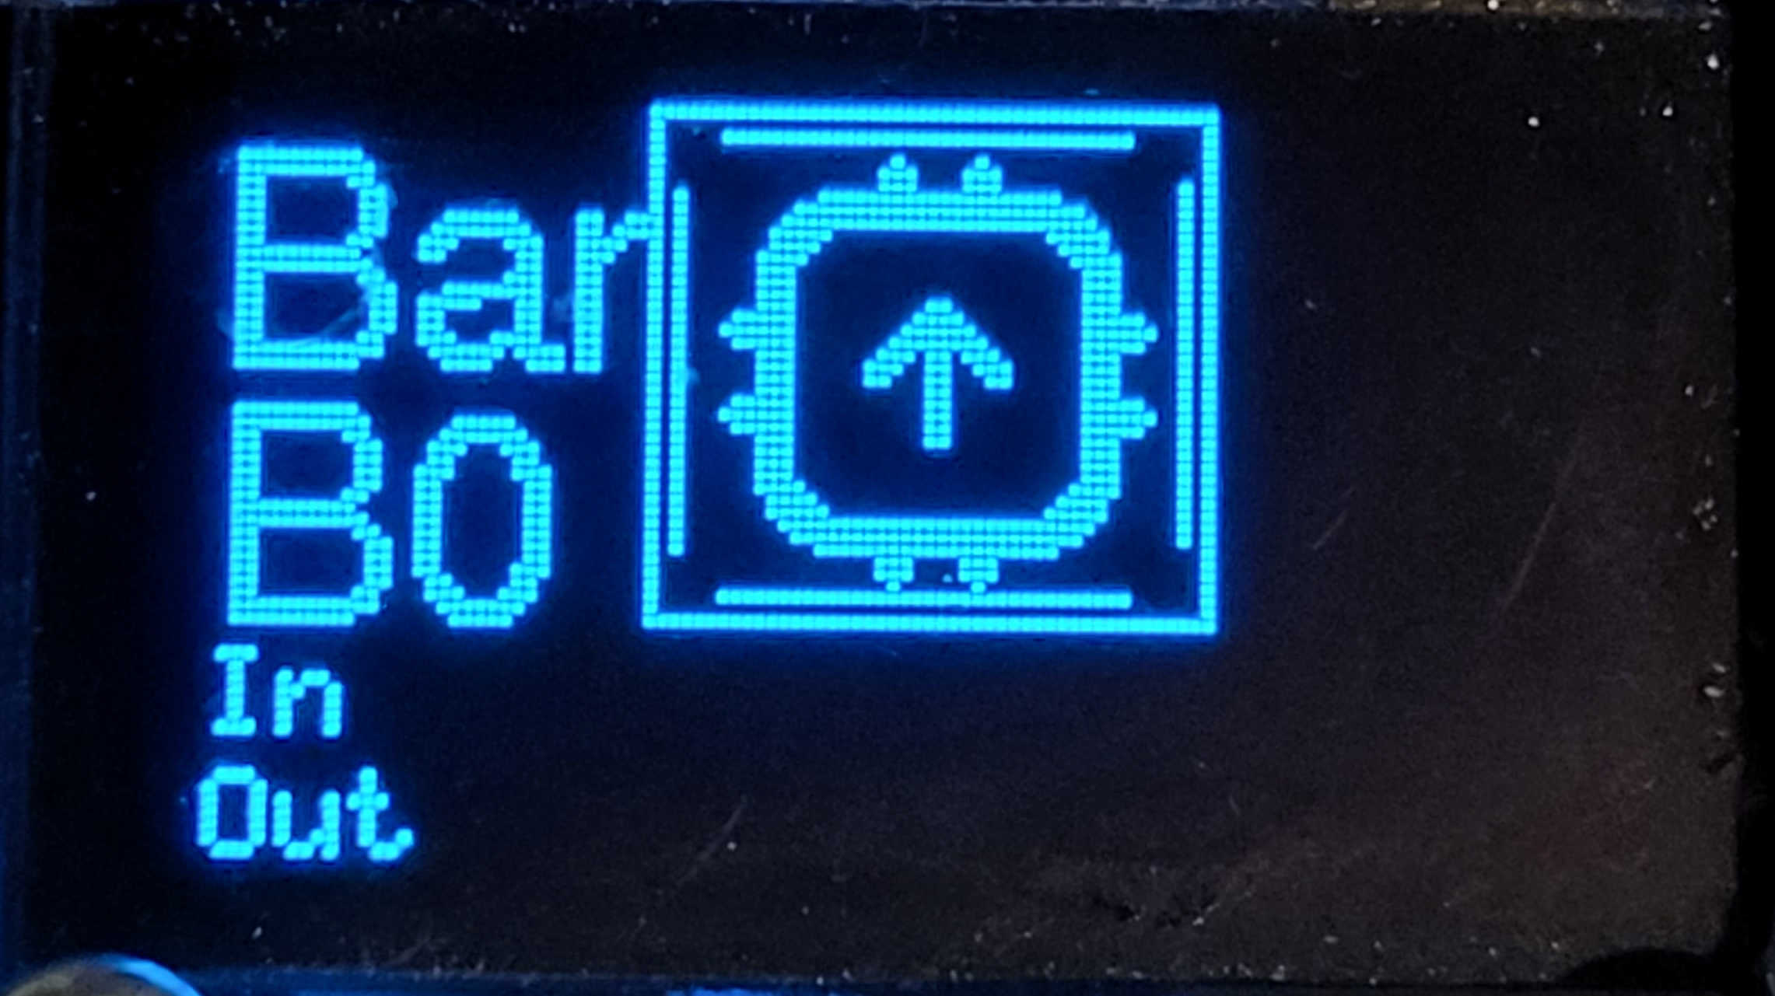
The screen goes off an the output clipping led is constantly lit (while no USB connection is made). This indicates the device is ready to have a new Firmware uploaded.

Connect the micro USB to a computer, then a usb drive named “RPI-RP2” (or similar), drag’n’drop the new firmware onto the drive. Upon Sucess the device restarts..
Technical Specs (known so far..)

* Outputs (symm): 5V max peak-to-peak
* Headphone Output: 200mW into 8Ohms
* Mic Input: differential pair 10kOhm input impedance
* Hi-Z Input: 1 MOhm input impedance
* Aux In: Stereo, 10 kOhm input impedance
* Power Supply: 12V AC, 500mA
* USB: for Firmware upgrade only
* Sampling rate: 48 kHz
* bit depth: 16bit
* Storage Banks: 100

