t=-5:0.001:5;

a=t.*(heaviside(t) - heaviside(t-1));
b=heaviside(t)-heaviside(t-1);
y=conv(a,b);

length_output=length(a)+length(b)-1;
k2=linspace(-5,5,length_output);

figure(1);
clf;
subplot(2,2,1);
xlabel('t');
ylabel('a[t]');
title('a[t]');
plot(t,a)
grid;

subplot (2,2,2);
xlabel('t');
ylabel('b[t]');
title ('b[t]');t=-5:0.001:5;
a=t.*(heaviside(t) - heaviside(t-1));
b=heaviside(t)-heaviside(t-1);
y=conv(a,b);

length_output=length(a)+length(b)-1;
k2=linspace(-5,5,length_output);

figure(1);
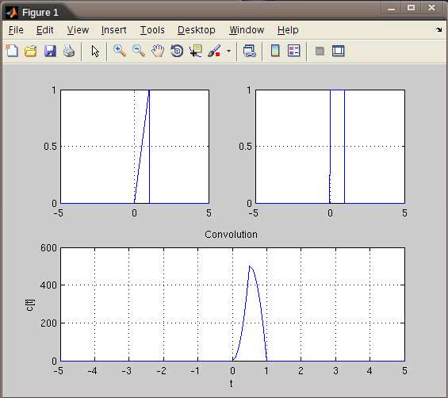
clf;
subplot(2,2,1);
xlabel('t');
ylabel('a[t]');
title('a[t]');
plot(t,a)
grid;

subplot (2,2,2);
xlabel('t');
ylabel('b[t]');
title ('b[t]');
plot(t,b);
grid;

subplot(2,1,2);
plot(k2,y);
grid;
xlabel('t');
plot(t,b);
grid;

subplot(2,1,2);
plot(k2,y);
grid;
xlabel('t');
ylabel('c[t]');
title ('Convolution');
t=-0:0.001:5;
a=heaviside(t) - heaviside(t-1) + heaviside(t-2) - heaviside(t-3) + heaviside(t-4) - heaviside(t-5);
b=exp(-t).*heaviside(t);
y=conv2(a,b);
length_output=length(a)+length(b)-1;
k2=linspace(0,5,length_output);
plot(k2,y);
grid;
