Fast Detection of Tumor Growth for Image Guided Radiotherapy

1- Introduction:
This Project tries to simplify the process of indirectly measuring growth of tumor by extending available techniques in IGRT (Image guided radiotherapy). The project is in collaboration with Stony Brook University Hospital, Radiation Oncology Department

1-1 IGRT Steps
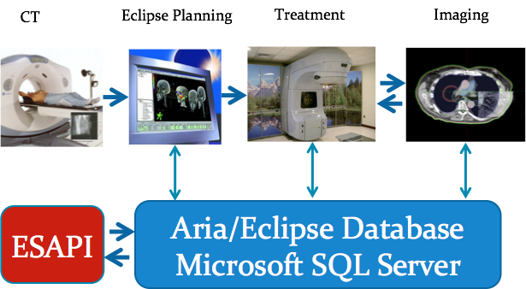
Figure 1: IGRT workflow
CT:
Initially for a patient with a suspected tumor, a CT (computed tomography) scan is taken. The physician marks isocenter or center of tumor. This CT is scan is 3D scan of tumor affected organ. CT machine stores 3D image from different orientations.
Planning:
The next step is to create a “plan” for this tumor. Plan includes information like amount of radiotherapeutic doses to different points on the target. This whole process is done by software Eclipse.

Treatment:
Third step is actual treatment. This step involves getting feeds from plan generated from last step. Radiotherapy dose are applied accordingly to the plan generated in the previous step.

Imaging:
Later body scans are taken by CBCT (Cone Beam computed tomography) devices. These devices again take 3D scans of the body. Again isocenter or center of tumor is marked. The image taken from CBCT is compared to the same from CT device. The difference in images can point to change in shape or size of the tumor and dosage is applied accordingly. Currently physicians have to manually find the difference in size of tumor between CT and CBCT images . According to change in size , dosage is applied for the treatment. CBCT images are taken after every treatment phase and images are compared with CT images to get change in tumor. Treatment and Imaging phase keep on alternating till the treatment is complete. Our project aims to find the change in CT and CBCT (hence the growth of tumor) automatically.

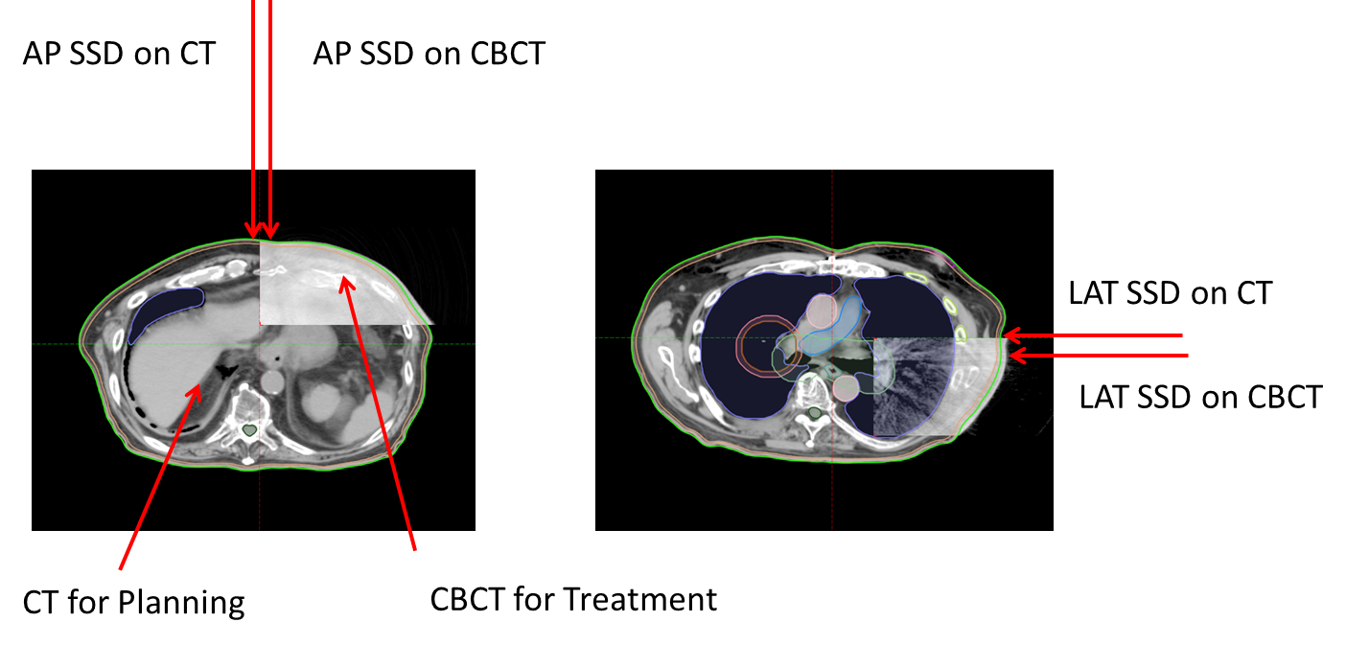
Figure 2: CT vs CBCT

1-2 Difference in current technique and our technique:
Right now physicians have to manually find the difference between two images. They align both images on top of each other such that isocenters are perfectly aligned. Then they measure the distance in millimeters from isocenter to the boundaries of the organ for both CT and CBCT. The difference between isocenter to tumor boundary gives the growth of tumor (as shown in figure 2). This process is tedious and has to repeated for each CBCT image. Doing it manually takes a lot of physicians time. The idea we're working on involves doing it automatically and giving difference in distances as output. We have access to API by which we can separately get both CT and CBCT. We can align both images according to the transformation between two images. (note both images have different size and camera orientations. We can find isocenter of the plan. Using isocenter, we can for both images, find the distance from the isocenter to the boundary of the tumor. We use linear algebra and digital image processing techniques to align two images automatically and then measuring the change in size of image

2- Project constraints:
Currently, Planning and treatment processes are integrated through the Varian Eclipse version 11 software. We have access to a limited set of features through ESAPI (Eclipse Scripting API). Using ESAPI, One can write scripts in C# language and run it through the Eclipse scripting plugin.

2-1 As this environment stores real patient information, based on HIPAA regulations, we were not allowed to copy/move patient’s data out of designated workstations.
Moreover, It took around ⅔ of the project’s total time to even get the initial access to those workstations.

2-2 Varian (Company that created the Eclipse software) does not support beyond the clinical needs of the users. More specifically, there is no commitment from the company side to help through a research project that is using this software.

2-3 There is a small online forum (https://variandeveloper.codeplex.com/discussions) that users can ask their questions about develoing ESAPI scripts. But, it usually is limited to basic questions and more specific questions are often left unanswered.

2-4 The API reference manual, briefly explains the input and output of methods but fails to elaborate use cases by examples.

2-5 At the beginning of the project, we had an image processing specialized PhD student assigned to this project, but we were deprived of his help when we really had access to the images. We have done all the image processing parts by ourselves in this project.

3- Methodology:

3-1 Information model
DICOM is a specification for the creation, transmission, and storage of digital medical image and report data. It defines a data dictionary, data structures, file formats, client and server services, workflow, and compression, among other things.

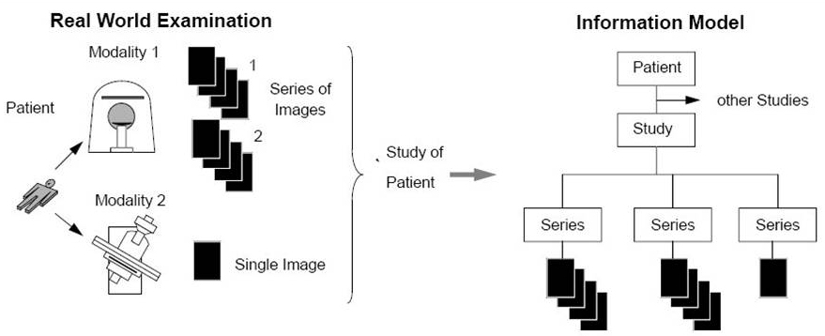
Figure 3: Information model

In the DICOM model, a patient can have 1..n studies (sometimes referred to as exams or procedures). Each study consists of 1..n series. A series generally equates to a specific type (modality) of data, or the position of a patient on the acquisition device. Each series contains 1..n DICOM object instances (most commonly images).
In each series, we have a volume image for that series (3D image) and different slices (2D planes) of the original volume image along the z-axis. The number of slices differ based on the slice thickness.

3-2 Finding the right slice
For our purpose we first need to find the right slice that matches the center of the Tumor. This center (Isocenter) is the center of isocentric beams used in the treatment process.

We can access isocenter from the API. But there is no direct means through API to find the right plane.
Hence, We get the coordination of the very first 2D slice of the 3D image. By having the initial Z value and the Z-step (Z resolution in eclipse), we find the right slice number using this formula:

We then save the pixel values of that particular slice as our CT plane where Isocenter resides.
The result is a cut of the CT volume that contains the Isocenter. In other words we choose the right slice from the CT 3D image when the center of the tumor is located.
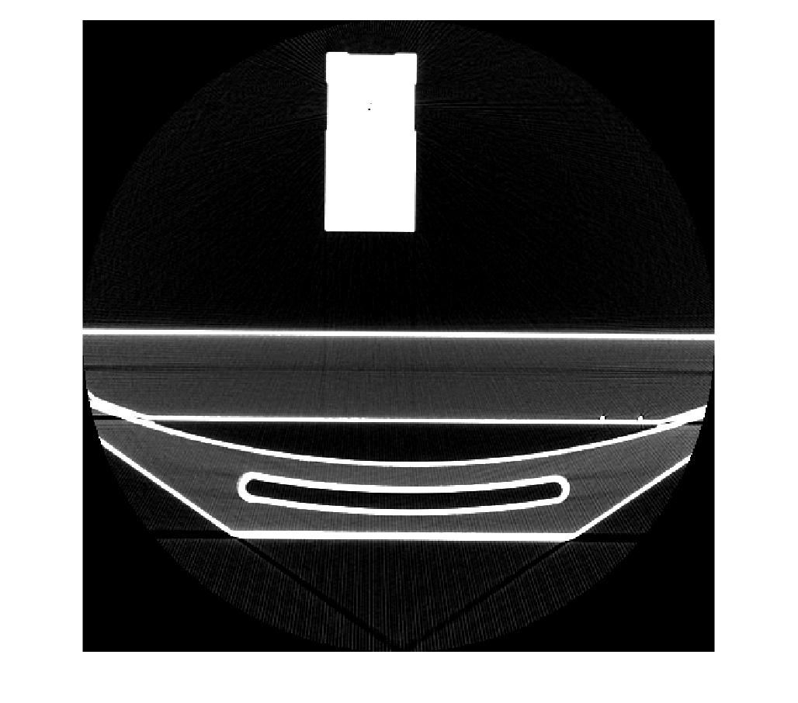
Figure 4: A CT slice

3-3 Measurements
Having the pixel values and pixel widths for each image. we apply Canny edge detection algorithm to find the borders of the image.
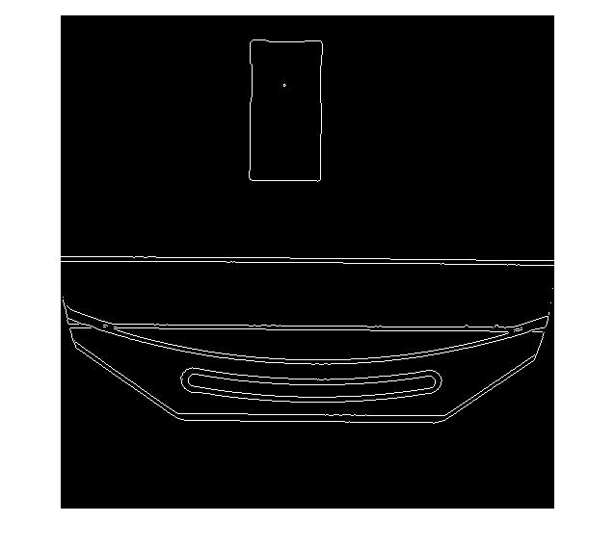
Figure 5: Borders of a CT slice

We now can measure the distance from the center of the tumor to the closest edge in two directions (X and Y axises).

Figure 6 depicts the Isocenter location in a CT image.
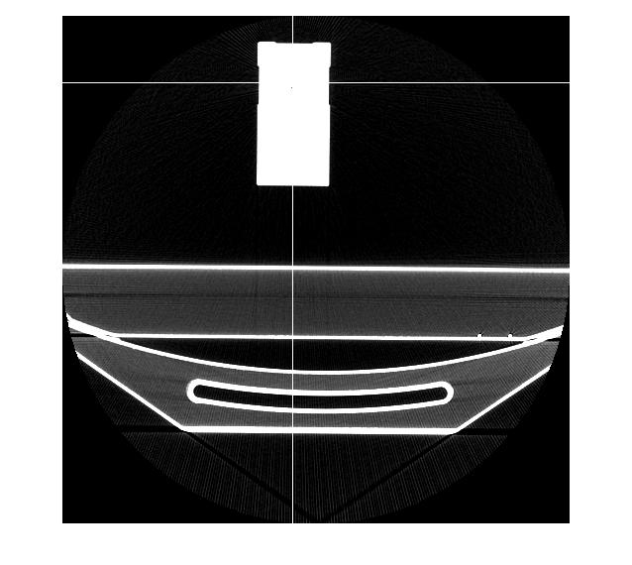
Figure 6: Isocenter

For example, in our case, using a dummy patient (OBI WEEKLY) these distances are illustrated as follows:

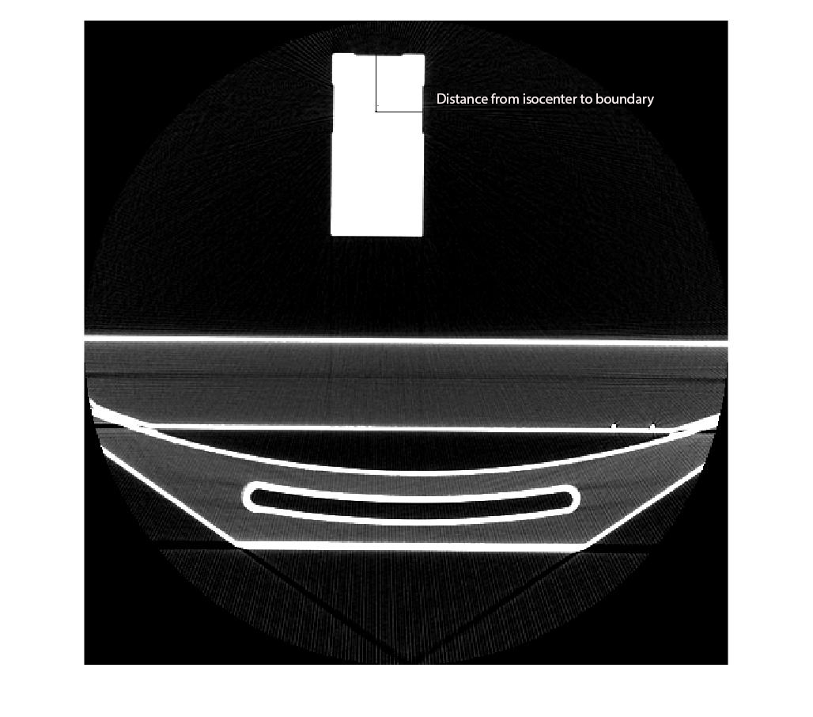
Figure 7: Distance from Isocenter to skin boundary

At this point, we have achieved the main goal of the project which is finding the distance from center of the tumor to patient’s skin (boundary).

3-4 CBCT

The same process needs to be applied to CBCT images.
In order to find the right slice for the CBCT image, We first find the latest series in our particular patient’s study.
Then, We transform Isocenter to the new coordination and find the right plane based on transformed Isocenter coordination.We then retrieve the pixel values for this CBCT plane

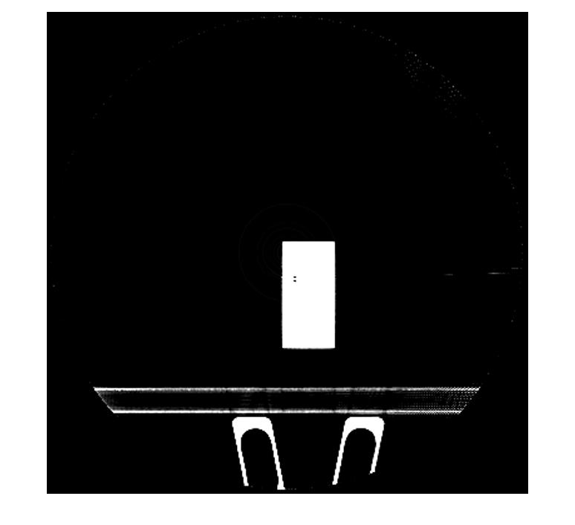
Figure 8: A CBCT slice

As CT and CBCT devices are different devices, they do not usually share the same coordination and even the same image size. In order to find the tumor center to skin differences for CT and CBCT, the coordinations need to match first.

4- Future Work
In recent weeks, we had several meetings with our stakeholder team to find the right transformed coordinations. There is a 4x4 transformation matrix accessible through the API which, when applied, does not seem to correctly transform from source coordination to the destination one.
We have identified that the issue is in the scaling part of the transformation matrix and strongly believe that this issue will be resolved soon.
After this has been done, the next steps are pretty straightforward and we only need to process the results of our software.
Dr. Xu and us believe we can have a really good publication for this work.

