Markup Boundary Fixing for Spatial Databases

1 When the contour length is less than 4 points, it is doomed to fail. Given the fact that the first point is identical to the last, only one point is different from the first and last point. As a result, it is not a valid polygon.

Solution: When this occurs, we simply discard it.

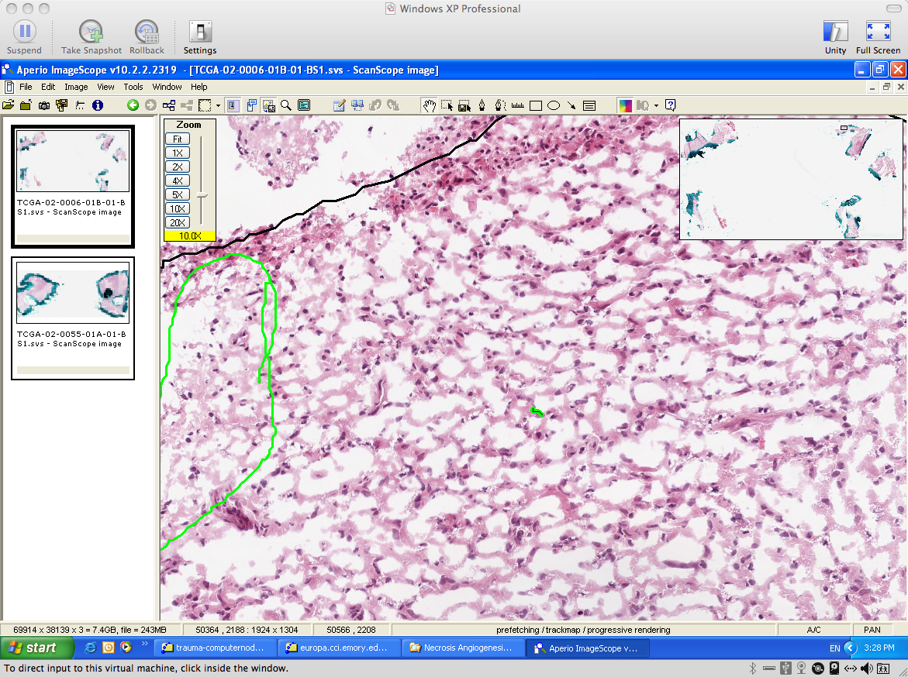

2 When negative points are in a contour, db2 doesn’t accept that.

Solution: When this occurs, we remove points having negative coordinates.

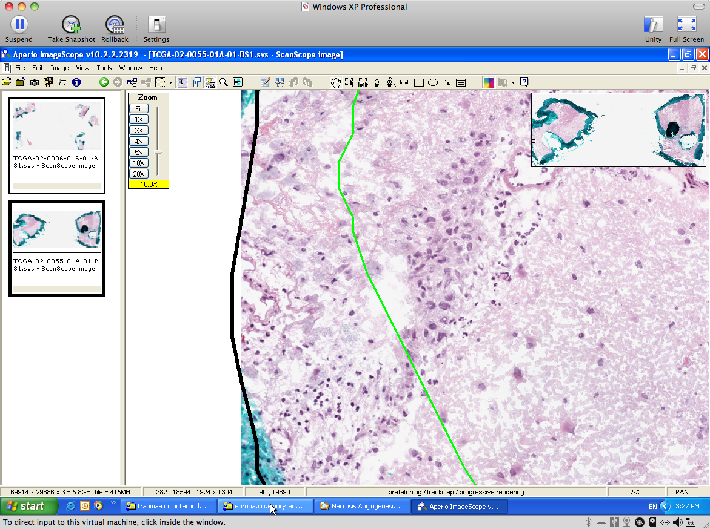
3 When same points are repeated in a row in a contour, db2 doesn’t accept that.

Solution: Compute the distance of any pair of adjacent points and only keep one instance of identical points in a row.
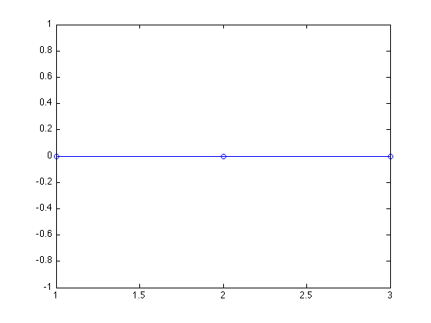
1
2
3
4
4 When a contour is open, i.e. the first point is not identical to the last point of the contour
, db2 doesn’t accept that.

Solution: When this occurs, we duplicate the first point and append this duplicated point to the end of the contour
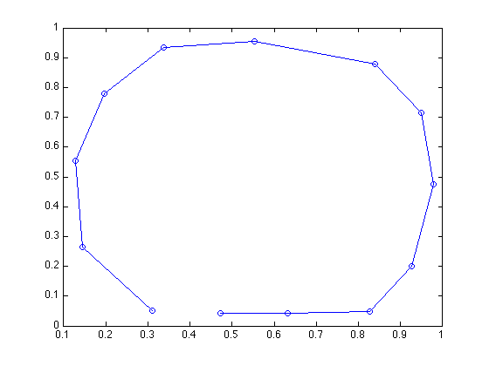
1
last

5 When some points are on the segments defined by other points in the contour (T-conjunction), db2 doesn’t accept that.

Solution: There are two T-conjunction sub-cases. Both of them can be detected by comparing slopes of adjacent segments and signs of changes in x- and y-direction. In either case, we remove the point connecting two adjacent segments with identical slope but different signs for changes in both x and y direction.

Case 1:

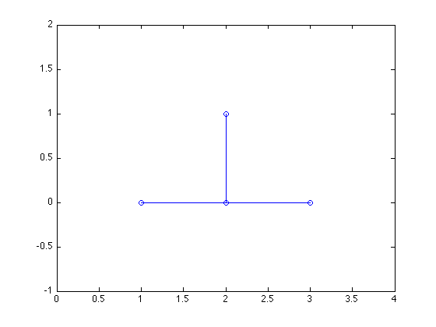
To be removed
1
2
3
4

Case 2:
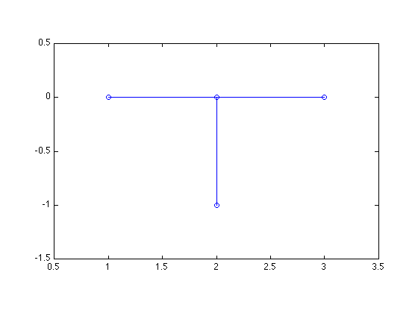
1
2
3
4
To be removed

6 When a segment of the contour goes across another segment of the contour, i.e. self-crossing, db2 doesn’t accept that.

Solution: Each segment is inspected to see if any other segment in the contour intersects it. The indices of the two intersected segments are recorded. The length of the self-crossing component (i.e. from point 4 to 11 in the example below) is compared with that of the remaining contour. The one having shorter length is removed.
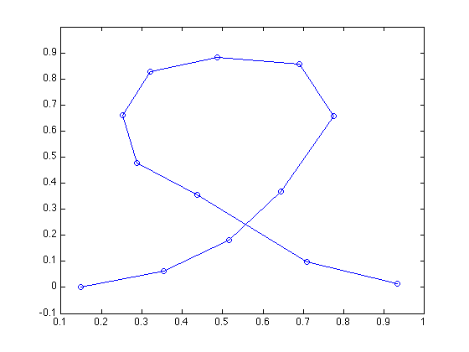
4
11
12
3

6 When any combination of the above six cases is occurred, db2 doesn’t accept that.
Solution: We create a workflow to address this problem. Each input contour keeps being corrected until it is stabilized. The complete flowchart is given as follows.
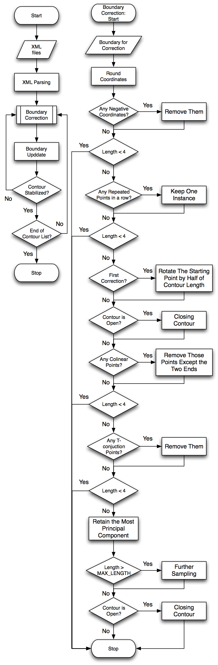

Following is a list of cases we encountered in processing our real data:

Case1:

1
last
2
Last-1
Last
1
2
Last-1
3

Case 2:

1
last
2
Last-1
Last-2
Last
1
2
Last-1
Case 3:

1
last
2
Last-1
Last-2
1
Last
Last-1
2
Case 4:

16
14
15,
Last-3
Last
1
1
2
Last
Last-1
Case 5:

Case 6:

