**FTRACE**

By

Regards

Ashish Tanwer

Masters, Computer Science, Stony Brook University

1063 morse avenue, apt 3-200,Sunnyvale,California-94089

[ashishtanwer@gmail.com](mailto:ashishtanwer@gmail.com), +1-[(631) 551-3060](tel:%28631%29%20551-3060)

<http://ashishtanwer.info>, <http://in.linkedin.com/in/ashishtanwer>

<http://www.youtube.com/user/ashishtanwer> <https://github.com/ashishtanwer>

Ftrace kernel tool that provides the low-overhead logging of Linux kernel events.

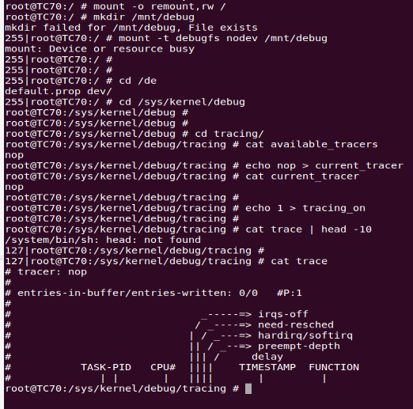

**USING** **FTRACE**

Ftrace has its control ﬁles in the debugfs system.This is usually mounted in /sys/kernel/debug. If it is not already mounted, then you can mount it yourself with:

# mount -t debugfs nodev /sys/kernel/debug

Many Developpers prefer to have this directory at the root of the system

# mkdir /mnt/debug

# mount -t debugfs nodev /mnt/debugfs

That creates a /debug/tracing subdirectory which is used to control ftrace and for getting output from the tool.

**Note**: all the command of this article will be pass in the /debug/tracing/ directory

**Choosing a tracer**

To find out which tracers are available, simply cat the available_tracers file in the tracing directory:

# cat available_tracers

function sched_switch nop

To enable, for example, the function tracer, just echo "function" into the current_tracer file.

# echo function > current_tracer

# cat current_tracer

function

**Note**: Ftrace can handle only one tracer at the same time

**Using a tracer**

At this point Ftrace is ready to trace the function, to start it just echo 1 in the tracing_on file

# echo 1 > tracing_on

To stop the trace, just echo 0 in the same file:

# echo 0 > tracing_on

The trace is contained in the trace file, here is an example of the output from a function trace. The header helps to decode the various fields in the trace.

# cat trace | head -10

# tracer: function

#

# TASK-PID CPU# TIMESTAMP FUNCTION

# | | | | |

avahi-daemon-630 [000] 9507.400848: vfs_read <-sys_read

avahi-daemon-630 [000] 9507.400848: rw_verify_area <-vfs_read

avahi-daemon-630 [000] 9507.400848: do_sync_read <-vfs_read

avahi-daemon-630 [000] 9507.400848: sock_aio_read <-do_sync_read

avahi-daemon-630 [000] 9507.400848: alloc_sock_iocb <-sock_aio_read

avahi-daemon-630 [000] 9507.400848: unix_stream_recvmsg <-sock_aio_read

**Tracing a specific process**

Perhaps you only need to trace a specific process, or set of processes. The file set_ftrace_pid lets you specify specific processes that you want to trace. To just trace the current thread you can do the following:

[tracing]# echo $$ > set_ftrace_pid

The above will set the function tracer to only trace the bash shell that executed the echo command. If you want to trace a specific process, you can create a shell script wrapper program.

[tracing]# cat ~/bin/ftrace-me

#!/bin/sh

DEBUGFS=`grep debugfs /proc/mounts | awk '{ [print](http://omappedia.org/wiki/Installing_and_Using_Ftrace) $2; }'`

echo $$ > $DEBUGFS/tracing/set_ftrace_pid

echo function > $DEBUGFS/tracing/current_tracer

exec $*

[tracing]# ~/bin/ftrace-me ls -ltr

Note, you must [clear](http://omappedia.org/wiki/Installing_and_Using_Ftrace) the set_ftrace_pid file if you want to go back to generic function tracing after performing the above.

[tracing]# echo -1 > set_ftrace_pid

**The Tracers in detail**

All the following tracers are plugins of Ftrace which bring different presentation of trace, and trace different things (Latency, scheduler events)

**nop tracer**

This is the tracer by default which trace no function. But it can still be usefull to trace events (see [#Trace event](http://omappedia.org/wiki/Installing_and_Using_Ftrace#Trace_event))

**Function tracer**

This tracer is activated by enabling CONFIG_FUNCTION_TRACER in the kernel configuration. To work, it needs the kernel variable ftrace_enabled to be turned on, otherwise this tracer is a nop.

# sysctl kernel.ftrace_enabled=1

# echo function > current_tracer

# cat current_tracer

function

[tracing]# cat trace | head -10

# tracer: function

#

# TASK-PID CPU# TIMESTAMP FUNCTION

# | | | | |

bash-16939 [000] 6075.461561: mutex_unlock <-tracing_set_tracer

<idle>-0 [001] 6075.461561: _spin_unlock_irqrestore <-hrtimer_get_next_event

<idle>-0 [001] 6075.461562: rcu_needs_cpu <-tick_nohz_stop_sched_tick

bash-16939 [000] 6075.461563: inotify_inode_queue_event <-vfs_write

<idle>-0 [001] 6075.461563: mwait_idle <-cpu_idle

bash-16939 [000] 6075.461563: __fsnotify_parent <-vfs_write

The header explains the format of the output pretty well. The first two items are the traced task name and PID. The CPU that the trace was executed on is within the brackets. The timestamp is the time since boot in <secs>.<usecs>format, followed by the function name with its parent following the "<-" symbol.