# Intelligent Wifi Client

By

Regards

Ashish Tanwer

Masters, Computer Science, Stony Brook University

1063 morse avenue, apt 3-200, Sunnyvale, California-94089

[ashishtanwer@gmail.com](mailto:ashishtanwer@gmail.com), +1-[(631) 551-3060](tel:%28631%29%20551-3060)

<http://ashishtanwer.info>, <http://in.linkedin.com/in/ashishtanwer>

<http://www.youtube.com/user/ashishtanwer> <https://github.com/ashishtanwer>

Android based service to intelligently switch between the different Wifi and Mobile Networks

Google Play:

<https://play.google.com/store/apps/details?id=com.wingslab.intelligentwifi>

GIThub:

<https://github.com/ashishtanwer/IntelligentWifiClient>

**Features**

* Interfacing with Accelerometer sensor to get the raw readings to acceleration along x y and z axis. Applying the high pass and low pass filter to the RAW readings. High pass will acceleration due to gravity =9.8. Low pass will give the external acceleration. We need the external acceleration to detect if we are travelling.
* User can specify the threshold acceleration after which Wifi Client will switch to profile suitable for Traelling.
* Interfacing with GPS sensor to get the raw readings to velocity. User can specify the threshold velocity after which Wifi Client will switch to profile suitable for Traelling.
* Interfacing with GPS to get the latitude and longitude. This is used to define the locations/regions in which we want to switch to a particular profile.
* A have added a Content Provider Database that can be used to store all loctions.

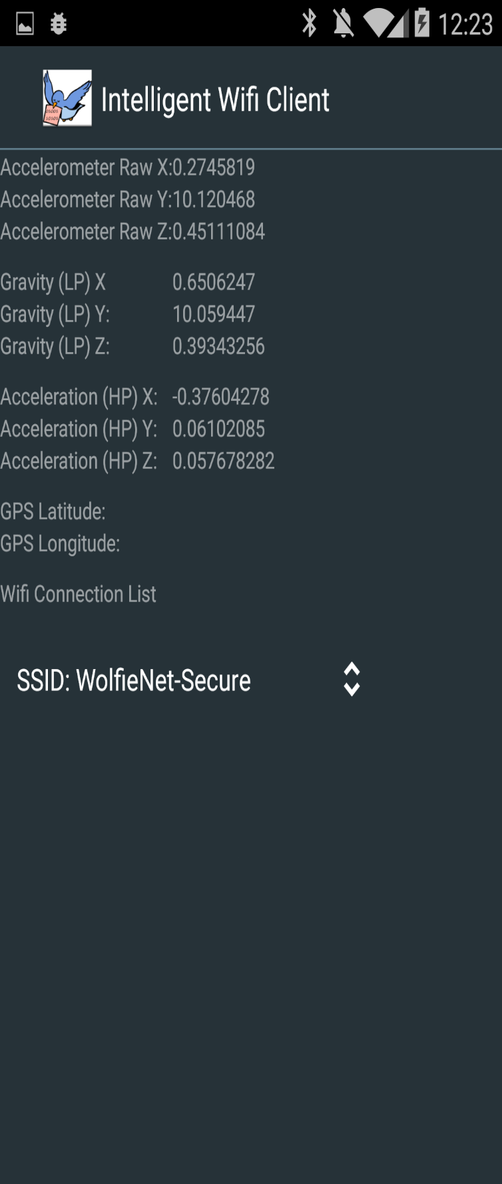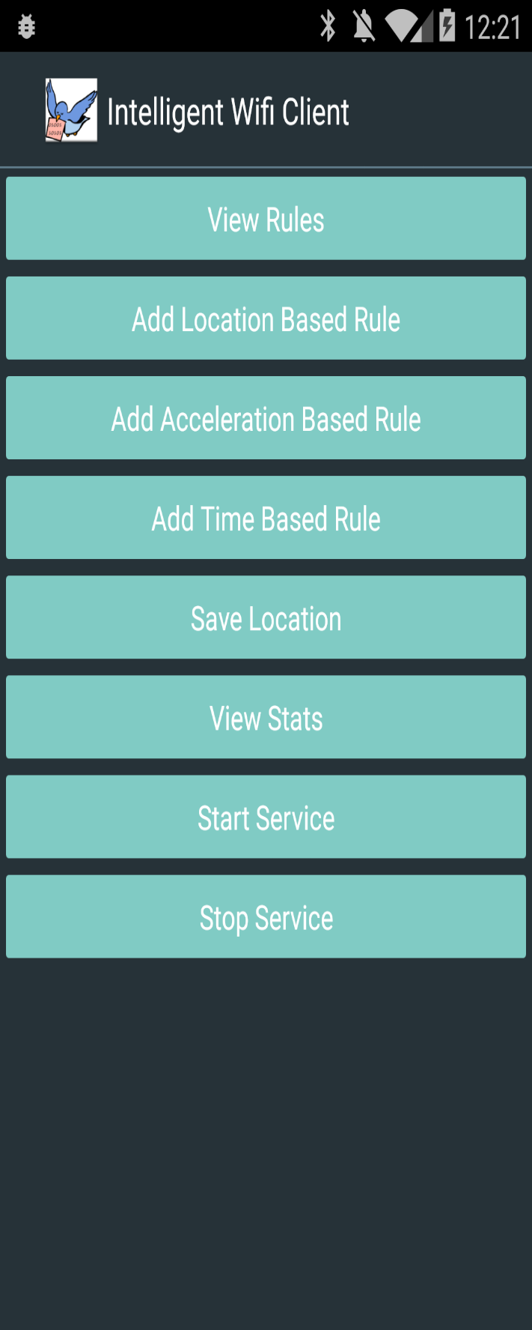

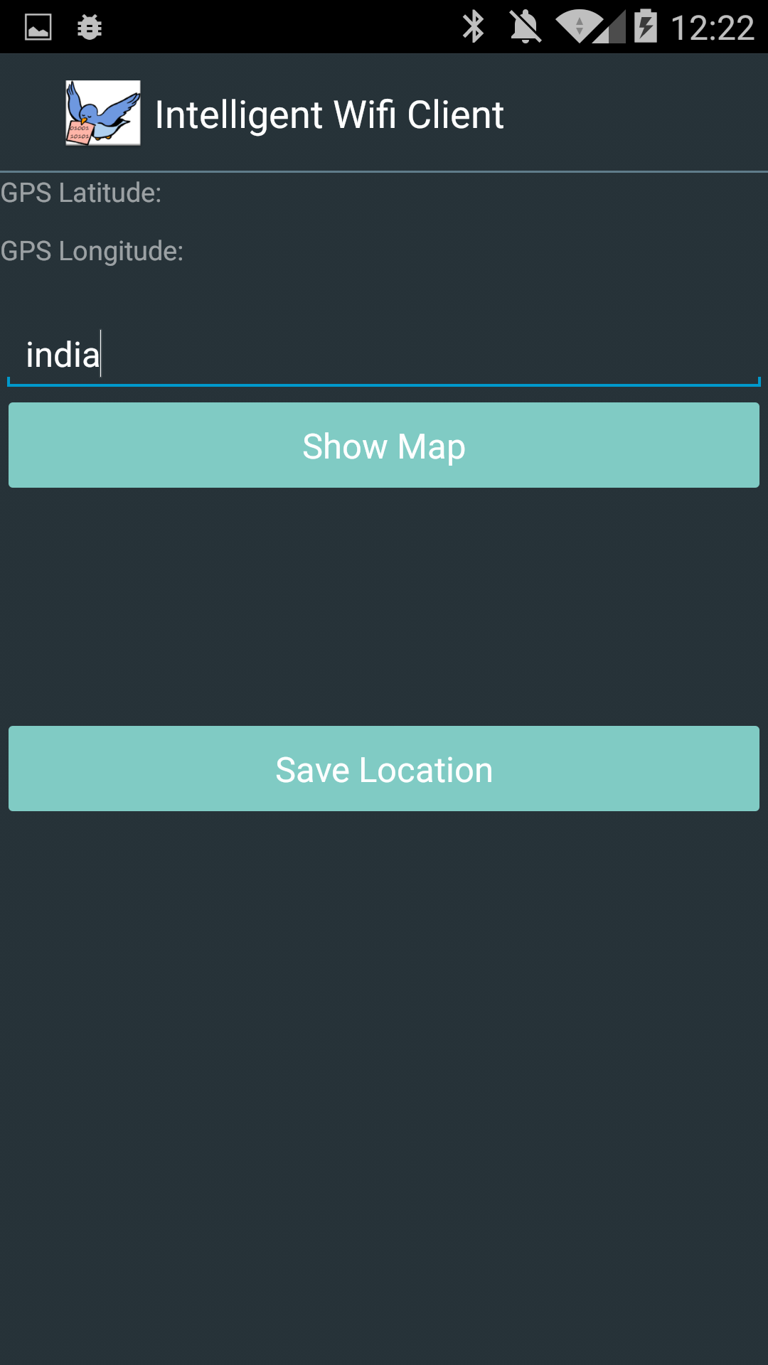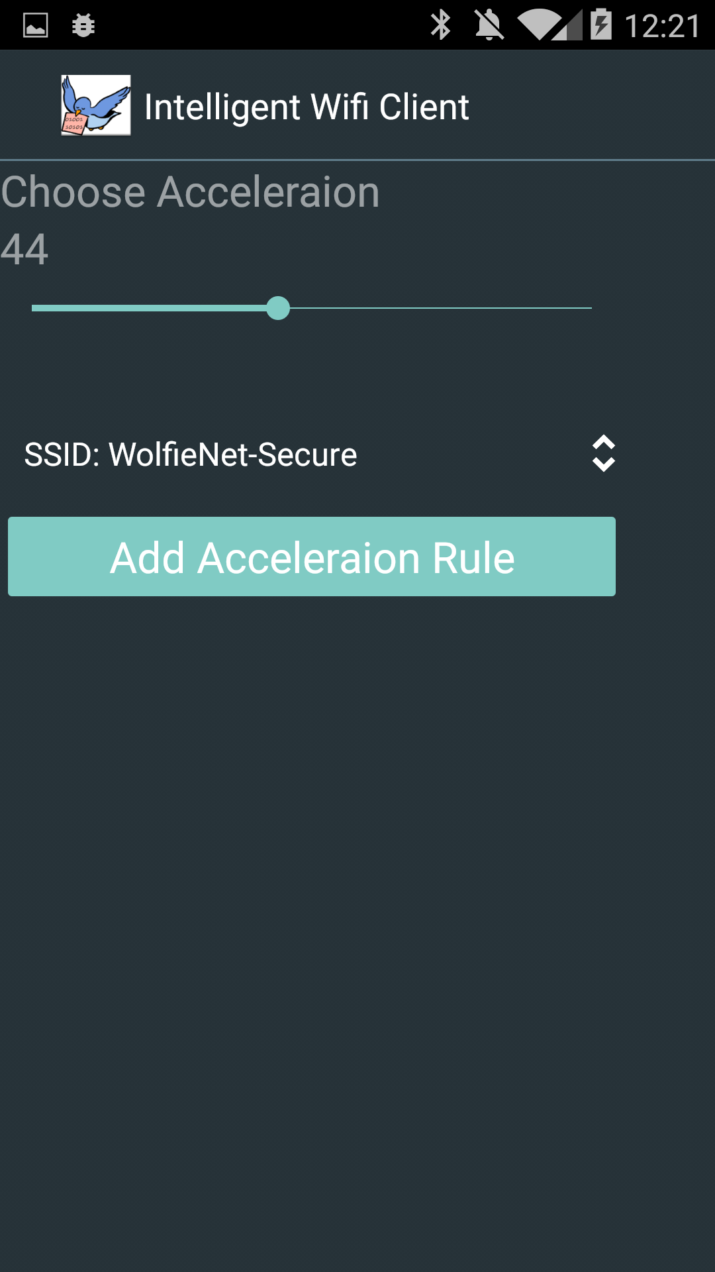

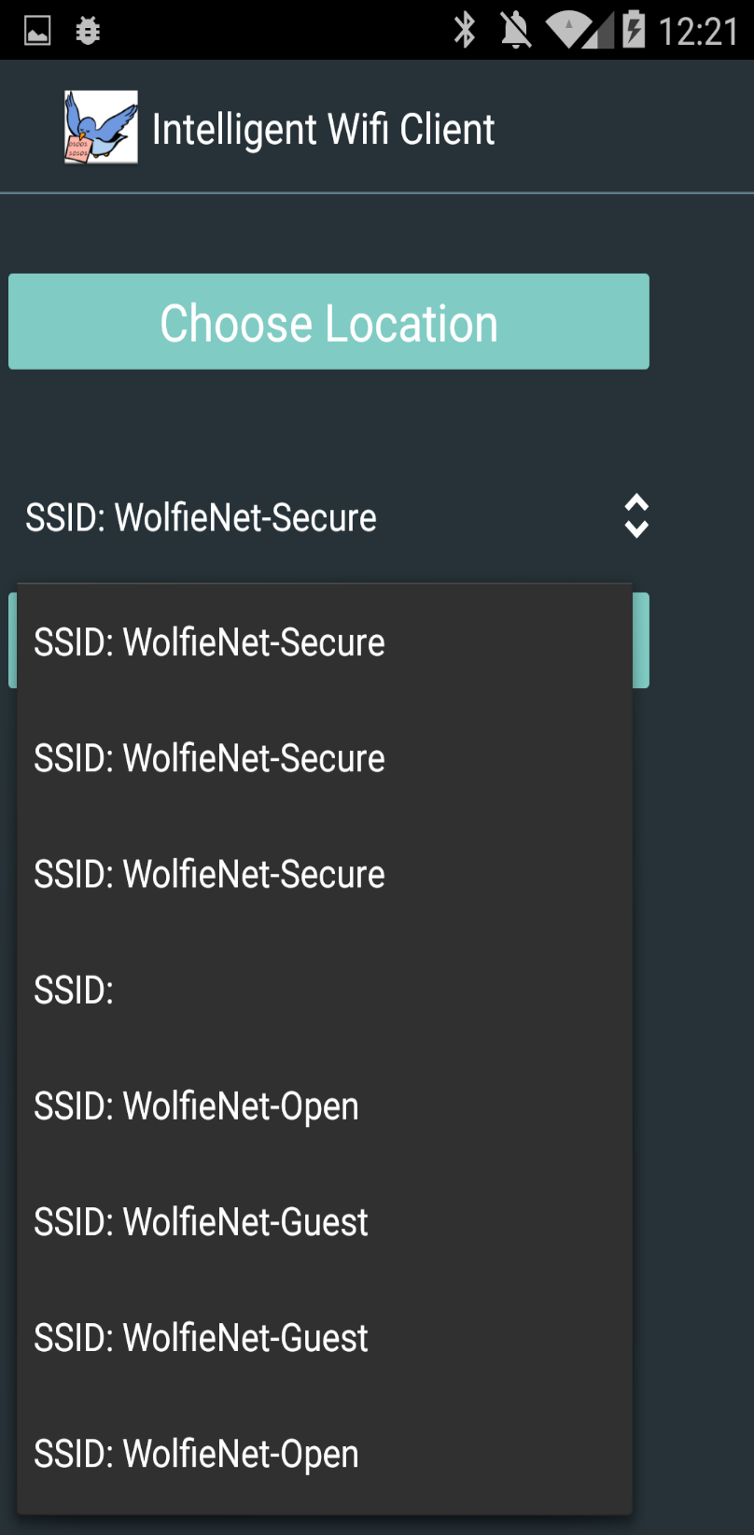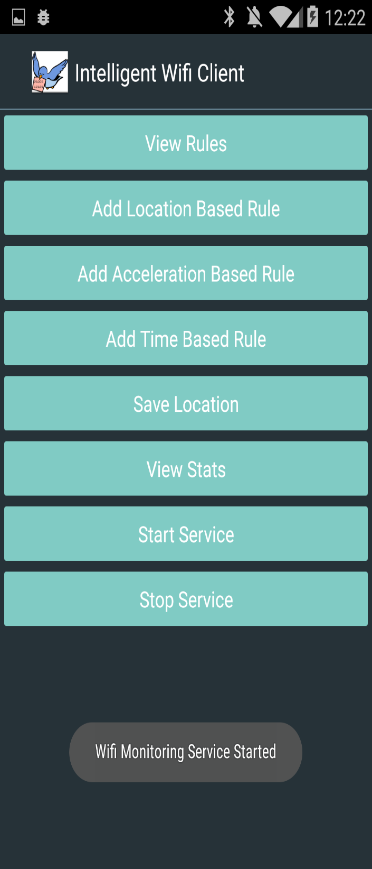

* Similarly user can add time based Rules.
* I have The activity added a Content Provider Database that can be used to store all Rules- time, location, acceleration, or velocity.
* Sats activity gets gets the WIfi Connection available from Android Wifi Manager and all other stats.
* 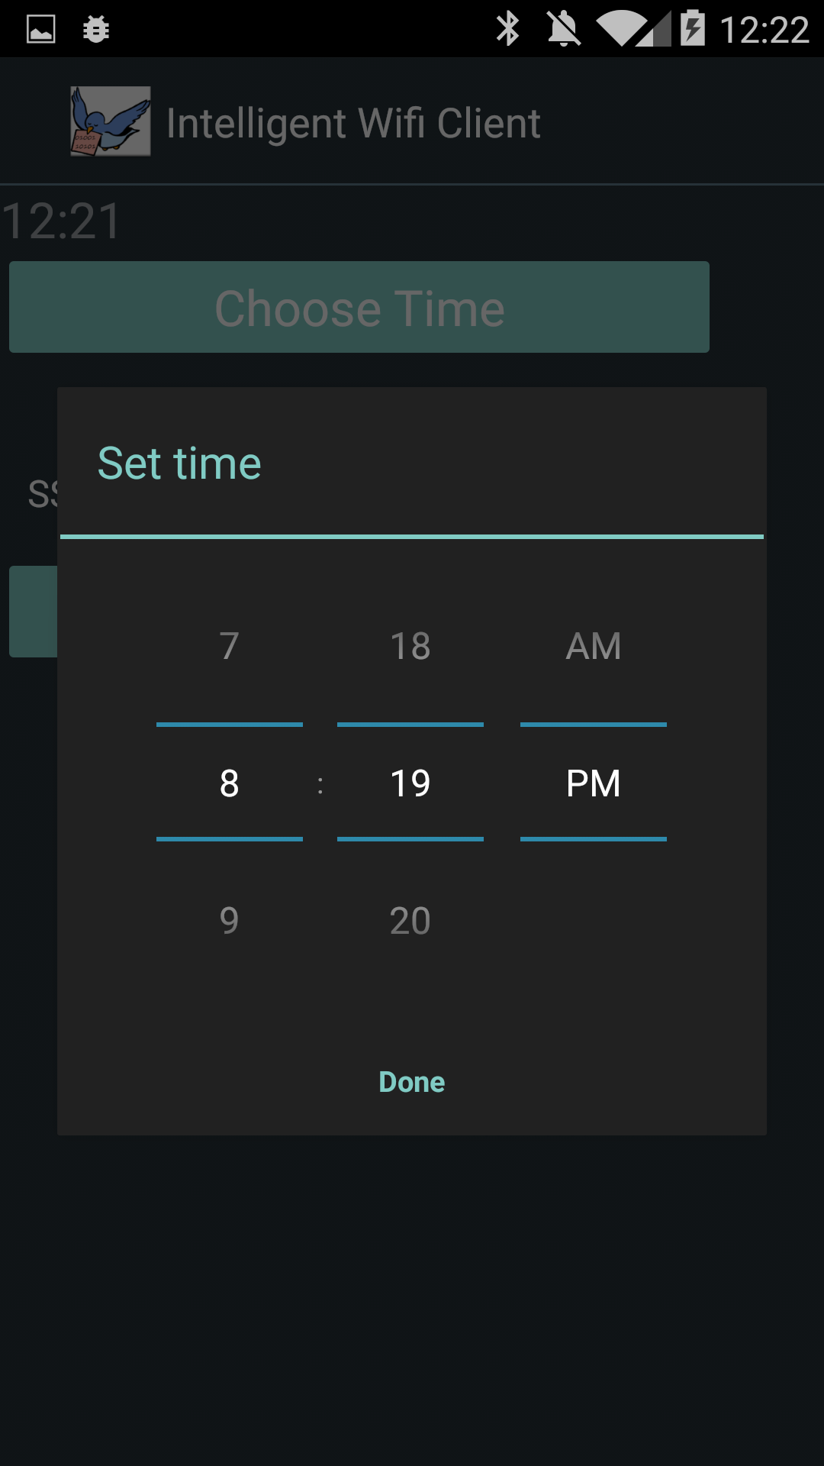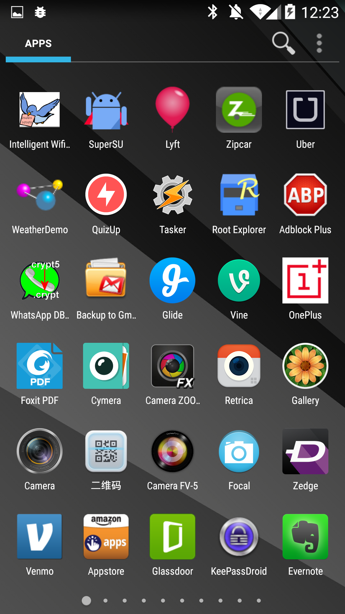The main activity will start/stop the Intelligent Wifi Monitoring Service that will keep running in background and triggers the appropriate rules.