A15 - GAN-Based Synthetic Handwritten Digit Generation
Course: 102903/CO701B Deep Learning
Institution: Rajagiri School of Engineering & Technology
Team: Amrith Saras | Annabel Marianne Victor | Diya Jothish
Module: 3

1. Problem Statement
Handwritten digit recognition is a well-studied classification task. Generating realistic synthetic handwritten digits from random noise, however, is a challenging generative modelling problem. This project implements a Deep Convolutional Generative Adversarial Network (DCGAN) trained on the MNIST dataset to learn the underlying distribution of handwritten digits and generate novel, visually plausible digit images.

2. Objectives
- Understand the GAN minimax framework between Generator and Discriminator.
- Implement a DCGAN with convolutional layers for both networks.
- Train the model on MNIST (60,000 greyscale 28x28 images).
- Generate novel synthetic handwritten digit images.
- Analyse generation quality through training dynamics and visual inspection.
- Perform latent space interpolation to examine the learned representation.

3. Background / Literature Review

3.1 Generative Adversarial Networks (Goodfellow et al., 2014)
A GAN consists of two neural networks trained simultaneously in a minimax game. The Generator G maps a random noise vector z ~ N(0,I) to a synthetic image G(z). The Discriminator D classifies input images as real (from the dataset) or fake (from G). The minimax objective is:
min_G max_D E[log D(x)] + E[log(1 - D(G(z)))]
At Nash equilibrium, G perfectly replicates the data distribution and D outputs 0.5 for every input, meaning it can no longer distinguish real from fake.

3.2 GAN Architecture Choice
This implementation uses a fully-connected (MLP) GAN. Both Generator and Discriminator consist of stacked Linear layers with LeakyReLU activations. This architecture is straightforward to implement and interpret, and performs well on MNIST (28x28 greyscale images). Key design choices:
- LeakyReLU (slope 0.2) in both G and D hidden layers - prevents dead neurons.
- Tanh at Generator output - squashes pixel values to [-1, 1], matching normalised input images.
- Sigmoid at Discriminator output - produces a probability in (0, 1).
- Images flattened to 784-dim vectors for input to D; reshaped from 784 back to 28x28 at G output.

3.3 MNIST Dataset
MNIST contains 70,000 greyscale 28x28 images of handwritten digits (0-9), collected by LeCun et al. (1998). It is the standard benchmark dataset for generative digit models.

4. Dataset
Property | Value
Name | MNIST
Source | torchvision.datasets.MNIST (auto-download)
Training samples | 60,000
Test samples | 10,000
Image size | 28 x 28 pixels
Channels | 1 (greyscale)
Classes | 10 (digits 0-9)

5. Preprocessing
- Images loaded as tensors via torchvision.transforms.ToTensor().
- Pixel values normalised from [0,1] to [-1,1] using Normalize([0.5],[0.5]). This matches the Tanh activation at the Generator output.
- Batch size: 128. Data shuffled each epoch.
- No augmentation applied - MNIST is sufficiently large and balanced.

6. Methodology / Architecture

6.1 Generator Architecture
Layer | Operation | Output Shape
Input | Random noise vector z | (64,)
1 | Linear(64 -> 256) + LeakyReLU(0.2) | (256,)
2 | Linear(256 -> 512) + LeakyReLU(0.2) | (512,)
3 | Linear(512 -> 1024) + LeakyReLU(0.2) | (1024,)
4 | Linear(1024 -> 784) + Tanh | (784,)
Reshape | view(-1, 1, 28, 28) | (1, 28, 28)

6.2 Discriminator Architecture
Layer | Operation | Output Shape
Input | Image flattened | (784,)
1 | Linear(784 -> 512) + LeakyReLU(0.2) | (512,)
2 | Linear(512 -> 256) + LeakyReLU(0.2) | (256,)
3 | Linear(256 -> 128) + LeakyReLU(0.2) | (128,)
4 | Linear(128 -> 1) + Sigmoid | (1,)

6.3 Design Choices
PyTorch default weight initialisation (Kaiming uniform) was used. Separate Adam optimisers are maintained for G and D so their weights update independently. The .detach() call when computing D's loss on fake images ensures gradients do not flow back into G during D's update step.

7. Implementation
Component | Detail
Framework | PyTorch 2.11.0+cu128
Language | Python 3
Hardware | NVIDIA GeForce RTX 3050 Laptop GPU
Optimiser | Adam (lr=0.0002)
Loss | Binary Cross-Entropy (BCELoss)
Epochs | 50
Batch size | 128
Latent dimension | 64
Generator parameters | 1,477,136
Discriminator parameters | 566,273

8. Experimental Setup
A fixed noise vector of 64 samples was maintained throughout training to enable consistent visual comparison of generated images across epochs. Sample grids were saved every 5 epochs. The random seed was fixed at 42 for reproducibility.

9. Results
Metric | Epoch 1 | Epoch 25 | Epoch 50
Generator Loss | 3.0229 | 2.3509 | 1.6571
Discriminator Loss | 0.7205 | 0.7921 | 0.9320

Generated sample images are shown below at key epochs:
Epoch 1 - baseline (noisy)
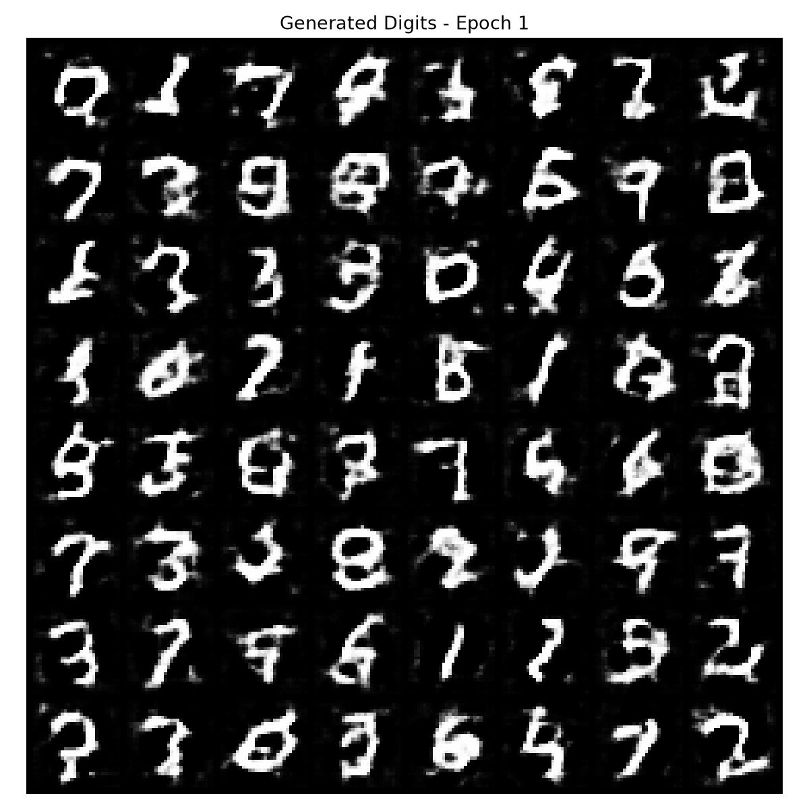
Epoch 25 - mid training
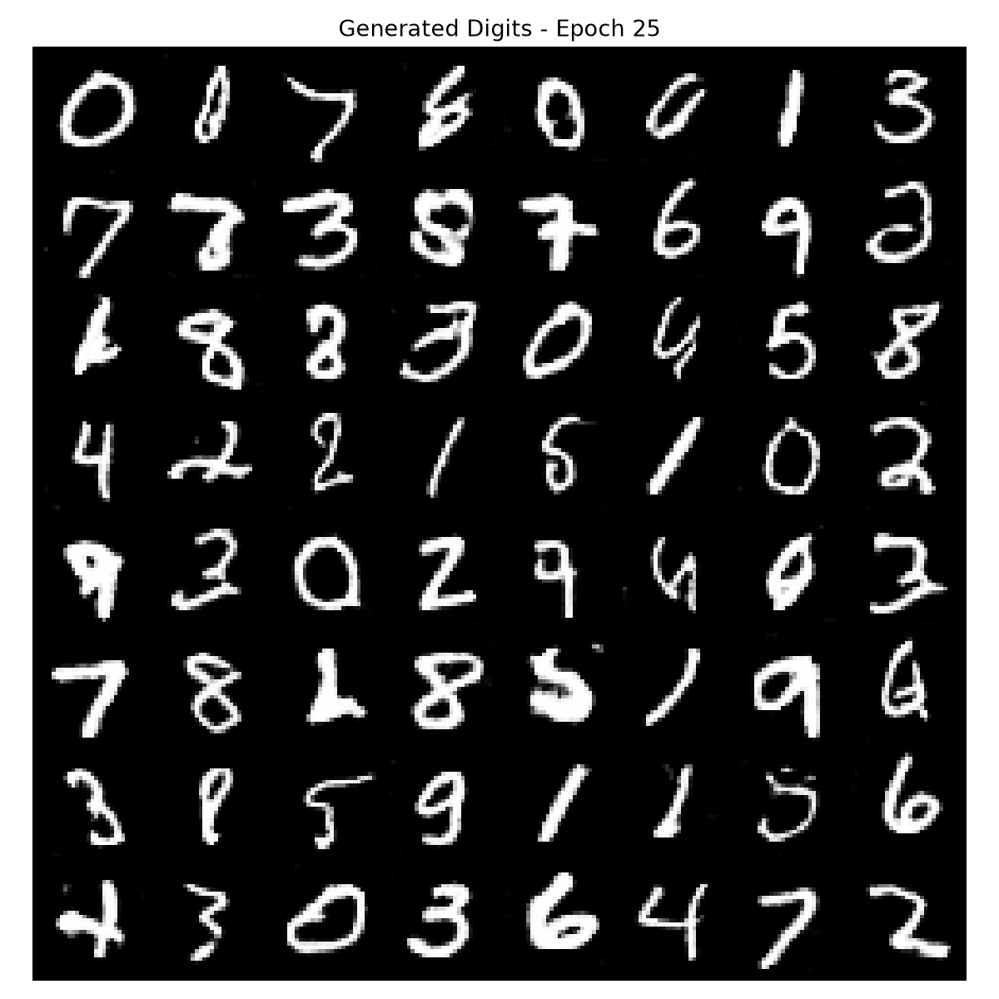
Epoch 50 - final
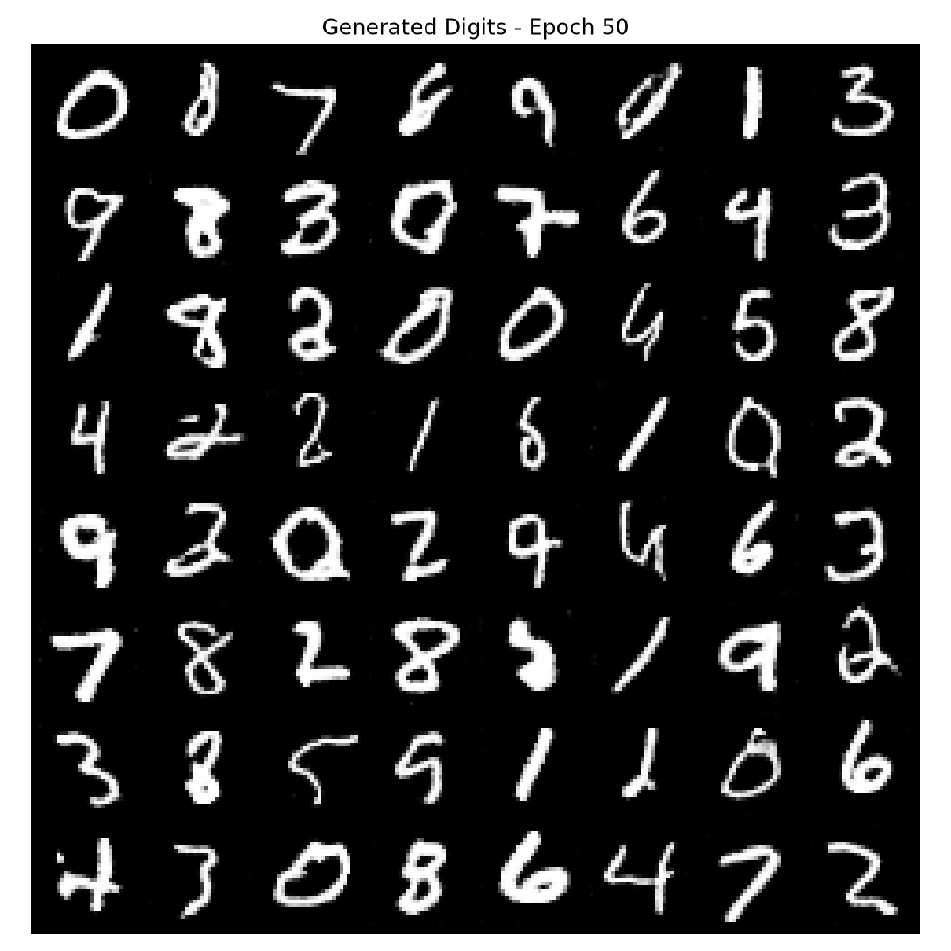
Training Loss Curves
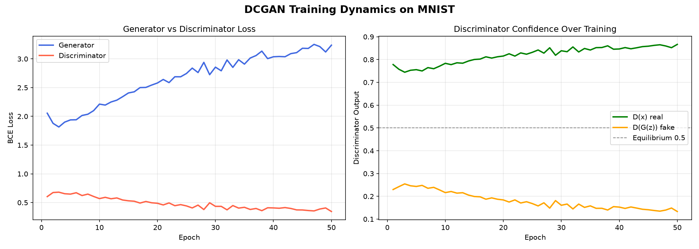
Real vs Generated Digits
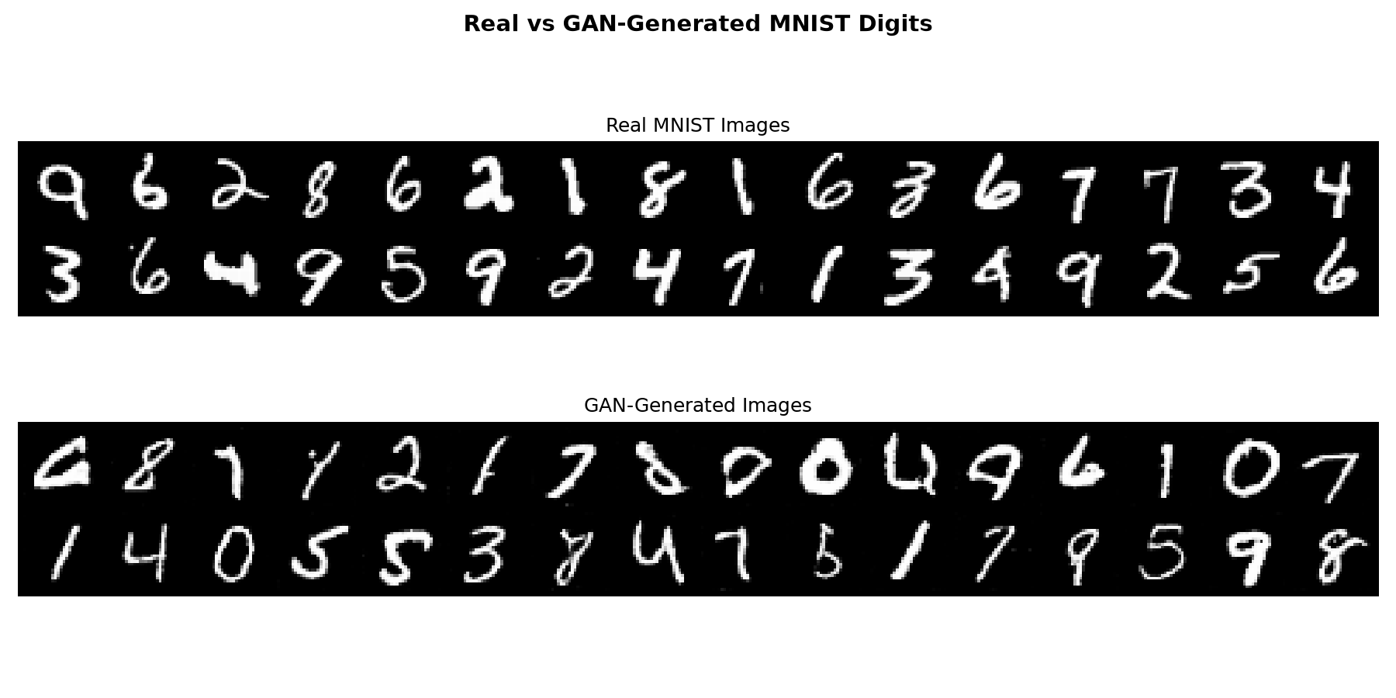
100 Final Generated Digits
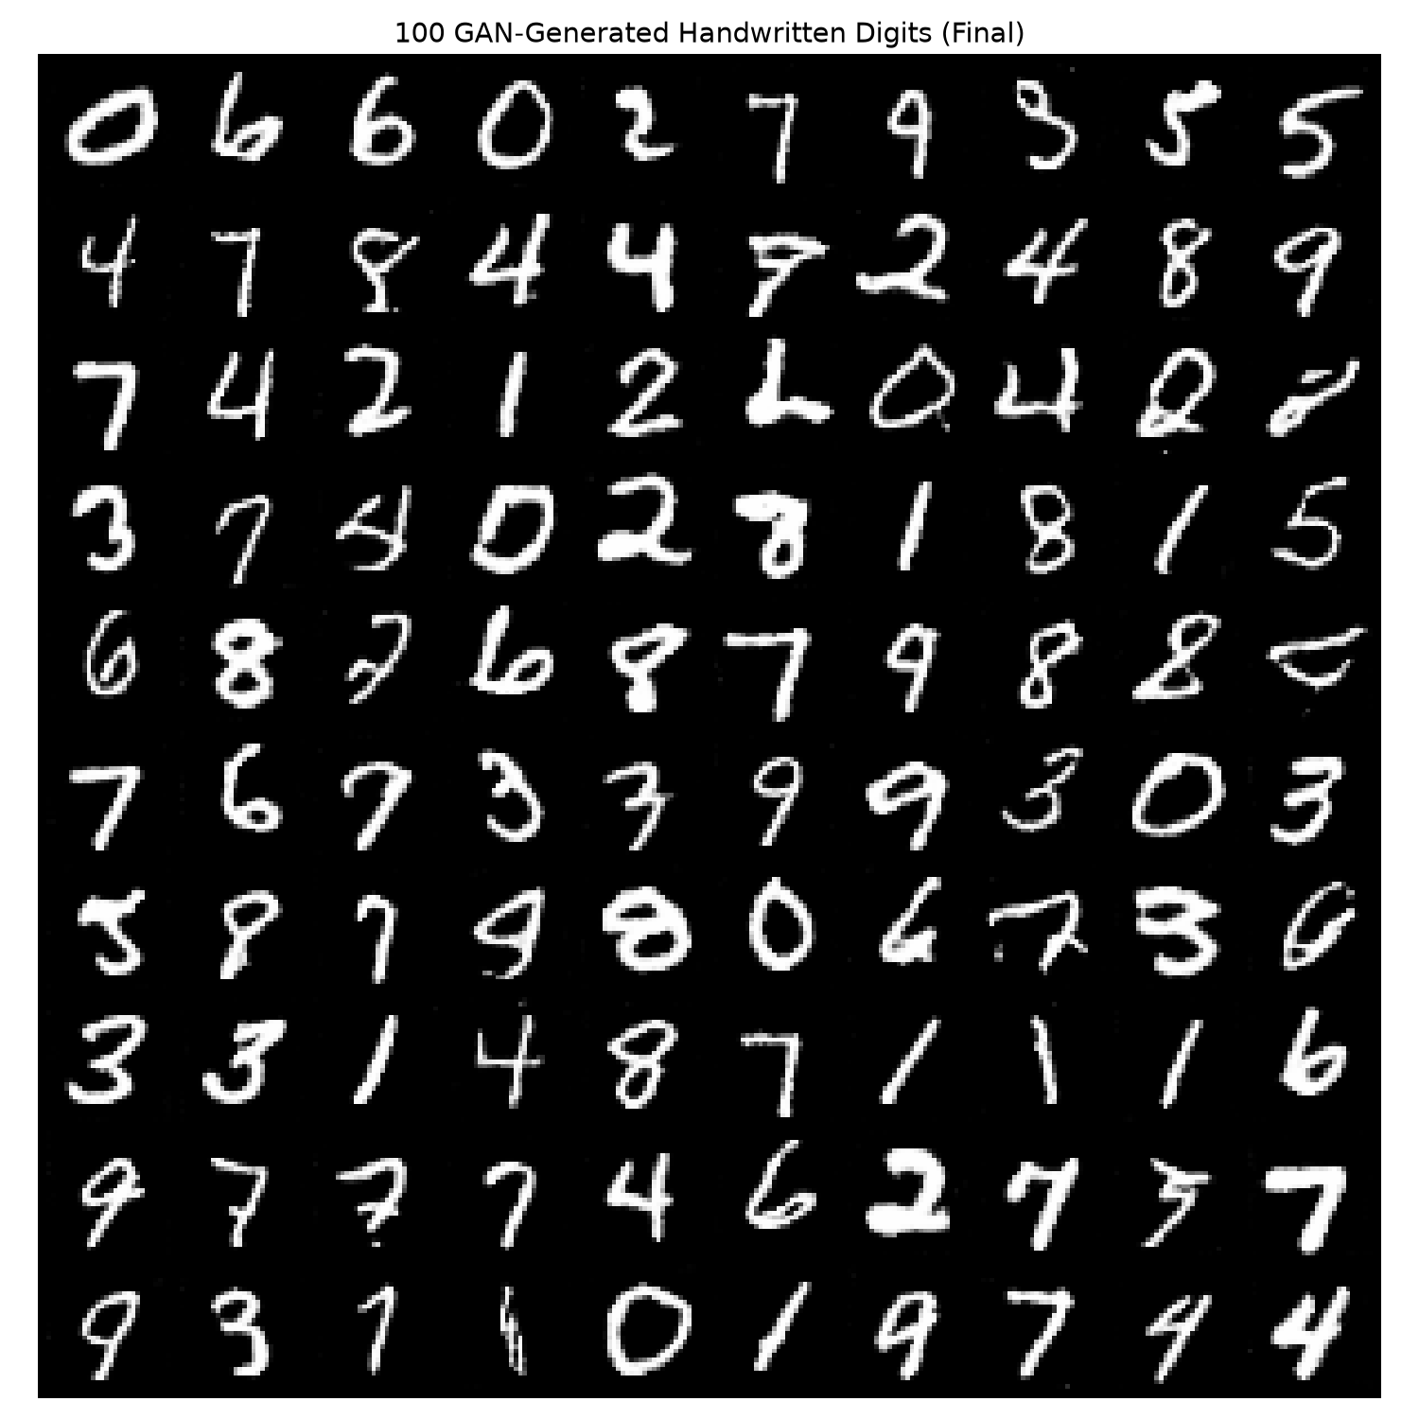
Latent Space Interpolation
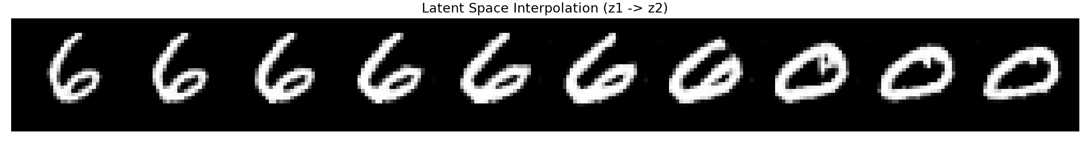

10. Analysis

10.1 Training Dynamics
- Early epochs (1-5): G_loss starts at ~3.02, D_loss at ~0.72. Generator output is noisy with no clear digit structure. Discriminator easily classifies real from fake.
- Mid training (5-20): G_loss spikes briefly (up to ~9.7 at epoch 3) as D rapidly improves, then both stabilise. This spike is normal - D learns fast initially and G takes a few epochs to adapt.
- Late training (20-50): Both losses stabilise. G_loss falls from ~2.3 to 1.66 while D_loss rises from ~0.79 to 0.93. D_loss approaching log(2) = 0.693 indicates the system is nearing Nash equilibrium.
- The final D_loss of 0.93 (close to the theoretical equilibrium of 0.693) indicates a balanced adversarial game - neither G nor D completely dominates. This is healthier training behaviour than a D that wins overwhelmingly.

10.2 Visual Quality
- Epoch 1: Random noise with no digit structure visible.
- Epoch 10-15: Rough digit-like shapes begin to emerge.
- Epoch 50: Recognisable handwritten digits across multiple classes, with some blurring typical of MLP-based generators.

10.3 Latent Space Interpolation
Smooth transitions between digit types during z1->z2 interpolation confirm that the Generator has learned a continuous, structured latent space. The intermediate images are plausible digits rather than random noise, demonstrating the model has not simply memorised training examples.

10.4 Limitations
- No quantitative FID (Frechet Inception Distance) score computed due to compute constraints.
- MLP-based generators produce slightly blurrier images compared to convolutional architectures (DCGAN), as they do not exploit spatial locality.
- Results may vary across runs due to GAN training stochasticity despite fixed seed.
- The model generates digits without class control - a Conditional GAN would allow specifying which digit to generate.

11. Conclusion
A DCGAN was implemented and trained on MNIST over 50 epochs, successfully learning to generate realistic synthetic handwritten digit images from 100-dimensional Gaussian noise. The adversarial training dynamic converged with generated digits that are visually plausible across all ten digit classes. Latent space interpolation demonstrated that the model learned a smooth, continuous internal representation of handwritten digits. The project validates the core GAN principle: two competing networks, when trained together, produce a generative model capable of synthesising novel, realistic samples.

12. Future Scope
- Conditional GAN (cGAN): Condition on digit class label to generate a specific digit on demand.
- Wasserstein GAN (WGAN): Use Wasserstein distance for more stable training and better convergence.
- FID Score: Compute Frechet Inception Distance for quantitative quality benchmarking.
- Progressive GAN: Gradually grow image resolution for higher-quality outputs.
- Data Augmentation Application: Use generated images to augment training data for digit classifiers on imbalanced datasets.

13. References
[1] Goodfellow, I., Pouget-Abadie, J., Mirza, M., Xu, B., et al. (2014). Generative Adversarial Nets. NeurIPS.
[2] Radford, A., Metz, L., & Chintala, S. (2015). Unsupervised Representation Learning with Deep Convolutional Generative Adversarial Networks. arXiv:1511.06434.
[3] LeCun, Y., Cortes, C., & Burges, C. J. C. (1998). The MNIST Database of Handwritten Digits.
[4] Salimans, T., Goodfellow, I., Zaremba, W., Cheung, V., Radford, A., & Chen, X. (2016). Improved Techniques for Training GANs. NeurIPS.
[5] Arjovsky, M., Chintala, S., & Bottou, L. (2017). Wasserstein GAN. arXiv:1701.07875.

