**Pipeline**

ITI intake 42 Open-Source Cloud platform development graduation project.

**Team members**:

1 – Zainab Sabry

2 – Mohamed El Sayed

3 – Ahmed Hassan

4 – Rinad Khaled

5 – Yasser Osama

**Technologies used**:

- Ansible

- Kubernetes

- Terraform

- Jenkins

- Nexus

- Kaniko

**Ansible**

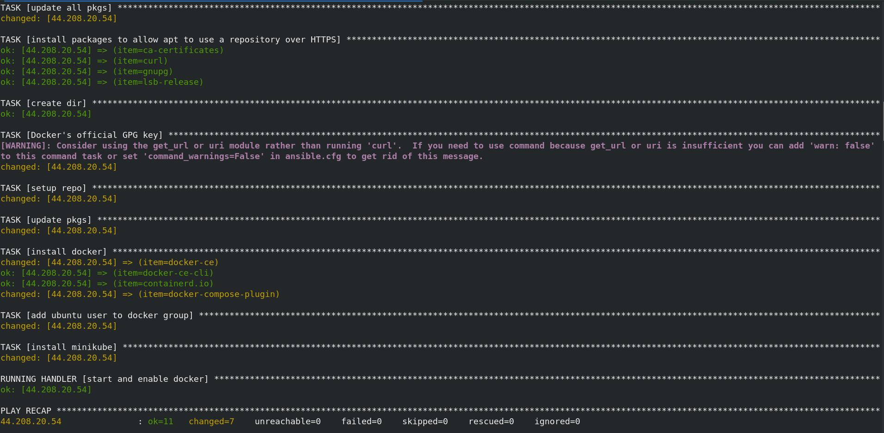

**Terraform**

-Terraform init

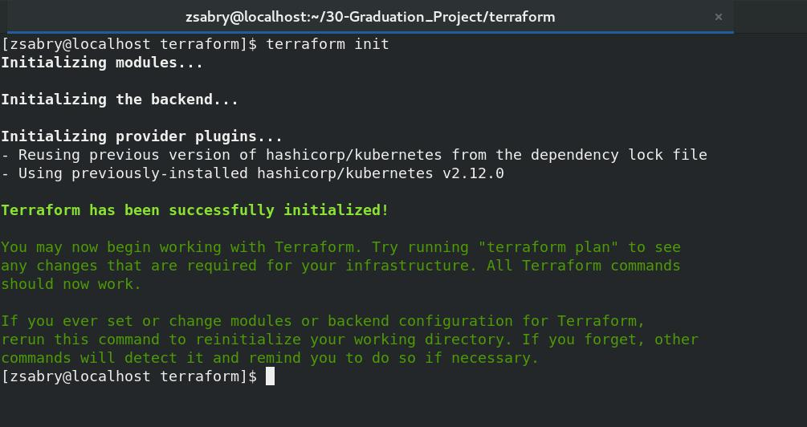

- Terraform apply

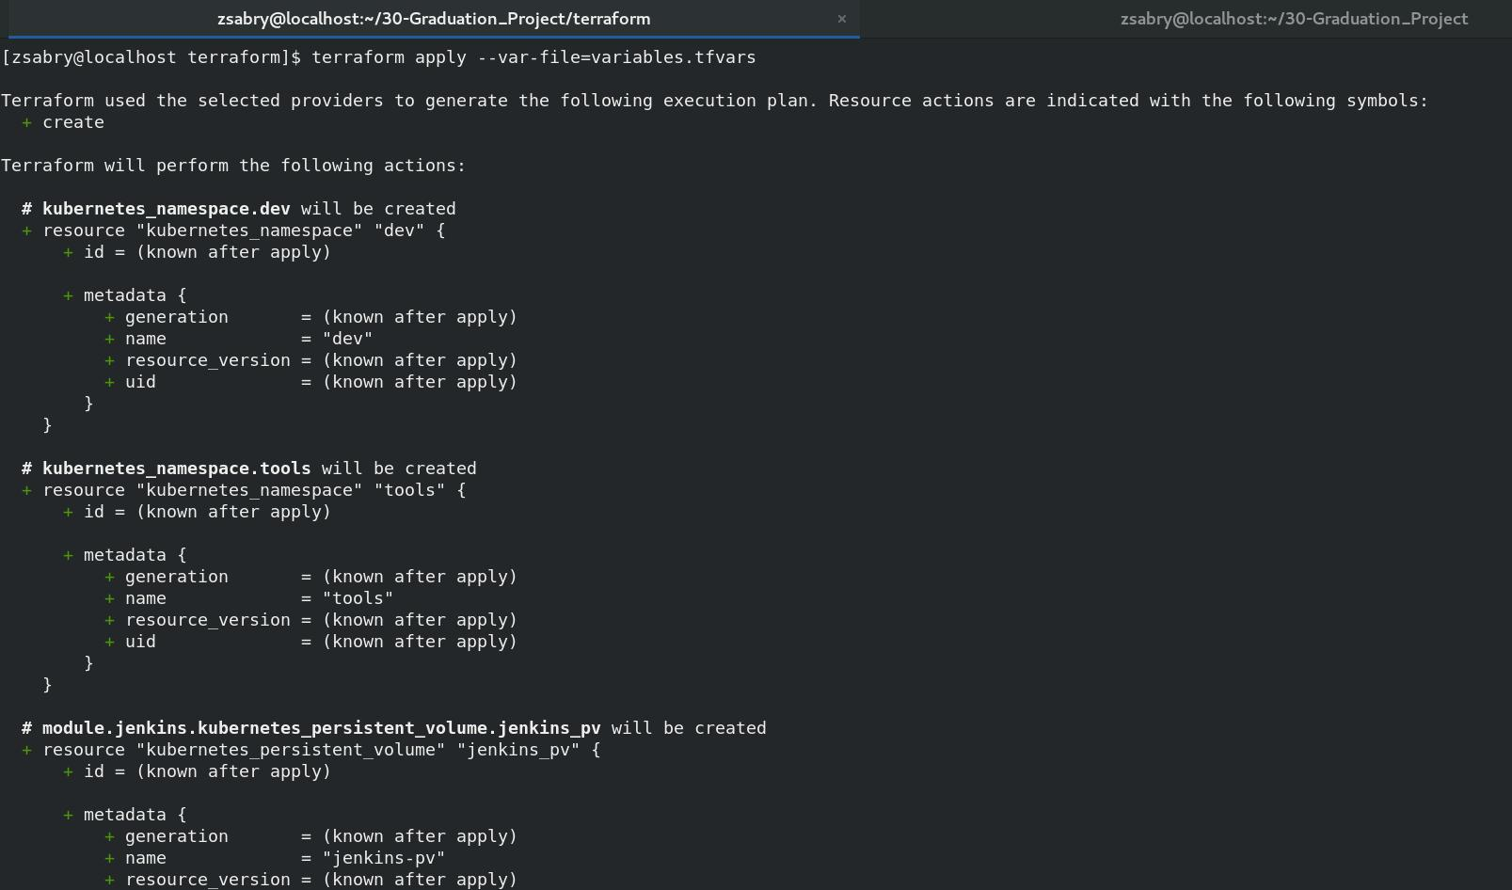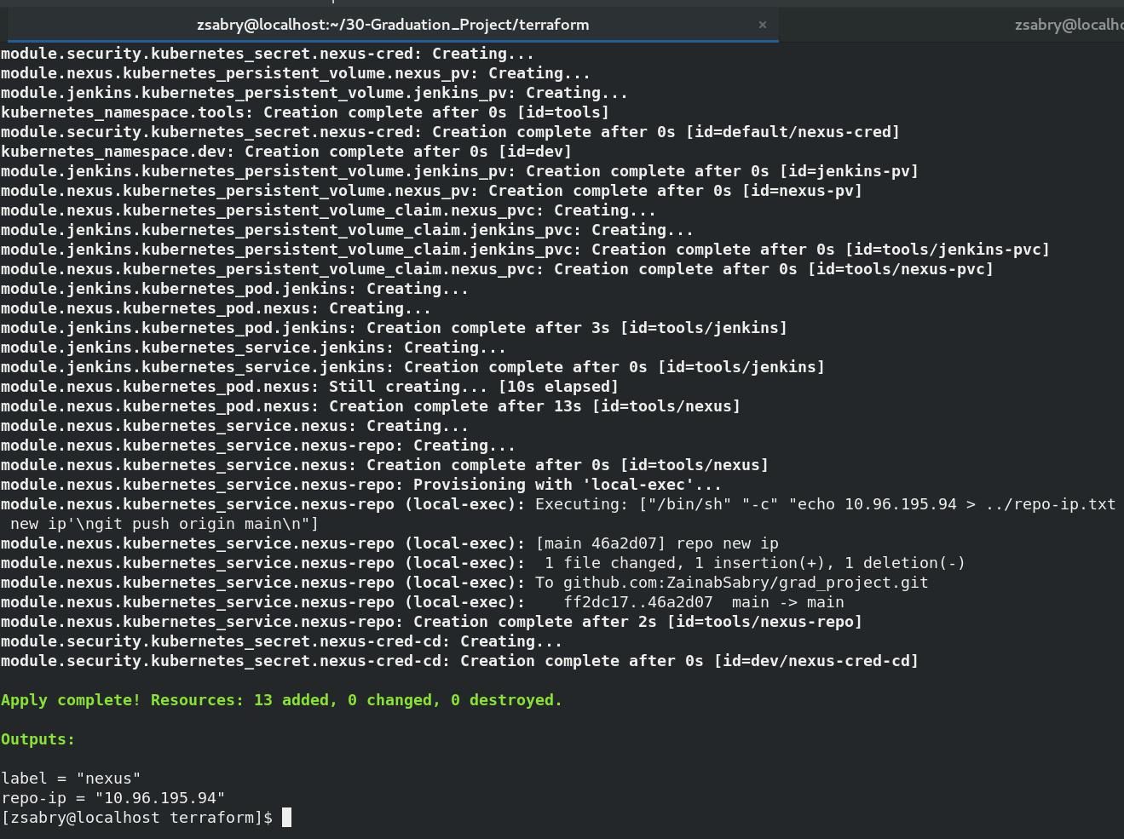

- Namespaces

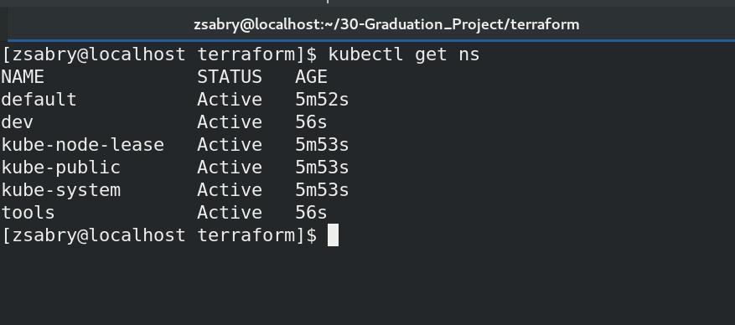

- Jenkins / Nexus pods

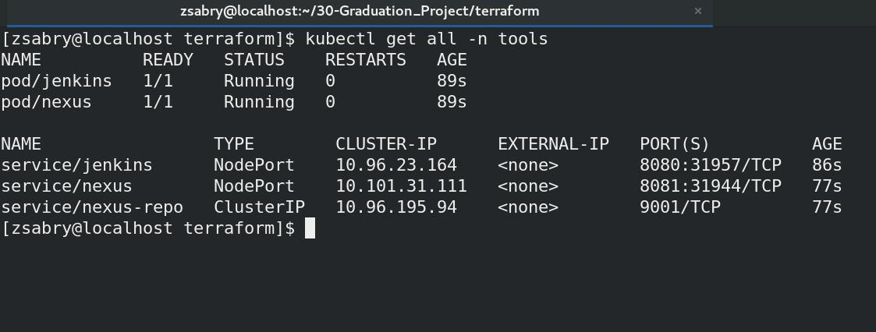

- Secrets

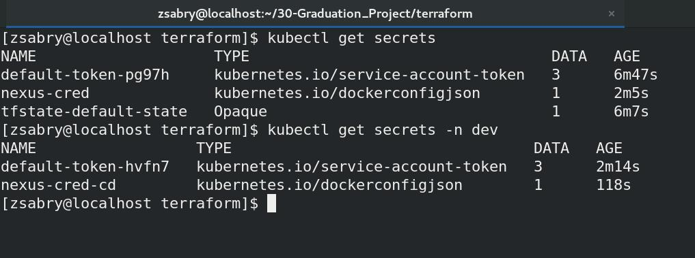

- Nexus repo-ip

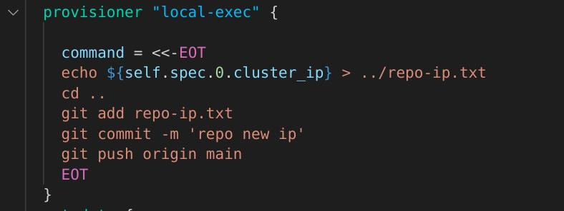

**Jenkins**

- Connect Jenkins to Minikube cluster

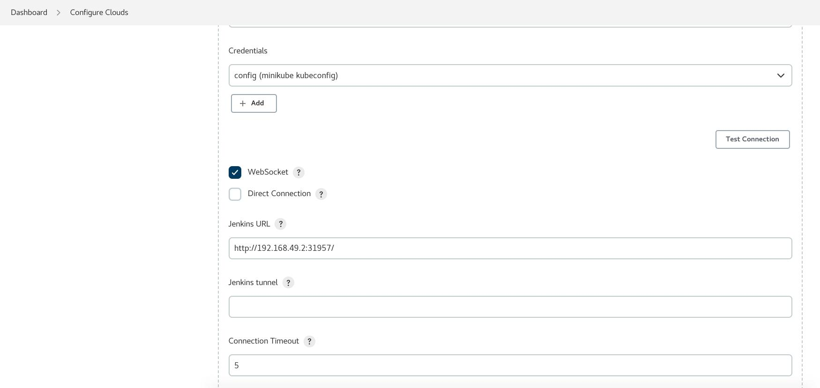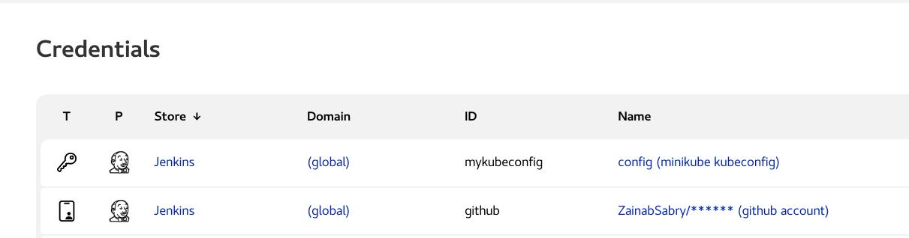



**Nexus**

- Nexus Repo

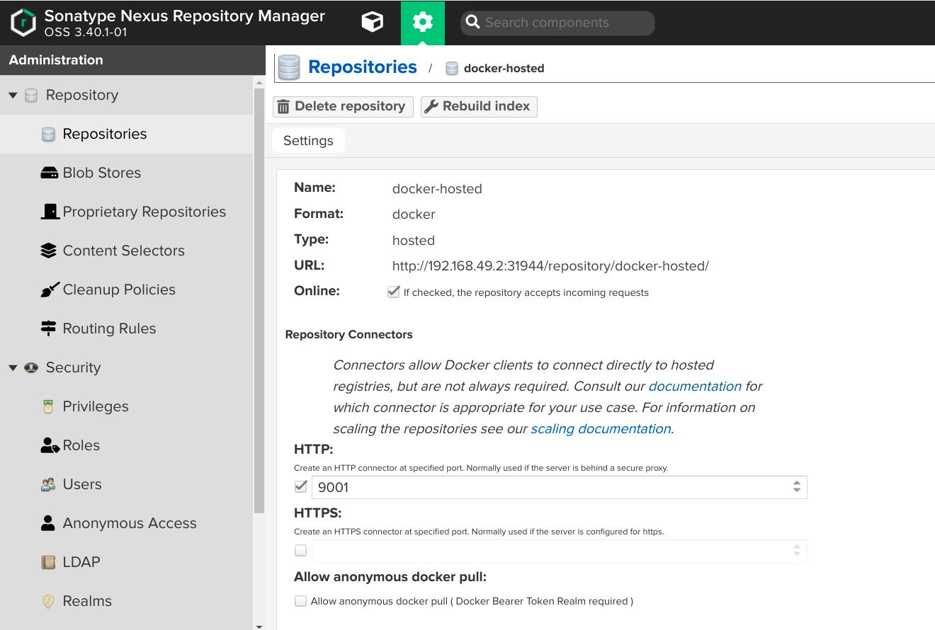

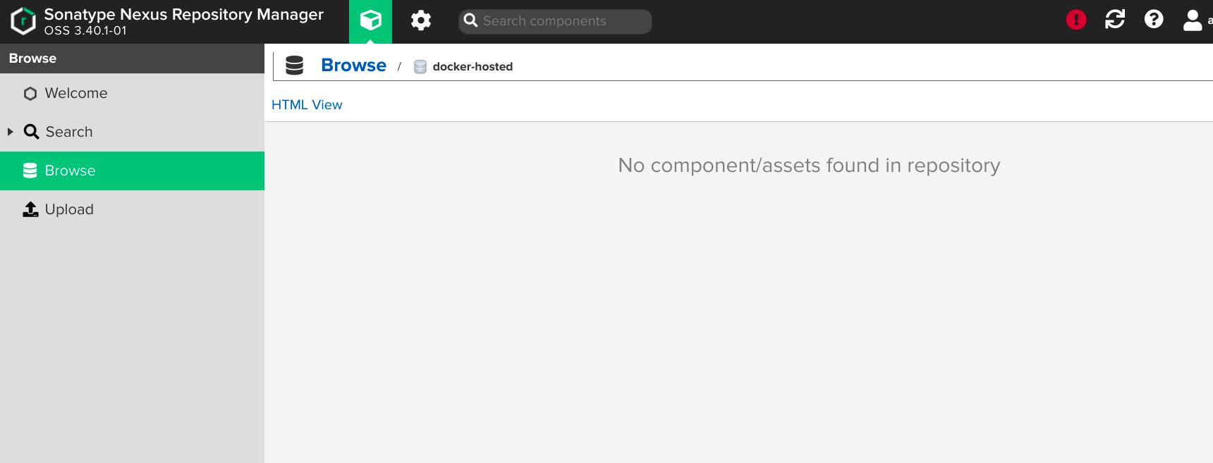

**CI**

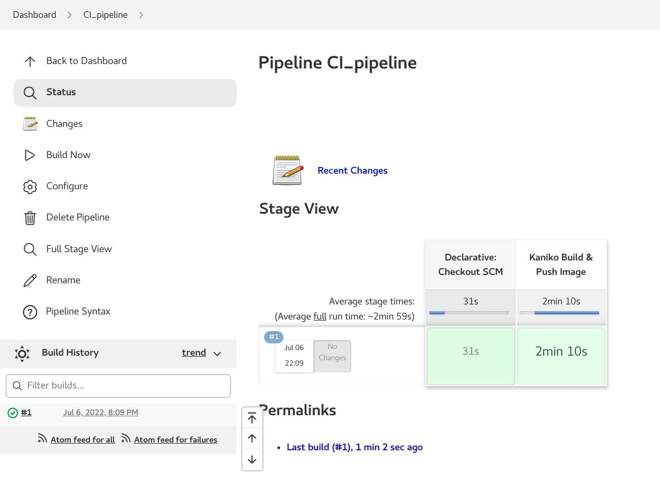- Nexus Repo after pipeline

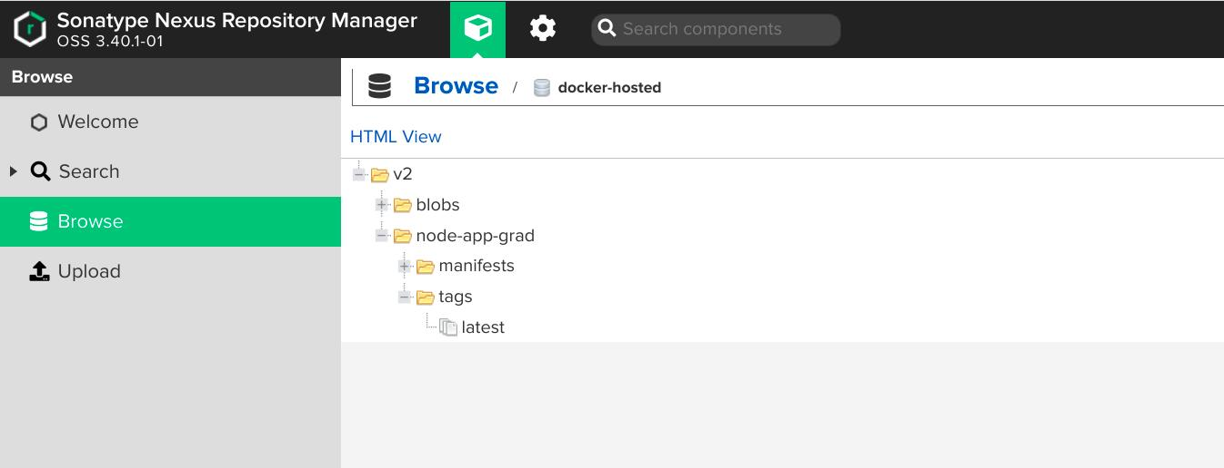

**CD**

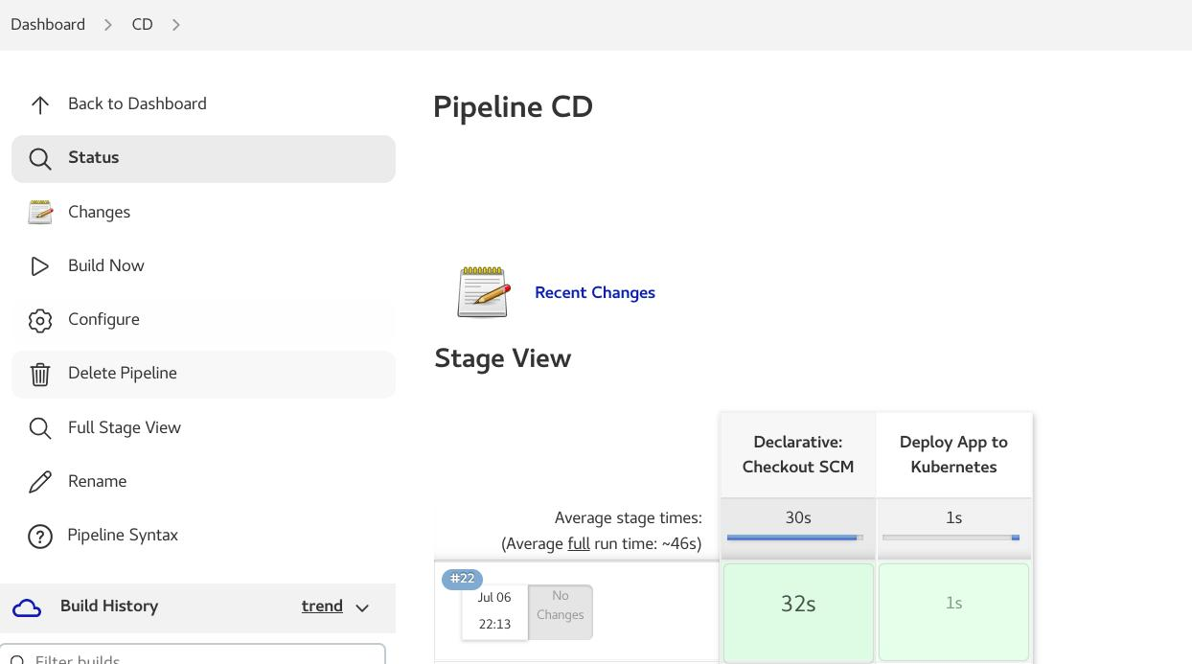- Node app deployment & Mysql deployed in minikube

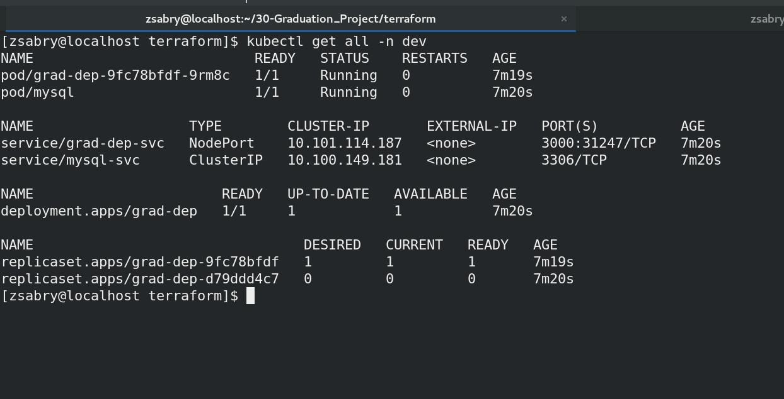

**Deployed Application**

