METHODS
Baseline system
The baseline system (Figure 3) follows a pipeline of six stages. The input, consisting of a question paired with a corresponding abstract, undergoes preprocessing which is handled implicitly by the vectorization step. The processed text is transformed into sparse feature vectors using TF-IDF, capturing term importance. Text representations are then passed into the model, a logistic regression classifier which predicts the most probable answer label. Finally, the system is evaluated using accuracy and F1-score to measure model performance.
Figure 3: Baseline system pipeline showing 6 stages.
Axes of experimentation
In order to evaluate performance and answer quality we systematically experiment with variations in text representation and AI method. We compare sparse text representations with denser embeddings and compare classification methods to answer generation. These two components are most influential in overall system performance and improvements in these components is expected to provide significant performance gains. Text representation choice determine how effectively meaningful information is captured from the input, while the model choice dictates how that information can be used to make accurate predictions. Additionally, the two components are interdependent, as different AI methods require different forms of input data so modifying the model necessitates corresponding changes in the input text representation. We therefore evaluate a set of representative pairings that align with the requirements of each method (Table 1).
 | Text representation | Model
Exp 0: baseline | TF-IDF | Logistic Regression
Exp 1 | BiomedBERT | Logistic Regression
Exp 2 | BioClinical ModernBERT | LR/MLP
Exp 3 | Raw text | BioGPT-Large
Exp 4 | Raw text | BioGPT-Large vs BioMed-R1-8B
Table 1: Experimental Setup showing Text Representation and Model across Baseline and 4 experiments.
Proposed improvements
Text representation a key component of the pipeline as it determines how linguistic and semantic information is captured from the input. Models must reason over long, information-dense contexts which will be particularly challenging for sparse representations. The baseline system using TF-IDF text representation is expected to perform adequately on straightforward instances but will struggle with complex questions and abstracts. TF-IDF representations are not able to capture word order and context which limits their ability to capture nuanced meanings and semantic relationships between words. We compare our baseline system using sparse text representation to BERT-based contextual embeddings. Contextual embeddings generated by pretrained biomedical language models BiomedBERT and BioClinical ModernBERT are able to encapsulate context-dependant meanings and are therefore expected to perform better. Multi-phase fine-tuning of BioBERT with long-answer bag-of-word statistics as additional supervision has previously achieved 68.1% accuracy (Jin et al., 2019). However this is significantly lower than single-human performance of 78% accuracy (Table 2) demonstrating a need for improvement.
The second key component of our QA pipeline is the AI method. The baseline system uses a logistic regression classifier which is chosen for its simplicity, interpretability and effectiveness on high-dimensional sparse data. While it provides a strong and efficient baseline, its performance is limited by its linear nature. This restricts its ability to capture complex patterns and interactions within the data. To address these limitations we compare our baseline system to two alternative prediction models: multilayer perceptrons (MLPs) and large language models. MLPs are expected to improve performance by enabling the model to capture nonlinear relationships within dense embeddings, allowing for more complex decision boundaries. Large language models are expected to provide the greatest performance gain as they integrate representation learning and reasoning within a single architecture making them better able to handle the complexities of biomedical language. Compared to logistic regression these models can extract and utilise contextual information from the text, resulting in increased performance particularly on more complex questions requiring deeper semantic understanding and inference.
 | Majority Performance | Reasoning-free Human Performance | Reasoning-required Human Performance
Accuracy | 0.552000 | 0.904000 | 0.780000
F1 (Macro) | 0.237113 | 0.841823 | 0.721920
Table 2: Accuracy of human annotators in reasoning free and reasoning required instances compared with majority performance of PubMedQA dataset (Jin et al. 2019.)

BiomedclinicalBERT

Methods

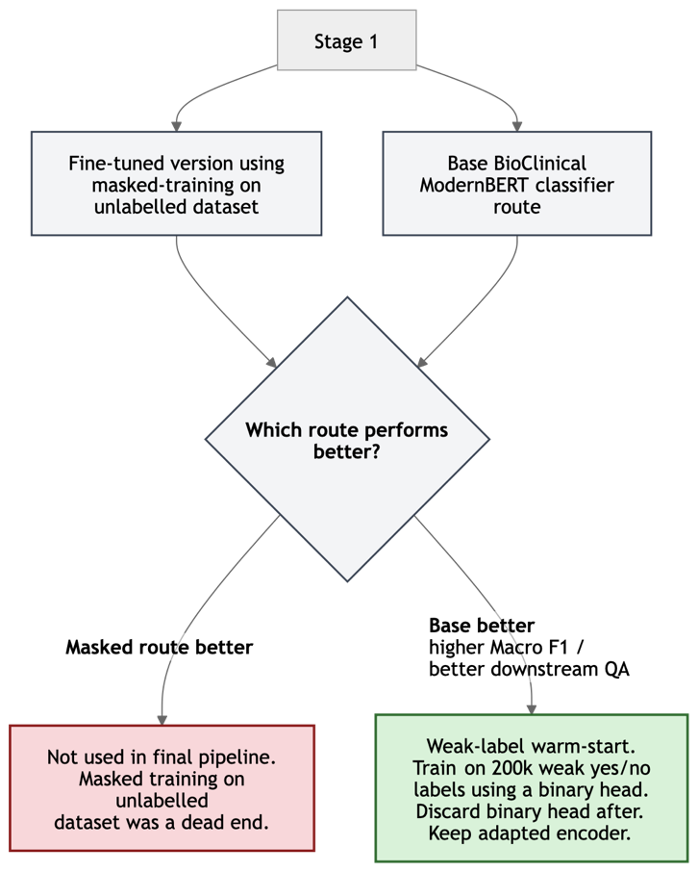 | 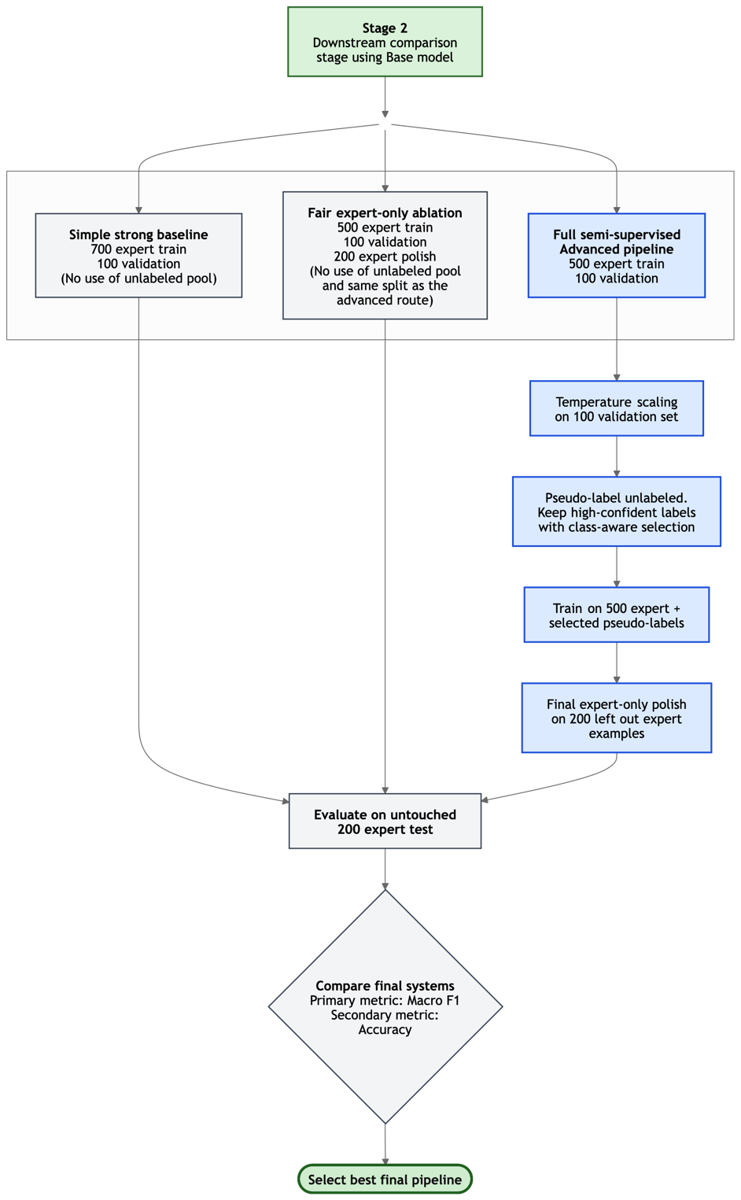

We modelled PubMedQA as a single medical question answering pipeline in which a question and its supporting abstract text are mapped to one of the labels: yes, no, or maybe. The diagram summarises the final systems and the decision process that led to it.

Preprocessing
{Each example was represented as a paired input of QUESTION and CONTEXTS, where the context strings were concatenated into a single text field. Labels were mapped as no = 0, maybe = 1, and yes = 2. Tokenisation used the paired form tokenizer(question, contexts) with truncation applied to the context side only, so that the question was always preserved in full.
We set max_length = 512. This choice was motivated by a token-length analysis over the expert-labelled data: across 5,000 examples, the mean length was 302.08 tokens, the median was 300, the 95th percentile was 443.05, the 99th percentile was 538.02, and only 90/5000 examples (1.80%) exceeded 512 tokens. This showed that 512 captures almost the entire dataset while avoiding unnecessary memory cost.} – This as well can be part of the ‘General Methods’

Base classifier and supervised optimisation
The main classifier was BioClinical ModernBERT with a three-class sequence-classification head. Initial naïve fine-tuning on fold 0 showed unstable learning and strong majority-class bias, particularly failure to model the underrepresented maybe class. We therefore treated class imbalance as the main optimisation problem and compared several training recipes to address this: plain fine-tuning, class-weighted loss, class-weighted loss plus weighted sampling, and weighted sampling alone.
Model selection used macro F1 as the primary metric, with accuracy and per-class F1 as secondary diagnostics. This was important because fold 0 was imbalanced: in training, yes = 249, no = 152, and maybe = 49; in development, yes = 27, no = 17, and maybe = 6. The final (best) supervised recipe used weighted sampling only, no class-weighted loss, a learning rate of 8e-6, gradient_accumulation_steps = 2, dynamic padding with DataCollatorWithPadding, early stopping with patience 2, and checkpoint selection by validation macro F1. This gave the best balance across classes and became the reference point for all later improvements.

Masked-training pilot and route selection
Our first proposed improvement was masked language model adaptation on the unlabelled biomedical text. The hypothesis was that further encoder adaptation on unlabelled data would improve downstream question answering. To test this cheaply, we ran a pilot masked-training stage on 5,000 examples drawn from an unlabelled pool of roughly 42,000 examples, with a smaller held-out subset for MLM evaluation. The remaining unlabelled data was reserved in case the pilot succeeded for further finetuning later on (pseudo-labelling).
All experiments were run on a MacBook M1 Max with 32 GB RAM using PyTorch and Hugging Face on MPS. Masked training was far more memory-intensive than downstream classification. Peak RAM remained high even when batch size was reduced from 8 to 2, indicating that memory use was driven mainly by model weights, activations, token-level tensors, and full bidirectional self-attention rather than batch size alone. Several reruns were required while adjusting batch size, gradient accumulation, sequence length, and epochs simply to obtain stable runs. Although MLM validation loss improved, downstream PubMedQA classification did not improve, even after extending training and restoring the full 512-token length from an initial 384. We therefore rejected the masked-training branch and continued with the better-performing base classifier route.

Weak-to-strong downstream pipeline
After rejecting masked adaptation, we designed the final system as a weak-to-strong semi-supervised pipeline. The weakly labelled set contained approximately 200,000 yes/no examples. We first fine-tuned the encoder on this binary task using a binary classification head, then discarded that head and retained only the adapted encoder. This stage was intended to teach coarse biomedical task structure cheaply, without forcing the model to learn the maybe class from weak labels that did not contain it.
We then constructed three downstream pipelines, all evaluated on the same untouched 200-example expert test set.
The first was a simple strong baseline: weak-label warm-start, followed by direct three-class fine-tuning on 700 expert training examples with 100 expert validation examples, and no use of the unlabelled pool. This tests whether a simple pipeline using more clean expert labels can outperform more elaborate semi-supervised methods.
The second was a fair expert-only ablation: weak-label warm-start, then three-class training on 500 expert train and 100 expert validation, followed by a final expert-only polish on a separate set of 200 expert examples. This matched the supervision schedule of the advanced route while excluding pseudo-labelling, so any performance difference could be attributed to the pseudo-label stage rather than a different data budget.
The third was the full semi-supervised advanced pipeline. Starting from the same weak-label warm-start, we trained a three-class expert teacher on 500 expert train and 100 expert validation. We then applied temperature scaling on the 100-example validation split so that pseudo-labelling decisions were based on calibrated probabilities rather than raw softmax scores. This teacher was used to pseudo-label an unlabelled pool of examples. To reduce confirmation bias and class drift, only high-confidence pseudo-labels were retained, using class-aware selection rather than a single global threshold. The model was then trained on the combination of the 500 expert examples and the selected pseudo-labelled examples, followed by a final expert-only polish on the held-back 200 expert examples.

Experimental design and leakage control
{The overall design followed a staged scientific method. We first optimised a strong supervised classifier, then tested one proposed improvement at a time to keep the experimental logic interpretable and avoided changing multiple major components simultaneously.
The downstream comparison was designed specifically to avoid leakage. The 200 final expert test examples were fixed in advance and never used for training, calibration, threshold selection, pseudo-labelling, or model selection. The final three models/ablations were then compared on this test set.
Across all final comparisons, macro F1 was the primary metric because class balance, especially on maybe, mattered more than raw accuracy. Accuracy was reported as a secondary metric. Our final hypothesis for BiomedClinicalBERT was that the full semi-supervised advanced pipeline would perform best, because it combines coarse adaptation from 200k weak labels, expert correction from 500 clean labels, selective expansion through calibrated high-confidence and class-aware pseudo-labelling on the unlabelled examples, and lastly, a final expert-only refinement stage.} – This final bit is for everyone. Im thinking, at the start we have a “General Methods” of all the things we all did so we don’t repeat ourselves in our sections and then we frame it under the ‘scientific method’ and a ‘design of experiments’ approach. I reckon theyd eat that up!

REFERENCES
Jin, Q. et al. (2019) ‘PubMedQA: A Dataset for Biomedical Research Question Answering’, in K. Inui et al. (eds) Proceedings of the 2019 Conference on Empirical Methods in Natural Language Processing and the 9th International Joint Conference on Natural Language Processing (EMNLP-IJCNLP). EMNLP-IJCNLP 2019, Hong Kong, China: Association for Computational Linguistics, pp. 2567–2577. Available at: https://doi.org/10.18653/v1/D19-1259.
Sakamoto, H., Watanabe, Y. and Satou, M. (2011) ‘Do preoperative statins reduce atrial fibrillation after coronary artery bypass grafting?’, Annals of thoracic and cardiovascular surgery, 17(4), pp. 376–382.
Luo, R., Sun, L., Xia, Y., Qin, T., Zhang, S., Poon, H. and Liu, T.-Y. (2022), BioGPT: Generative Pre-trained Transformer for Biomedical Text Generation and Mining. Briefings in Bioinformatics, 23(6), bbac409.
- Justifies BioGPT-Large as a generative biomedical QA model and strong literature benchmark, reporting 78.2% accuracy on PubMedQA and showing that domain-specific generative language models can perform very strongly on biomedical question answering.
Singhal, K., Tu, T., Gottweis, J., Sayres, R., Wulczyn, E., Amin, M., Hou, L., Clark, K., Pfohl, S.R., Cole-Lewis, H., Neal, D., Rashid, Q.M. and others. (2025), Toward expert-level medical question answering with large language models. Nature Medicine, 31, pp. 943–950.
- Justifies comparing classifier-based systems with LLM-based medical QA, showing that specialist medical LLMs can achieve very strong performance on medical QA benchmarks including PubMedQA.
Thapa, R., Wu, Q., Wu, K., Zhang, H., Zhang, A., Wu, E., Ye, H., Bedi, S., Aresh, N., Boen, J., Reddy, S., Athiwaratkun, B., Song, S.L. and Zou, J. (2025), Disentangling Reasoning and Knowledge in Medical Large Language Models. arXiv preprint arXiv:2505.11462.
- Reason for including BioMed-R1-8B as a recent reasoning-focused biomedical language model for reasoning based tasks.
Gu, Y., Tinn, R., Cheng, H., Lucas, M., Usuyama, N., Liu, X., Naumann, T., Gao, J. and Poon, H. (2020), Domain-Specific Language Model Pretraining for Biomedical Natural Language Processing. arXiv preprint arXiv:2007.15779.
- Justifies testing PubMedBERT/BiomedBERT-style contextual embeddings, showing that biomedical-domain pretraining improves downstream biomedical NLP performance.
Warner, B., Smyrnis, G., Queijo, J., Pióro, P., Duderstadt, B., Repinski, L., Miller, A., Marx, K., Mazaré, P.-E., Gokaslan, A., Howard, J., Bekman, S. and Rafailov, R. (2025), Smarter, Better, Faster, Longer: A Modern Bidirectional Encoder for Fast, Memory Efficient, and Long Context Finetuning and Inference. In Proceedings of ACL 2025.
- The reason we are using ModernBERT-based classification, presenting ModernBERT as a stronger and more efficient encoder with improved long-context handling for classification tasks.
Younes, Y. and Mathiak, B. (2022), Handling Class Imbalance when Detecting Dataset Mentions with Pre-trained Language Models. In Proceedings of the 5th International Conference on Natural Language and Speech Processing (ICNLSP 2022), pp. 79–88.
- Justifies prioritising macro F1 and imbalance handling, showing that class imbalance can significantly affect pretrained language model classifiers and minority-class performance.
Gururangan, S., Marasović, A., Swayamdipta, S., Lo, K., Beltagy, I., Downey, D. and Smith, N.A. (2020), Don’t Stop Pretraining: Adapt Language Models to Domains and Tasks. In Proceedings of ACL 2020.
- Gives credence to using the masked-language-model adaptation pilot, showing that continued pretraining on in-domain or task-relevant unlabeled text can improve downstream classification.
Yang, W., Zhang, R., Chen, J. and Sheng, J. (2025), Calibrating Pseudo-Labeling with Class Distribution for Semi-supervised Text Classification. In Proceedings of EMNLP 2025.
- Justifies the calibrated pseudo-labeling and class-aware semi-supervised pipeline, showing that pseudo-labeling can bias toward majority classes and that calibration can improve reliability.

