­­

Human Computer Interaction

­

DT228/2

AMIR AKBARI

C1842284

Contents

Introduction 2

Website Design 2

Heuristic Evaluation using Nielsen's Heuristics 6

Website Redesign 7

Conclusion 10

References 11

# Introduction

I have chosen powercity.ie as my website for discussion, I think this website needs so much improvement, So on this report I’m going to redesign this website using low and medium Fidelity Prototypes and making sure using Nielsen’s 10 General Principle for the interaction design.

# Website Design

Powercity.ie

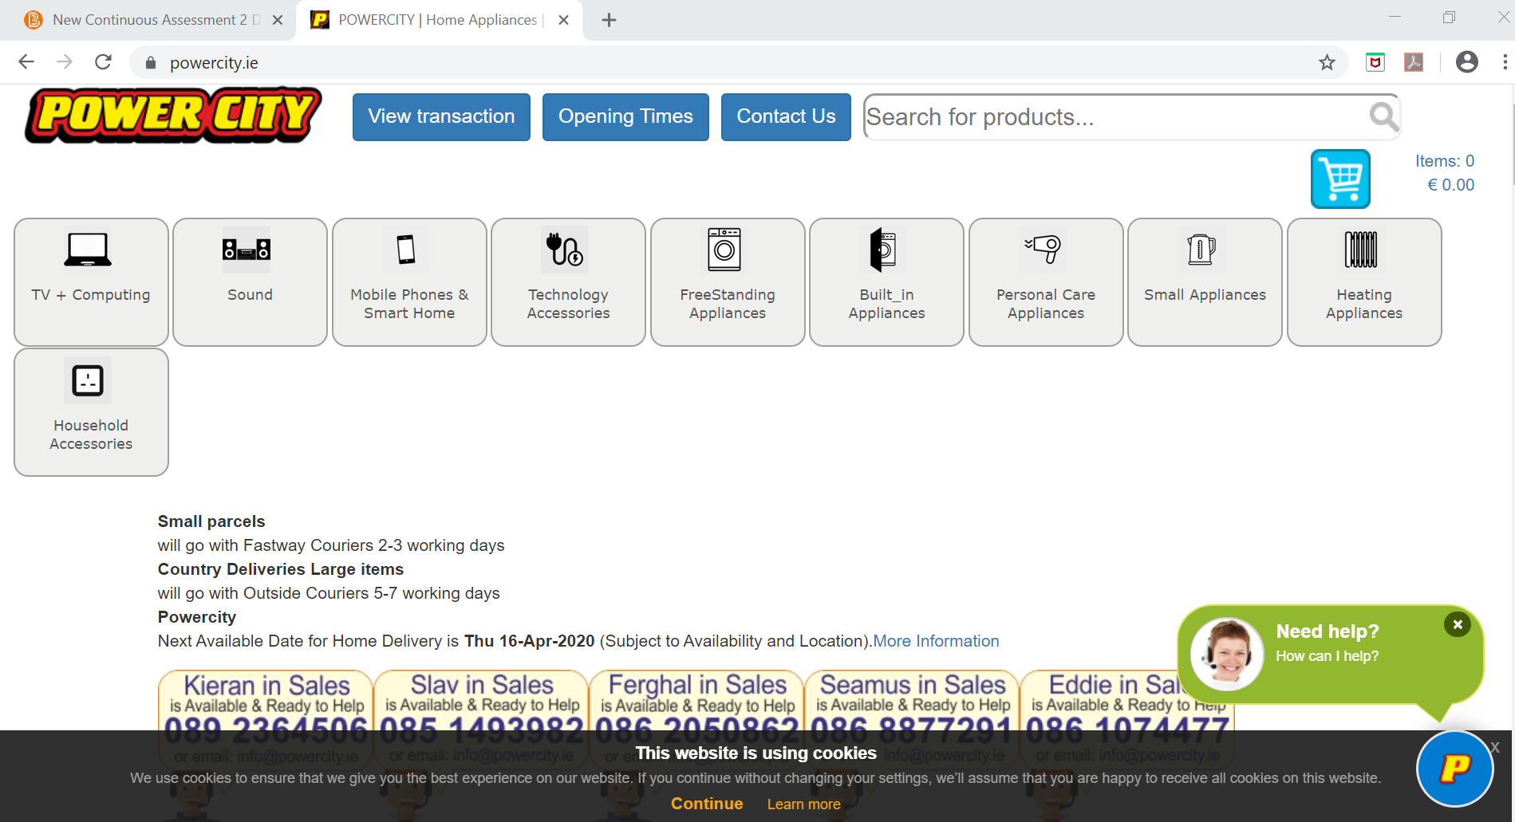

In this website there is no drop down menu, which I think is one big problem, as you can see the only display the buttons which they using it as menu. There is so much white spaces in this website and this website is so long because they advertise so much which I think this would be so hard for people to look for something they wanted or even memories it.

The bar menu or the buttons won’t move with the page so that means the users have to go all the way back at the top to order search for something, but also there is some good points which for example the big text they used, it clear and everyone can read it, when users choose something and when they going to the basket it would show the options for delivery before users pay.

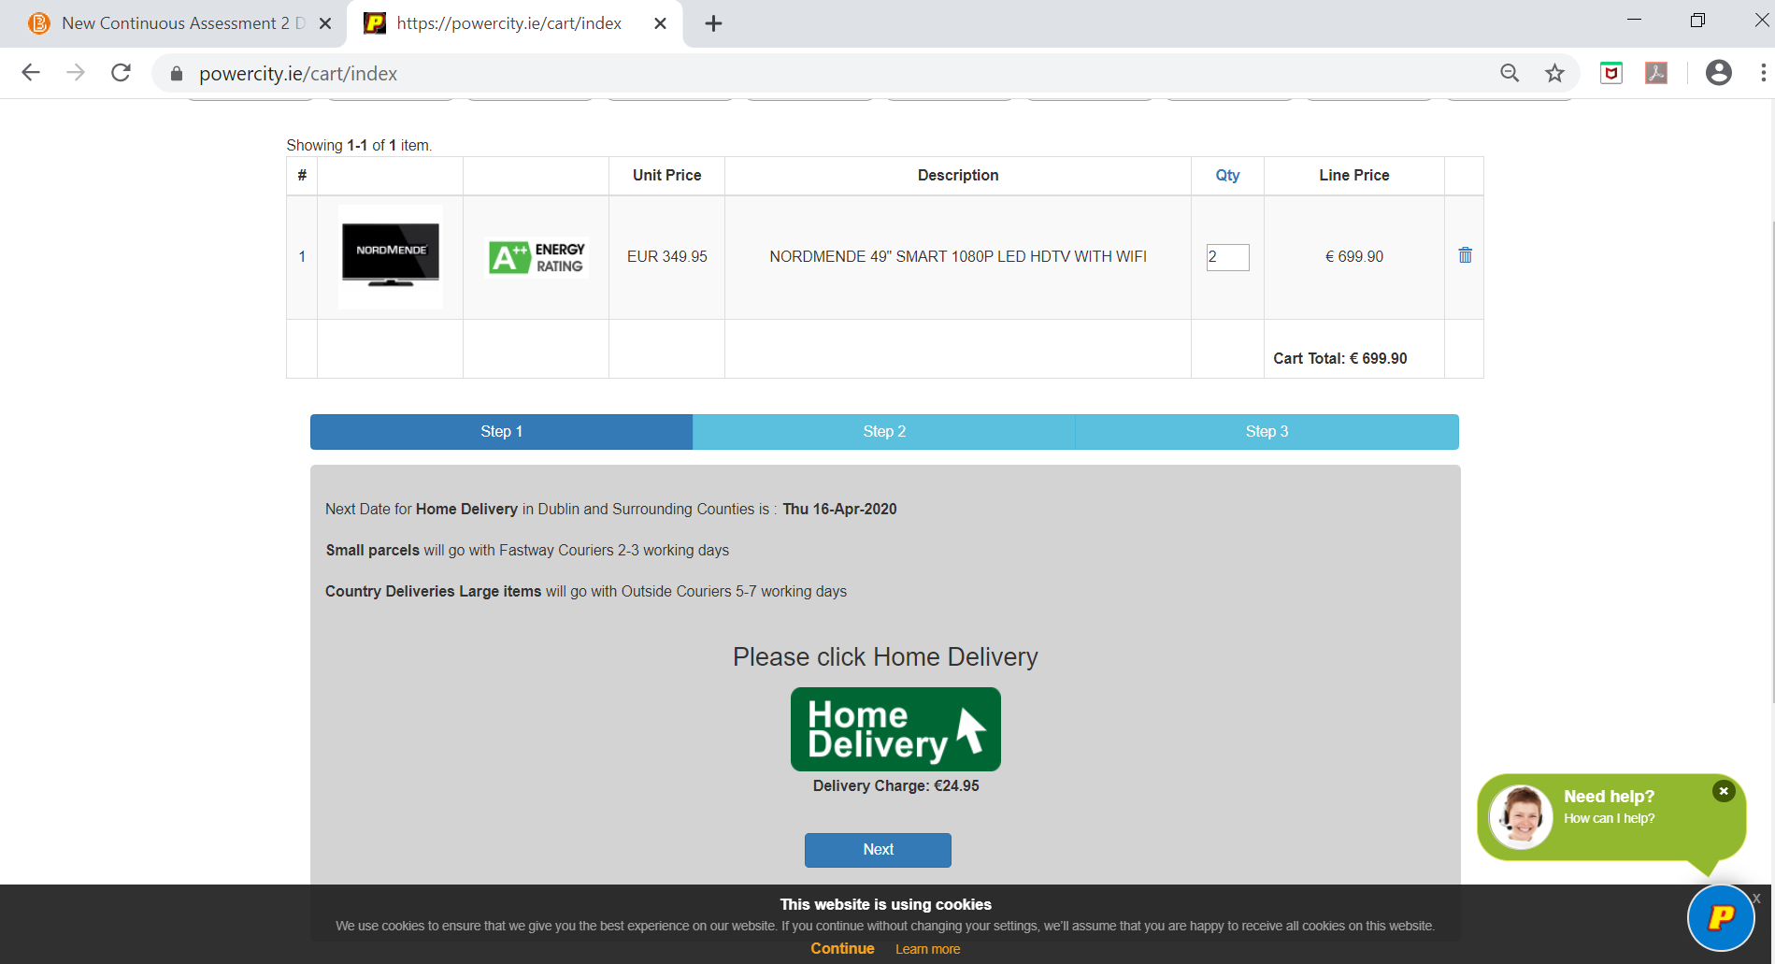

This website Speak the users language, not clearly marked for the exit users have to press back on the keyboard or press back on the top of the page. So many information again in those buttons menu, in this website they using a huge footer which again so many white spaces around and I think the texts are small if someone have some eyes problem then it is hard for them to read it.

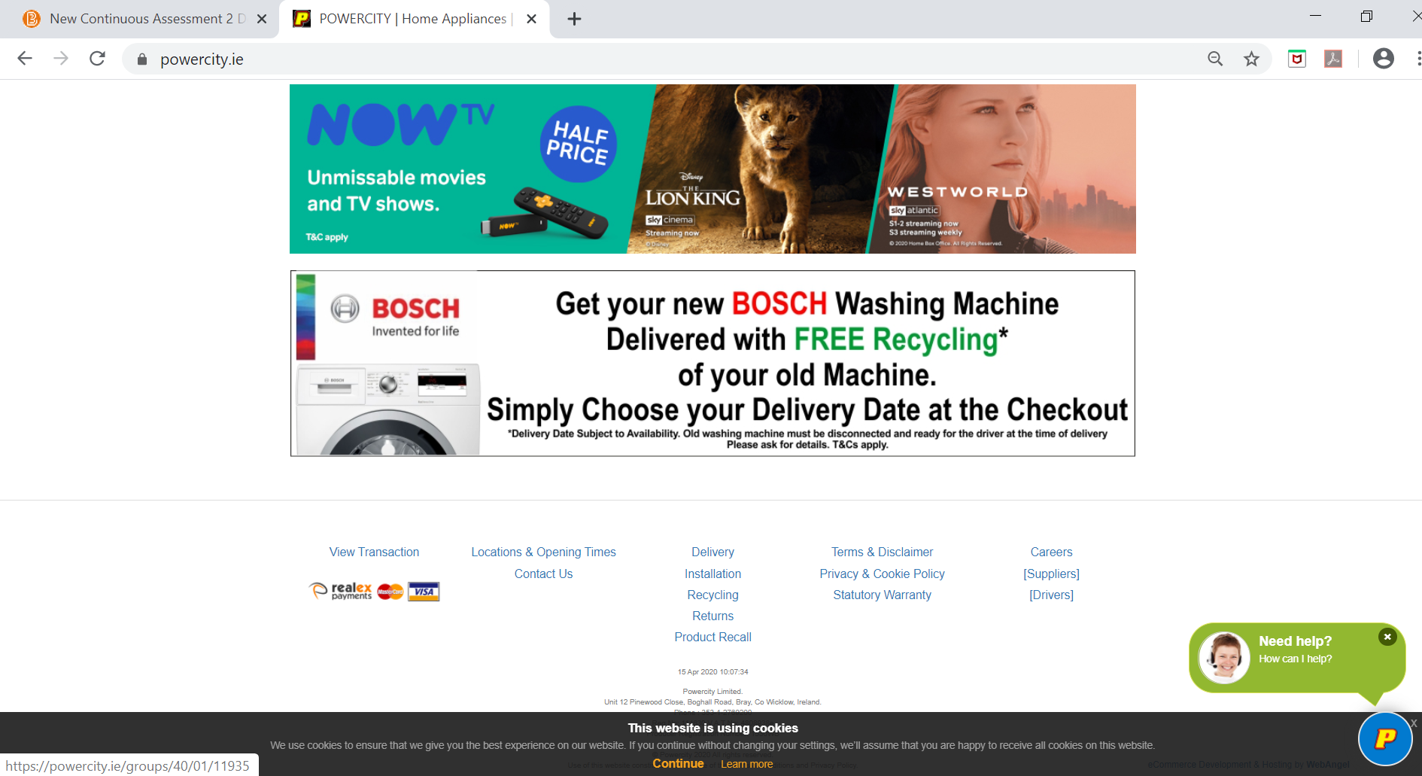

too much information it’s a bit hard to find one thing I think for older user it going to be so hard to but something online form this website so they viewers for this website would be low. But the information is new and well updated. It is a simple website, there is no Good Error massage.

The website is accessible it’s easy enough to use it for example if someone can’t use the mouse can use the tab button to get through all the content. They can press enter in each buttons and then you have drop down which is good for the people who can’t type. Also there a is option on the left side which u can narrow your searches by brand, power source.

I used <https://wave.webaim.org/> website to find out specific errors and also here is the results

This website have 16 Errors, 4 contrast Errors, 43 alerts, 38 features, 16 Structural Elements and 127 ARIA

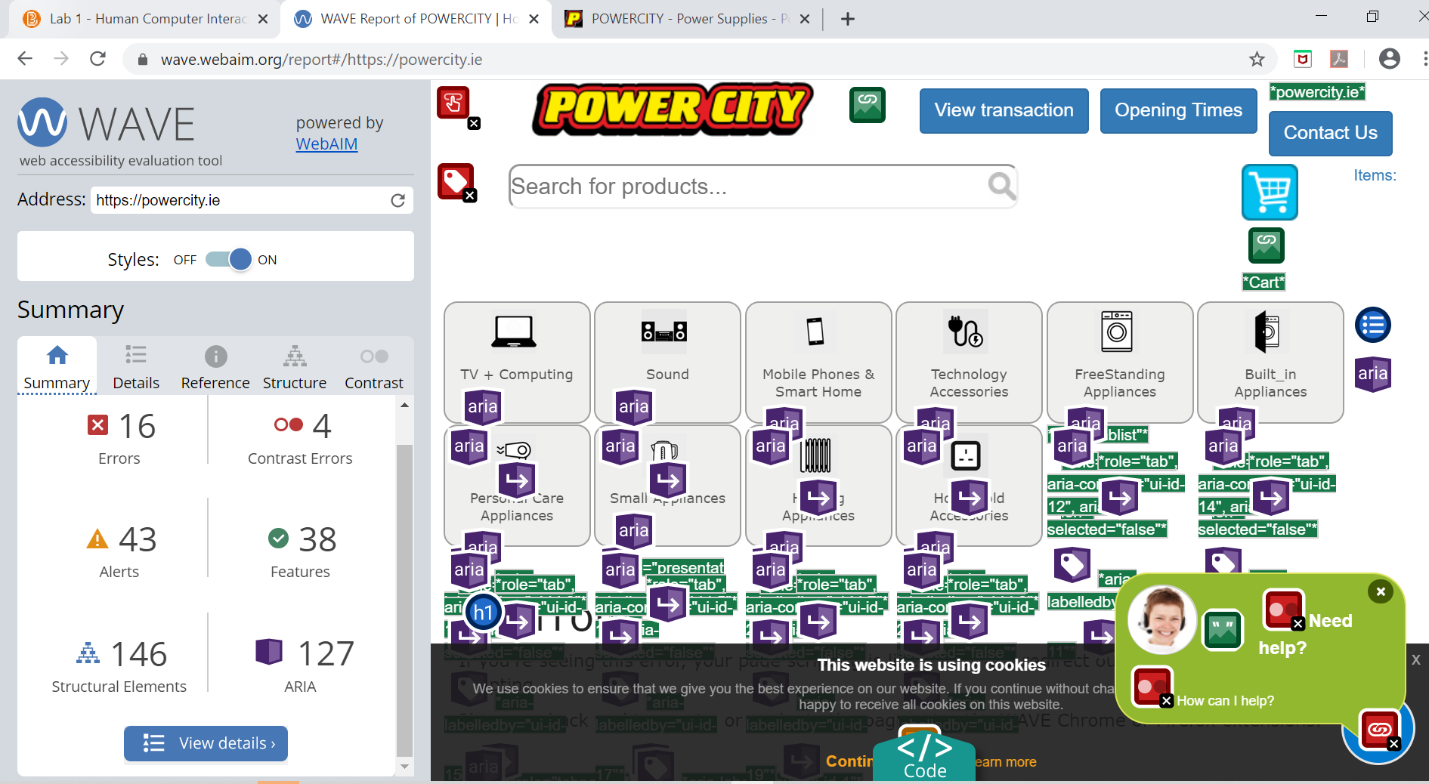

And then I used <https://ready.mobi/> to see how mobile friendly is this website and here is the results:

The tested page performed extremely poorly, scoring only 0.69. Some serious test failures were detected and should be addressed. The tested page weight, in terms of bytes downloaded, is very high and user experience will suffer as a result.

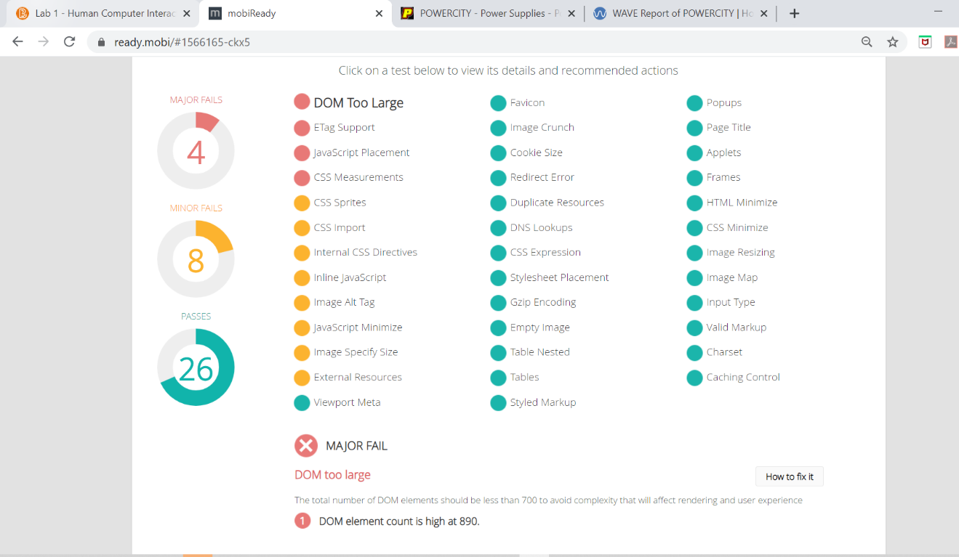

# Heuristic Evaluation using Nielsen's Heuristics

1. Visibility of system status?

No Login Page for customers.

1. Match between system and the real world?

Speaks users language, only the stock check buttons can be confusing for users

1. User Control and freedom?

Users can search normally but there is no go back.

1. Consistency and standards ?

Just menu would be confusing for some people and maybe to find something on the page

1. Help users recognise, diagnose and recover from errors?

If the product is not on database or its sold out, it wont display massage, users have to check first, which I think it bad and wasting users time.

1. Recognition rather than recall ?

Yes, a lot. We had to keep go back and its hard to memorise the names and prices.

1. Error prevention ?

No, there was no Error for SQL or failed to display a massage or image.

1. Flexibility and efficiency of use ?

There was no keyboard shortcuts, everything was using mouse mainly and it was hard to use keyboard but it is possible.

1. Aesthetic and minimalist design?

Basic design, and also too much going on, a lot of white spaces.

1. Help and documentation ?

There is help button which users can chat there, there is feedback page and contact page.

# Website Redesign

Original Design

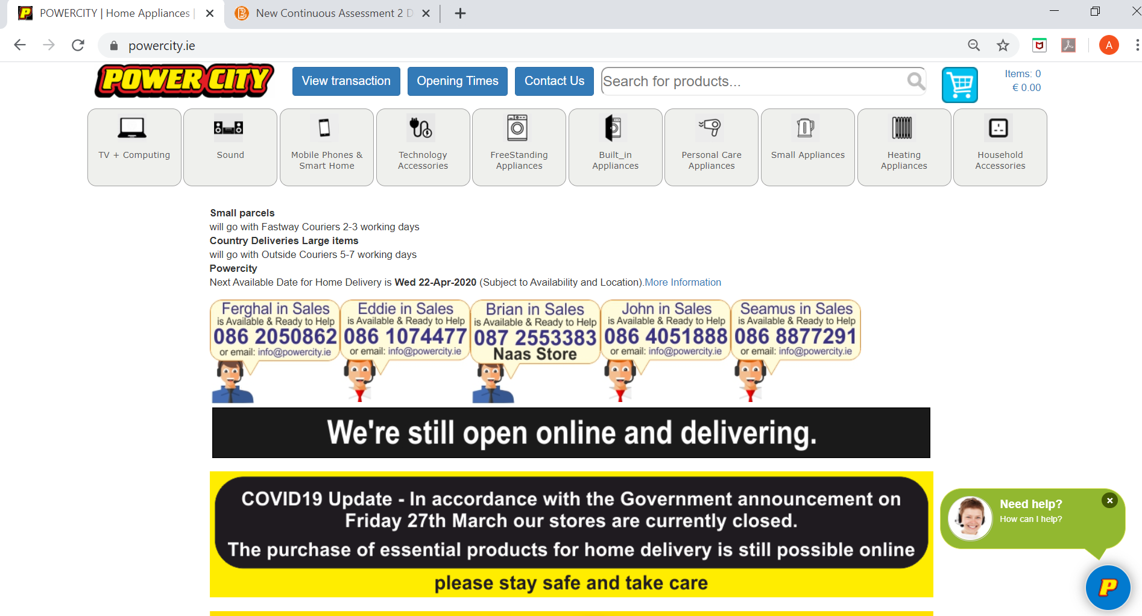

Here is the original design for PowerCity.ie website as we see lots of stuff could be improve for example there is lots of boxes, there is lots of white spaces, the menu doesn’t look great.

So here is some improvement I worked on, for me menu was the priority then I tried to reduce the boxes and get rid of the white spaces.

**Final Paper Prototype**

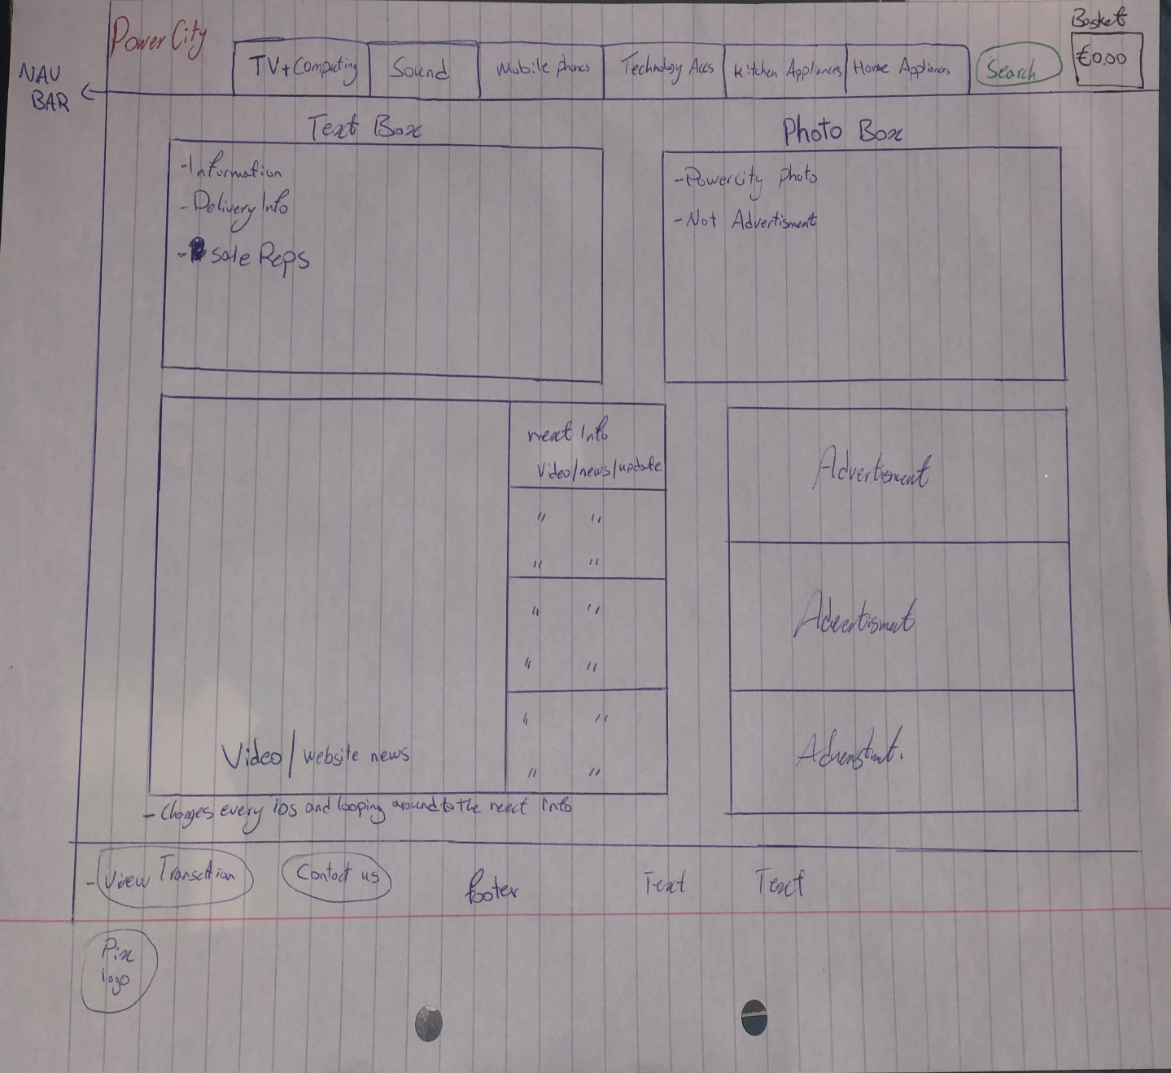

**NOTE: video box will change every 10s and loops through all content**

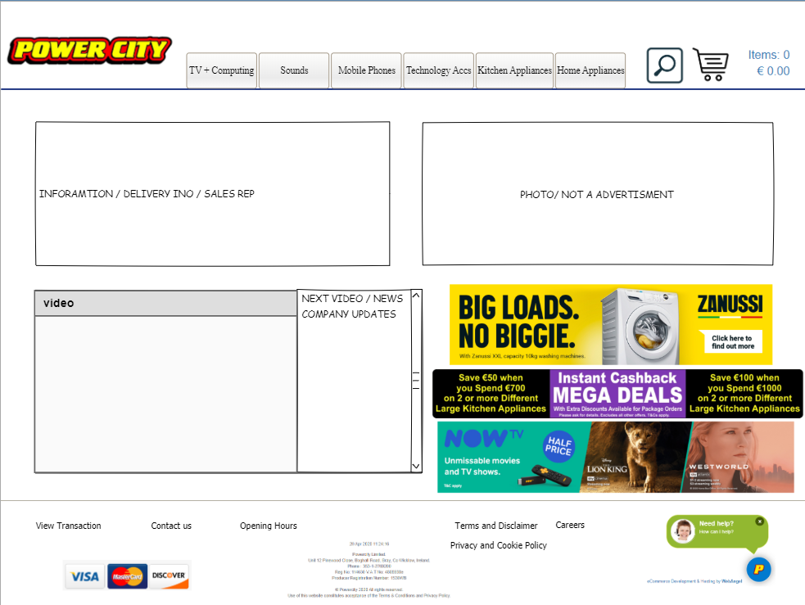**Medium Fidelity Prototype**

# Conclusion

In my opinion this website wasn’t great as design, so I have redesign it and I think already looks better and more modern. The old design had some major problems, if an older user was trying to but something online they definitely would have problems. It was so hard to memorise all the deals and prices. There is not exist mark. The menu was so confusing even for myself. There wasn’t any major error on the page which that’s good, it was only so much advertisement boxes and so many white spaces.

Now in this new design I did I reduced the menu to 6 buttons s now if someone need kitchen appliances would click on that then they would see all, also if someone looking for specific item they could filter that page base on their max and min price and brands they want. Also I reduced the advertisement boxes and tried to fit them nicely, I think this now looks like much better and also I added the new video box which can have videos and texts which every 10s would loops through each one and shows in big side, I think this new design would help in memorising stuff and it is easier to use it.

I’m pretty sure there could be more improvement like for example take the menu and create a drop down menu on the right side. But I thought this would be the simple version of what we have already and just few pieces improved.

What have I learned from this assignment:

1. Learned more about web design
2. Learned about Nielsen's Heuristics
3. Learned Pencil tool for Prototypes

And yes I have enjoyed this assignment.

# References

1. <https://www.nngroup.com/articles/ten-usability-heuristics/>
2. <https://www.interaction-design.org/literature/article/heuristic-evaluation-how-to-conduct-a-heuristic-evaluation>
3. <https://careerfoundry.com/en/blog/ui-design/8-sites-with-great-ui/>
4. <https://ready.mobi/>
5. <https://wave.webaim.org/>
6. <https://www.interaction-design.org/literature/topics/interaction-design>
7. <https://www.justinmind.com/blog/17-interactive-website-designs-youll-want-to-steal/>
8. <https://www.guerillagirl.de/2017/03/18/seven-stages-of-action-don-norman/>
9. <https://theblog.adobe.com/prototyping-difference-low-fidelity-high-fidelity-prototypes-use/>
10. <https://www.sciencedirect.com/topics/computer-science/medium-fidelity>