W228/307c



DUBLIN INSTITUTE OF TECHNOLOGY
_____________

BSc. (Honours) Degree in Computer Science

Year 3
______________

WINTER EXAMINATIONS 2017/18
______________

Mobile Software Development cmpu3026

Dr. Susan McKeever
Dr. Deirdre Lillis
Mr Kevin Foley

Friday 19th january 16:00 p.m. – 18:00 p.m.

Duration: 2 Hours

Instructions to candidates

Question 1 is compulsory.

Answer Question 1 and two of the remaining three questions

Question 1 carries 50 marks. All other questions carry 25 marks each.

Q1. | (a) | Write the XML code for the row layout required for the list shown in Figure 1.
(10 marks)

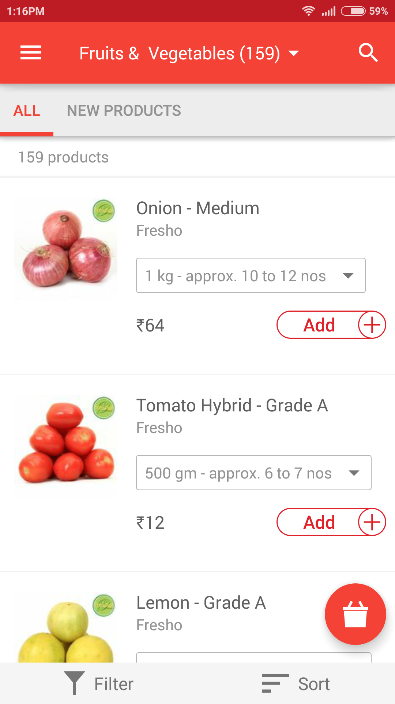
Figure 1 List

<TextView>android:id =”” android:text=”” </TextView>
<linearLayout>
<ImageView> </ImageView>
<TextView>android:text=”” </TextView>
<Spinner> </Spinner>
<TextView>android:text=”” </TextView>
<ImageButton> </ImageButton>

</LinearLayout>

 | (b) | Android uses resources for static information. Describe the following:  - Two examples of how resources (held in the res directory) can be used to simplify software maintenance. (5 marks)  Resource have drawable and layout files, drawable file store image and layout file store screen design. It helps designer easy and fast to find resource.  - How resources play a part in making Android compliant with Model-View-Controller principles. (5 marks)  - View = layout, resources and built-in classes like Button derived from android.view.View.  - Controller = Activity  - Model = the classes that implement the application logic  (10 marks)
 | (c) | Explain the use of custom adapters in Android list development. In your own words, explain how to implement a custom adapter based on using an array as the data source.  Use ArrayAdapter and arrayList  Custom adapter can use to control the out put.  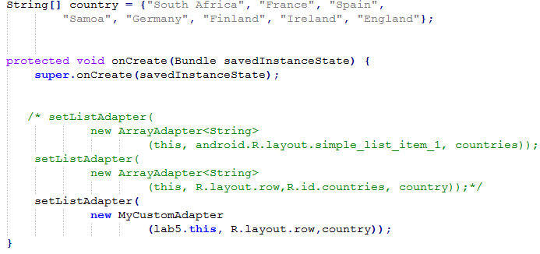  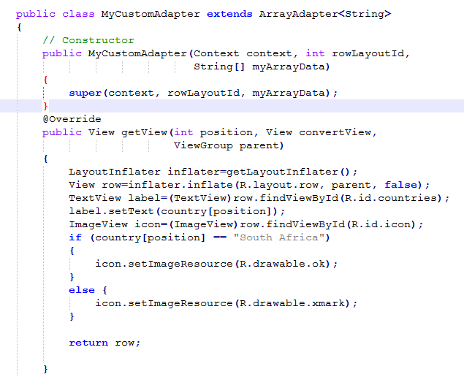  \ (10 marks)
 | (d) | Answer, with explanation, the following questions about the code in Figure 2:  - Pick out an example of casting and explain its use.  ListView lv = (ListView) view.findViewById(R.id.lvSome);  Find id is lvSome from layout and set it to type of listView. (4 marks)  - What class does the inflate() method belong to? (line 25) (3 marks)  LayoutInflater  - Why are the brackets < > used? (line 18) Declare the data type in the array (3 marks)  - How would you change the code in order to encapsulate(封装) the attributes of the MyFragment class?  Private ThingsAdapter adapter;  Public ThingsAdapter getAda()  {return adapter}  Public void setAda(ThingsAdapter adapter)  {this.adapter = adapter} (3 marks)  - What class does the setAdapter() method belong to? (line 31) (3 marks)  View  - What do static and final mean as used in line 5? (4 marks)  Static is variable maxCount will initialized first and once when execution  Final is variable maxCount get a value can not make change.  Initiazed maxcount = 2 and cant make change  (Q1(d) 20 marks)
1 public class MyFragment extends Fragment
2 {
3 ThingsAdapter adapter;
4 FragmentActivity listener;
5 static final maxCount = 2;
6
7
8 public void onAttach(Context context) {
9 super.onAttach(context);
10 if (context instanceof Activity){
11 this.listener = (FragmentActivity) context;
12 }
13 }
14
15
16 public void onCreate(Bundle savedInstanceState) {
17 super.onCreate(savedInstanceState);
18 ArrayList<Thing> things = new ArrayList<Thing>();
19 adapter = new ThingsAdapter(getActivity(), things);
20 }
21
22
23 public View onCreateView(LayoutInflater inflater, ViewGroup parent, 24 Bundle savedInstanceState) {
25 return inflater.inflate(R.layout.fragment_some, parent, false);
26 }
27
28
29 public void onViewCreated(View view, Bundle savedInstanceState) {
30 ListView lv = (ListView) view.findViewById(R.id.lvSome);
31 lv.setAdapter(adapter);
32 }
33
34 }

Figure 2: Sample code

Q2. | (a) | Explain what choices you would recommend for persistent data storage for the following app:  The Sports News app will be used to share sports commentary from people attending sports events. Users will use the app to contribute sports updates in real time if they are at a sports event or to read sports comments supplied by other users. Users can choose which particular sports they want highlighted in their news feed and notifications.  (10 marks)
 | (b) |  | The Sports News app described in Q2(a) will be developed as a native Android app. Explain how a developer can investigate the audience size when deciding what target API and device sizes to cater for in the app.  (5 marks)
 |  | Q2 continued
 | (c) | If version 2 of the Sports News app is now being released, how does the developer trigger an update of the database on the phone when Version 2 of the app is downloaded?  (5 marks)
 | (d) | Explain the purpose of content providers in Android.  (5 marks)  Content provider is used to manage access to structured set of data. They encapsulate the data and provide abstraction as well as the mechanism for defining data security.  (Q2 25 marks)

Q3. | (a) | Explain the following:  - The purpose of and differences between AsynchTask and Intent Service.  (5 marks)  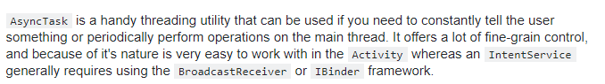  - The support for the Model View Controller architecture in Android.  View = layout, resources and built-in classes like Button derived from android.view.View.  Controller = Activity  Model = the classes that implement the application logic  (5 Marks)
 | (b) | A developer opens a new blank activity in Android Studio. Answer the following:  - When the new activity class is created in Android Studio, it extends AppCompatActivity. What is the AppCompatActivity class? (5 marks)  Base class for activities that use the support library action bar features.  - The developer wants to use the activity to manage a list, so would prefer to use ListActivity as the super class. How will the use of ListActivity as a super class change their activity code, over the use of AppCompatActivity as a super class?  import android.app.ListActivity;  extends ListActivity, not extends appcompatactivity (5 Marks)
 | (c) |  | Explain how Android lifecycle methods, such as onPause() and onResume() can be used to make an app run more efficiently.  For example, onPause() can use in onCreate() for location tracking to restart update location, and onResume() can use in onCreate() for location tracking to stop update location.  (5 marks)
Q4. | (a) | Explain, mentioning any advantages, how nested classes can be used to implement the following in Android.  - Implementation of listener functionality for user interface components, such as button click responses; (5 marks)  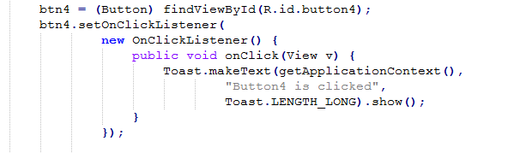  - Custom adapter classes for lists. (5 marks)  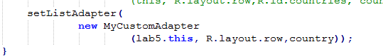  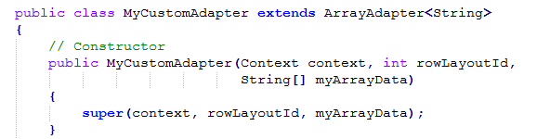  (10 marks)
 | (b) | Explain the steps involved in setting up Location tracking and responses to location changes in an Android app.  (10 marks)  First create location permission for app.  Implements LocationListener  Use “ActivityCompat.requestPermissions” to implemente permission  Math.round(location.getLatitude()), Math.round(location.getLongitude())
 | (c) | Explain five factors to be considered when choosing to develop a mobile app as a native app (e.g using Android) versus a hybrid app (e.g. using PhoneGap).  (5 marks)
Cost of development
Security
Personalization(个性化)
Performance
User experience
Internet conncetion
Update
Build

