Title

Steve Chick

24/01/2016

Contents

**No table of contents entries found.**

Abstract

This is a document which will test the interaction between Word and Github. Testing to find out if there are any strange interactions with some of the more useful features of Word.

Equations

Here are some equations which I decided would be fun to write;

$$a=b^{2}-\lim_{x→∞}{\sum_{1}^{n}{\frac{1}{nx}}}$$

$$p\left(x\right)=e^{-nx}$$

Figures and captions

I am now inserting some random pictures as “figures” and adding captions.

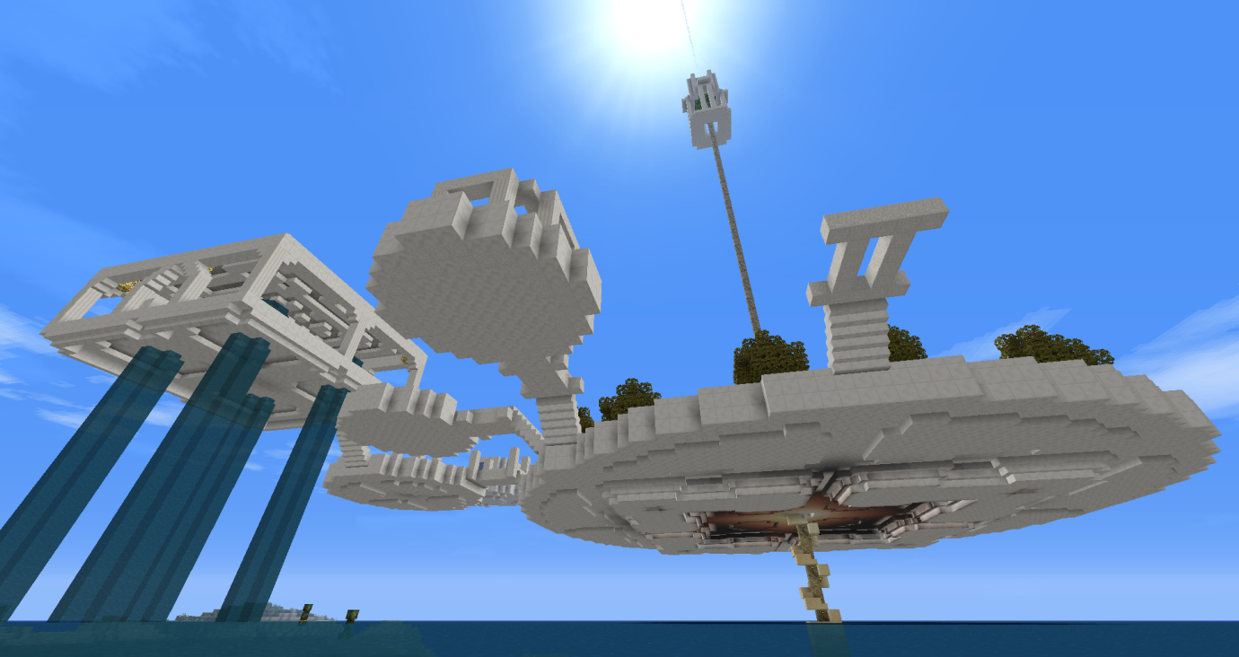

Figure 1 - A sweet Nether Quartz construction in Minecraft, which we dubbed "Olympus". Can’t remember what the big spire in the middle was for.

Some more spacer text.

Because I can.

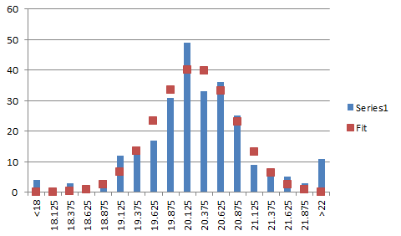

Figure 2 - A fit of a Gaussian to some data which I took at some point. It's been so long that I can't remember what the data was related to.

Text Changes

Here I am using lorem ipsum bacon and some different text attributes, like bold italic underline sub/super-script etc etc.

*acon ipsum dolor amet pastrami shank pig tail sirloin hamburger cow, filet mignon frankfurter. Sausage salami pork corned beef kielbasa short ribs turkey pork chop alcatra tail fatback jowl chuck prosciutto* meatloaf. **Rump** cow alcatra t-bone, **meatloaf** pork chop capicola. **Bacon** turkey beef rump. Bresaola capicola flank landjaeger.

Flank hamburger pork loin, pancetta strip steak meatball spare ribs landjaeger sirloin tri-tip pastrami tongue. Short loin landjaeger pork loin corned beef doner turducken swine ham hock fatback strip steak ground round tri-tip drumstick biltong pig. Turkey andouille alcatra shank. Strip steak leberkas landjaeger, filet mignon alcatra swine ball tip pork chop chuck. Cupim flank picanha jerky ham hock meatloaf swine. Kevin ribeye landjaeger beef ribs tongue pork belly picanha jerky fatback. Pastrami shankle jerky prosciutto.

Chicken salami capicola tri-tip bacon. Cupim cow brisket ham hock, alcatra pancetta fatback short ribs. Ribeye jerky boudin tenderloin, tail corned beef doner tri-tip turducken pork loin frankfurter shank meatball pancetta flank. Spare ribs strip steak prosciutto, kevin landjaeger beef boudin tenderloin venison brisket short ribs chuck.

Cupim leberkas hamburger spare ribs andouille meatloaf chicken ball tip turducken tri-tip capicola fatback. Salami swine frankfurter andouille bacon jerky. Meatball turducken brisket tongue. Pork doner flank corned beef spare ribs bresaola, picanha ham hock swine landjaeger kevin biltong beef. Fatback beef ribs spare ribs kielbasa t-bone cupim strip steak, pork belly salami beef doner sausage ribeye pig. Ham hock kevin beef ribs sirloin.

Landjaeger boudin shankle, filet mignon beef tongue meatloaf strip steak pork cupim prosciutto salami ball tip sausage. Short ribs filet mignon brisket, alcatra turducken leberkas shank fatback pork loin cow kevin. Cow picanha bacon pig. Alcatra short loin ribeye brisket, kevin pork belly kielbasa prosciutto porchetta jerky ham hock picanha bresaola landjaeger drumstick.