**Team 9**

Tim Hoke

Mohammad Alshaiji

Luis Hilbert Rivas

Stuart Packard

ECE 411 - Fall 2024

PDS design sheet

Due: 10/24/24

Rev1

**Product Design Specification**

* **Product Name**
  + The FOPS! Feline Obesity Prevention System.
* **Executive Summary with Concept of Operations**

The device helps cat owners achieve their cat’s target weight by automatically recording weight measurements. Each time the cat enters its bed, the device records a weight measurement and stores the result. Users can log the amount of food they give their cat, and based on their target weight, adjust the feeding amounts to see how it affects the cat’s weight. The software’s user interface displays these weight trends in easy-to-read plots, allowing users to observe and track trends over time. They can use the trends to make an informed decision on how to adjust their cat's diet.

This approach is valuable for managing a cat’s weight, whether the goal is to address overweight, underweight, or maintain optimal health. Unlike relying solely on observation, the device offers a precise, data-driven method for weight management. It automates data collection, minimizing the need for manual effort from the owner.

Although regular vet visits remain essential, this device provides insight into weight changes between those visits, which typically occur only once or twice a year.

* **Brief “Market” Analysis**

Cat owners who need to manage their cat’s weight will benefit from this product, especially those who struggle to weigh their cat. Some cats, being timid, won’t let their owners pick them up and place them on a scale. In some cases, owners have physical impairments that make it difficult or impossible to lift their pet. Our product provides a solution by automatically weighing the cat in its bed. It also appeals to gadget lovers who enjoy the convenience of automated tools. Although designed for cats, small dog owners can also use this scale, and we plan to expand to larger pets in the future.

Our main competitors include brands that sell at pet supply retailers like Petco, PetSmart, and of course, Amazon. Companies such as IBE Supply and Unipaws focus on offering scales with digital readouts and comfortable seating for pets. Some of these companies, like Unipaws, also let users track measurements through a Bluetooth connection to a smartphone.

Our design stands out from other pet scales. We’ve created a form factor that integrates with a cat bed, using curved or beveled edges to hold it securely in place. Unlike competitors’ steel-plate scales, our product offers a more attractive, cat-bed-like aesthetic. More importantly, the scale provides automatic and continuous weight measurements, so users don’t need to forcibly weigh their pets. This allows owners to monitor weight fluctuations more frequently.

Competitor products range from $60 for basic designs to $125-$150 for those with digital readouts and Bluetooth features. Our components cost around $50, so we can sell this product for $99.99, offering more features at a lower price than the competition, while still maintaining a healthy profit margin.

* **Requirements**
  + Must have continuous power; the system needs to be online and ready to take a measurement whenever a cat lays on its bed.
  + Must be able to collect data points of weight over time and display a plot of data to the user.
  + Must collect data automatically.
  + Users must not have to manually put the cat onto the scale in order to get weight measurements.
  + Must be able to weigh a cat accurately within the normal weight range of a cat.
  + Must be able to communicate with a custom software application to observe collected data.
  + Should be able to zero out scale manually with display or interface on the device.
  + Should have an indication that power is on.
  + Should have something interesting for the cat to interact with.
  + Should be shaped in a way that encourages long term sitting by the cat.
  + Should be able to display force as function of time graph to user quickly.
  + Website/application should display graphs and tables of previous values.

**System Architecture**

* Level 0:  
  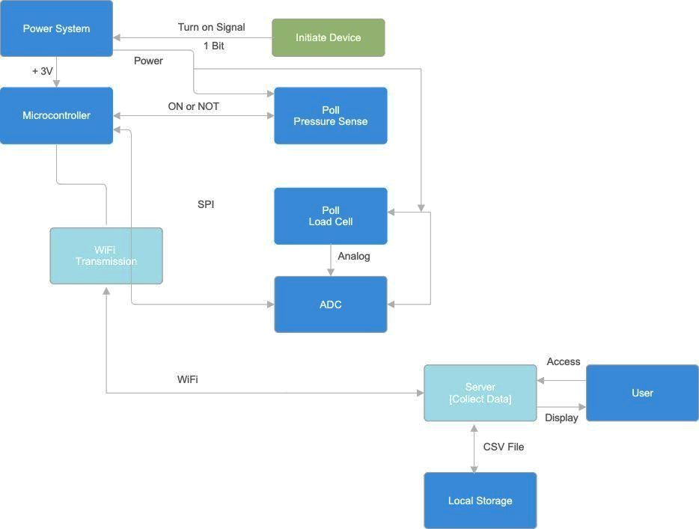
  + Level 1:

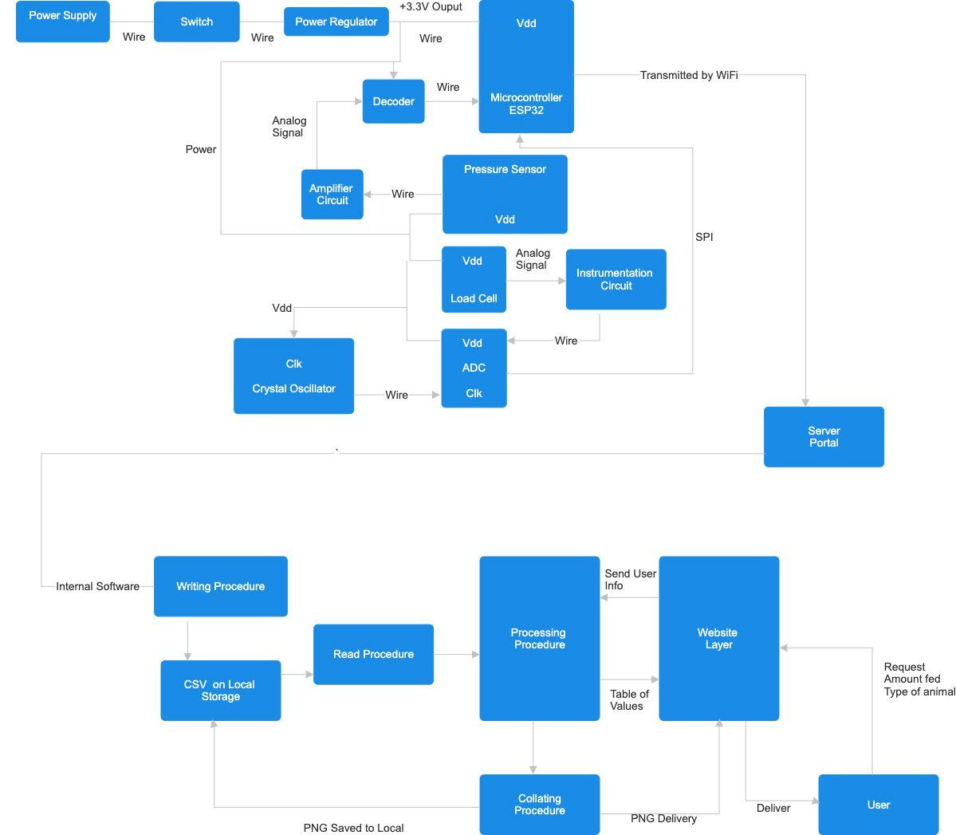

* **Design Specification**
  + 5V wall plug for power supply, plugged into barrel jack on housing. Voltage regulator ICs for powered components that aren’t 5V tolerant.
  + Metallic foil strain gauge for weight measurement
  + High precision ADC for reading output of strain gauge, SPI output
  + ESP32 will be the controller that accepts and processes signals/data
  + Strain gauge will be mounted to stiff upper and lower platform
  + The mechanical portion will be a rectangular surface and enclosure for load cell and PCBA.
  + Flexible piezoresistive polymer composite pressure sensors serve as actuator. * * Pressure on sensor will indicate to the controller to take measurement.
  + A web server will be set up to offload data from the ESP32 over WiFi for storage and user interaction.
  + Espressif IDF and Platform.io have VSCode extensions popular for ESP32 programming. So is Arduino IDE.