Book of Renagul

* Name: Renagul Gheni
* Nationality: Chinese
* ID no.: 652825198103200022
* Sex: woman
* Age: 39
* Occupation: 15 years as an art teacher at a Chinese goverment school
* Education: Bsc degree in literature and arts
* Other: She speaks Chinese well

**She is mother of 2**

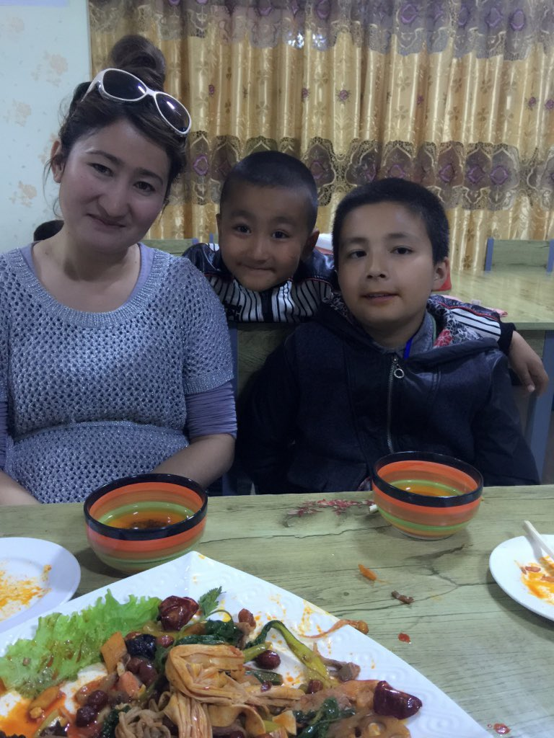

**She is sister of Kalbinur Gheni**



**Her status, after being illegally detained in a Chinese communist concentration camp for 2 years, is being illegally sentenced to 17 years. Her story is the following:**

| **Date** | **Event** |
| --- | --- |
| 2018-2020 | **Renagul dissapears in 2018, her family loses contact with her for 2 years**. Later they learn Renagul was illegally detained in a concentration camp. During this 2 year period the Chinese goverment never notifies her family about the whereabouts of Renagul, which is again illegal per the Chinese Criminal Procedure Law. |
| Jan 2020 | **Kalbinur Gheni posts her testimony on Twitter and asks for help in order to free her sister. [1]** |
| Oct 2020 | **Gyula Csom sends an inquiry to the Chinese Consulate in Hungary**. **[2]** |
|  | **The Hungarian Chinese Consulate responds to the 3rd email and suggests that the family should follow the normal procedure and report her dissapearence to police**: "Hello. We have no idea about what you said. If her family are searching for a missing family member, they should report to the local police."" Recall that the Chinese goverment never notified her family about Renagul's whereabouts between 2018 and 2020. |
| Nov 2020 | **Gyula Csom again asks for help from the consulate** after reporting them that the family followed the normal procedure, but the police refused to share information with them. |
|  | **The consulate does not respond.** |
| Dec 2020 | **Kalbinur Gheni learns that her sister has been recently sentenced to 7 years for praying after their father passed away and given extra 10 years for having a Quran. [3]** |
|  | **Having learned the situation, Gyula Csom demands the release of Renagul Geni through the Chinese Consulate.** |
|  | **The consulate rejects the demand**: "Hello. China is a law-based country and respects rule of law. Since the accused has been sentenced, the court must have solid evidence and the sentence is strictly in line with the crime the accused committed according to relevant law. If they are not convinced, she can still argue through legal channel. We cannot accept any subjective, baseless smear. Please watch your language." |
|  | **Gyula Csom sends the following email to the consulate, then 2 others, but the consulate never replies**:  "Renagul Gheni was detained 2 years ago but authorities never notified her family of the reasons for detention and the place of custody" even though they are obliged to that in accordance with the Criminal Procedure Law of the People's Republic of China.  Recently the local authorities went to her family to inform her verbally that her daughter was sentenced to 7 years for praying while her father passed away in 2013, and to extra 10 years for having a religious book. They again did not provide any official paper about any court order.  If we can beleive what local aithorities told to Renagul Gheni's family, then she was illegally detained and sentenced - since as per the Constitution Article 36: "No state organ, social organization or individual shall coerce citizens to believe in or not to believe in any religion, nor shall they discriminate against citizens who believe in or do not believe in any religion.  I do hope though that the information provided by local authorities was incorrect and Renagul Gheni was not illegally detained. I do hope it, however up until official court order is presented we cannot rule out the possibility that local authorities told the truth and Renagul Gheni was illegally detained. In fact we cannot rule out anything, since not a single official paper was provided.  A law-based regime which respects rule of law should act according to it and state agencies must also submit to the law, even to the procedural laws, such as the Criminal Procedure Law. Since local authorities failed to pass the official documents to the family multiple times, now I respectfully ask you to correct their failures and help gathering the appropiate official documents and passing them to the family. This action could then resolve the case if except procedural errors, everythig else was lawful which both of us hope. Otherwise one must ask the serious question: why do authorities fail to provide the court orders? Please take this seriously and act according to the informations you were provided. We both want to avoid escalation." |

**References**

[1] Kalbinur Gheni’s testimony, 6 Jan 2020 <https://twitter.com/Qelbinur10/status/1214058448310210560>

[2] Email exchange between Gyula Csom and the Hungarian Chinese consulate, 10 Oct 2020 – 26 Dec 2020   
<https://twitter.com/csomgyula/status/1315035733288194048> Archived here: [ChineseConsulateCampaign](../ChineseConsulateCampaign)

[3] Kalibur’s post about her sister’s state, 3 Dec 2020 <https://twitter.com/Qelbinur10/status/1334299224712876032>