Forced birth control in Xinjiang

Gyula Csom, 2021-02-03, WORKING DRAFT

**Starting from 2018 the Chinese government started to “de-radicalize” Uyghur women:**

For a period of time, the penetration of religious extremism made implementing family planning policy in southern Xinjiang, including Kashgar and Hotan prefectures, particularly difficult, the research center's report said. That had led to rapid population growth in those areas as some extremists incited locals to resist family planning policy, resulting in the prevalence of early marriage and bigamy, and frequent unplanned births.

In the process of eradicating extremism, the minds of Uygur women were emancipated and gender equality and reproductive health were promoted, making them no long baby-making machines, it said. Women have since been striving to become healthy, confident and independent.

*CHINA DAILY: Eradication of extremism has given Xinjiang women more autonomy, says report, 2021-01-07:* [*https://www.chinadaily.com.cn/a/202101/07/WS5ff6fb03a31024ad0baa134a.html*](https://www.chinadaily.com.cn/a/202101/07/WS5ff6fb03a31024ad0baa134a.html)

**„De-radicalization” of woman means that: „otherwise the Chinese government will send the woman to concentration camp”.** Since: as per the Xinjiang de-extremification law the Chinese government will label women extremists if they interfere with family planning policies, hence they can put them into concentration camp:

Article 9:The following words and actions under the influence of extremism are extremification, and are to be prohibited:

[…]

(14) "Deliberately interfering with or undermining the implementation of family planning policies"

*Unofficial translation of the Xinjiang Uighur Autonomous Region Regulation on De-extremification, 2018:* [*https://www.chinalawtranslate.com/en/decision-to-revise-the-xinjiang-uighur-autonomous-region-regulation-on-de-extremification/*](https://www.chinalawtranslate.com/en/decision-to-revise-the-xinjiang-uighur-autonomous-region-regulation-on-de-extremification/)

第九条 受极端主义影响，下列言论和行为属于极端化，予以禁止：

[…]

（十四）蓄意干涉或破坏计划生育政策实施的；

*新疆维吾尔自治区去极端化条例:* [*https://www.xinjiang.gov.cn/xinjiang/fsljzcfg/201810/ce79abb87ad847cdaa7d1e4e07423358.shtml*](https://www.xinjiang.gov.cn/xinjiang/fsljzcfg/201810/ce79abb87ad847cdaa7d1e4e07423358.shtml)

**According to the National Bureau of Statistics of China, within two years, between 2018 and 2019 the Chinese government’s „de-radicalization” efforts hit several hundred thousand women:**

|  |  |  |  |  |  |  |
| --- | --- | --- | --- | --- | --- | --- |
| **Year** | **Total population* [thousand]** | **Average population** [thousand]** | **Natural growth rate [%]** | **Birth rate*** [%]** | **Birth number**** [thousand]** | **Birth diff from 2017 [thousand]** |
| **2009** | 21 590 |  | 1,599 | 1,599 |  |  |
| **2010** | 21 850 | 21 720 | 1,599 | 1,599 | 347,3 |  |
| **2011** | 22 090 | 21 970 | 1,499 | 1,499 | 329,3 |  |
| **2012** | 22 330 | 22 210 | 1,532 | 1,532 | 340,3 |  |
| **2013** | 22 640 | 22 485 | 1,584 | 1,584 | 356,2 |  |
| **2014** | 22 980 | 22 810 | 1,147 | 1,644 | 375,0 |  |
| **2015** | 23 600 | 23 290 | 1,108 | 1,559 | 363,1 |  |
| **2016** | 23 980 | 23 790 | 1,108 | 1,534 | 364,9 |  |
| **2017** | 24 450 | 24 215 | 1,14 | 1,588 | 384,5 |  |
| **2018** | 24 870 | 24 660 | 0,613 | 1,069 | 263,6 | -121 |
| **2019** | 25 230 | 25 050 | 0,369 | 0,814 | 203,9 | -181 |

*Source:* [*http://www.stats.gov.cn/english/Statisticaldata/AnnualData/*](http://www.stats.gov.cn/english/Statisticaldata/AnnualData/) *or* [*https://data.stats.gov.cn/english/easyquery.htm?cn=E0103*](https://data.stats.gov.cn/english/easyquery.htm?cn=E0103)

**\*Total population means resident population at a certain point in time:**

Total Population refers to the total number of people alive at a certain point of time within a given area.

The annual statistics on total population is taken at midnight, the 3lst of December.

[*http://tjj.cq.gov.cn/tjnj/2019/zk/html/zbe03.htm*](http://tjj.cq.gov.cn/tjnj/2019/zk/html/zbe03.htm)

As Adrian Zenz reports:

Recently, population in the PRC (to include Xinjiang) has been counted in two different ways. The first is “household registered population” (年末户籍人口, nianmo huji renkou) which refers to people who are formally registered as being from Xinjiang under China’s household registration, or “hukou” (户口) system. The second is “permanent resident population” (年末总人口, nianmo zong renkou -or- 年末常住人口, nianmo changzhu renkou) which refers to the number of people locally residing in Xinjiang by December 31 of each respective year, who have lived in there for at least 6 months.

The latter term encompasses persons from other parts of China who migrate to another province, typically for work-related reasons.

*Sterilizations, IUDs, and Mandatory Birth Control: The CCP's Campaign to Suppress Uyghur Birthrates in Xinjiang, 2020:* [*https://www.researchgate.net/publication/343971074_Sterilizations_IUDs_and_Mandatory_Birth_Control_The_CCP%27s_Campaign_to_Suppress_Uyghur_Birthrates_in_Xinjiang*](https://www.researchgate.net/publication/343971074_Sterilizations_IUDs_and_Mandatory_Birth_Control_The_CCP%27s_Campaign_to_Suppress_Uyghur_Birthrates_in_Xinjiang)

According to the National Bureau of Statistics of China, the above numbers represents resident population:

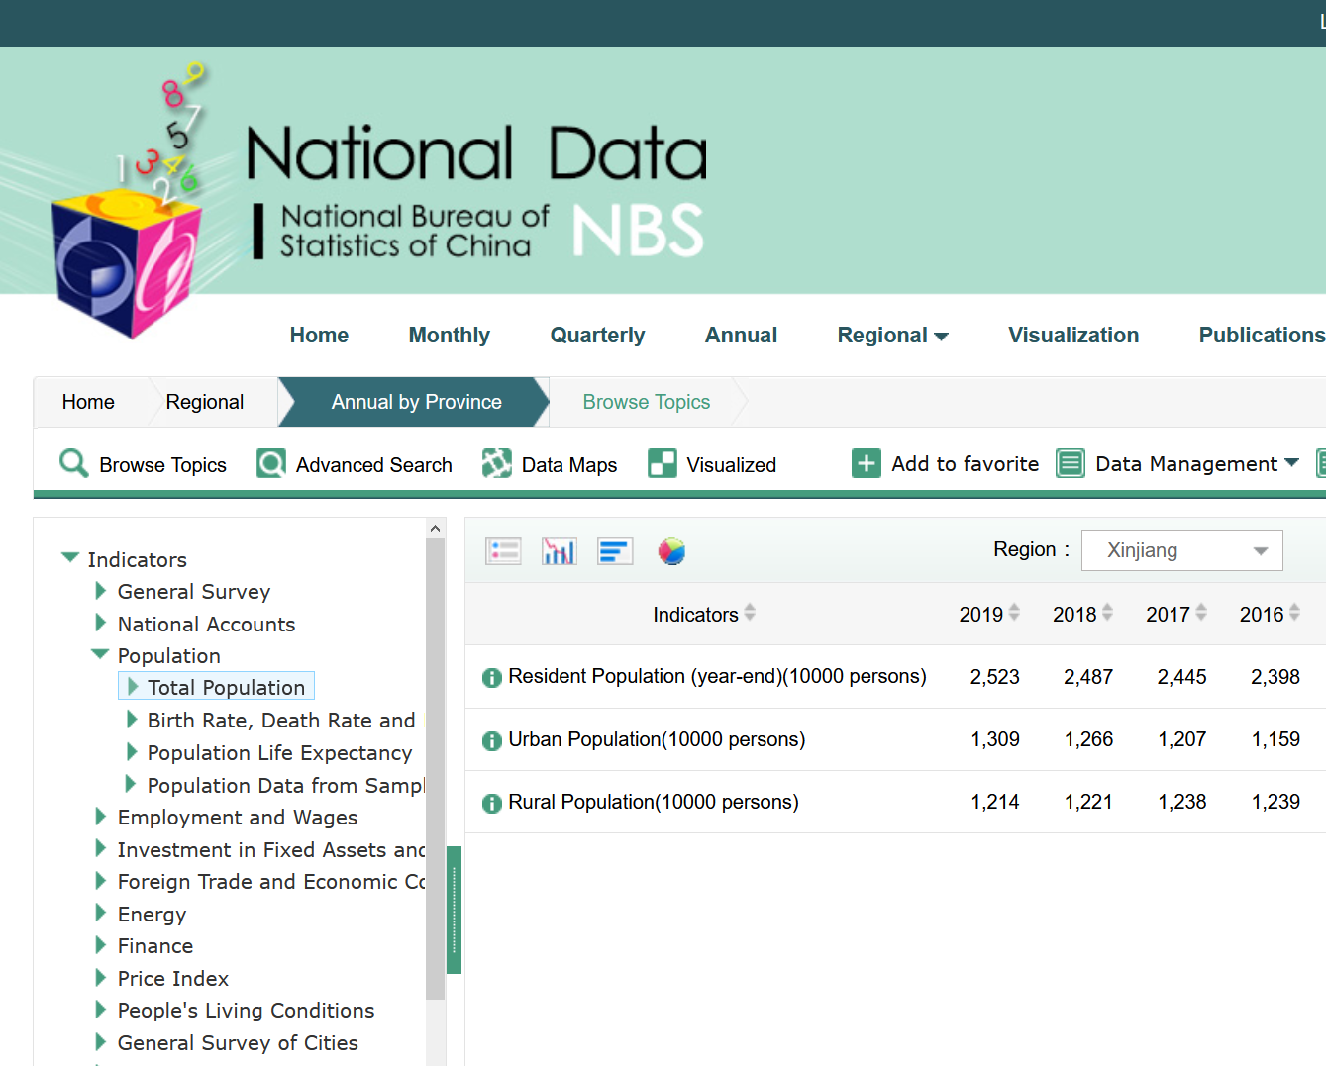

[*https://data.stats.gov.cn/english/easyquery.htm?cn=E0103*](https://data.stats.gov.cn/english/easyquery.htm?cn=E0103)

**\*\*Birth rate is the ratio of the number of birth and average population:**

Birth Rate (or Crude Birth Rate) refers to the ratio of the number of births to the average population (or mid-period population) during a certain period of time (usually a year), expressed in ‰. Birth rate in the chapter refers to annual birth rate. The following formula is used:

Birth Rate = Number of Births / Average Number of Population × 1000‰

[*http://tjj.cq.gov.cn/tjnj/2019/zk/html/zbe03.htm*](http://tjj.cq.gov.cn/tjnj/2019/zk/html/zbe03.htm)

**\*\*\*Average population is the average of the population at the beginning and at the end of the year:**

Annual average population is the average of the number of population at the beginning of the year and that at the end of the year. Sometimes it is substituted by the mid-year population.

[*http://tjj.cq.gov.cn/tjnj/2019/zk/html/zbe03.htm*](http://tjj.cq.gov.cn/tjnj/2019/zk/html/zbe03.htm)

**\*\*\*\*Birth number is the product of the birth rate and the average population number**

The statistical data does not tell which average formula was used in which year, also I do not have the mid-year statistics. For this reason, when calculating birth number I always used the first method for the average population.