Goals

# Forced assimilation of Uyghur ethnicity using the most inhuman means

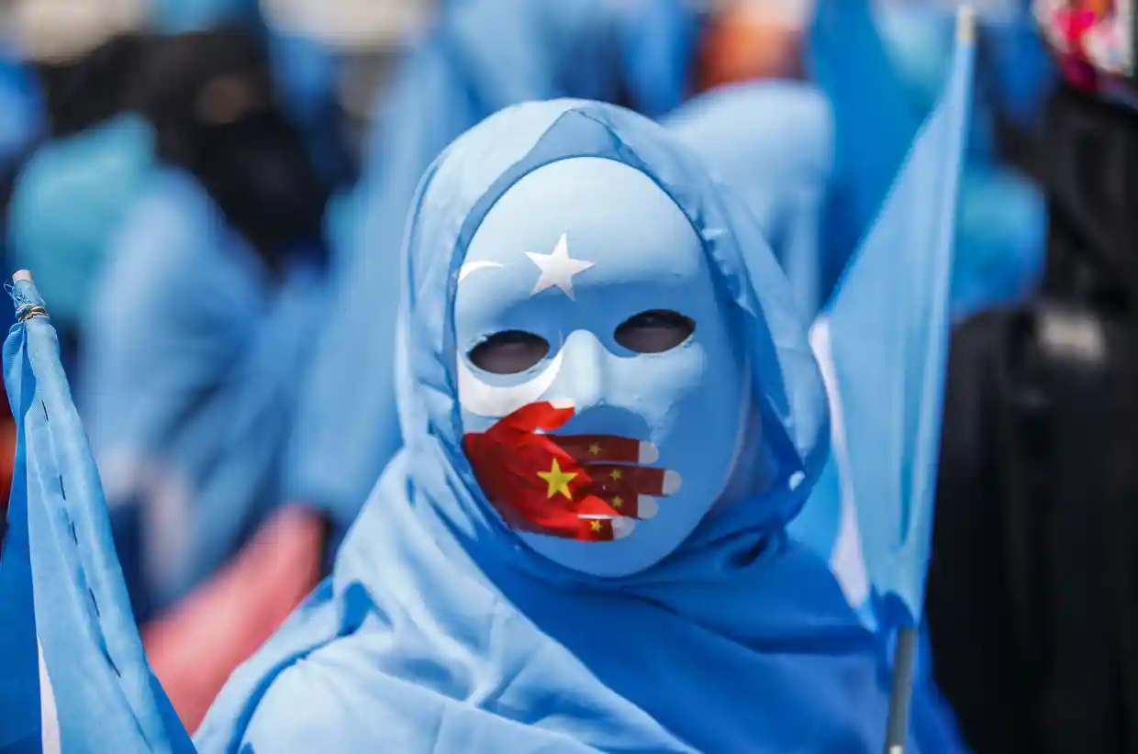

The apparent goal of the Chinese government is to forcibly assimilate Uyghur, Kazakh and Kyrgyz ethnic groups and other Muslim minority groups in East Turkestan. They attempt to destroy an over 1000 year old ethnic culture and transform the people into a uniform crowd with no real religious and ethnic identity.

In order to forcibly assimilate Uyghurs and other ethnicities, the Chinese government uses the most inhuman means:

Destroying ethnic culture and muslim religion

By destroying religious and cultural facilities, such as mosques and cemeteries. By preventing religious freedom through banning normal religious practices and labeling them as extremism. By eliminating leaders and reengineering the population and families.

There are also news about that the Chinese government is planning to rewrite the Quran in order to make the religion adhering to the Chinese government rules.

The destruction of Uyghur cultural and Muslim religious practices is a means for the Chinese goverment to destroy the “soul” or identity of the Uyghurs.

Eliminating leaders

Persecution of leaders targets both religious and secular leaders, incuding imams, scholars, business and political leaders. Many of them are detained and sentenced for alleged crimes, such as Ilham Tohti who was sentenced in 2014 to life imprisonment by the Chinese government, while in January 2020 was nominated for a Nobel Peace Prize.

The elimination of Uyghur leaders is a means for the Chinese goverment to destroy both the current Uyghur generation who now lost their leaders and the next Uyghur generation by eliminating teachers.

Reengineering and terrorizing adult population

An estimated 1-3 million Uyghurs, the 10-30% percent of the Uyghur population, are held in concentration camps where they are forcibly re-educated, used in forced labour and often undergo both psyhcological tortures and physichal tortures, including mass rape.

Those Uyghurs who are not detained live in constant fear, due to the constant surveillance by state police, where anyone anytime can be detained for no reason if the artificial algorithm decides so.

Reprogramming Uyghur people is the de facto means for the Chinese goverment to destroy the current Uyghur generation and by that the next generation as well.

Reengineering and terrorizing families

One of the most inhuman means of the Uyghur genocide is to treat families, mothers, children as inanimate objects that can be forcibly reegineered.

According to the state media, the Chinese government sees large family mothers as „baby-making machines” who had to be re-educated to get rid of religious extremism. There are also news that the Chinese government applies not just forced re-education, but forced birth control as well, including sterilization, IUD and abortion. According to Chinese government statistics, in 2018 these forced measures resulted in an estimated almost 40% drop in birth rate, which means that 1 in every 3 family (planning to have child) was affected.

Families are torn apart when parents are detained into concentration camps. An estimated 500,000 children are torn out from such families and put into orphanages where the are indoctrinated inline with the Chinese government directives. There are news that some children never gets to the orphanages, instead live in the streets or dies.

The indoctrination of Uyghur children and preventing (decreasing) birth is the de facto means for the Chinese goverment to destroy the next Uyghur generation.

Summary

The Chinese goverment attempts to systematically destroy ethnicities and minorities in East Turkestan. The means they use exhausts the concept of genocide in its informal meaning: „something terrible is happening there”.

Whether the forced assimilation in East Turkestan also exhausts the concept of genocide under international law (<https://www.un.org/en/genocideprevention/genocide.shtml>), that must be determined by independent courts, such as the Uyghur Tribunal (<https://uyghurtribunal.com/>).