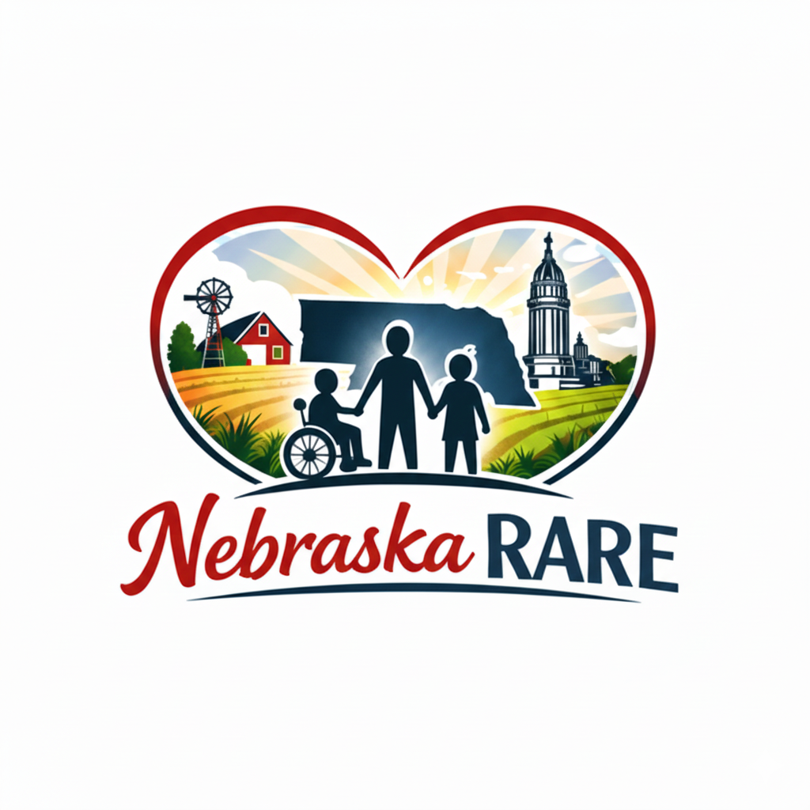

PHOTO & MEDIA RELEASE FORM

CONSENT AND RELEASE
I, __________________________, hereby grant Nebraska RARE permission to use photographs and/or video of my family for use in official digital and print materials.
I ACKNOWLEDGE THAT:
- Purpose: Images will represent Nebraska RARE’s mission of advocacy and community inclusion.
- Compensation: No financial compensation will be provided for the use of these images.
- Revocation: I may request removal of digital images at any time by emailing info@nebraska-rare.org.
- Public Nature: I understand these images will be accessible to the public on nebraska-rare.org.

Family Name: _________________________________________________
Date: __________________________
Signature: ____________________________________________________ (Parent or legal guardian signature required)

