|  |
| --- |
|  |
| **SOFTWARE REQUIREMENTS SPECIFICATION** |
| **MERCURY TOURS** |
|  |
| Capgemini |
| 11/20/2018 |

|  |
| --- |
| © 2005, Mercury Interactive (v. 011003-1.01-058) |

**INDEX**

**INTRODUCTION**

Mercury Tours is an online application from where you can book flights

Link : <http://newtours.demoaut.com/>

User Name : mercury

Password : mercury

**OBJECTIVE**

**HOME PAGE**

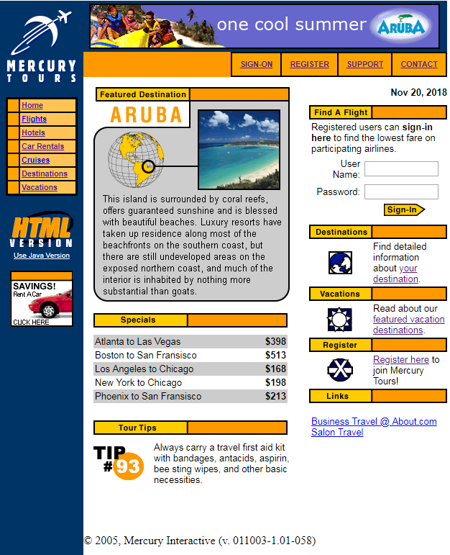

**SIGN-ON**

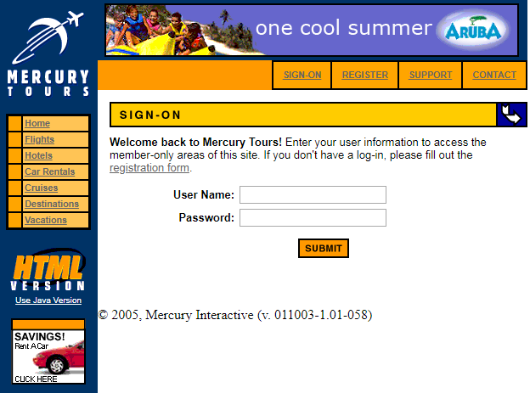

**REGISTER**

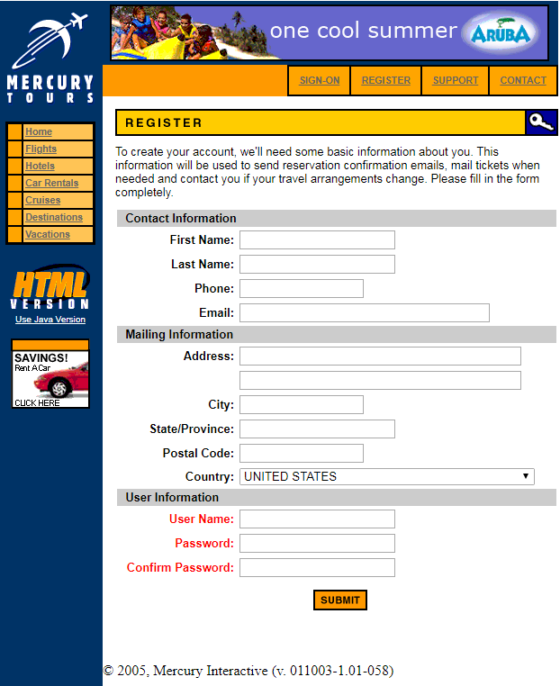

**SUPPORT**

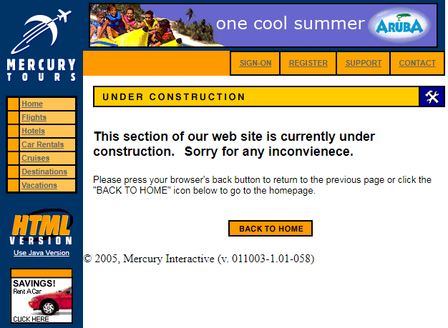

**CONTACT**

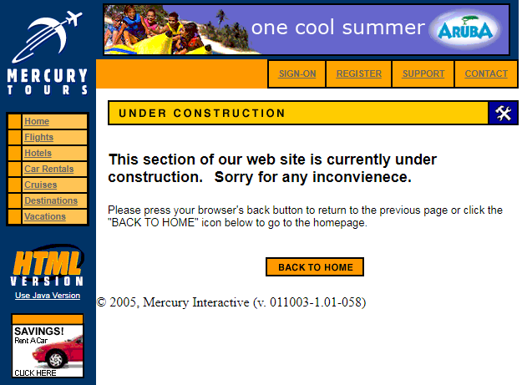

**CONCLUSION**