**Using Form ADV Data**

**To Predict if Financial Advice**

**Received will be Conflicted**

1. **Introduction and Background**

As part of regulatory requirements for registered investment advisors (RIA), the SEC collects information including criteria such as products and services offered, assets under management, disciplinary actions against them. This information is collected by the SEC and must be disclosed to the public in the Form ADV filed annually by RIAs.

Form ADV is the uniform form used by investment advisers to register with both the Securities and Exchange Commission (SEC) and state securities authorities. The form consists of two parts:

* **Form ADV Part 1** requires information about the investment adviser’s business, ownership, clients, employees, business practices, affiliations, and any disciplinary events of the adviser or its employees. Part 1 is organized in a check-the-box, fill-in-the-blank format.
* **Form ADV Part 2** requires investment advisers to prepare narrative brochures written in plain English that contain information such as the types of advisory services offered, the adviser’s fee schedule, disciplinary information, conflicts of interest, and the educational and business background of management and key advisory personnel of the adviser.

**Conflicted Advice:** Generally speaking, RIAs are legally obligated to deliver financial advice in the best interest of investors, or under a “fiduciary” standard of care. However, broker-dealers (BD) only need to meet a suitability standard when delivering financial advice. There also exist many cases where an RIA is also registered as a BD and can “switch hats” when giving financial advice.

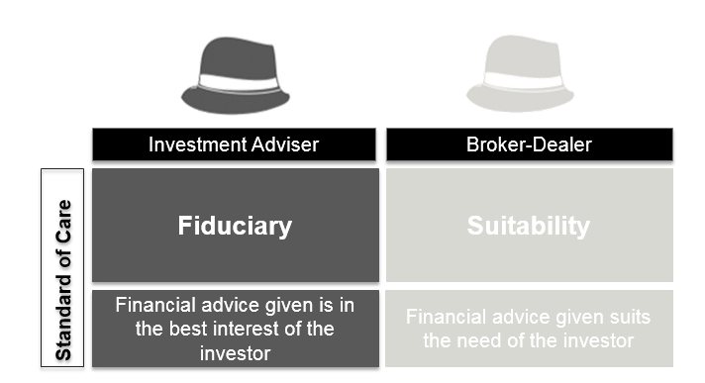

What does this mean for investors? Advice delivered under a fiduciary standard is the highest standard an investor can receive, whereas advice under a suitability standard is generally considered a lower standard. This becomes very problematic when an advisor (RIA or BD or dually registered) offers advice in the form of financial products.

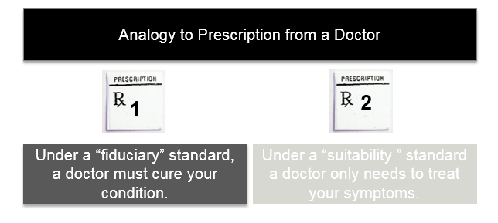

Financial products can have certain commissions or fees for the advisor. Illustrated above is an analogy making the connection between fiduciary and suitability advice and a prescription from a doctor. Considering a simplistic hypothetical scenario where a medical condition can both be cured or the symptoms managed, a doctor giving a prescription under a fiduciary standard will cure the existing condition while doctor giving a prescription under a suitability standard may offer a prescription to manage symptoms rather than treat the underlying condition. To further illustrate that point, if a doctor opted for the “suitable” prescription option over the “fiduciary” prescription option because they are receiving commission from the pharmaceutical company, they are clearly giving conflicted advice.

Based on hand labeled analysis of over 100 Form ADV records, it my hypothesis that the information contained in the Form ADV (part 1) can be used to make accurate predictions on whether there is a high likelihood of receiving conflicted advice from a financial advisor.

1. **Data Sources**

SEC Form ADV part 1 is publicly available [here](http://www.sec.gov/foia/docs/invafoia.htm). This data set 11,766 observations with 215 distinctive features. A full data dictionary explaining what is contained in each feature is available here <link to ADV Part 1 instructions>.

The training data consists of 120 hand labeled observations. <A redacted version of this data set will be uploaded at a later time>.

1. **Methodology**

<Place holder Add>

1. **Descriptive and Exploratory Analysis –DRAFT Current Status**

<Currently examining all 215 features. Initial hypothesis was that only features identified when making hand labeled data: Compensation Arrangements, Advisory Activities, Business Activities and Financial Industry Affiliation. Still working on fitting a naïve bayes model.

Issue 1: Not able to access ADV Part 2 in bulk – currently trying to figure out if I can access SEC’s API to either scrape ADV part 2 or do a look up based on unique identifiers in ADV Part 1

Issue 2: Training data is only 1 class (all conflicted advice) can add 1 observation (not conflicted) that I recently looked up for an unrelated project. Not sure how to get additional observations of different class

Issue 3: Output of final prediction, initially thought to be a binary classification problem, but may change depending on resolution to Issue 2.

<ADD Detailed Data Dictionary of FINAL Features identified>

1. **Predictions from Training Data and Machine Learning**

<Place holder Add>

1. **Model Selection**

<Place holder Add>

1. **Predictions**

<Place holder Add>

1. **Conclusion**

<Place holder Add>