Subject: Vendor downpayment

Summary:
S.No | Transaction  Code | Description
1 | F-47 | Downpayment request by User dept.
2 | F-48 | Down Payment Made by Accounts Dept.
3 | ME23N | Purchase Order Display-history
4 | MIRO | MIRO-Invoice Verification
5 | F-54 | Transfer from Special GL to Normal
6 | F-44 | Clearing of Normal Items
7 | F-53 | Clearing of Party Payment
8 | FBL1N | Display Bill details of Vendor

Transaction Code F- 47 For Down Payment Request

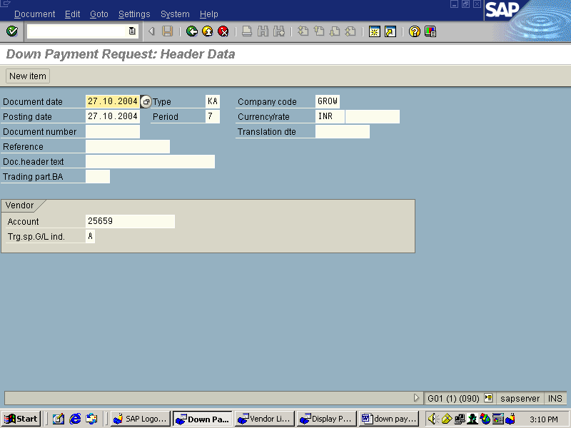

Please enter the following fields
Document date , Company code, posting date, Currency, Vendor Number, Putting “A” in transaction spcila G/L indicator

Note: Don’t chage the document type From “KA” to any other

Press enter you will see the following screen

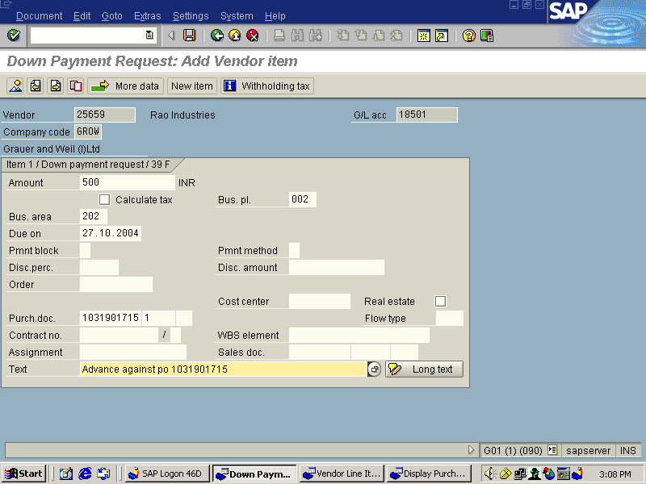

Enter the amount, put relevant business place and business area, purchase document number with item number and write appropriate text in text column.
Press save button
After that you will see the following screen with document number in the footer.

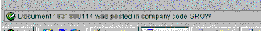

TRANSACTION CODE F-48 FOR VENDOR DOWN PAYMENT MADE

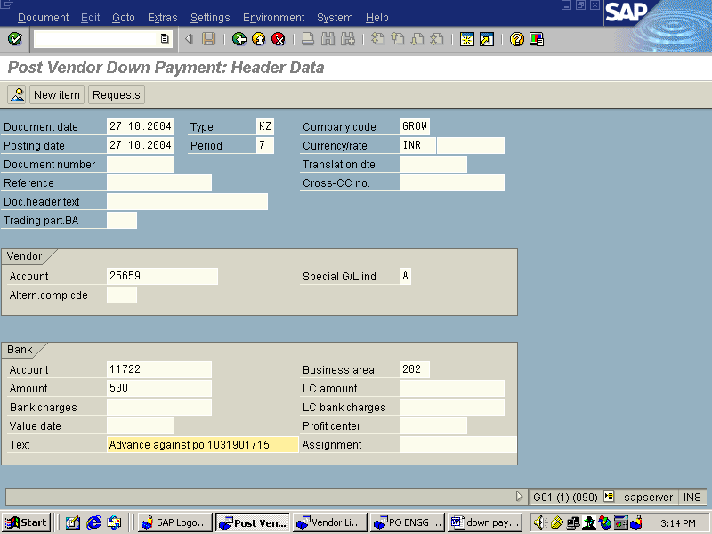

Type Document date, company code, posting date, currency, Vendor Number, bank, business area , advance payment amount as per PO, write an appropriate text .

Go to “request” button in the header and click it

You will see the following screen
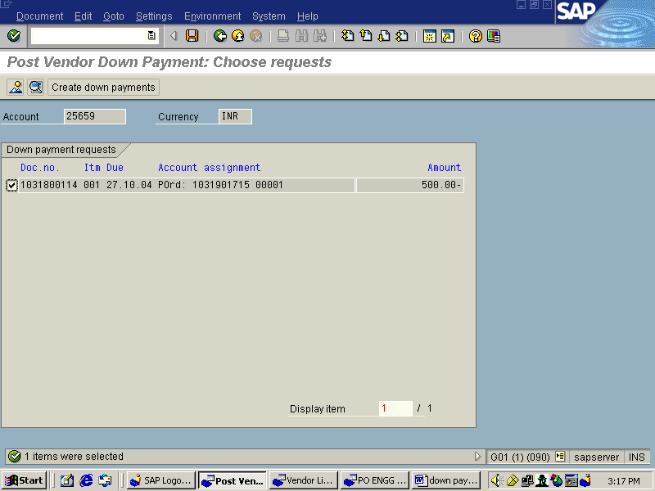

Choose the appropriate advance payment by putting a tick mark and click Create down payment button in the header.

After this you will see the following screen
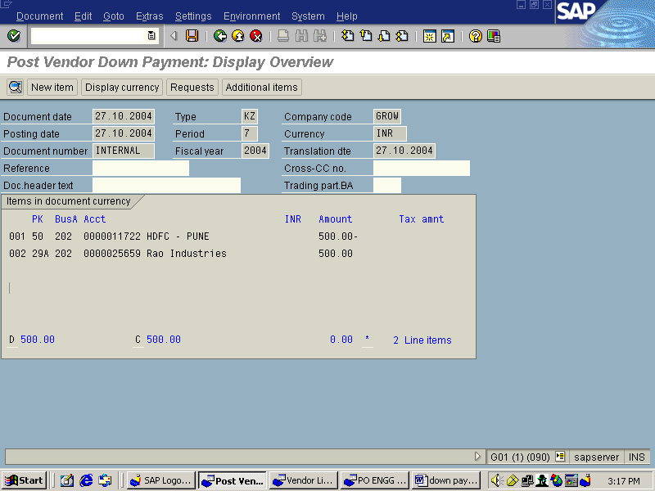

Press save button you will see the document number which is shown in the following screen

Transaction Code: “FBL1N” Vendor Line Item Dispaly

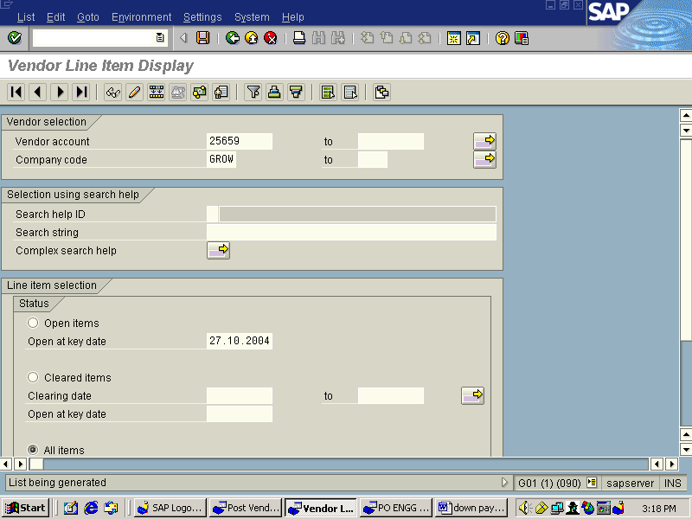

Enter vendor number , company code , open key date ,then select open item and below the screen select normal and special G/L account
Press enter
The following screen will appear
From which we can come to know total open down payment.

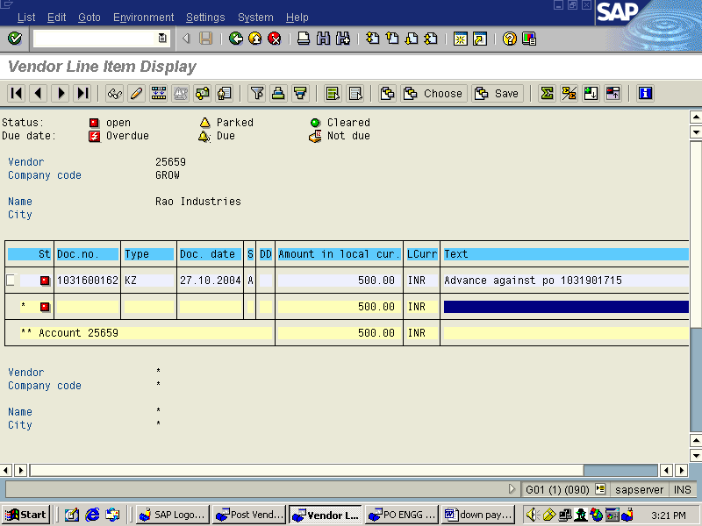

Also In Purchase Order Display (ME23N) Header it will show the downpayment amount given to vendor(Important Note: This will appear here only when the person prepares
F-47 i.e. downpayment request write Po reference there, other wise it will not shown in the PO) .Here in the header downpayment will show sum of payments made against all items in the purchase order

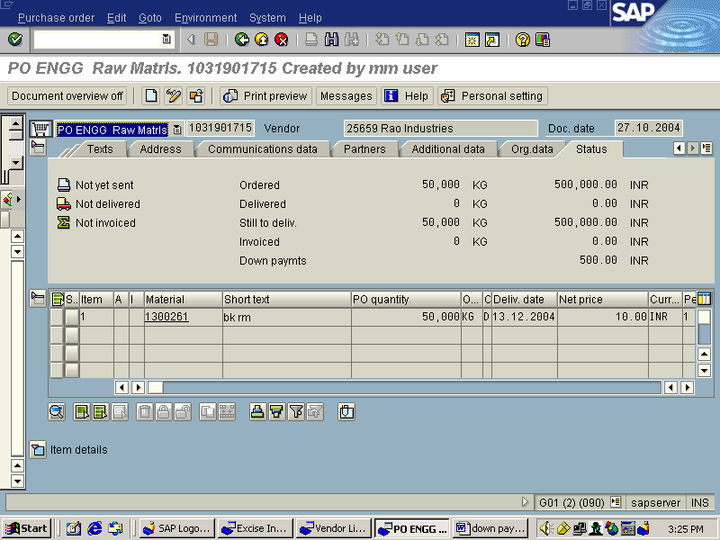

Also in Purchase Order display screen (ME23N) item detail, Purchase history tb it will show document wise advance payment made to the vendor after F-48.

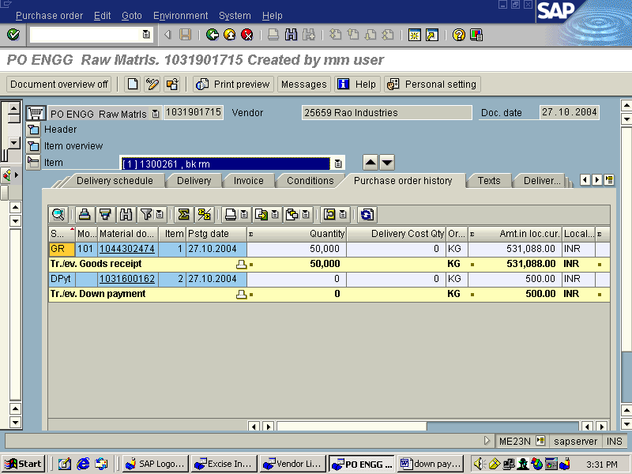

Transaction Code: MIRO
While Invoice Verification system gives message about the total downpayment pending against that vendor “automatically”

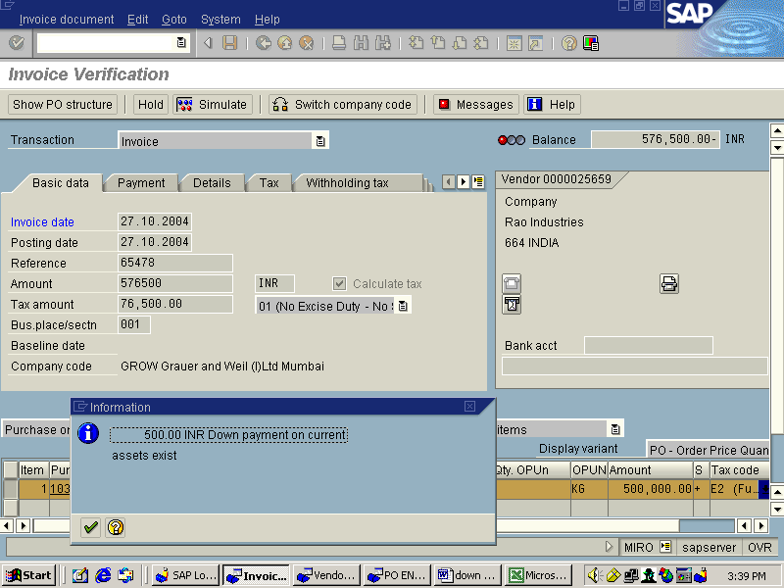

After that complete the Invoice verification process system will generate the RE document

Now in Transaction Code “FBL1N” it will show all the open items in red dot ,those are Down payment and RE document amount(Invoice Amount)

Enter vendor Number , company code , open key date ,then select open item and below the screen select normal and special G/L account
Press enter
The following screen will appear
From which we can come to know open down payment, and invoice amount.

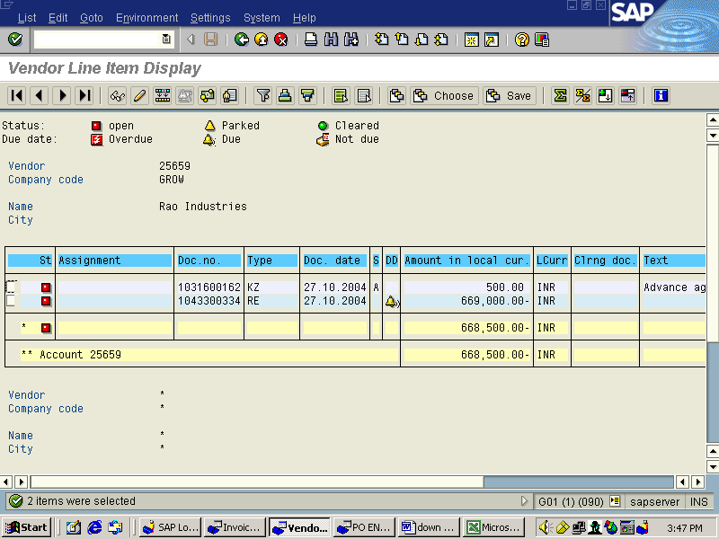

Transaction code: F-54
Here we transfer Special GL to Normal GL Account because down payment to vendor is a special GL account enter
The screen will appear as shown below, Remove Invoice number which is shown by default by system
Click on Process downpayments
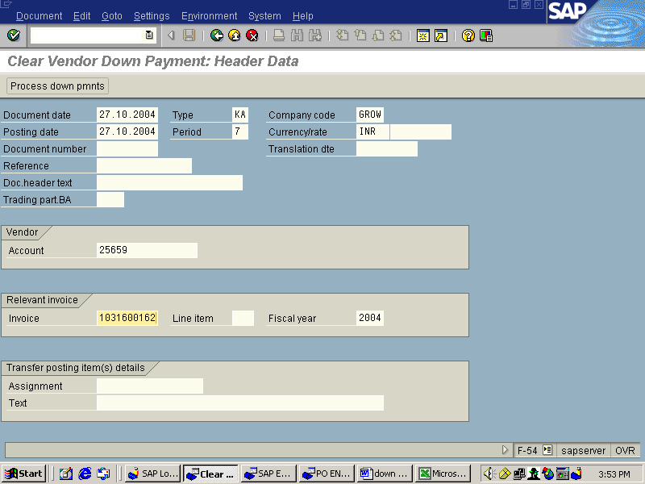
Ensure to remove Invoice Number as shown below

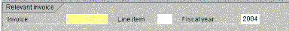

After clicking process down payments following screen will appear,in yellow colour field double click or type Downpayment amount(Example Rs.500 in this case)

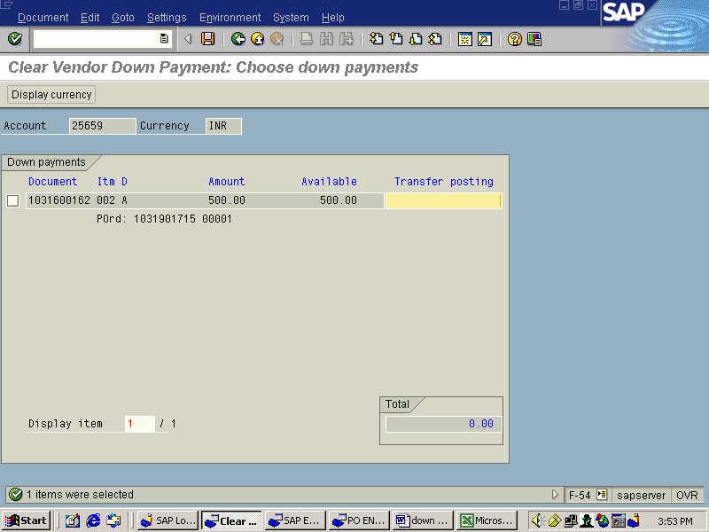

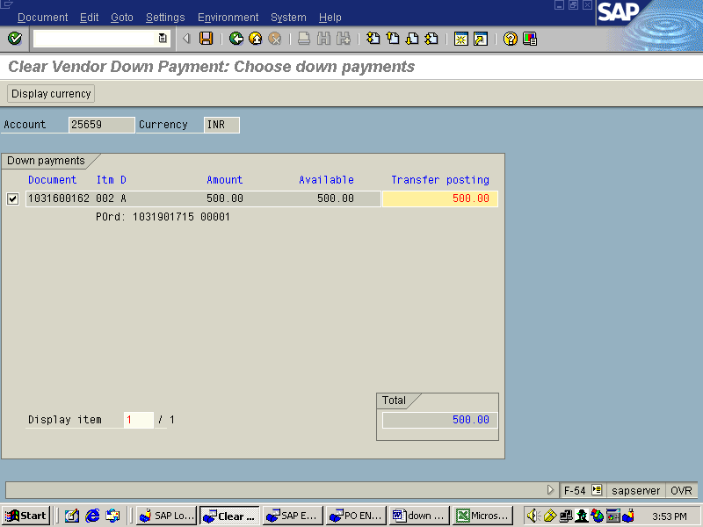
Type amount shown as above then click enter .

Blue colour line will be displayed.Double click on this line. After double clicking line colour will change to Black colour , then click enter

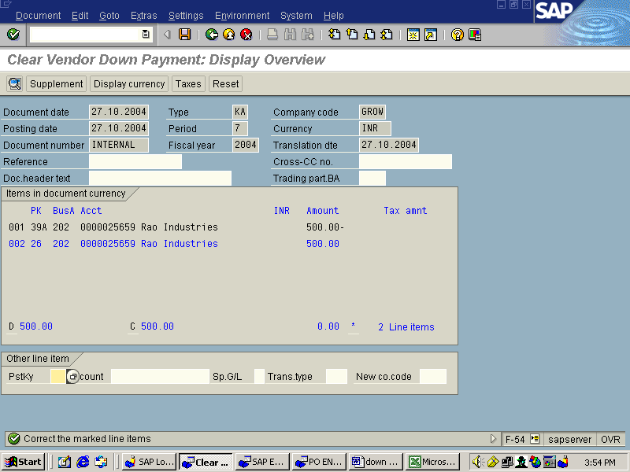

After click enter following screen will appear ,type self explanatory text

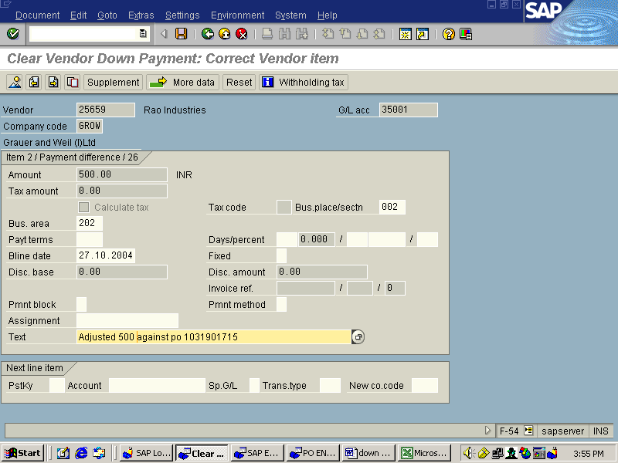

Save the document it will generate a number

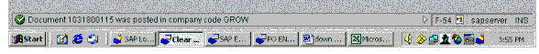

Transaction Code: ME23N
Here in the Purchase Order History, we can see that down payment has been cleared .

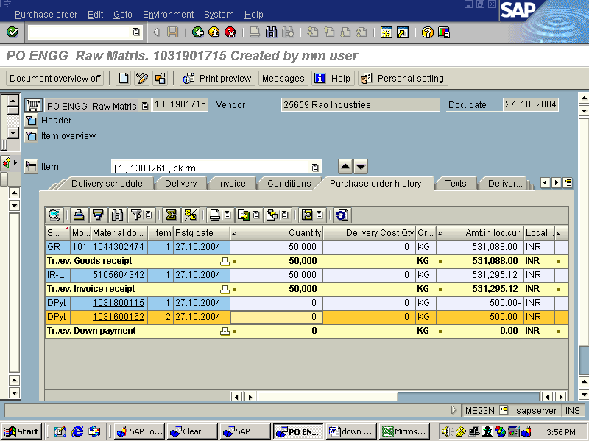
In PO header down payment will shown as zero as it has been cleared
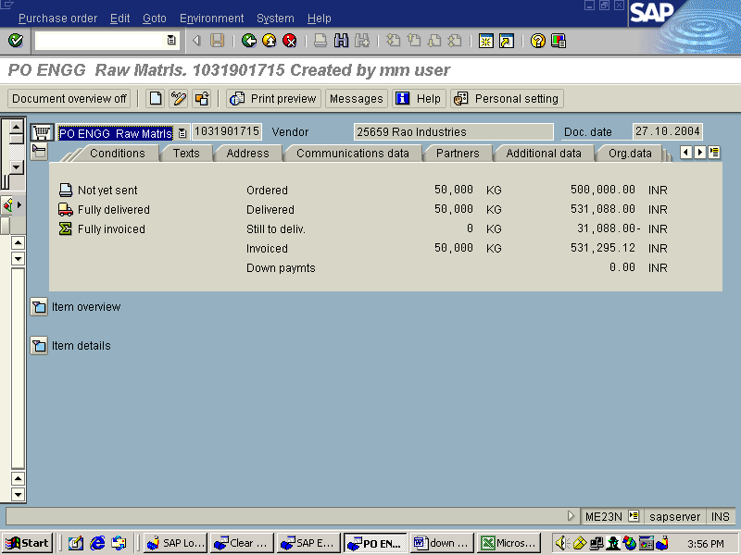

Transaction Code:F-44
Clearing of Normal GL Account .Here we are adjusting downpayment against Vendor Invoice

Type vendor Number as shown below and click on Process Open Items

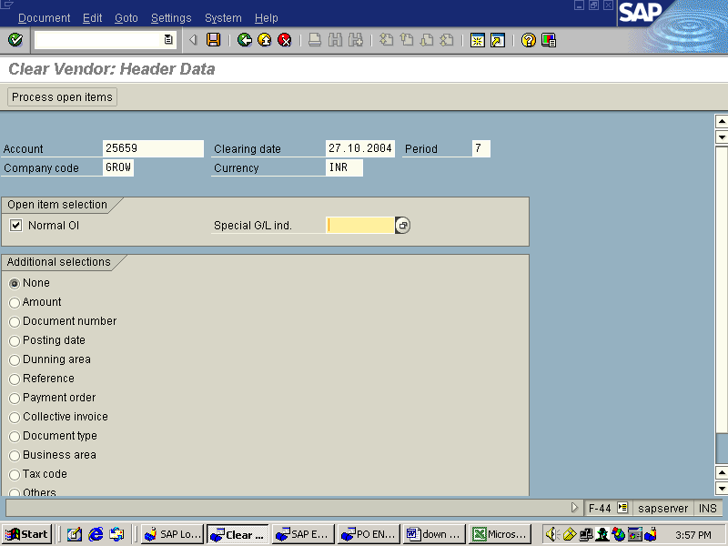

After clicking on Process Open Items following screen will appear

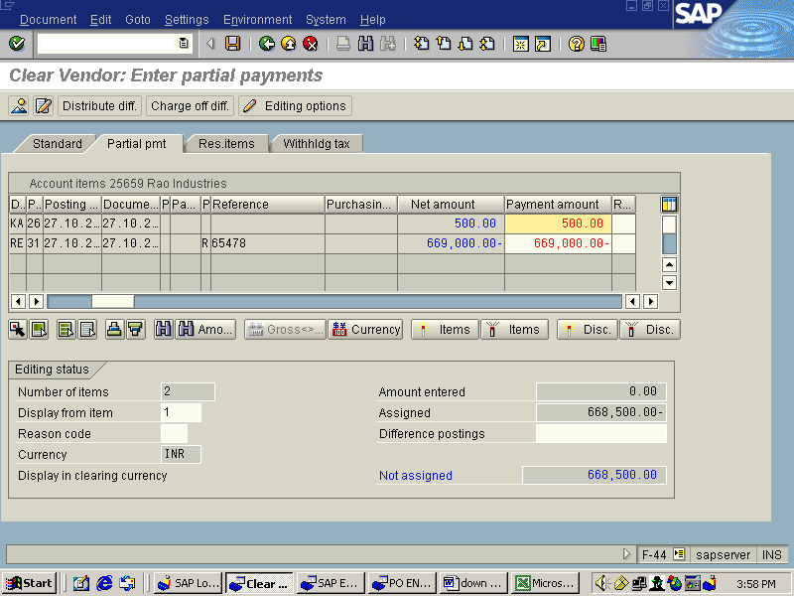

In this screen in the column Payment Amount remove invoice amount suggested by system and type Down payment amount( Example Rs.500)
Not assigned figure should always be zero.
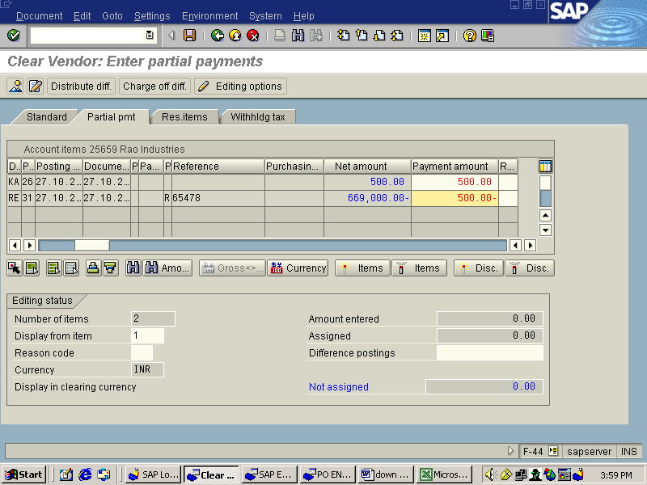

Not assigned figure should always be zero.

Transaction Code:FBL1N

Here downpayment amount shown as green after clearing

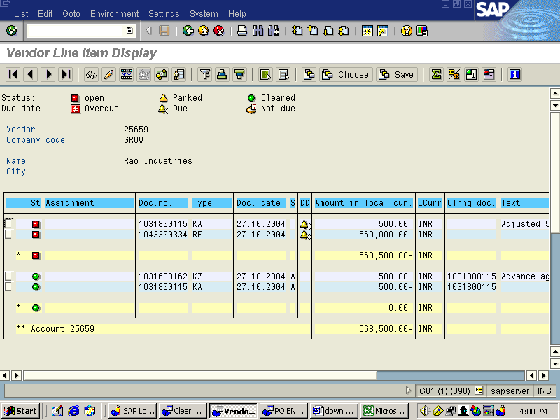

Transaction code F-53
Post Outgoing Payments

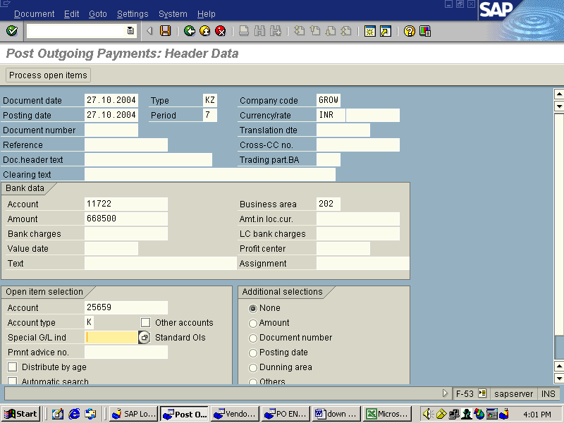
Enter the document date, company code , posting date, currency, appropriate bank account, amount, and Vendor Number
Then goto process open item button and click it .Then you will view the following screen.

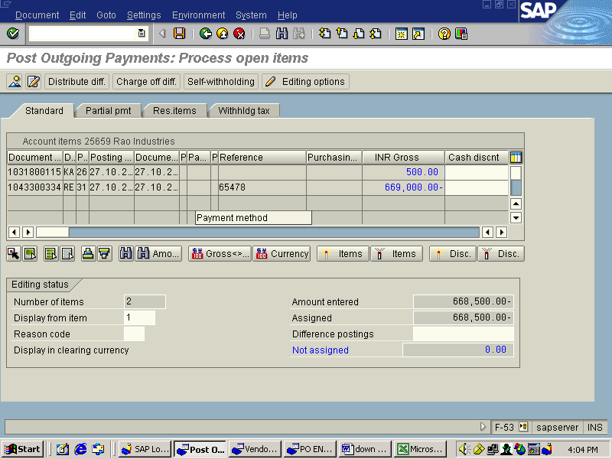
In this screen if you want to make full and final payment goto standard deactivate all amount which are not relating to a particular PO and assure that not assigned amount should be zero then save it.

If you want to make an another partial payment please click on partial payment then deactivate the amounts which are not related to the particular PO and enter the partial payment against the PO and assure that Not assigned amount should be zero Then simply save
Remove R from FBL1N. then only it will shown in blue colour save it it will generate a document number.(“R”means payment block: We can remove it by double clicking in the line item in FBL1N,Remove “R” keep it blank and save)

Transaction Code : FBL1N
Here it will show that all items are cleared. Finally all the cleared items will shown in green colour bullets.This indicates that there are no open items in Downpayment and vendor invoice amount as shown in the following screen

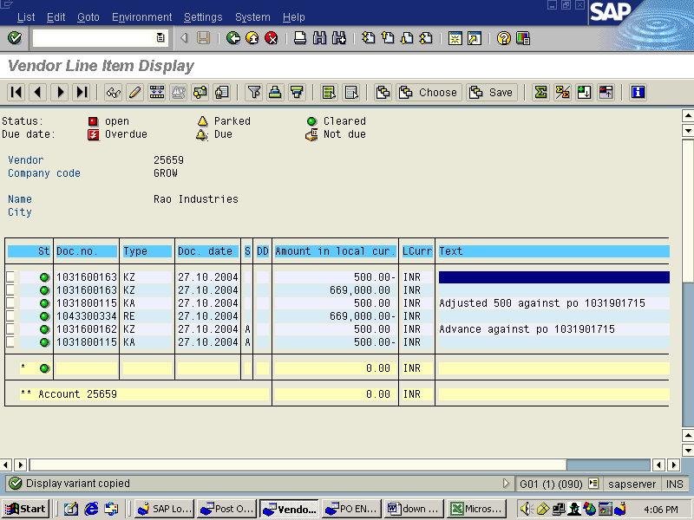

End of The Process.

