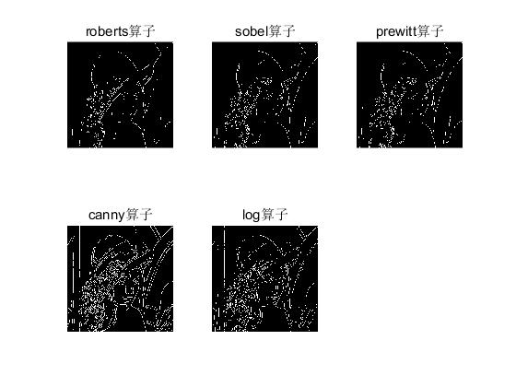I=imread('C:\Users\Lenovo\Desktop\lena.jpg');

I=rgb2gray(I);

B=edge(I,'roberts');

C=edge(I,'sobel');

D=edge(I,'prewitt');

E=edge(I,'canny');

F=edge(I,'log');

subplot(231);imshow(B);title('roberts算子');

subplot(232);imshow(C);title('sobel算子');

subplot(233);imshow(D);title('prewitt算子');

subplot(234);imshow(E);title('canny算子');

subplot(235);imshow(F);title('log算子');

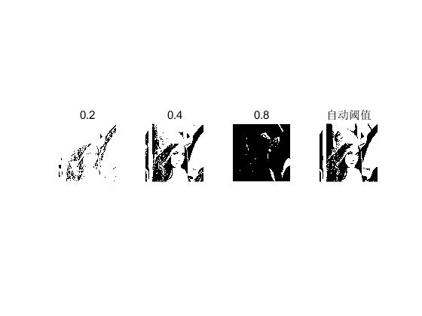I=imread('C:\Users\Lenovo\Desktop\lena.jpg');

I=rgb2gray(I);

B1=im2bw(I,0.2);

B2=im2bw(I,0.4);

B3=im2bw(I,0.8);

B4=im2bw(I,graythresh(I));

subplot(141);imshow(B1);title('0.2');

subplot(142);imshow(B2);title('0.4');

subplot(143);imshow(B3);title('0.8');

subplot(144);imshow(B4);title('自动阈值');

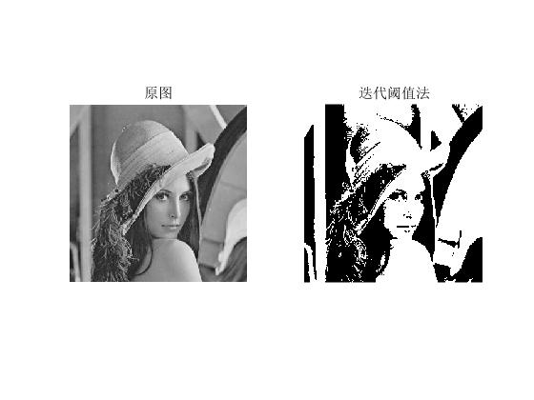I=imread('C:\Users\Lenovo\Desktop\lena.jpg');

J=rgb2gray(I);

[N,M]=size(J);

sumJ=0;

for i=1:N

for j=1:M

sumJ=sumJ+double(J(i,j));

end

end

T0=sumJ/(N\*M);

numu1=0;sumu1=0;

numu2=0;sumu2=0;

while(1)

for i=1:N

for j=1:M

if (J(i,j)<T0)

numu1=numu1+1;

sumu1=sumu1+double(J(i,j));

end

if (J(i,j)>=T0)

numu2=numu2+1;

sumu2=sumu2+double(J(i,j));

end

end

end

A=sumu1/numu1;

B=sumu2/numu2;

T1=(A+B)/2;

if abs(T1-T0)<=1

break;

else

T0=T1;

end

end

k=zeros(M,N);

k(J>T1)=255;

k(J<T1)=0;

subplot(121);imshow(J);title('原图');

subplot(122);imshow(k);title('迭代阈值法');