Lab10

Dylan Rodwell: 105341089

# 10.1

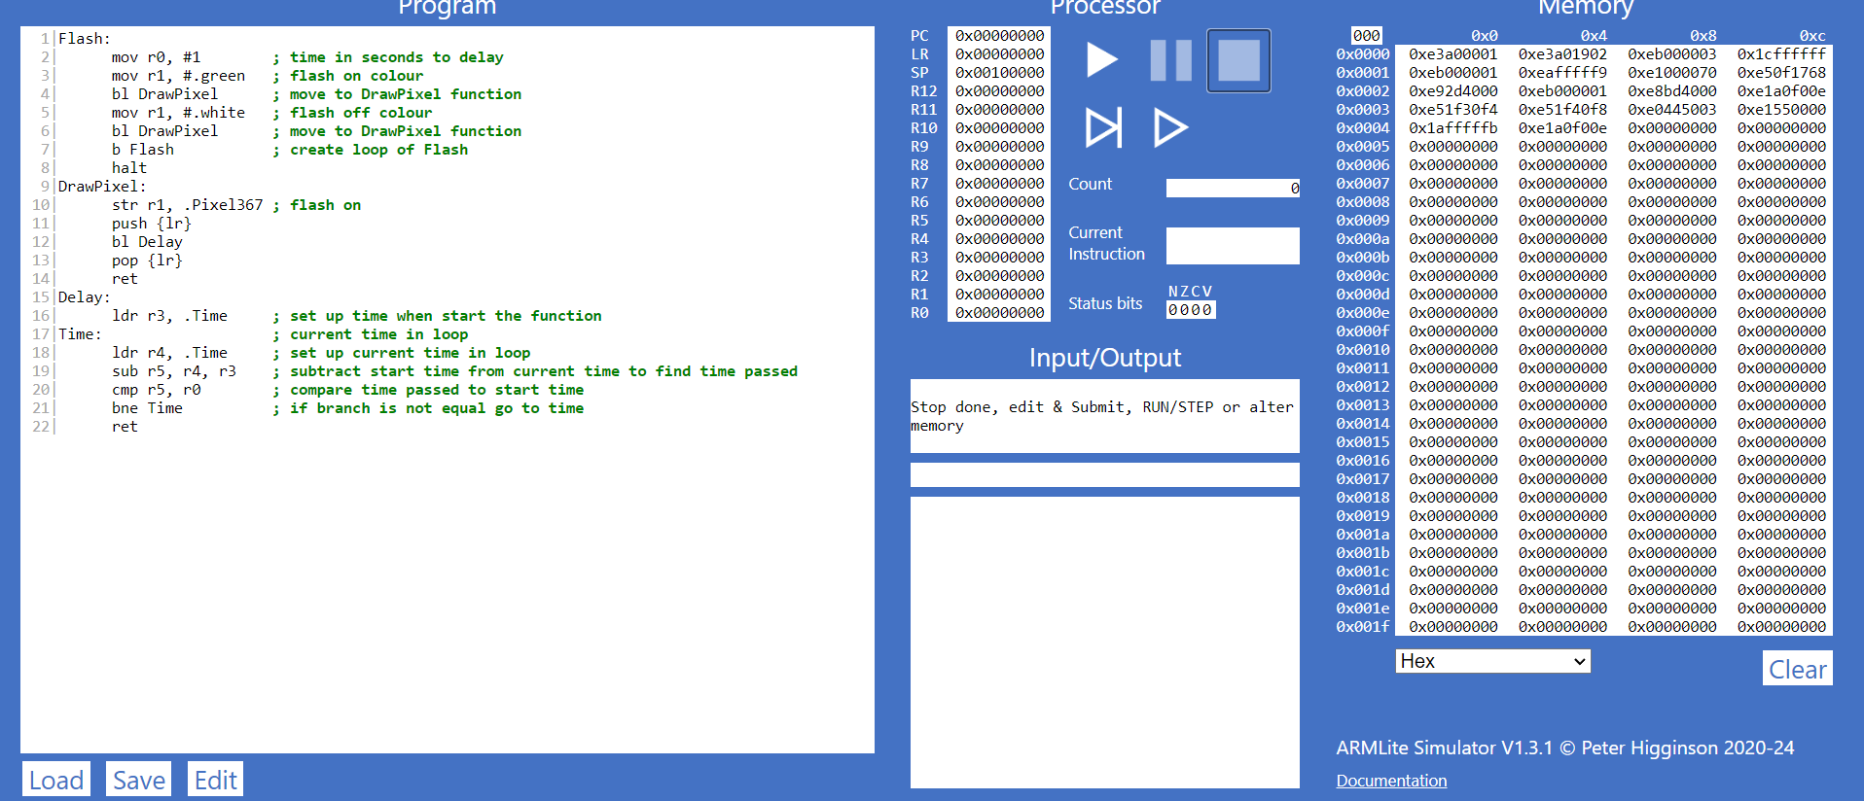  1|Flash:

  2|      mov r0, #1        ; time in seconds to delay

  3|      mov r1, #.green   ; flash on colour

  4|      bl DrawPixel      ; move to DrawPixel function

  5|      mov r1, #.white   ; flash off colour

  6|      bl DrawPixel      ; move to DrawPixel function

  7|      b Flash           ; create loop of Flash

  8|      halt

  9|DrawPixel:

 10|      str r1, .Pixel367 ; flash on

 11|      push {lr}

 12|      bl Delay

 13|      pop {lr}

 14|      ret

 15|Delay:

 16|      ldr r3, .Time     ; set up time when start the function

 17|Time:                   ; current time in loop

 18|      ldr r4, .Time     ; set up current time in loop

 19|      sub r5, r4, r3    ; subtract start time from current time to find time passed

 20|      cmp r5, r0        ; compare time passed to start time

 21|      bne Time          ; if branch is not equal go to time

 22|      ret

# 10.2

  1|Flash:

  2|      mov r0, #1        ; delay time

  3|      mov r1, #2        ; pause time

  4|      mov r2, #.green   ; flash on

  5|      bl DrawPixel      ; draws pixel

  6|      mov r2, #.white   ; flash off

  7|      bl DrawPixel      ; draws pixel

  8|      mov r2, #.green   ; flash on

  9|      bl DrawPixel      ; draws pixel

 10|      push {r0}

 11|      mov r0, r1        ; change delay time to 2 seconds

 12|      pop {r0}

 13|      mov r2, #.white   ; flash off

 14|      bl DrawPixel      ; draws pixel

 15|      b Flash           ; loop Flash

 16|      halt

 17|DrawPixel:

 18|      str r2, .Pixel367 ; flash on

 19|      push {lr}

 20|      bl Delay          ; Delay function

 21|      pop {lr}

 22|      ret               ; returns to Flash

 23|Delay:

 24|      ldr r3, .Time     ; set up time when start the function

 25|Time:                   ; current time in loop

 26|      ldr r4, .Time     ; set up current time in loop

 27|      sub r5, r4, r3    ; subtract start time from current time to find time passed

 28|      cmp r5, r0        ; compare time passed to start time

 29|      bne Time          ; if branch is not equal go to time

 30|      ret               ; returns to DrawPixel function

# 10.3

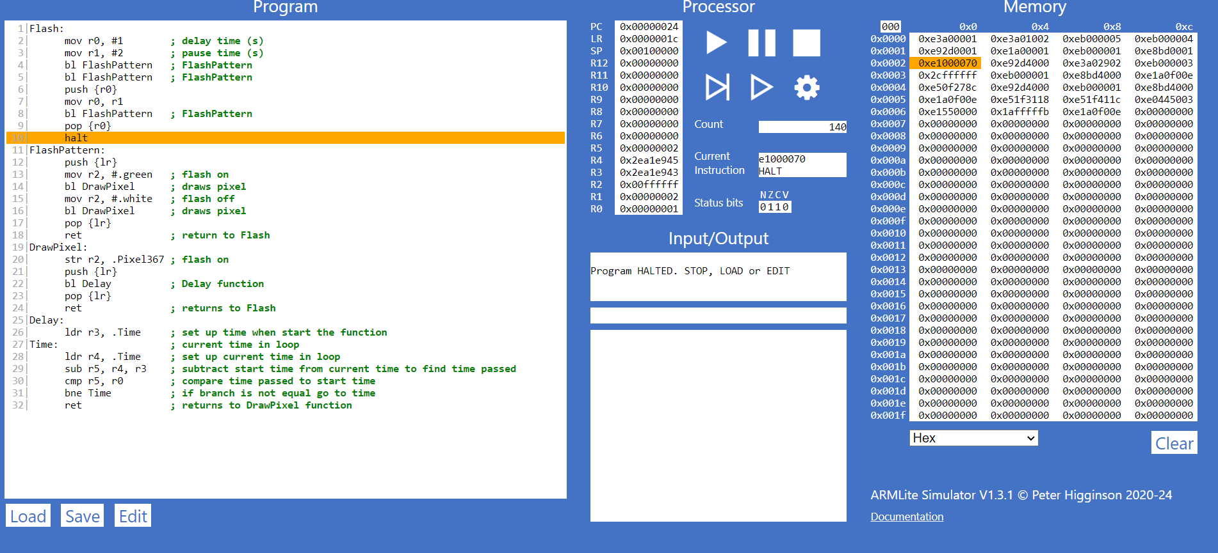

  1|Flash:

  2|      mov r0, #1        ; delay time (s)

  3|      mov r1, #2        ; pause time (s)

  4|      bl FlashPattern   ; FlashPattern

  5|      bl FlashPattern   ; FlashPattern

  6|      push {r0}

  7|      mov r0, r1

  8|      bl FlashPattern   ; FlashPattern

  9|      pop {r0}

 10|      halt

 11|FlashPattern:

 12|      push {lr}

 13|      mov r2, #.green   ; flash on

 14|      bl DrawPixel      ; draws pixel

 15|      mov r2, #.white   ; flash off

 16|      bl DrawPixel      ; draws pixel

 17|      pop {lr}

 18|      ret               ; return to Flash

 19|DrawPixel:

 20|      str r2, .Pixel367 ; flash on

 21|      push {lr}

 22|      bl Delay          ; Delay function

 23|      pop {lr}

 24|      ret               ; returns to Flash

 25|Delay:

 26|      ldr r3, .Time     ; set up time when start the function

 27|Time:                   ; current time in loop

 28|      ldr r4, .Time     ; set up current time in loop

 29|      sub r5, r4, r3    ; subtract start time from current time to find time passed

 30|      cmp r5, r0        ; compare time passed to start time

 31|      bne Time          ; if branch is not equal go to time

 32|      ret               ; returns to DrawPixel function