Image | Name | Min/Max temp | Min/Max toxicity | Min/Max Atm. Density
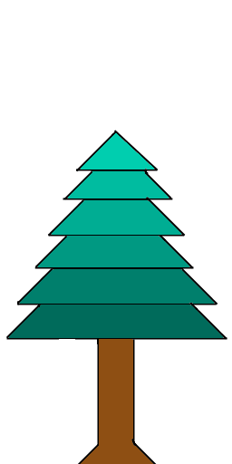 | Coniferous1 | 0 - 10 | 0 - 15 | 0 - 90
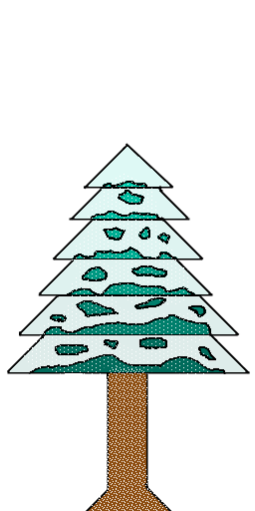 | Coniferous2 | -20 - 0 | 0 - 15 | 0 - 90
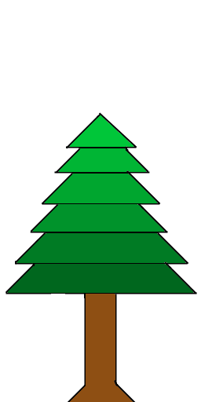 | Coniferous3 | 10 - 20 | 0-15 | 0-90

