Project Proposal: DNA Tiling Through Self-Assembly

Project Definition and Scope
The Boolean satisfiability problem, or SAT, is one of the best examples of the NP-Complete class of problems. An instance of SAT is an expression that is checked to see if there are any combinations of true and false inputs resulting in the entire expression being true. This, like all other members of the NP-complete class, requires non-deterministic polynomial to find the solution. When attempting to solve the SAT problem on a traditional computer, the computational time required grows much faster than the size of the input, thus making it intractable.
DNA self-assembly is the spontaneous formation of DNA molecules into stable structures. With the right conditions, single strands of Watson-Crick complementary DNA will hybridize. Leonard Adleman was the first to utilize this property in his use of linear self-assembly to solve the Hamiltonian Path problem. [2] Using Adleman's work, as well as the fact that it is shown tiling to be Turing-universal, Erik Winfree proposed the idea that DNA tiling through self-assembly could therefore be utilized as a universal Turing machine as well. [6] The purpose of this paper is to show some techniques for applying DNA tiling to SAT with a focus on the Laguodakis and LaBean designs for implementing an algorithmic approach using DNA tiling.
Lit Review
The difficulty of solving the SAT problem on a conventional computer arises from the exponential number of assignments that are possible. Checking a single assignment is easy; it can be done in linear time. However, checking 2^{m} different assignments quickly becomes intractable. Drawing on Adleman's work, Richard Lipton was the first to suggest that DNA could be used to solve the SAT problem in polynomial time. [1] Currently, there are several methods being explored as ways to compute SAT using DNA self-assembly. One such model is called the Stickers model, while two other methods involve DNA tiling.
The Stickers model consists of two types of DNA molecules, memory DNA strands, and sticker strands. DNA sections are divided into individual bits. Four operations used in this model: set, clear, separate, and combine. These operations are used on the bit strings that are represented by the DNA strands. [3] The stickers are parts of DNA that contain a certain sequence of bases. The stickers are only able to anneal at this location. When annealing occurs, that bit corresponds to a one. Computation using the Stickers model is a series of these operations, with the result obtained by reading a string from a result tube. [3] The largest SAT problem solved using DNA, was computed using a variation of the sticker model. It was a 20 variable, 24-clause 3-CNF expression. [4]
A second model for solving SAT, currently being researched, is based on tiling. It was originally proposed by Winfree and is called the string tile model. This method uses hairpin tiles for computation. It requires 2*m + 2 of these tiles, each of width n, where n is the number of clauses in the expression and m is the number of variables. There are two tiles for each variable representing true and false. The hairpin strands join the tiles together based on the value of the variable, as well as if that value satisfies the clause. This concept is illustrated in figure 0. If a circular strand is present in the assembly, then there is a solution to the expression. Using linear self-assembly, Winfree states that a SAT problem can be solved in O(1) steps with this method. [5]
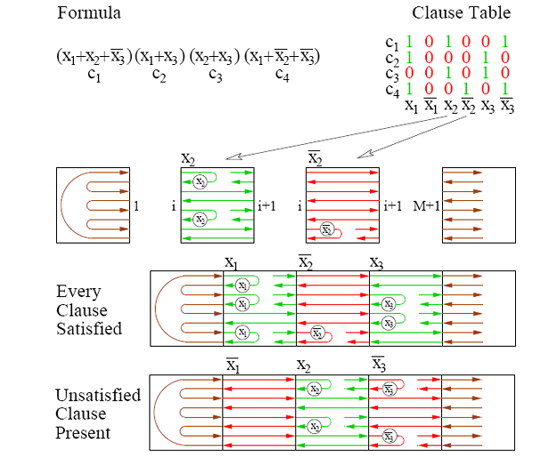
Figure 0
Example of the string tile model for SAT. [5]

A problem with these approaches is the inability to perform calculations on multiple instances with ease. Rather, in order to compute different instances of SAT, much computation time is spent encoding and decoding information onto the DNA tiles. This increases the chances of an error occurring, which would render the computation useless. A solution, proposed by Lagoudakis and LaBean, builds on past work in DNA tiling by presenting an algorithmic approach that is instance-independent of the data. [1] Like the Winfree method, this method is capable of solving SAT in O(m) steps. [5] The Laguodakis and LaBean designs are explored in depth in the following section.
Case Study
The Laguodakis and LaBean paper specifies two methods for solving SAT with DNA which they call Design A and Design B. Both methods create an initial tile library. This library is a generalized collection of tiles based that do not depend on specific data. This feature is what makes these two methods instance-independent. For clarification, a tile is represented as a square that has one to four “sticky” corners, each having a certain label. Ligation only occurs between corners with identical labels. A tile is selected from the library only when the tile in question has two corners that can bind with tiles that are already part of an assembly.
In Design A, variables and clauses are encoded as input. This design can be described with the help of a table (Figure 1). The variables are placed in the far left column and clauses in the bottom row. The table is then filled from the bottom up, row-by-row. The second column is for the input values for the variables, the top row of this column is a 'T'. Using the value from the second column, if variable x_{i} satisfies clause C_{j} then an 'OK' is placed in the table at that cell, otherwise C_{j} is propagated up the column. As soon as an 'OK' is found, the 'OK' is propagated up the column. When the top row of the table is reached, if a 'T' is directly to the left of the current column and an 'OK' is below, then a 'T' is placed in that cell. The current input values satisfy the expression if and only if a 'T' reaches the end of the top row where a special tile, called 'SS,' is located.
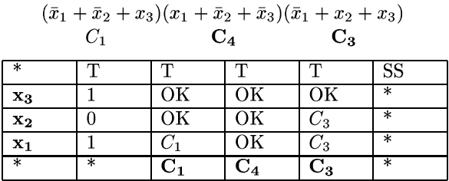
Figure 1
Demonstration of the basic algorithm for Design A. [1]

Abstracting this algorithm into DNA tiles is straightforward. Figure 2 illustrates the tiling for the expression shown figure 1. It is similar in form to the table, the variables are encoded on the leftmost tiles, and the clauses are encoded along the rightmost tiles. The light blue assignment tiles correspond to the second column in the table. This is where each input value is encoded. The yellow tiles represent the testing of a value to see if it satisfies a clause. The red tiles correspond to the top row of the table. If a red 'Success' tile is present, then the expression is satisfied, otherwise it is not. [1]
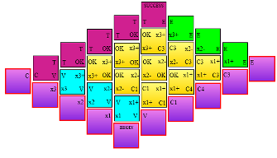
Figure 2
Tiling from figure 1 [1].

Design B is similar to Design A in functionality. However, it is slightly more complex. The primary difference is that Design B encodes literals, not clauses. Literals are the components of the clauses. For example: the clause (x + y + !z) has three literals, x, y, and !z. This design is best described with the help of a table similar to that of Design A.

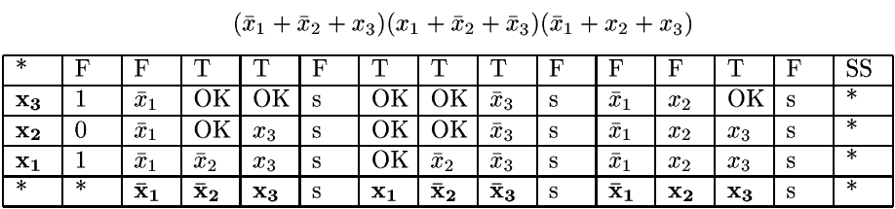
Figure 3
Table for Design B. [1]

The literals are encoded on the bottom row. Separating the literals of one clause, from those of another, is a separator column. Working bottom up, row by row, and using the input value from the second column, each literal is checked to see if it is satisfied. If it is, then an 'OK' is propagated upwards. If it is not, then the literal is propagated upwards. If an 'OK' occurs, then a 'T' will propagate along the top row, until it reaches the next separator. At this point, the process is restarted for the next group of literals. If a group of literals fails to propagate a 'T' to the separator, then the current input assignment fails to satisfy the expression. Like Design A, translating Design B into a tiling algorithm follows directly from the above process. Figure 4 shows the successful tiling. With the exception of the differences in the computation tiles, input tiles, and helper tiles, the tiling algorithm for Design B is identical to that of Design A. These differences in tile types is resolved strictly by adding different tiles to the tile library, no change needs to be made to the algorithm.
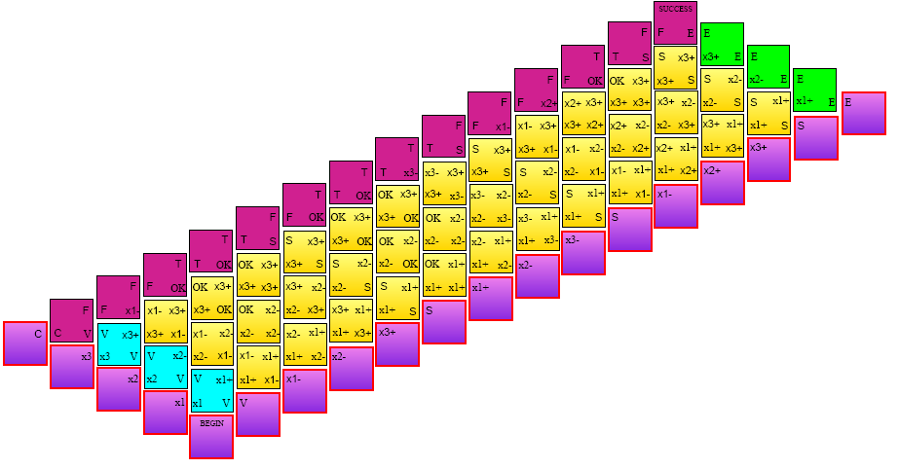
Figure 4
Successful tiling from figure 3 [1]

According to Laguodakis and LaBean, one of the primary differences in the two designs is complexity. They use three measures of complexity: computation time, space, and number of tile types. In terms of time and space, Design A is superior. In terms of number of tile types, Design B is more efficient. Laguodakis and LaBean feel that Design B is better for two reasons: 1) the input is not restricted to 3CNF form; it can be in any CNF form. 2) The total number of tile types is O(m²). Design A requires O(m⁴) tile types and input must be in 3CNF form. [1] However, by looking at the above table, the complexities for time and space are of the same order. The paper states: “design A results in smaller computation time and space but asymptotically it seems that the difference disappears.” [1] This is due to the fact that even though the class is O(m³) or O(m⁴), there are other values added and multiplied to the complexity function for Design B. However, as input size grows, these become less of a factor and the complexities converge to the values in figure 5.
--- | Design A | Design B
Time Complexity | O(m³) | O(m³)
Space Complexity | O(m⁴) | O(m⁴)
Number of Tile Types | O(m⁴) | O(m²)
Figure 5
Comparison of complexities (m = # of variables)

While the Laguodakis and LaBean designs provide a way to create a robust, instance-independent algorithm, the designs can still suffer from the limitation of space. Like other DNA methods, the space required for computation grows exponentially as the instance size grows. Therefore, the volume required can become a limiting factor. Another potential problem with this method is the assumption that only tiles with matching corners will bind. This binding is actually DNA ligation, and without precisely controlled environmental factors, errors will occur in the process, thus rendering the calculations worthless. These facts did not concern Laguodakis and LaBean, for they are strictly focusing on an algorithmic approach to DNA tiling and not with the implementation. Therefore, they do not address the errors that can be introduced due to inadequate control over temperature, Ph, or other environmental factors.
Take-Home Deliverable
A program has been built allowing a user to find all satisfying and non-satisfying assignments for a given expression, using the Laguodakis and LaBean methodologies. A user can use either Design A or Design B to calculate the result. By double-clicking on one of the assignments in the listboxes, the user can see the resulting tile structure. The complexity differences between the two designs can be seen by this application. Running the expression on a 3.4Ghz computer:
“(!b + c + g)( c + !e + !h)(!a + b + d)(!c + e + f)(a + !f + e)(e + g + h)(!b + d + f)(c + !d + e)
(a + d + !f)(b + !f + h)(y + t + !u)(!a + !d + v)(!a + !c + v)(q + r + !b)(c + e + !f)” results in a 176 second execution time and requires 4581016 tiles for Method A. Method B runs in 569 seconds and requires 15953452 tiles. This application also helps to show the time-space trade-off of tiling by DNA self-assembly. Attempting to run a 23-variable, 17-clause expression using Design B, ran for 2 days, using over 7 billion tiles before being prematurely terminated by a temporary hardware failure. It would have run for at least another 2 days had it been allowed to complete the calculation. With that information in mind, the primary advantage and potential problem of tiling with DNA is clear. A massively parallel system such as DNA self-assembly, would significantly decrease this running time. Instead of having to execute row by row, column by column on a traditional Von Neumann computer, tiling can occur at multiple places at once--anywhere an open slot is available. With billions of strands of DNA available, these slots can be quickly be filled. However, the massive amount of tiles, and therefore, DNA required, can become a limiting factor due to the errors, and required space.
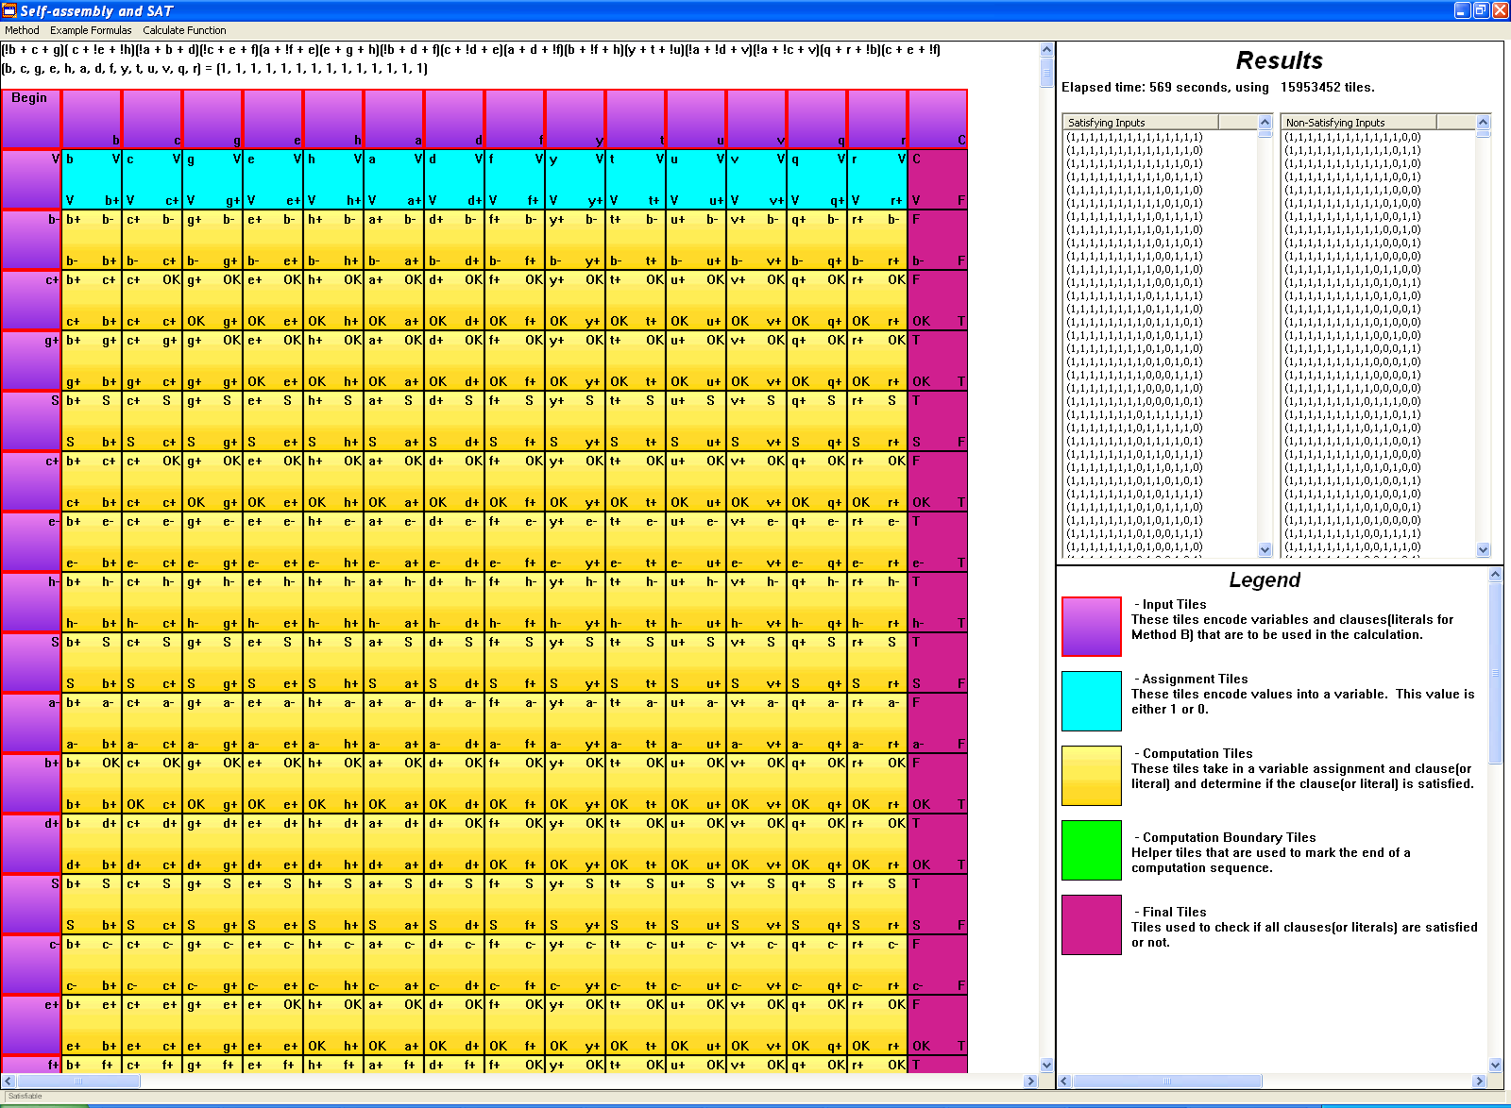
Figure 6
Screenshot from application

In conclusion, the potential advantages of tiling by DNA self-assembly are clear, as are its weakness. Massive parallelism provides great computing potential, but is limited by space, as well as other environmental factors. However, these issues aside, the ability to solve the satisfiability problem in polynomial time means that these methods can be used to solve other NP-complete problems in polynomial time as well. This feature alone makes DNA tiling by self-assembly an important area of study.
References
[1] Michail G. Lagoudakis and Thomas H. LaBean. “2D DNA Self-Assembly for Satisfiability.”
[2] Seeman, Nadrian C., Winfree, Erik, and Yang, Xiaoping. “Universal Computation via Self-assembly of DNA: Some Theory and Experiments.” 7 Aug. 1996.<http://www.dna.caltech.edu/Papers/self-assem.pdf>
[3] Adleman, Leonard M., Winfree, Erik, Roweis, Sam, et. al. “A Sticker based Model for DNA Computation.” May 1996. <http://citeseer.ist.psu.edu/cache/papers/cs/1062/ftp:zSzzSzhope.caltech.eduzSzpubzSzroweiszSzDIMACSzSzstickers.pdf/roweis96sticker.pdf>
[4] Adleman, Leonard M., Braich, Ravinderjit S., Chelyapov, Nickolas, et.al. “Solution of a 20-Variable 3-SAT Problem on a DNA Computer.” Sciencexpress 14 March 2002 <http://www.dna.caltech.edu/courses/cs191/paperscs191/Braichetal_Science2002.pdf>
[5] Eng, Tony, Rozenberg, Grzegorz, and Winfree, Erik. “String Tile Models for DNA Computing by Self-Assembly.” <http://www.dna.caltech.edu/Papers/stringtiles.pdf>
[6] Papadakis, Nick, Rothemund, Paul, and Winfree, Erik. “Algorithmic Self-Assembly of DNA Sierpinski Triangles.” PLoS Biology 2.12 December 2004: <http://www.dna.caltech.edu/Papers/SierpinskiDNA_PLoS2004.pdf>

