Trello Board: https://trello.com/b/DL9q0lEU/final-project

User Stories:
1. As a user, I need a simple and easy to use interface that does not overcomplicate things.
2. As a user, I need to have the ability to submit notes and conversations history with ease.
3. As a user, I need to be able to view my existing Google Calendar through the Customer Manager.
4. As a user, I need to be able to sort through both my contacts and companies with multiple sorting functions.
5. As a user, I need to be able to create tasks based on company or user.

Breaking Down User Stories and Burndown Chart:

Task | Corresponding Story Number | Duration | priority | Complexity | Lead Person
Create formatted UI that can be replicated throughout site | 1 | 4 hours | 8 | High | Josh
Create “Conversation History” page and integrate into Dashboard | 2 | 6 hours | 5 | Average | Nicholas
Integrate “Google Calendar” into Calendar page | 3 | 5 hours | 4 | Low | Nicholas
Create “Contacts” page | 4 | 4 hours | 5 | Average | Nicholas
Create “Companies” page | 4 | 4 hours | 5 | Average | Jeff
Set up input path forms for “Companies” page | 4 | 3 hours | 4 | Average | Jeff
Set up input path forms for “Contacts” page | 4 | 3 hours | 4 | Average | Noah
Create “Task List” Page | 5 | 6 hours | 6 | Average | Josh
Set up “Add Task” form for “Task List” Page | 5 | 5 hours | 5 | High | Nicholas
Set up view settings for “Task List” page to search by multiple items | 5 | 6 hours | 5 | High | Noah
Create “Quick Notes” page and integrate into Dashboard | 2 | 6 hours | 5 | Average | Noah

Days 4:

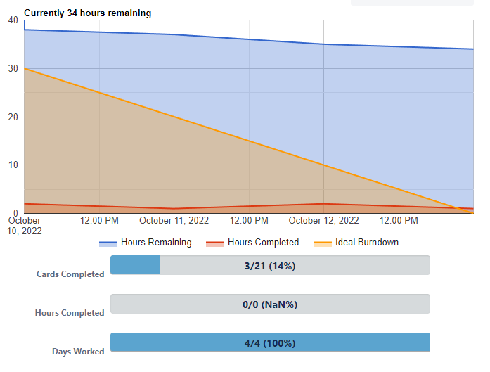

Days 9:
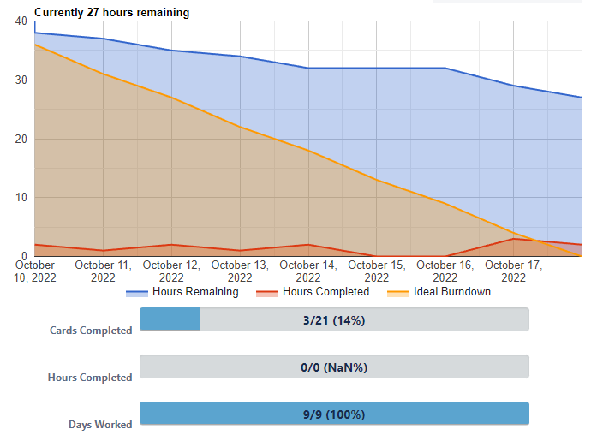

Days 14:
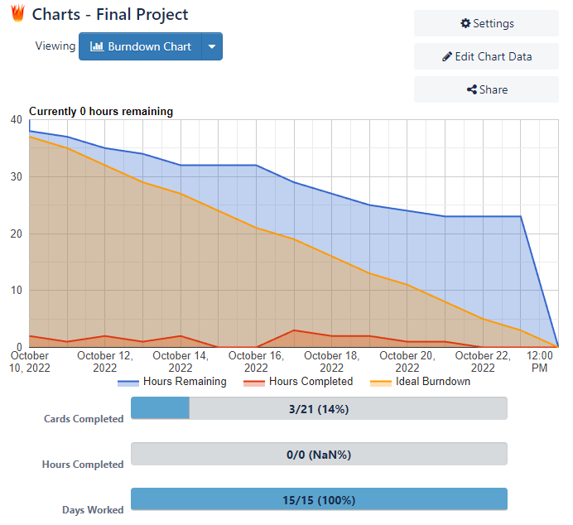

Repo URL on GitHub: https://github.com/Storrzy12/finalproject.git

Daily Scrum:

